Vincent Hu

Project 6SERVO – Control a Servo with interrupts

1. Timer1 setup
   1. TCCR1A = 0
   2. TCCR1B = 0b00001100
   3. TCNT1 = 0
   4. OCR1A = floor(16000.0/256.0 * pulse_width)
   5. TIMSK1 = 0b00000010
   6. T_min = 1
   7. OCRAx_min = 250
   8. T_max = 2
   9. OCRAx_max = 500
2. Angular resolution = 1.5

y = floor(16000/256.0 * (0.5/45 * x + 1.5))

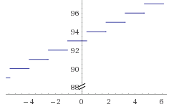

It takes at least a 1.5 degree change in input angle to cause a difference in the servo angle.