{‘eth’: [

{‘path’: “m/44'/60'/0'/0/0”,

‘address’: ‘0x3D6d8350132F0B5CeE406df2D6AFB14C46fE4E3c’,

‘privkey’: ‘0xea0f32f6497fa3747ff9ddcd95f0c5643b9aa4505d880aad001c06c8feafbe29’,

‘pubkey’: ‘03ae04daddaf81868e850202602d4ffa25b4cd75087e5626b120458ffa5c974f8e’},

{‘path’: “m/44'/60'/0'/0/1",

‘address’: ‘0xEed255EBF1bA3ED522ef992d1Dead1c7Cf07B3bF’,

‘privkey’:‘0x44d270115e64b52d664da7b64e71e419946fa988d30e01395c97375ed18ed1a2,

‘pubkey’:‘026abb94ff848a303c7d09974d5560a4bd95392d5a98fa15d681bbdf74d106c864’},

{‘path’: “m/44'/60'/0'/0/2”, ‘address’: ‘0x5ac7f333eBaEA3C136775800062b3fbA93cc4DB3’, ‘privkey’: ‘0xa9a900a7748613bf9558d58cd1ad8f791fb3cc01d806c1cdf4dfaeefd70292bf’, ‘pubkey’: ‘02170544633bc0307197bdba9b7ee8150845c38616b8d3c4c357f272bac39b1209’}, {‘path’: “m/44'/60'/0'/0/3", ‘address’: ‘0x1d0c88e99222769CEcFD36C6cC59CE8cA9ca860e’, ‘privkey’: ‘0xc0d8df8db7d1d5e43e917453a8f5aea68845da7340732d950e0c0bf601df710a’, ‘pubkey’: ‘02769a955b711577881d60262f347724217df5754e1eebaa662d8d9b574d5e56a2’}, {‘path’: “m/44'/60'/0'/0/4”, ‘address’: ‘0x08C72cFa5103BD158ebfdE7FBdf45Afd27766F55’, ‘privkey’: ‘0x673022a7dc86115ef9865695655509dc39e05f2966771bb66480466fa65a8890’, ‘pubkey’: ‘02cd63f92428bc63c635dac2bf8f31db4f3a2bbc9aecd8b824a0e9df997cfc33db’}, {‘path’: “m/44'/60'/0'/0/5", ‘address’: ‘0x5D7b27FdA2C0b170E7d1320055f616737bFf4481’, ‘privkey’: ‘0x8c3a731db80e0e5a5fe1d017916a33ffd9861911ac771bdbe6111ce9c1d96439’, ‘pubkey’: ‘03130c4de8110c7a233f5909f422163b46b5ce26fc279b68ef5ad0288a5cd85b7d’}, {‘path’: “m/44'/60'/0'/0/6”, ‘address’: ‘0x8a360f7BE78E52fed2a100b8037F0069B28152a5’, ‘privkey’: ‘0xa218356489355bb8eb6a60ead29a5a0a928e25f4593e69664e4d25b50c63d894’, ‘pubkey’: ‘028fb02663b748fdeb65c11147e254989cc98bf39c0fb5d2624c554f0424423abd’}, {‘path’: “m/44'/60'/0'/0/7", ‘address’: ‘0x98Cd3981840e8672d48A9F52F81E7D6FC843d0BC’, ‘privkey’: ‘0x8df0653cf5b5ae1cbbe90e21545ebfe75c8c7d5616587d1e02c644e3fd1e8909’, ‘pubkey’: ‘03951120fbabb04c865792ff65f20391a9516831cfe77c7b0e4ce425026f5646c9’}, {‘path’: “m/44'/60'/0'/0/8”, ‘address’: ‘0xbbA73c44A01276DE92a6B94EfAD4fC1C7771B921’, ‘privkey’: ‘0x8f1b29de2c86b4292dcc92b66a5e2504332caa6351ccb12e1798e2a9436c4d15’, ‘pubkey’: ‘039818f5a0eaba51b88edc314e26d9c4a7896ec022b6d13bb6539f244155733958’}, {‘path’: “m/44'/60'/0'/0/9", ‘address’: ‘0x58D97FAa603b576A8b80cC4d4485A9704475B80C’, ‘privkey’: ‘0xa298cabced5bfdc571031cd33a948c657cec2d0c6453de9cde77b098a9162f9e’, ‘pubkey’: ‘039ff3aaf3dfa5cbf2c2d9ae49a34cd4e97dd0008f0f47bc0f16ff2777e4773c2e’}],

‘btc-test’: [{‘path’: “m/44'/1'/0'/0/0”, ‘address’: ‘n18zXQqmr4UuHbaKaGb2G7pWXShAtX53DK’, ‘privkey’: ‘cR5nLZnXpdZUQSCV8TUbjKZyruZwLvD6goXFiSiw5Fo372eZPpHM’, ‘pubkey’: ‘03e3e1146b0e67b7934f8f28bdf1c1d25bcd60f5869885deb30e1c1eb1dcafcc5f’}, {‘path’: “m/44'/1'/0'/0/1", ‘address’: ‘mxJE1rmwUeiBgJR5cCoH5mosZ8WtHDpQZU’, ‘privkey’: ‘cU7KsGVpBgCzkyjiruAPWWnqw66gqH9cGmsimsWBxtdXeRhbwM1c’, ‘pubkey’: ‘03196dae496a824c953daf423f5f741b7fff86e803b096a1c16ed747add920559c’}, {‘path’: “m/44'/1'/0'/0/2”, ‘address’: ‘mzeMpjioZdW4RieRCidHKmVmo93MSK45LK’, ‘privkey’: ‘cP9C2aMceatzDkLrCxh8Ef8pBe1i65E2cNxbcCDUr9sQZpwnc6U1’, ‘pubkey’: ‘03a5625d0093f3422228f4ad269d933d3c02adddc7d40c6d6dbf45794687846a1e’}, {‘path’: “m/44'/1'/0'/0/3", ‘address’: ‘mqXeQXy65bRwhbwaoLeEAALMLeQvUC2tAP’, ‘privkey’: ‘cPnrs3mrrFpXvHY1hANnPxfkpG9RDdWB6rd68zXEiS8hqBPLA5xX’, ‘pubkey’: ‘033c6c629da178fc089d71c59d7ab6fe538fa07cc36c696d46ec1ec570dfbe021f’}, {‘path’: “m/44'/1'/0'/0/4”, ‘address’: ‘mmqeYzPvjRFYpEw8AjyoJ4ZRMEYjhhwufb’, ‘privkey’: ‘cSgviY7hA8uSLDVKLJBf2Z3KiXe6QScLkdbACWbYPwH7ETo1AeTs’, ‘pubkey’: ‘0291e4b756b104fc56f872355c5649db187f6ae0996c3c30b1822149fdfcc520bb1’}, {‘path’: “m/44'/1'/0'/0/5", ‘address’: ‘mjktiitkFfwDdYspuxyUKYeLwEwnPiqXEP’, ‘privkey’: ‘cPX8QvogxiW1iddBFRGMDqhN8NACLMH1oVVcSTMoH146awmazF53’, ‘pubkey’: ‘022fd28a4a316e9754cdce51da93fff7d7f11510d8f17cc88553d70d9aaeb561c4’}, {‘path’: “m/44'/1'/0'/0/6”, ‘address’: ‘mpwP4xNFQiKLDkWHnsspPLA8fqCV3yhBmp’, ‘privkey’: ‘cSSZU77ZWoSJ529qtLh8gjQ49dpqtRmScsb1nUN63E3vu8nx9PC4’, ‘pubkey’: ‘02ea61cb23e209cb048d7291d51cdab53eb3c0d96d7fe93f9795edd422c8f36283’}, {‘path’: “m/44'/1'/0'/0/7", ‘address’: ‘mpBdYMqGL1AYbNhVZYUTj353FSnmPqsftz’, ‘privkey’: ‘cRNb6AUCGVVBjqmMxi12KpkZdBZv8Rv2mgh37oRAUdwFVHTMHZsD’, ‘pubkey’: ‘024e48ff65019231bec0dae27dc3ff415db415c06652bcc098649bd91e6b5b3143’}, {‘path’: “m/44'/1'/0'/0/8”, ‘address’: ‘n3NhLeozqNP9STvTSAD7NH6YPrrkA3vp9B’, ‘privkey’: ‘cU7sGLVRJGKKWAQXwRH7mJXVGGVBbDeWUCsnBmxrXQgW39Wp1Xtu’, ‘pubkey’: ‘0398538466a840417e95ab18263cedb3a02b19930b12d81ddd88b8d3b8e2d72d9a’}, {‘path’: “m/44'/1'/0'/0/9", ‘address’: ‘n2BTYA6UBpXKhtsSxoWGYPKDVekvp774Cp’, ‘privkey’: ‘cPaBF7wmdcTxt8wQtz58pH5M5azqYjM9kAA6LhCXJVsZrcMx6vBV’, ‘pubkey’: ‘038fc88b261fa883f1d76c7137c241dbb509f89cbbf80c536b2f56cd840c3fd15b’}]}

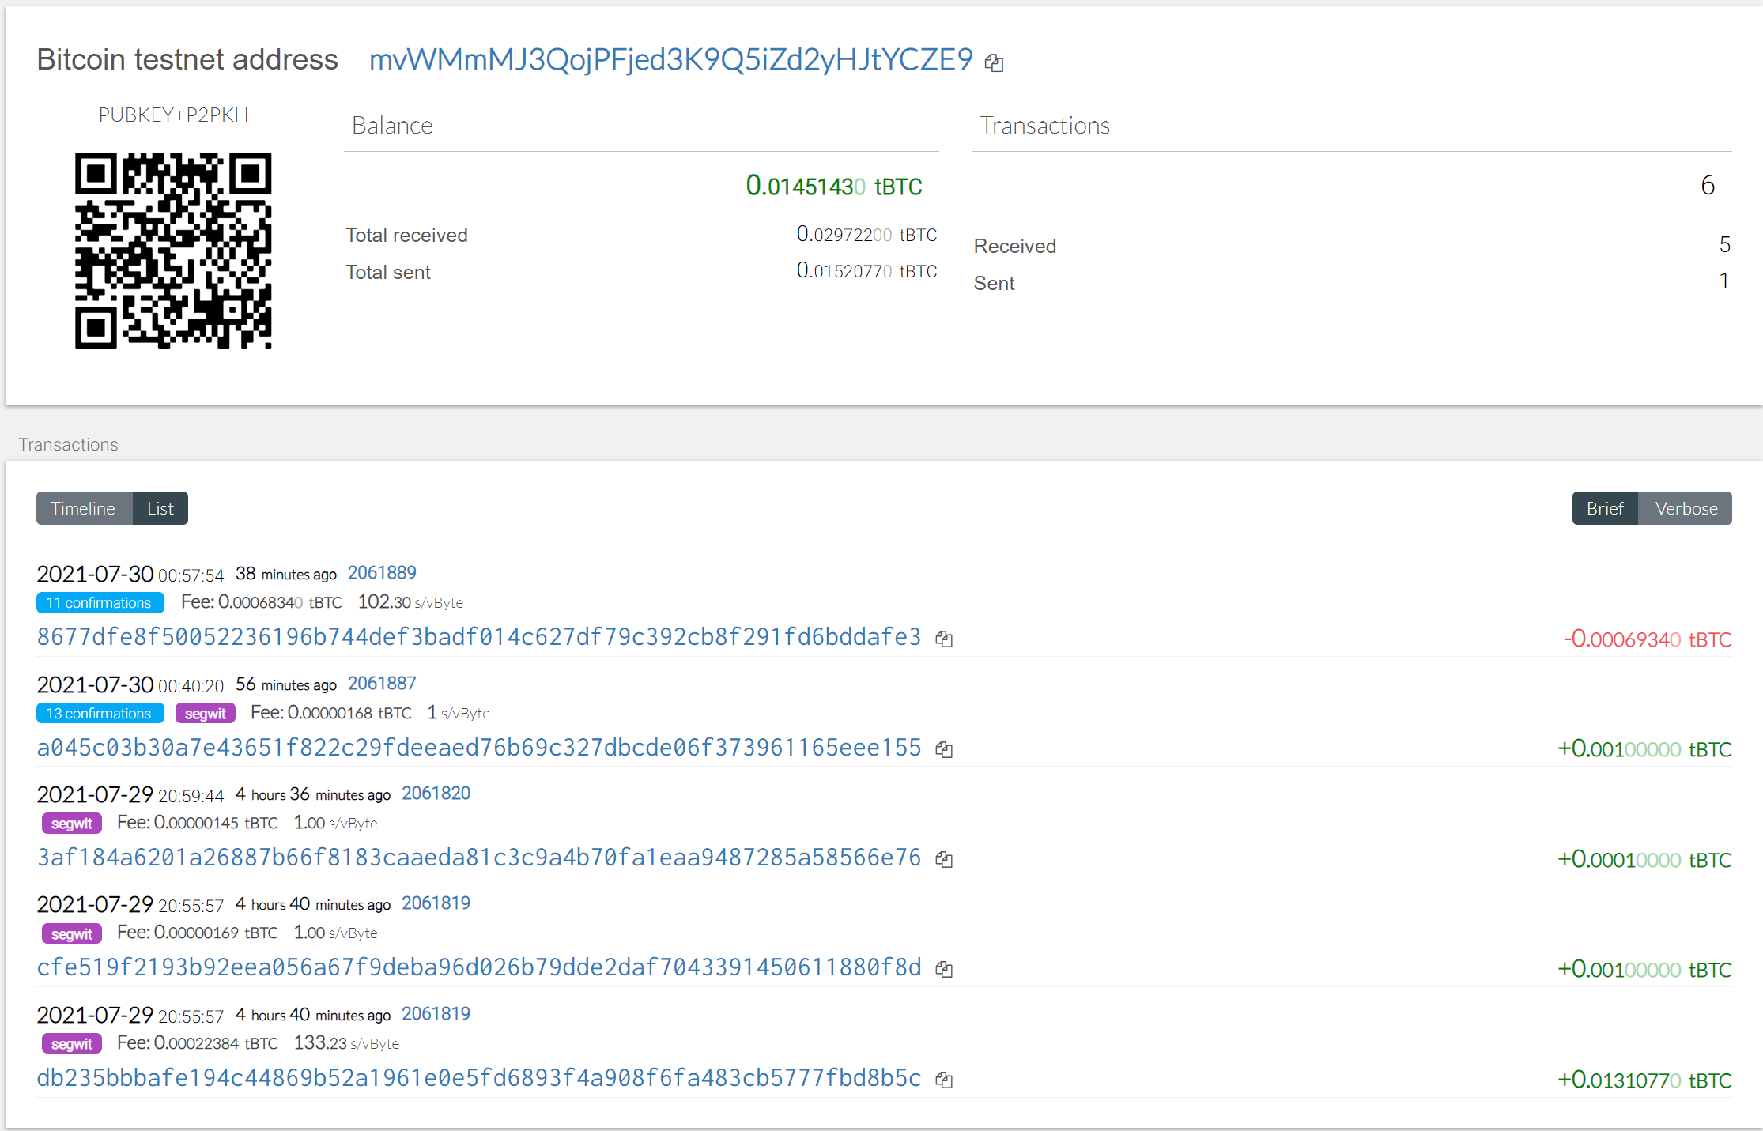

alias python='winpty python.exe'



