All distance, Orientation +/+

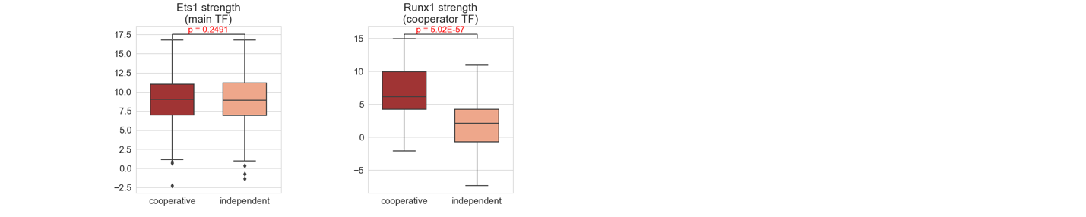

All distance, Orientation +/-

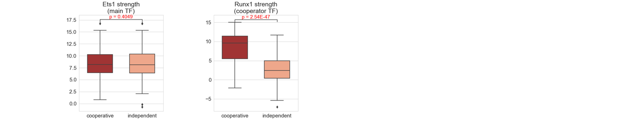

All distance , Orientation -/+

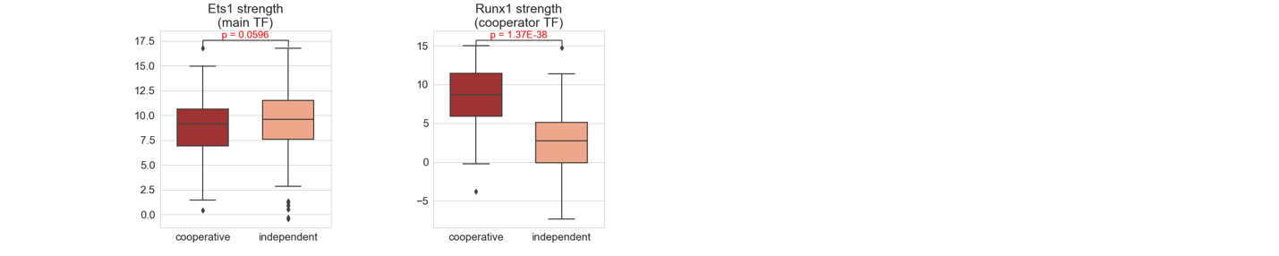

All distance, Orientation -/-

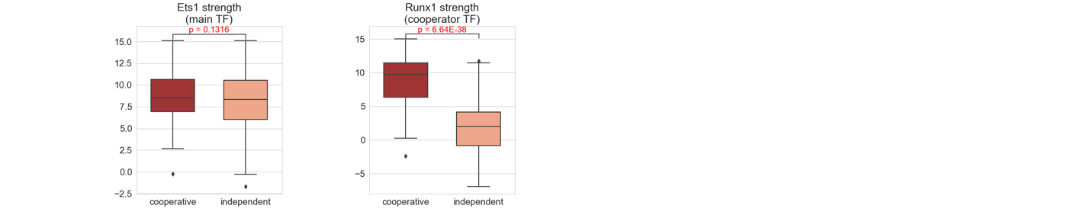

Distance 5, all orientation

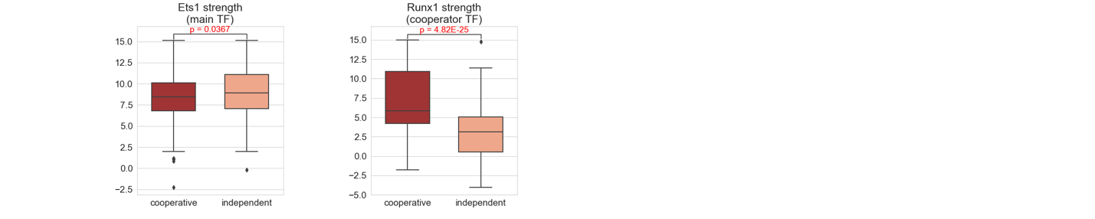

Distance 7, all orientation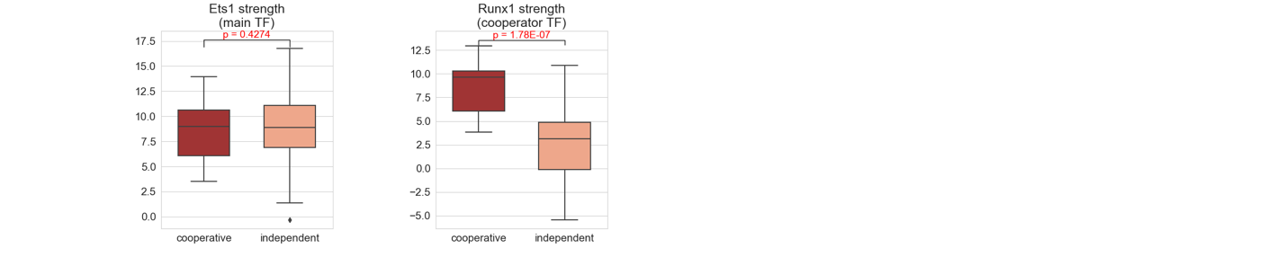

Distance 5, orientation ++

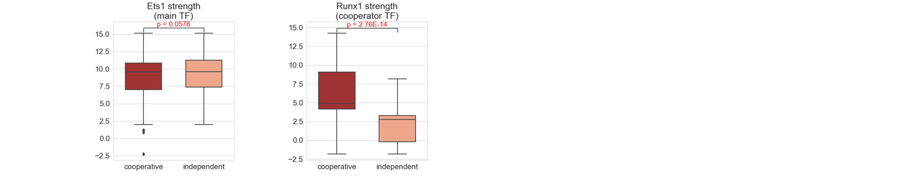

Distance 5, orientation +-

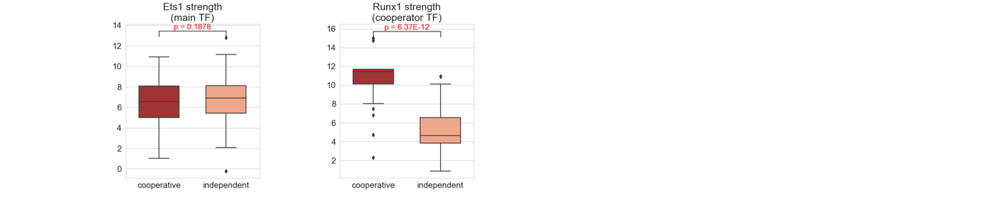

Distance 5, orientation -+

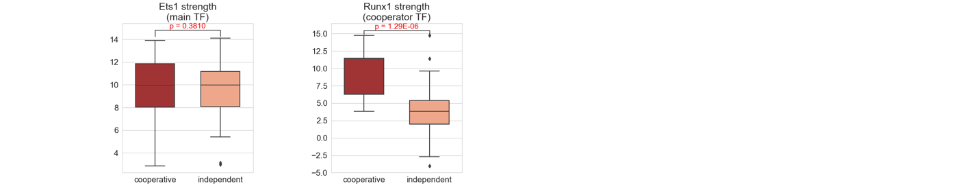

Distance 5, orientation –

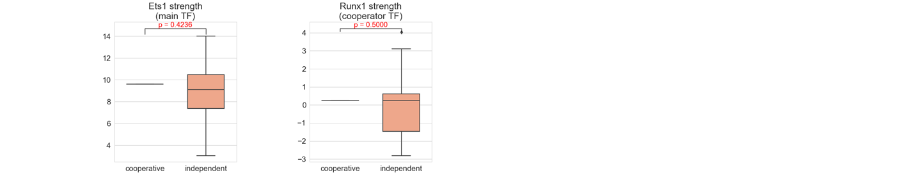

Count per distance, orientation:

distance orientation label

4 -/+ independent 7

-/- independent 6

5 +/+ cooperative 266

independent 59

+/- cooperative 46

independent 36

-/+ cooperative 16

independent 65

-/- cooperative 1

independent 26

6 +/+ independent 4

+/- cooperative 6

independent 7

-/+ cooperative 1

independent 4

-/- cooperative 6

independent 13

7 +/+ cooperative 9

independent 22

+/- cooperative 1

independent 6

-/+ cooperative 5

independent 21

-/- cooperative 2

independent 16

8 +/+ cooperative 31

independent 26

+/- cooperative 4

independent 19

-/+ cooperative 9

independent 25

-/- cooperative 4

independent 13

9 +/+ cooperative 16

independent 15

+/- cooperative 1

independent 9

-/+ cooperative 10

independent 20

-/- cooperative 1

independent 16

10 +/+ cooperative 13

independent 13

+/- cooperative 10

independent 11

-/+ cooperative 7

independent 11

-/- cooperative 2

independent 13

11 +/+ cooperative 17

independent 21

+/- cooperative 19

independent 11

-/+ cooperative 11

independent 19

-/- cooperative 15

independent 20

12 +/+ cooperative 16

independent 13

+/- cooperative 23

independent 9

-/+ cooperative 3

independent 16

-/- cooperative 6

independent 12

13 +/+ cooperative 9

independent 17

+/- cooperative 20

independent 17

-/+ cooperative 12

independent 15

-/- cooperative 8

independent 16

14 +/+ cooperative 13

independent 15

+/- cooperative 23

independent 13

-/+ cooperative 4

independent 13

-/- cooperative 10

independent 19

15 +/+ cooperative 5

independent 11

+/- cooperative 20

independent 14

-/+ cooperative 5

independent 16

-/- cooperative 9

independent 20

16 +/+ cooperative 5

independent 17

+/- cooperative 13

independent 16

-/+ cooperative 7

independent 12

-/- cooperative 7

independent 17

17 +/+ cooperative 12

independent 18

+/- cooperative 20

independent 14

-/+ cooperative 10

independent 18

-/- cooperative 8

independent 14

18 +/+ cooperative 11

independent 15

+/- cooperative 10

independent 10

-/+ cooperative 3

independent 14

-/- cooperative 6

independent 10

19 +/+ cooperative 10

independent 16

+/- cooperative 9

independent 11

-/+ independent 1

-/- cooperative 3

independent 13

20 +/- cooperative 16

independent 10

-/+ cooperative 6

independent 15

21 +/+ cooperative 10

independent 9

-/+ cooperative 6

independent 15

-/- cooperative 6

independent 14

22 +/+ cooperative 8

independent 4

+/- cooperative 14

independent 12

-/+ cooperative 5

independent 10

-/- cooperative 5

independent 18

23 +/+ cooperative 5

independent 10

+/- cooperative 8

independent 8

-/+ cooperative 10

independent 4

-/- cooperative 8

independent 8

24 +/+ cooperative 5

independent 10

+/- cooperative 5

independent 12

-/- cooperative 6

independent 12

25 +/- cooperative 4

independent 8