**All distances, per orientation**

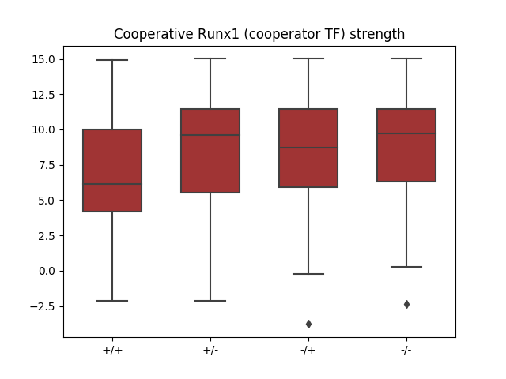

Statistical testing (wilcox testing) for **Runx1 strength**

“+/+” less than “+/-“, p-value: 7.528e-12

“+/+” less than “+/-“, p-value: 3.451e-09

“+/+” less than “-/-“, p-value: 1.680e-09

**Without dist=5, per orientation**

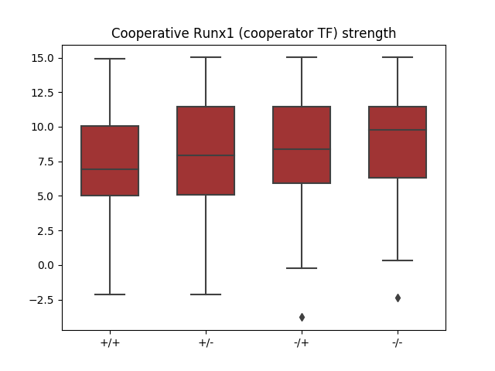

Statistical testing (wilcox testing) for **Runx1 strength**

“+/+” less than “+/-“, p-value: 9.347e-02

“+/+” less than “+/-“, p-value: 1.471e-02

“+/+” less than “-/-“, p-value: 1.071e-03

**Per distance**

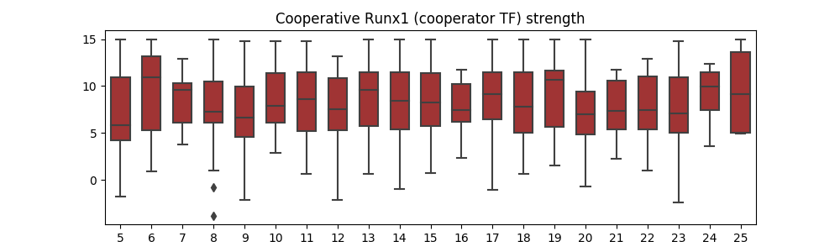

p-value of dist=5 < dist=x:

6 : 0.011172275719306894

7 : 0.045781651223720375

8 : 0.012050024889575135

**9 : 0.4490822144224069**

10 : 0.007704196565938581

11 : 0.007284303039464805

12 : 0.019674154189799738

13 : 0.0008780853226397507

14 : 0.005860447571664324

15 : 0.005270408637312045

16 : 0.008227875162040627

17 : 0.0026895392822346236

18 : 0.023238490750864465

19 : 0.0028888251317531425

**20 : 0.408471913746886**

21 : 0.053996611922750334

22 : 0.05266196710034696

23 : 0.05157422961257851

24 : 0.009824234559079093

25 : 0.09101496558467803

🡪 There seems to be a periodicity from dist=9 to dist=20 (~10.5bp?)

**Per distance, orientation**

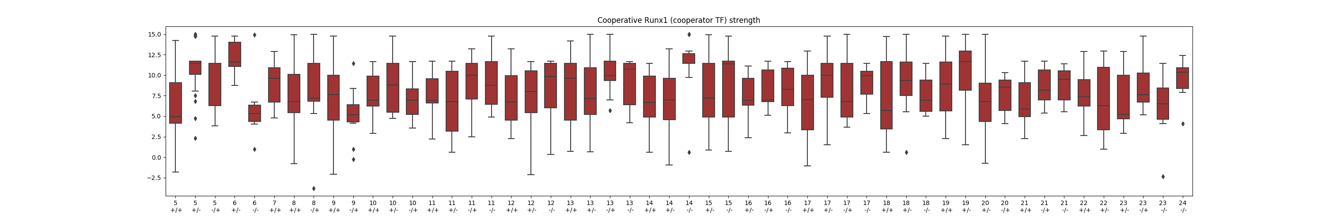

p-value (5, '+/+') less than x:

(5, '+/-') : 1.67e-16

(5, '-/+') : 1.38e-05

(6, '+/-') : 1.54e-04

**(6, '-/-') : 0.47**

(7, '+/+') : 2.89e-03

(8, '+/+') : 3.78e-03

(8, '-/+') : 1.54e-02

(9, '+/+') : 7.17e-02

**(9, '-/+') : 0.51**

(10, '+/+') : 5.26e-03

(10, '+/-') : 2.18e-03

**(10, '-/+') : 0.18**

(11, '+/+') : 1.07e-02

**(11, '+/-') : 0.34**

(11, '-/+') : 3.48e-03

(11, '-/-') : 4.95e-05

(12, '+/+') : 6.49e-02

(12, '+/-') : 7.12e-04

(12, '-/-') : 3.71e-02

**(13, '+/+') : 0.11**

(13, '+/-') : 1.33e-02

(13, '-/+') : 5.94e-05

(13, '-/-') : 4.38e-03

**(14, '+/+') : 0.16**

(14, '+/-') : 6.89e-02

(14, '-/-') : 3.36e-05

(15, '+/-') : 8.31e-03

(15, '-/-') : 1.54e-02

(16, '+/-') : 1.42e-02

(16, '-/+') : 6.72e-03

(16, '-/-') : 3.84e-02

**(17, '+/+') : 0.22**

(17, '+/-') : 7.94e-05

(17, '-/+') : 5.69e-02

(17, '-/-') : 3.17e-03

**(18, '+/+') : 0.21**

(18, '+/-') : 2.99e-03

(18, '-/-') : 4.01e-02

(19, '+/+') : 1.78e-02

(19, '+/-') : 3.03e-03

**(20, '+/-') : 0.13**

**(20, '-/+') : 0.18**

**(21, '+/+') : 0.16**

(21, '-/+') : 9.96e-03

(21, '-/-') : 1.73e-02

(22, '+/+') : 3.82e-02

**(22, '+/-') : 0.19**

**(23, '+/-') : 0.36**

(23, '-/+') : 1.85e-03

**(23, '-/-') : 0.19**

(24, '-/-') : 2.64e-02

**Dist=7, ori +/+**

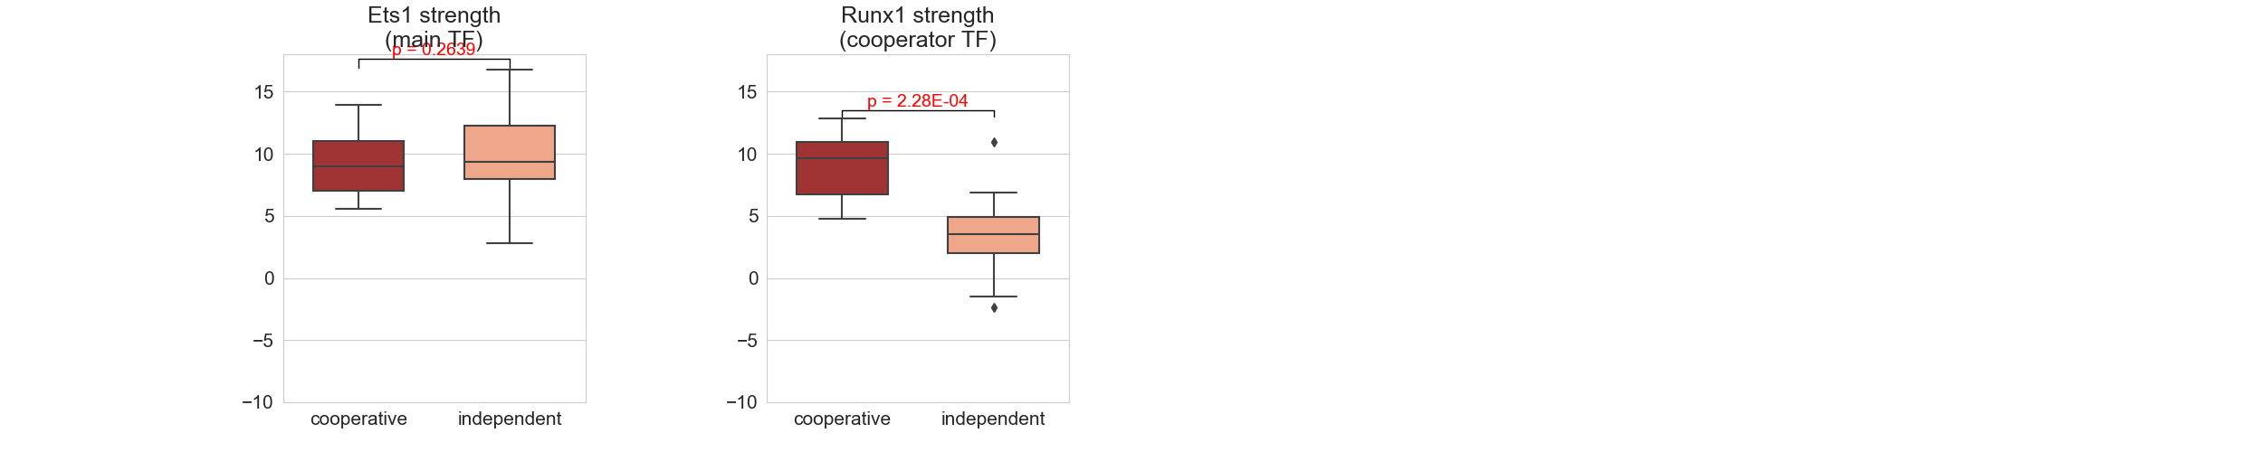

**Dist=7, ori +/-**

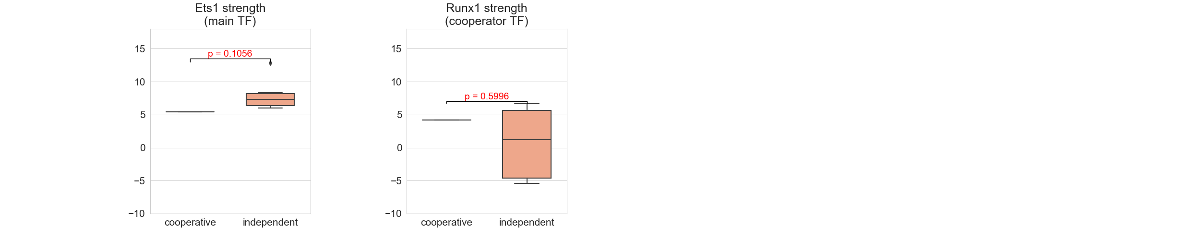

**Dist=7, ori -/+**

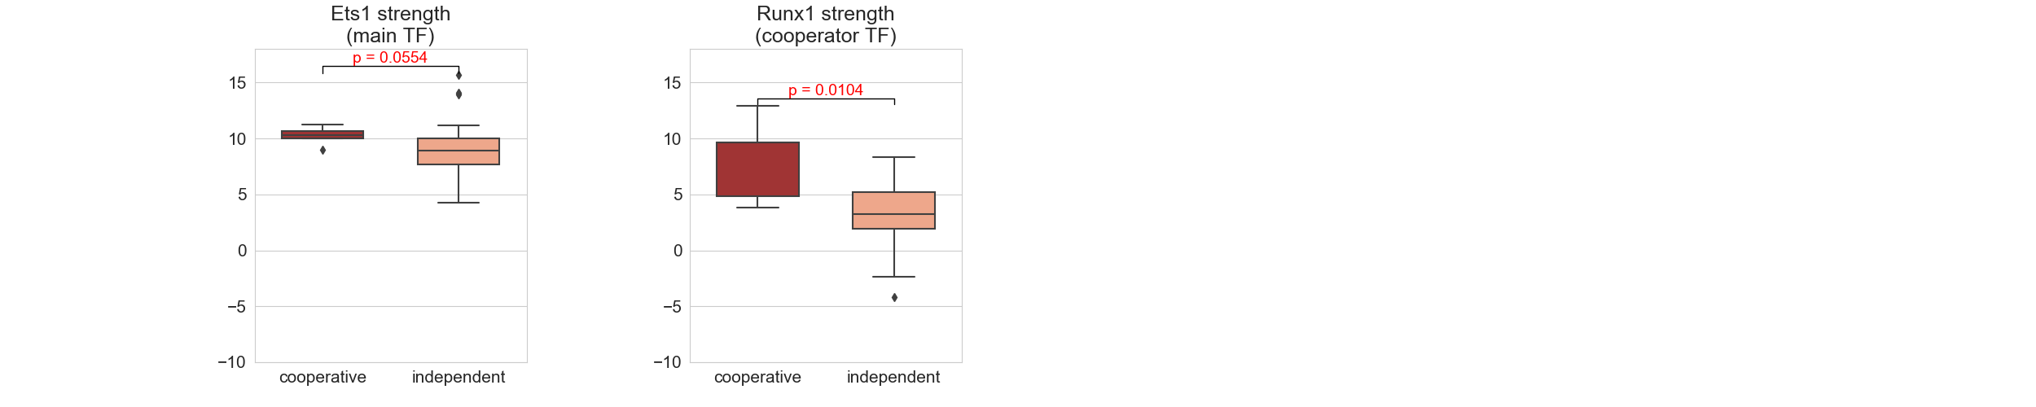

**Dist=7, ori -/-**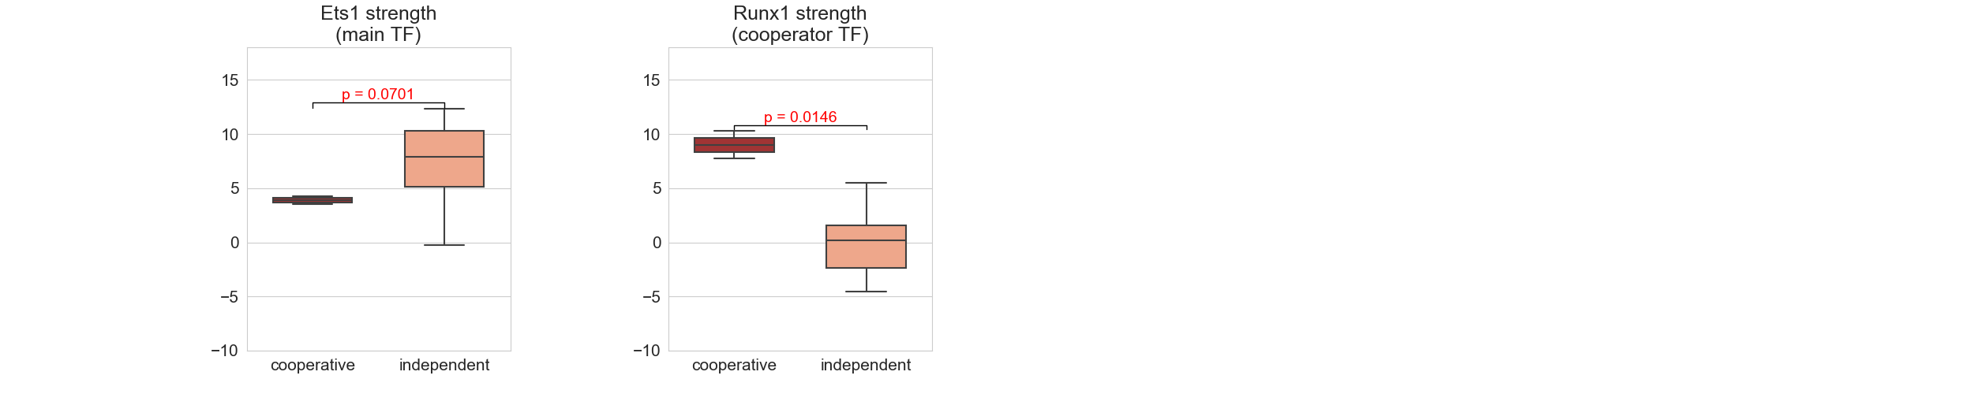

**Distance 9, ori +/+ (coop=16, indep=15)**

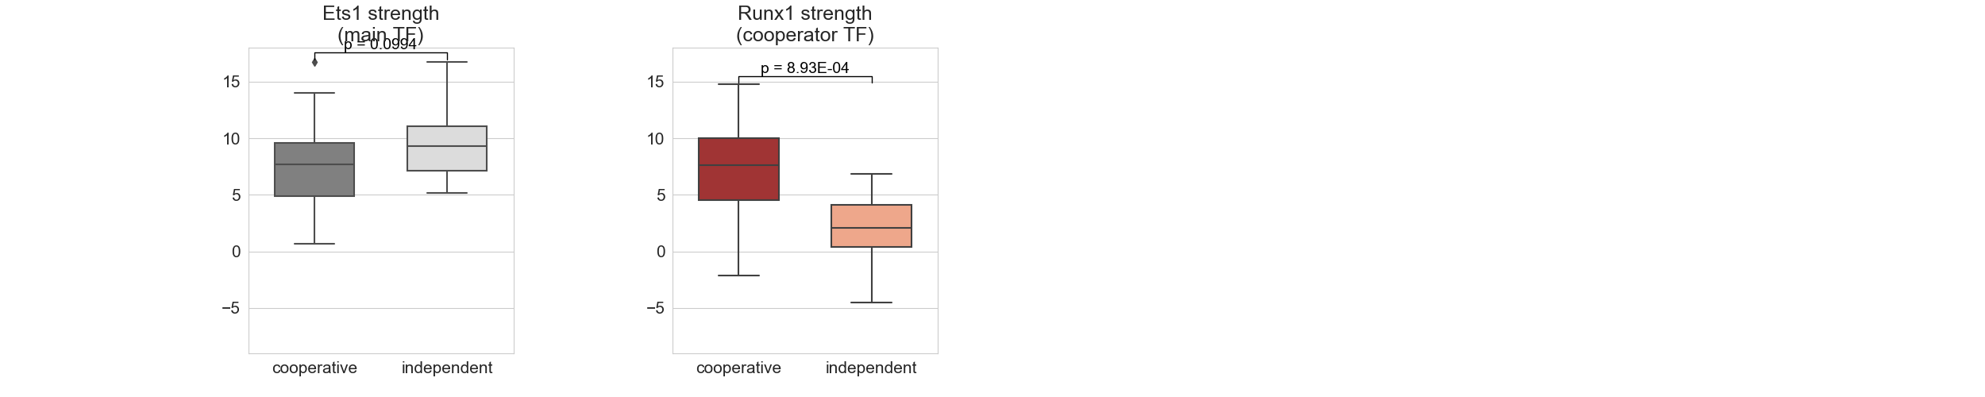

**Distance 9, ori +/- (coop=1, indep=9)**

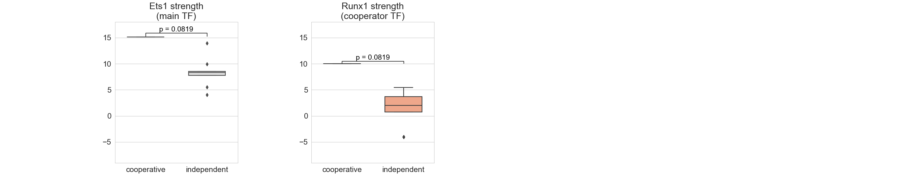

**Distance 9, ori -/+ (coop=10, indep=20)**

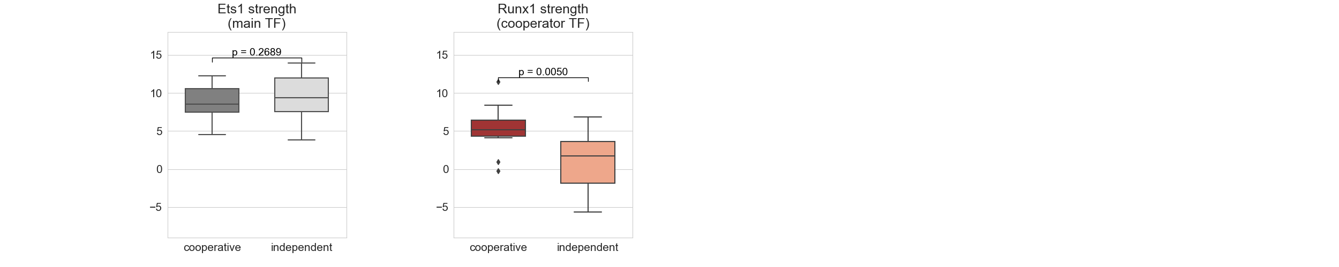

**Distance 9, ori -/- (coop=1, indep=16)**

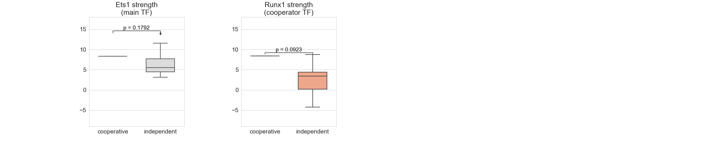

**Distance 20, ori +/- (coop=16, indep=10)**

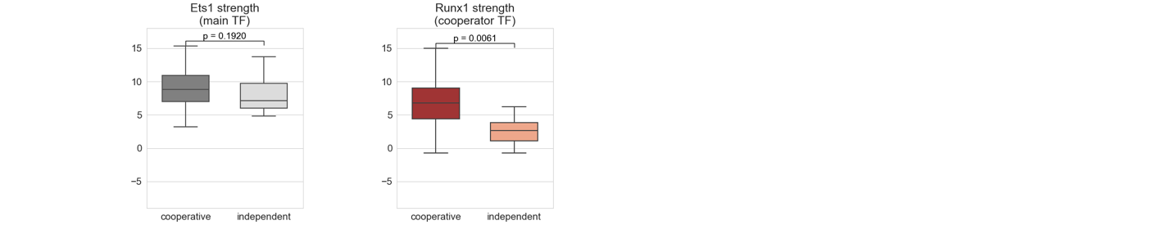

**Distance 20, ori -/+ (coop=6, indep=15)**

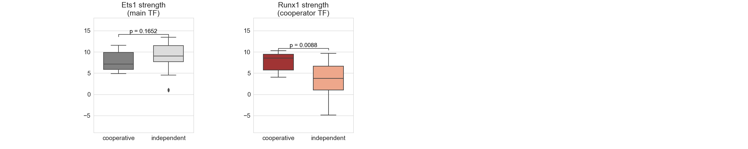

**Without dist=5, orientation +/+**

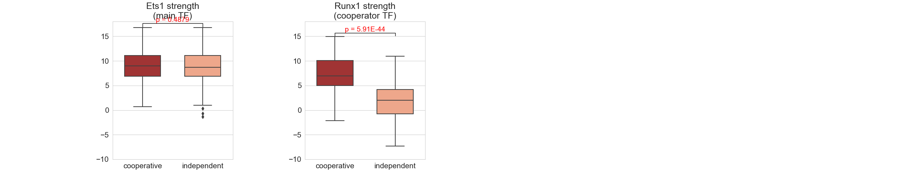

**Without dist=5, orientation +/-**

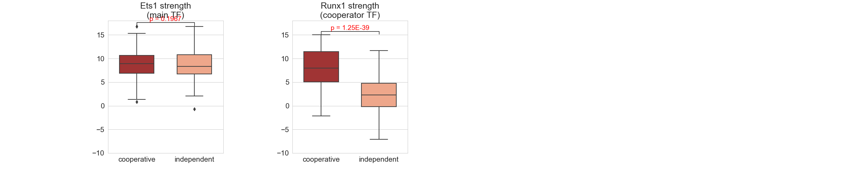

**Without dist=5, orientation -/+**

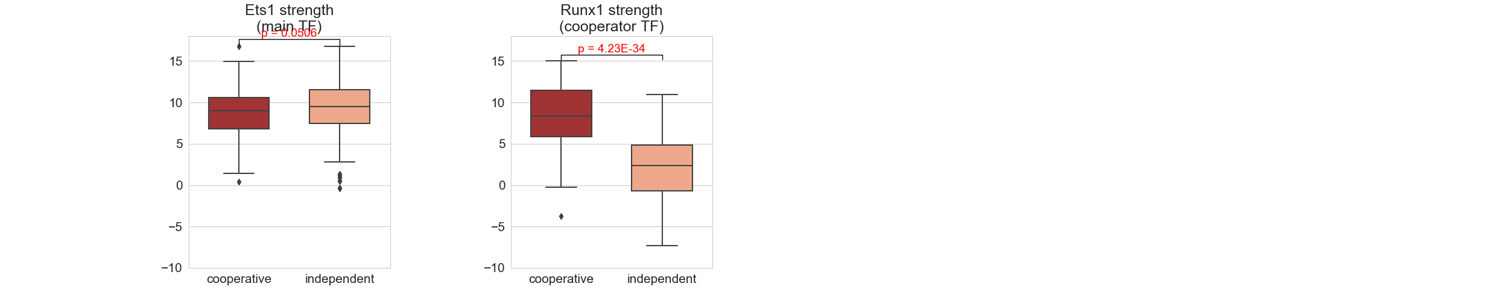

**Without dist=5, orientation -/-**

