Drip Cloud — Website Wireframes
Part 1 | Planning / Design Documentation
Purpose: These wireframes document the structure of the existing Drip Cloud pages and identify the main content areas. The header navigation is shown in the proposed position because the Part 1 feedback requires navigation links to be placed in the header.
Figure 1: Home Page Wireframe
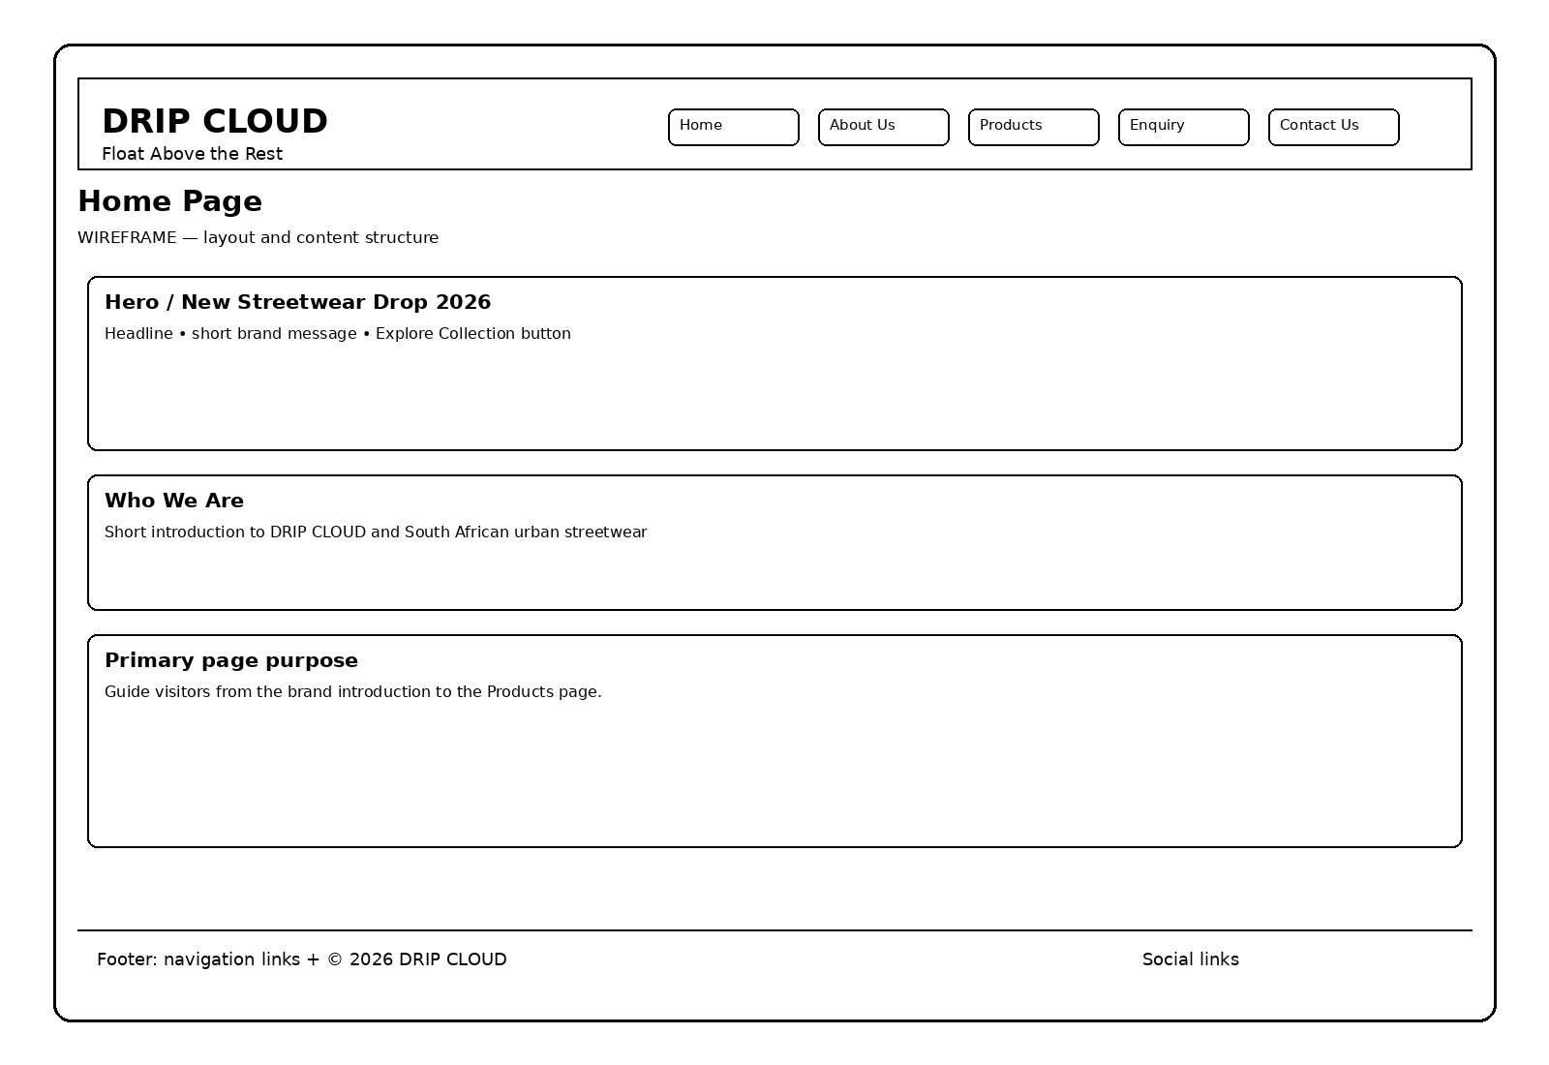
Comment: The Home page currently contains the DRIP CLOUD heading, tagline, a New Streetwear Drop hero section, an Explore Collection link and a Who We Are section. The wireframe keeps these elements and shows the navigation moved into the header as the planned improvement.

Figure 2: Products Page Wireframe
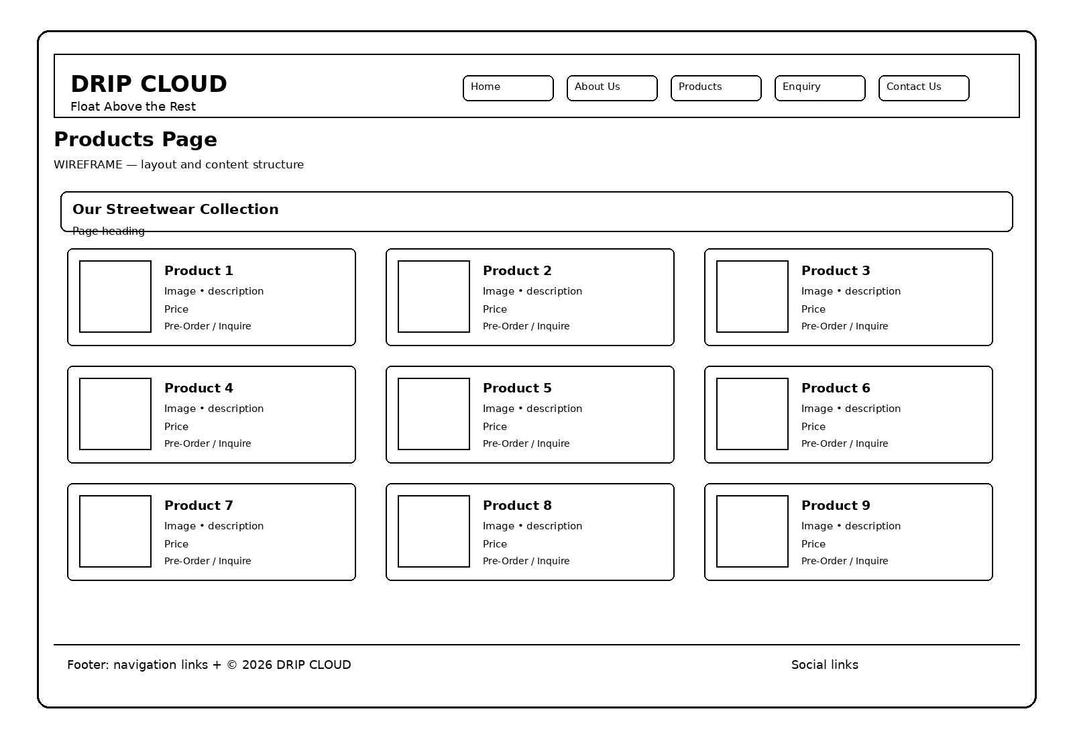
Comment: The Products page is structured around the Streetwear Collection and a product grid. Each product area contains an image, product name, description, price and a Pre-Order / Inquire link.

Figure 3: About Us Page Wireframe
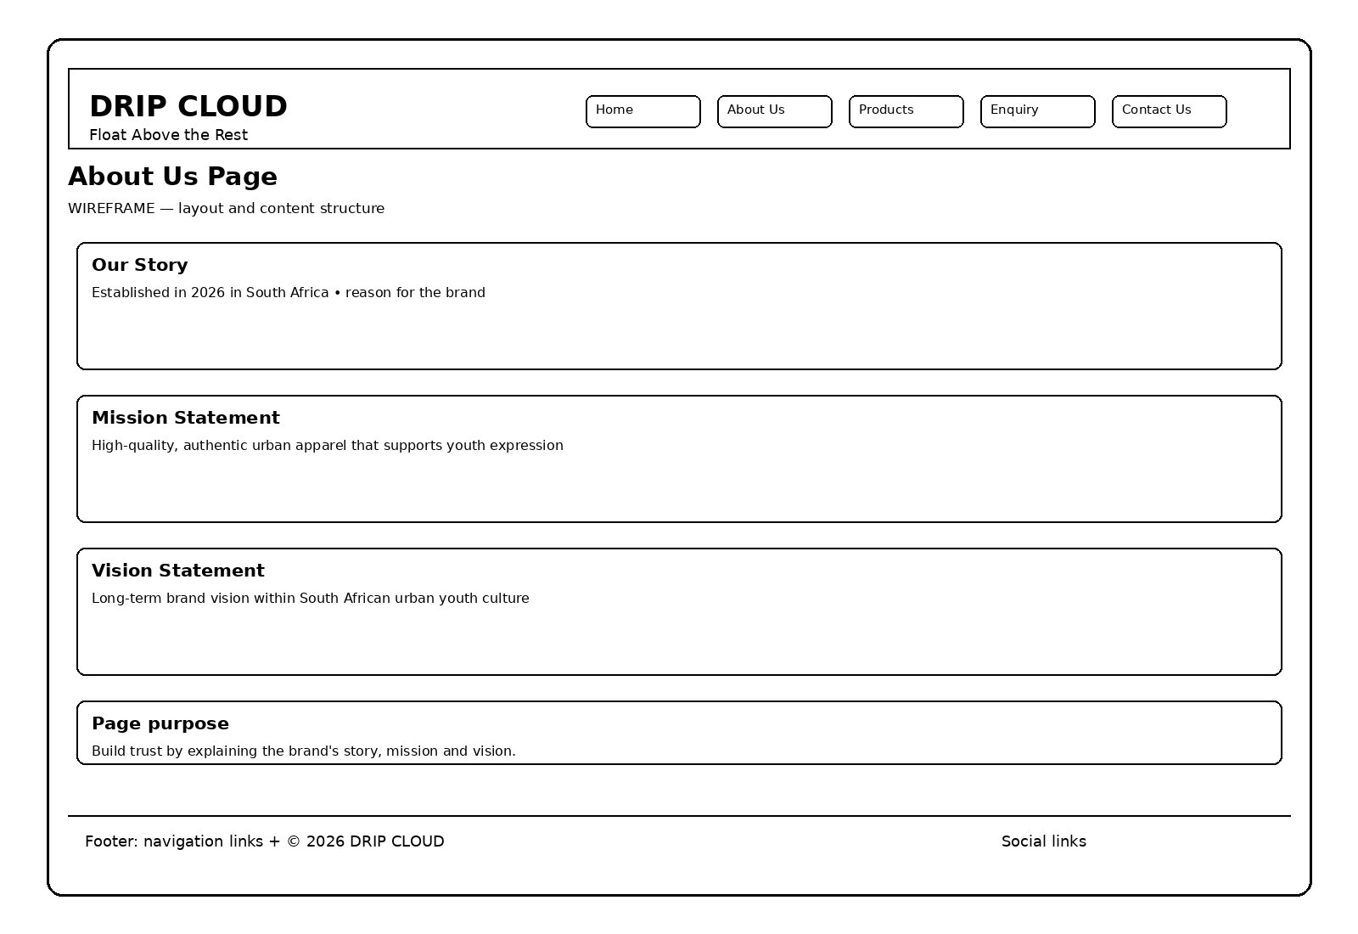
Comment: The About page contains the brand story, mission statement and vision statement. These sections explain the purpose and identity of Drip Cloud.

Figure 4: Product Enquiry Page Wireframe
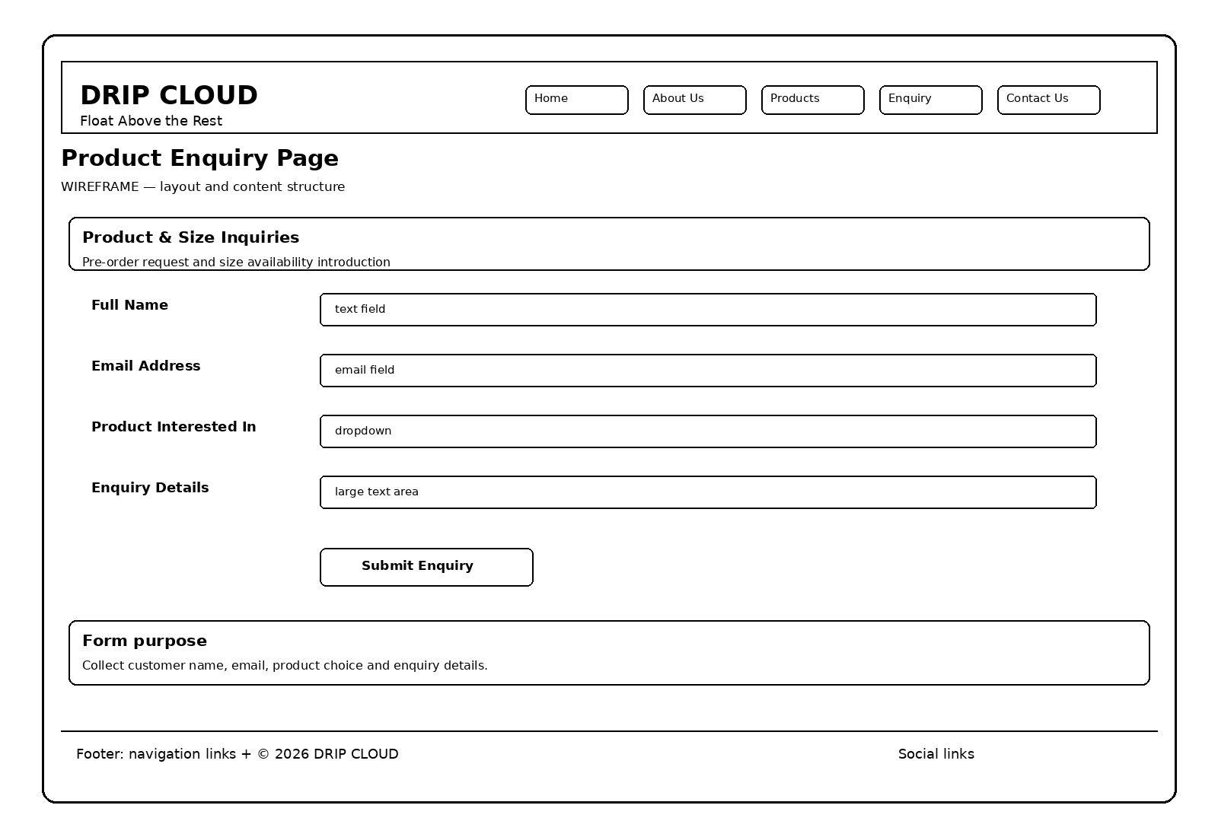
Comment: The Enquiry page contains a product and size enquiry form. The main fields are Full Name, Email Address, Product Interested In and Enquiry Details, followed by a Submit Enquiry button.

Figure 5: Contact Us Page Wireframe
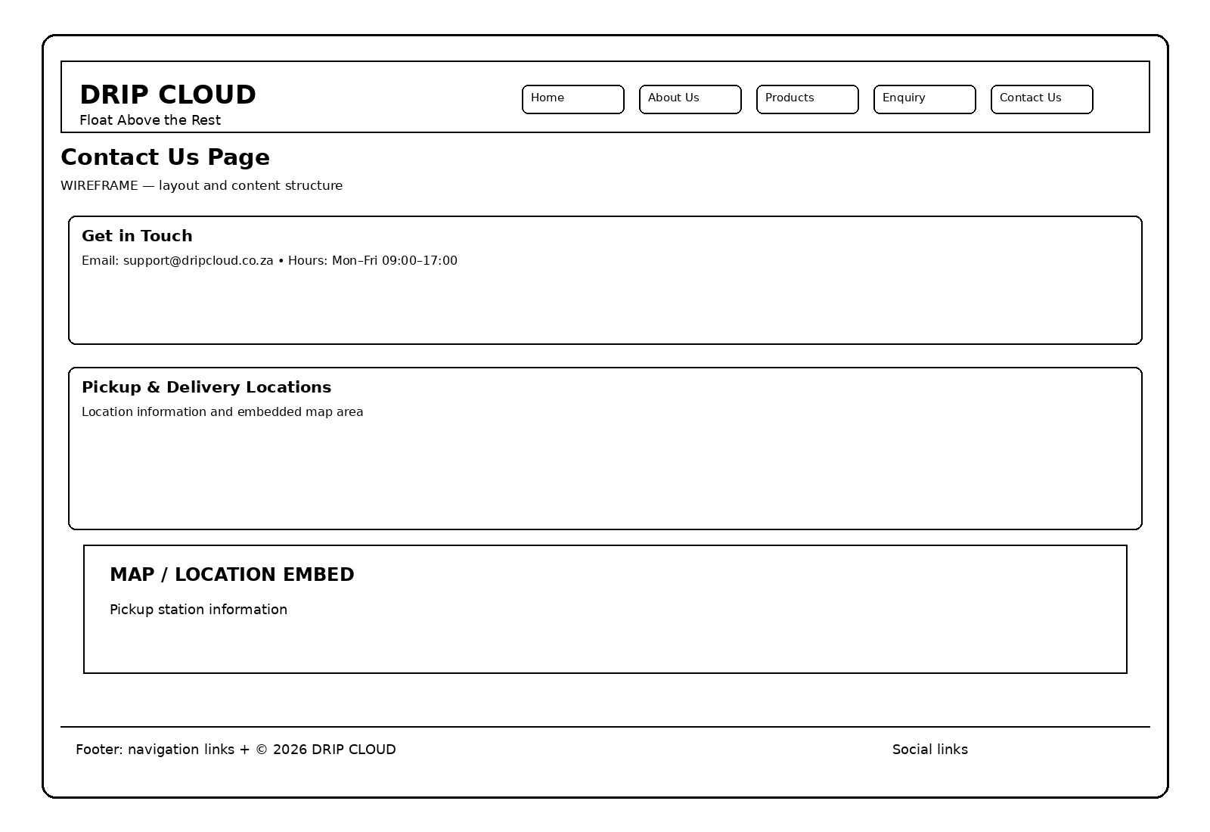
Comment: The Contact page provides the business email, operating hours and pickup/delivery location information, including a map area.

Wireframe Notes for the Fix
1. The wireframes are planning diagrams, not screenshots of the finished website.
2. The page content is based on the current Drip Cloud repository pages.
3. The navigation is deliberately shown in the header to address the Part 1 navigation feedback.
4. Keep these wireframes in the Part 1 submission document under the Website Wireframes section.
5. The next fix is to implement the header navigation consistently across the website.

