Download

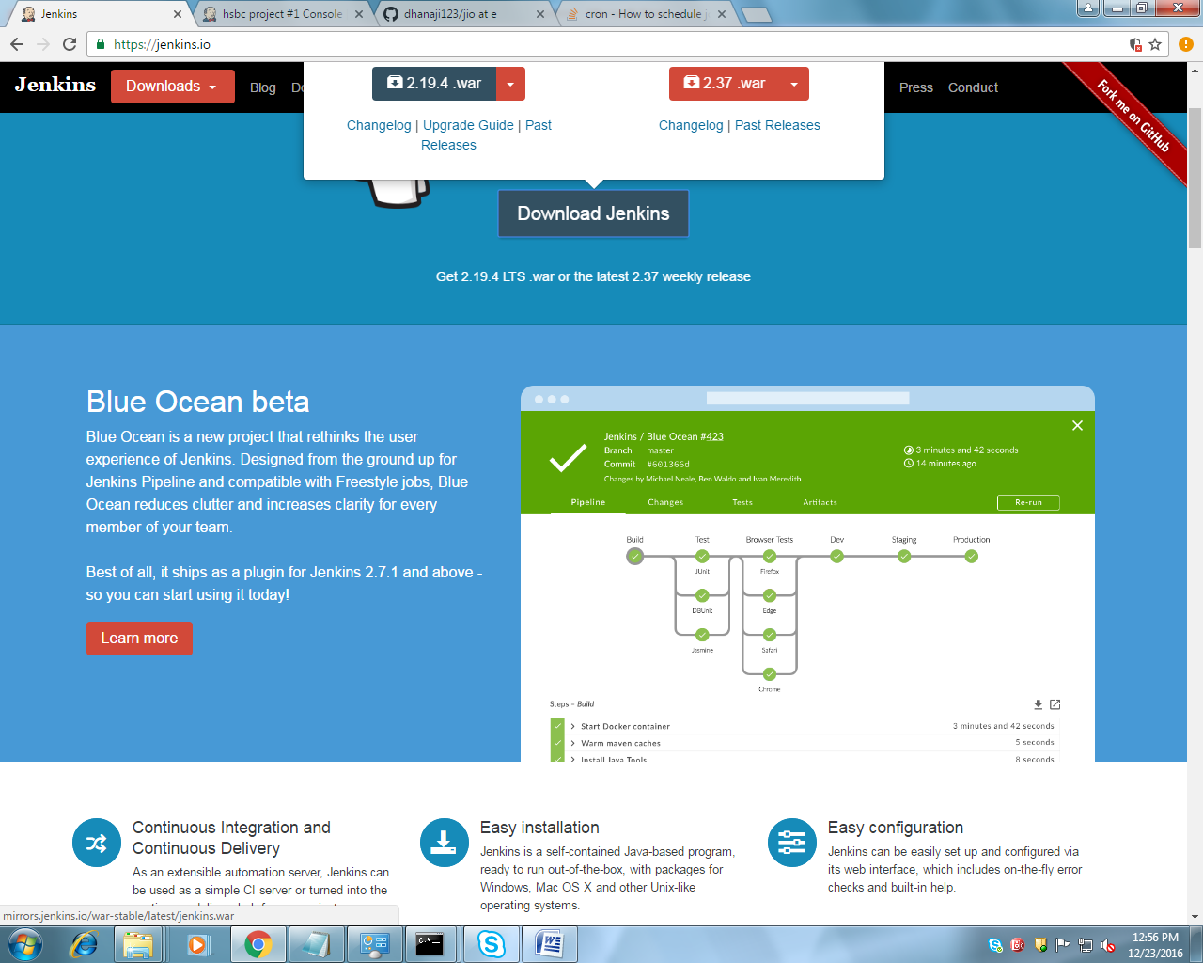

Run jenkins

1. step start the sever from jenkins folder

java -jar jenkins.war --httpPort=8888

2.copy the password from given location

3 step

install the suggested plugin

3. continue as admin

4.manage plugin - global tool configuratin

java home path

C:\Program Files \Java\jdk1.8

gradhle home path

D:\gradle-3.2.1 (no bin)

github

C:\Program Files\Git\bin\git.exe

-------------------------------

verify plugins in installed option

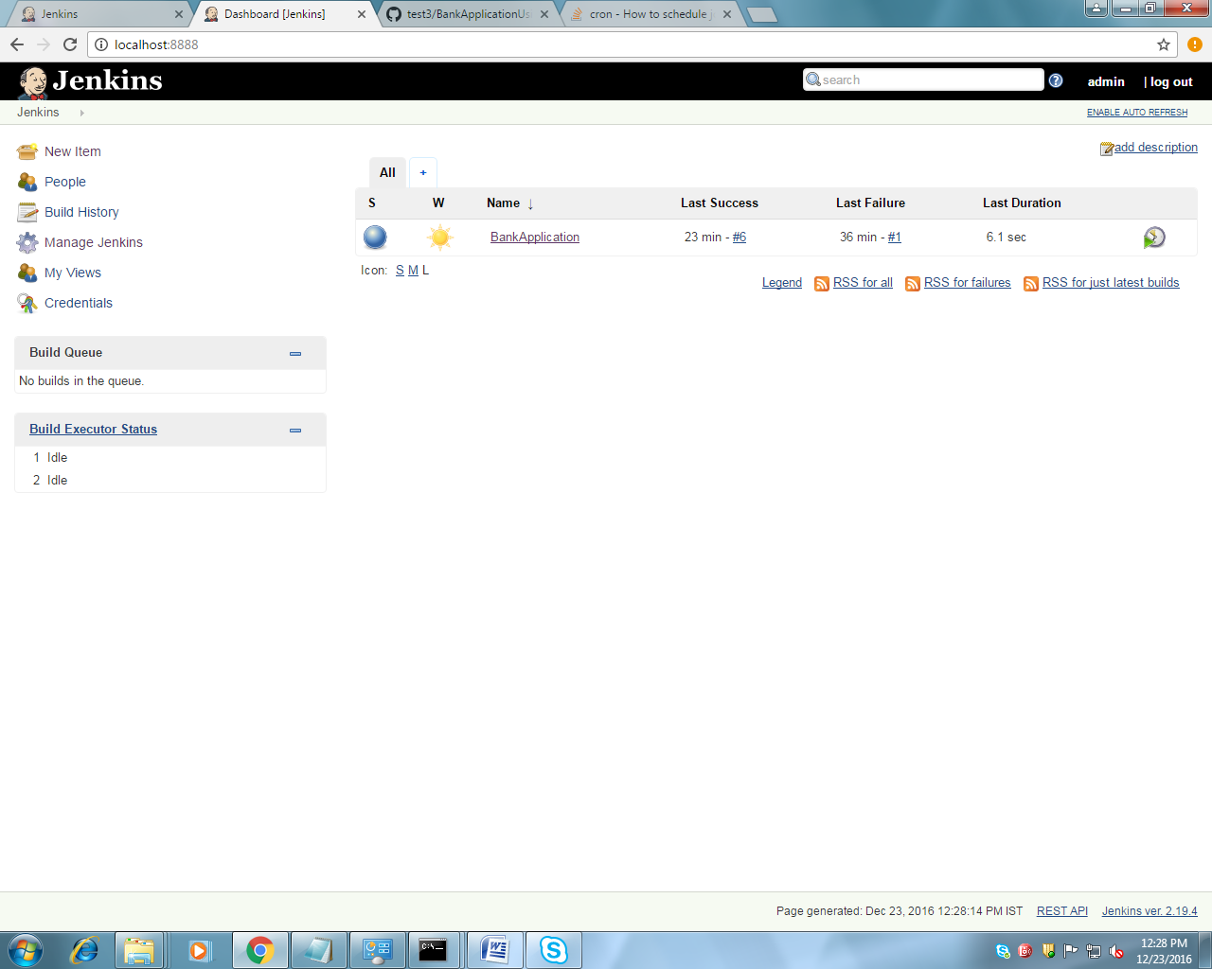

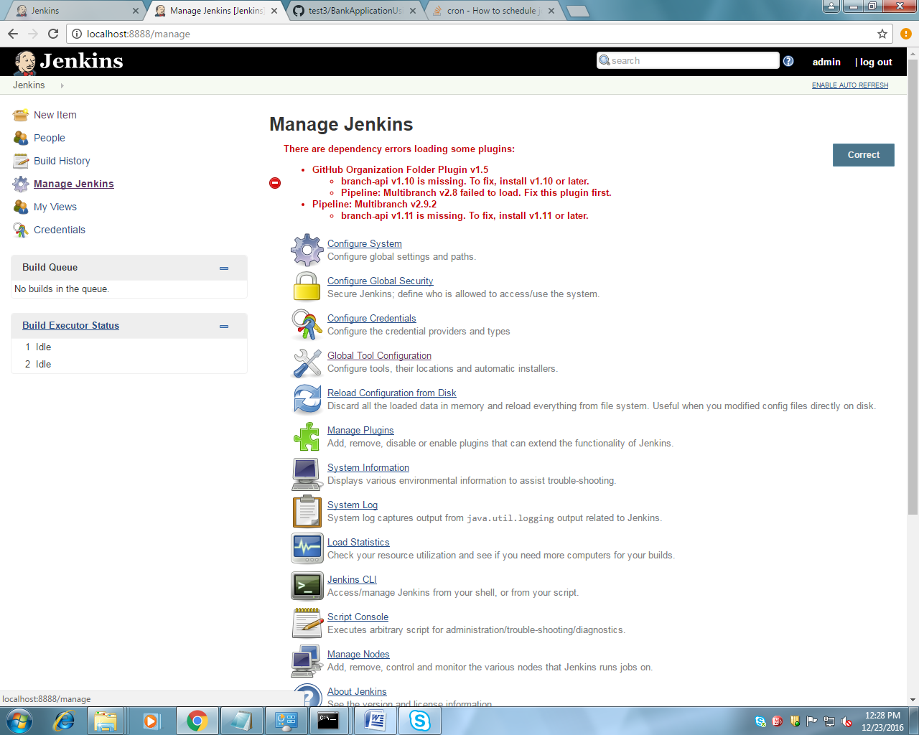

1java home path

2. git exe path

3.gradle home path

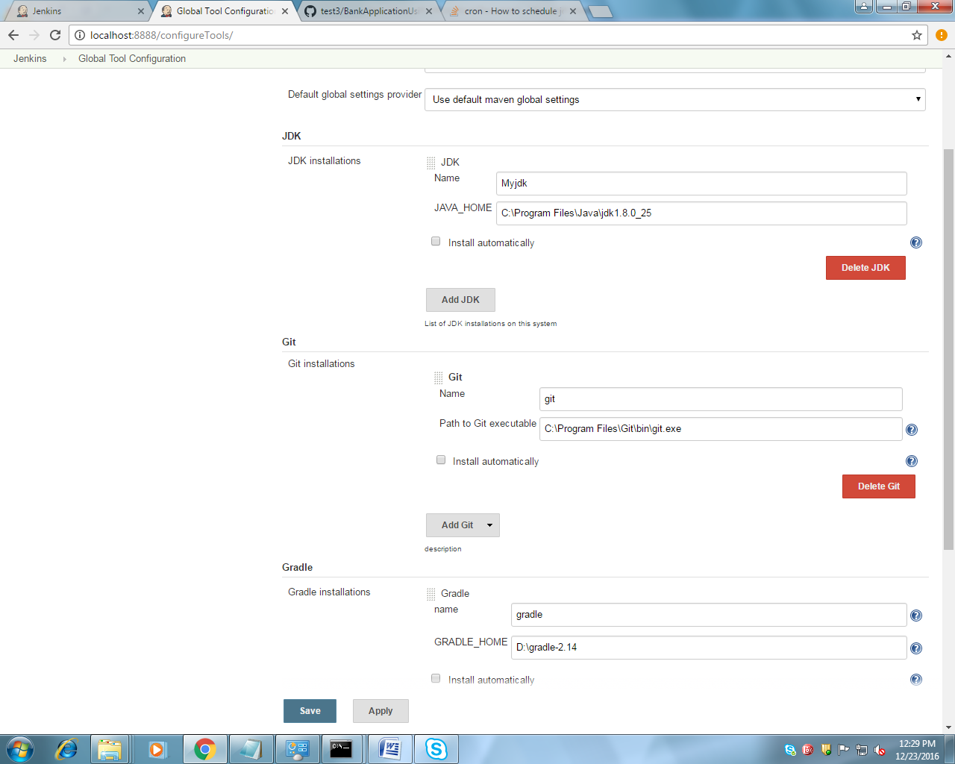

Create new Task or Project-> New item

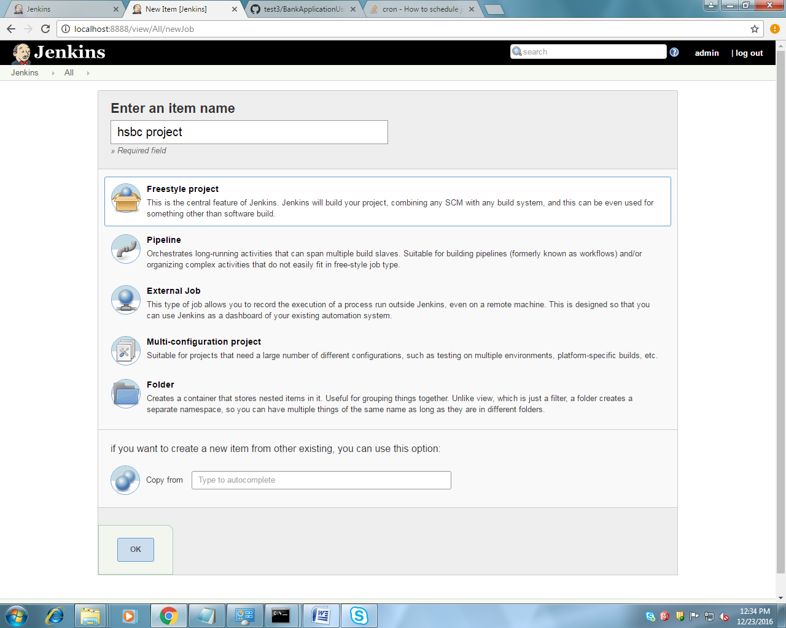

Enter project name and select freestyle project

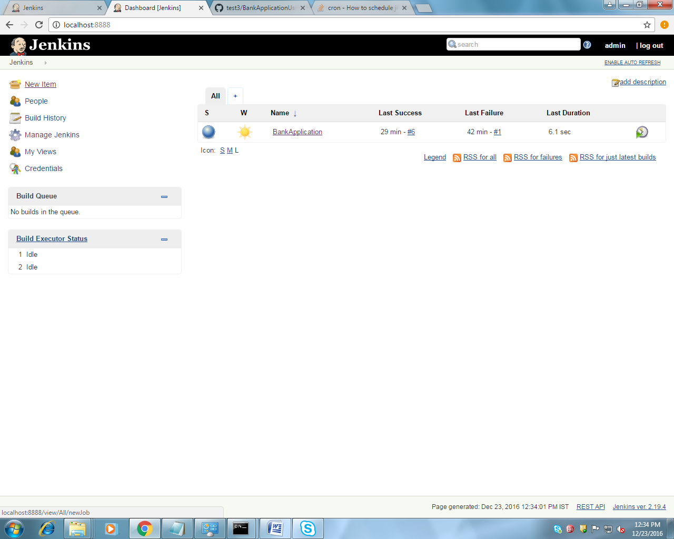

Project Build Configurations

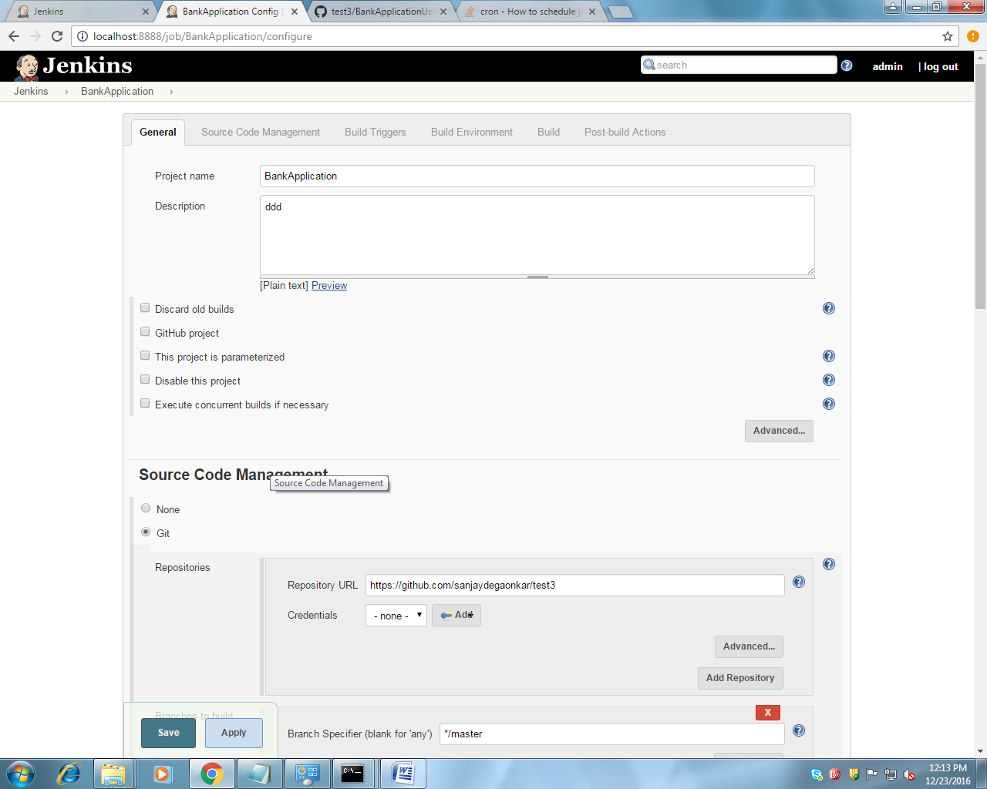

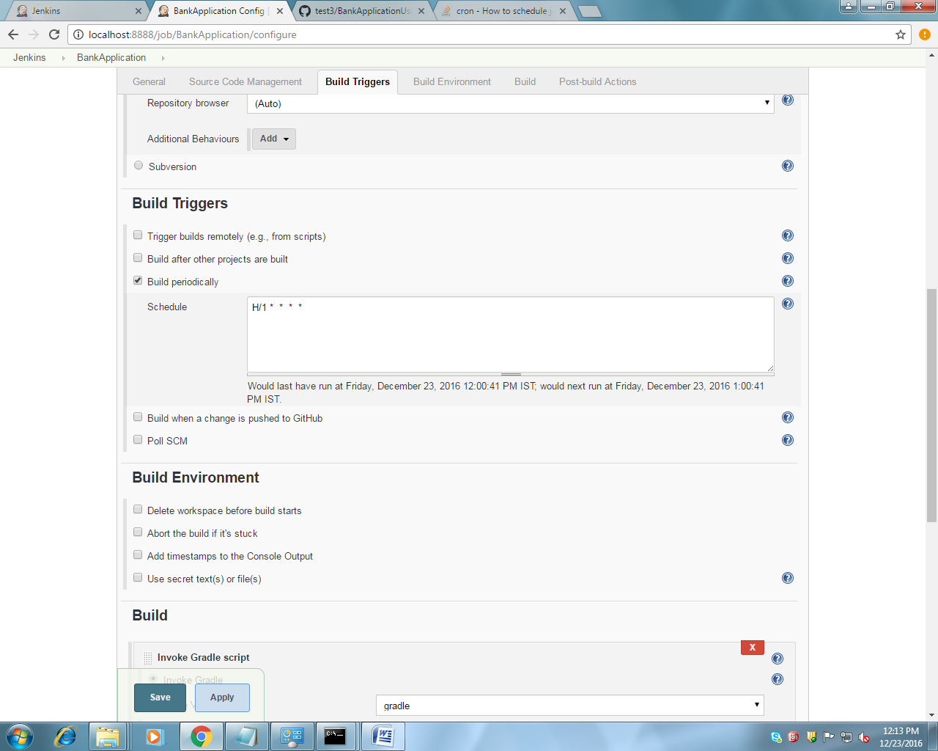

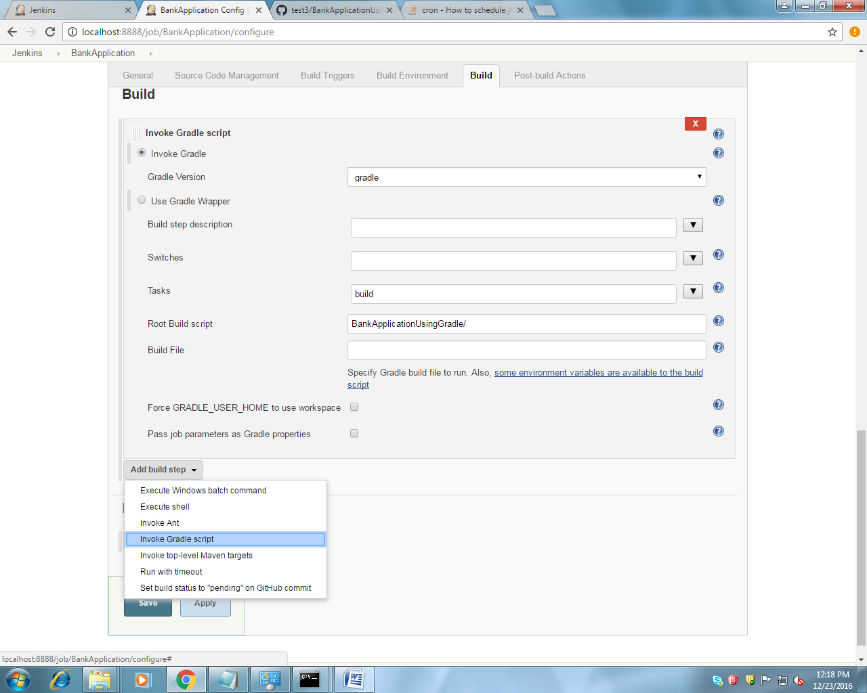

1.Invoke gradle name as u given in gloabal tool configration

2. taks –build

3.gradle project path from home path to /(aleready we have given github home path)

e.g BankApplicationUsingGradle/

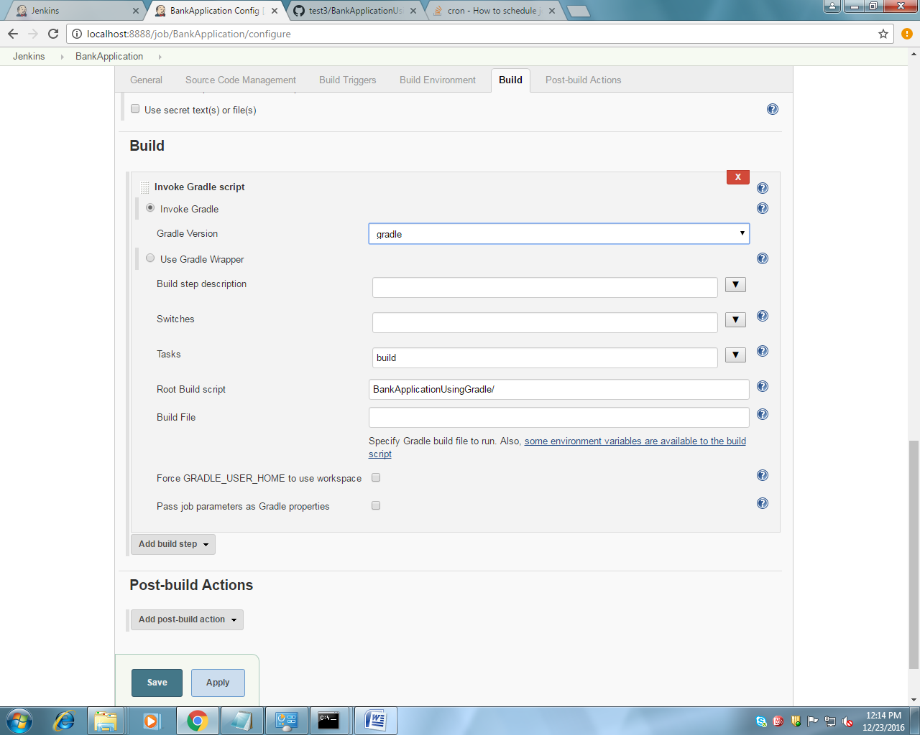

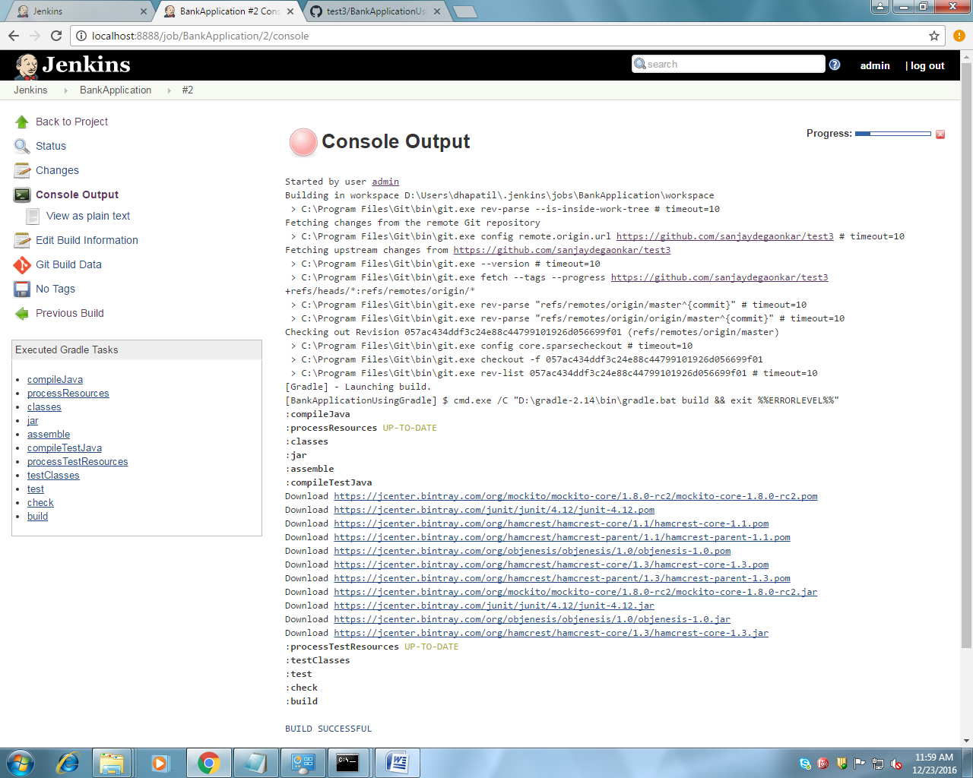

PROJECT DEPLOY LOCATION

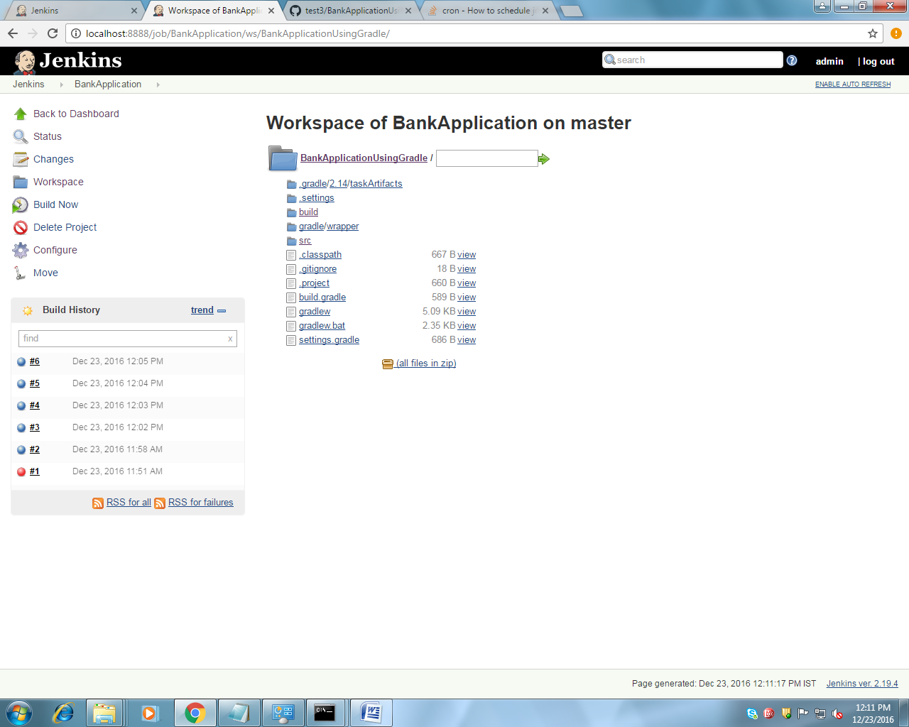

PROJECT DEPLOY LOCATION



