Student: Ninh DO SID#25949105
CS287 – Homework#5
1A.
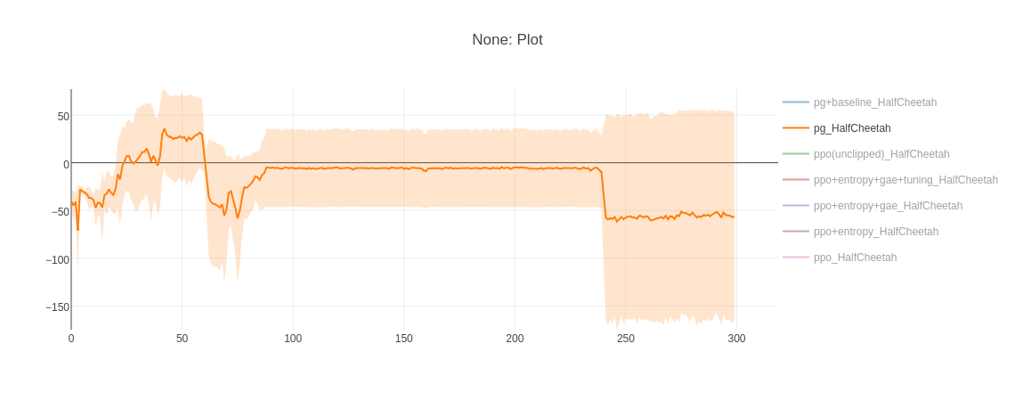
(a) HalfCheetah
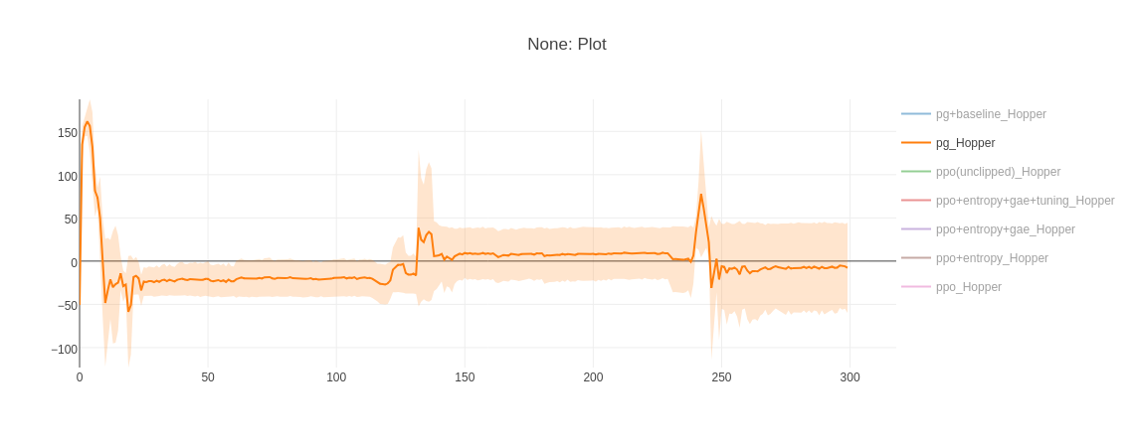
(b) Hopper
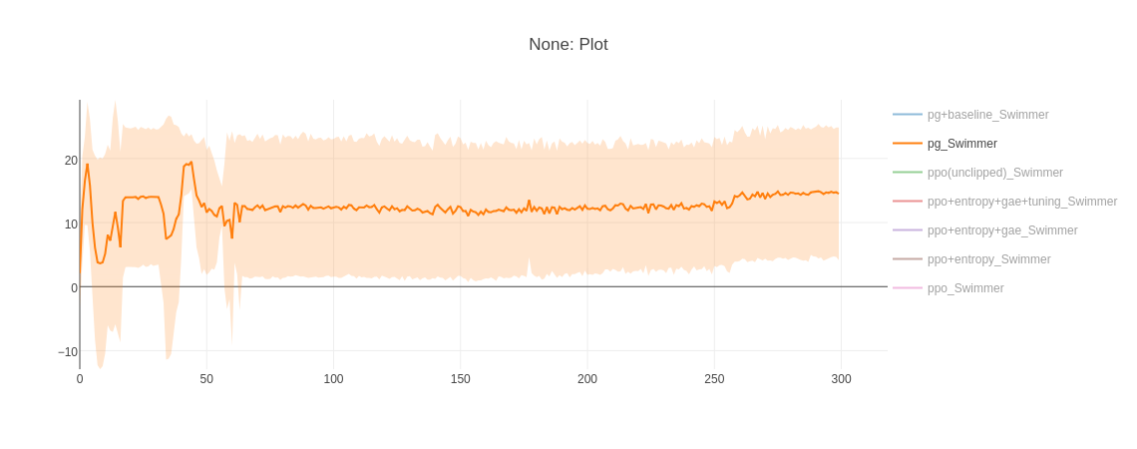
(c) Swimmer
1B.
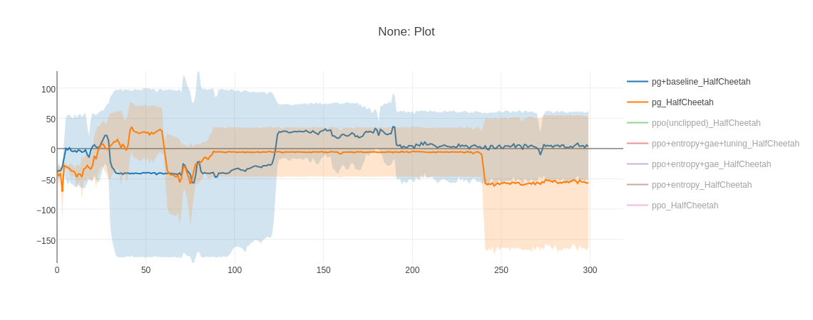
(a) HalfCheetah
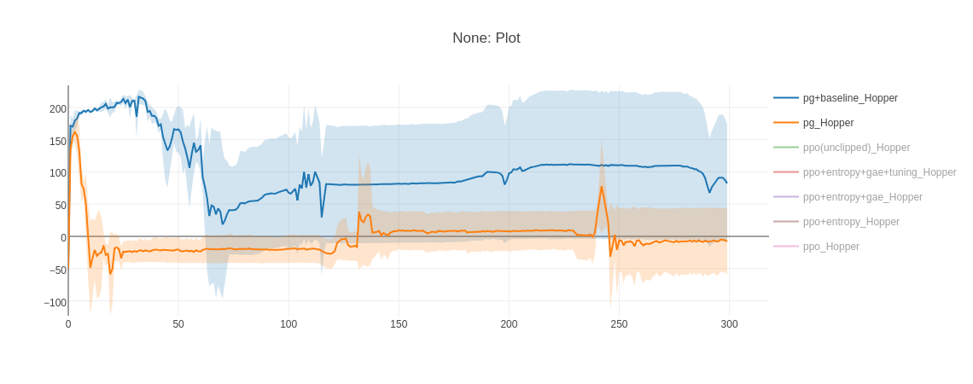
(b) Hopper
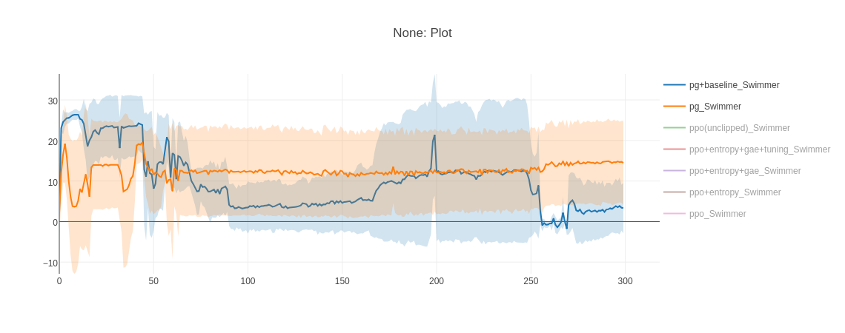
(c) Swimmer

1C.
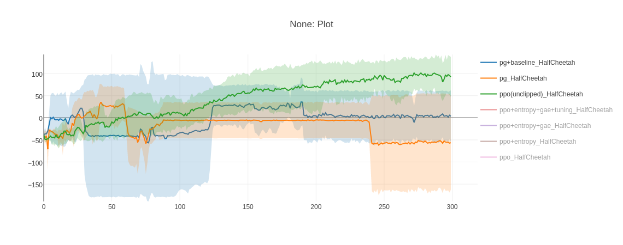
(a) HalfCheetah
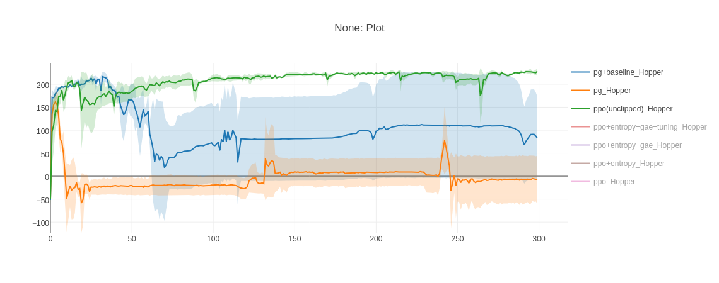
(b) Hopper
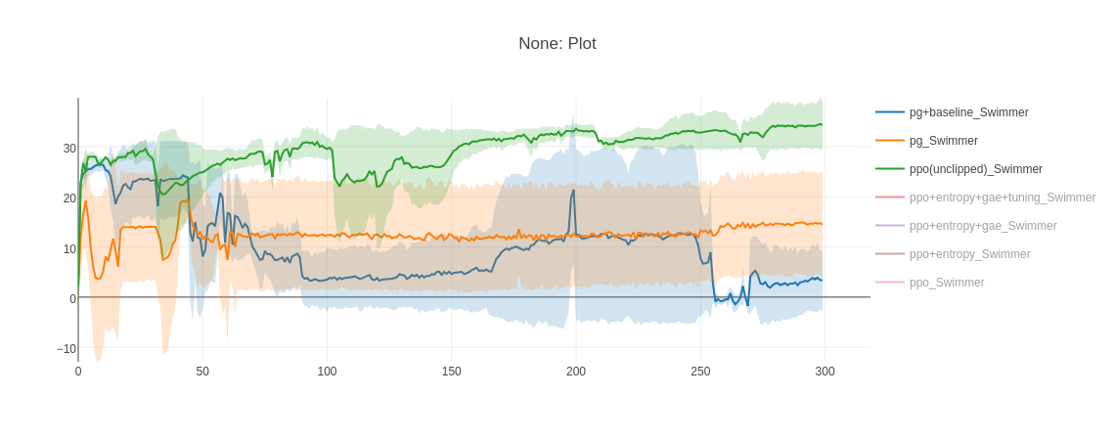
(c) Swimmer

1D.
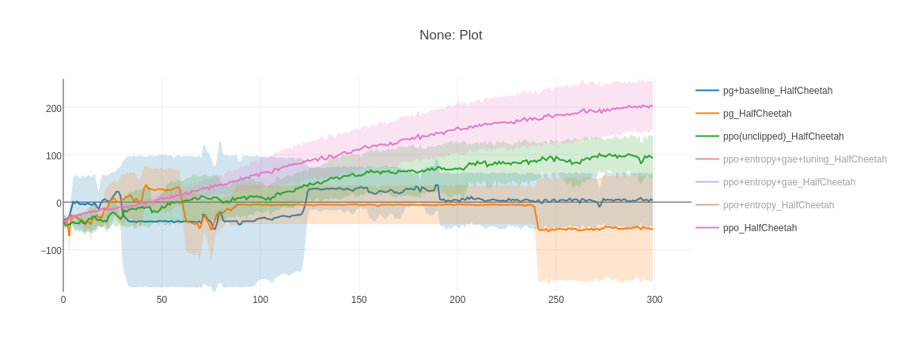
(a) HalfCheetah
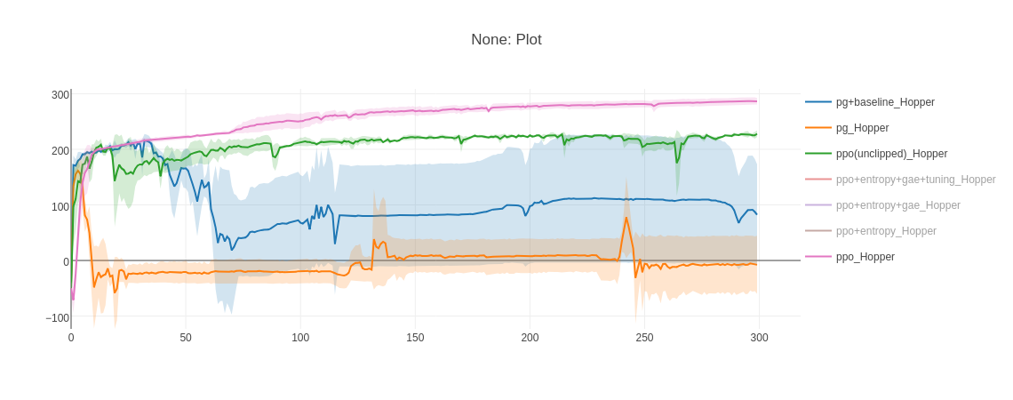
(b) Hopper
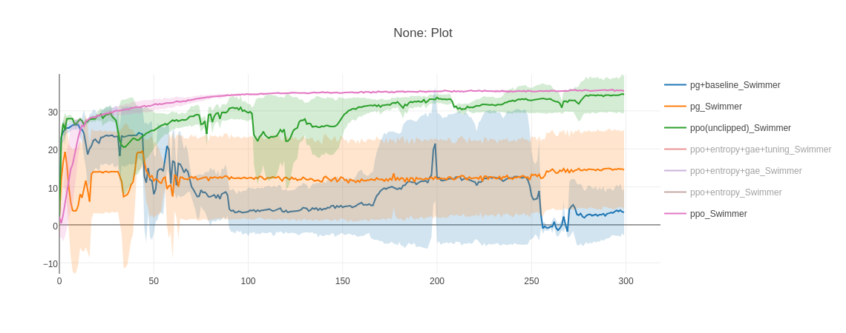
(c) Swimmer

1E.
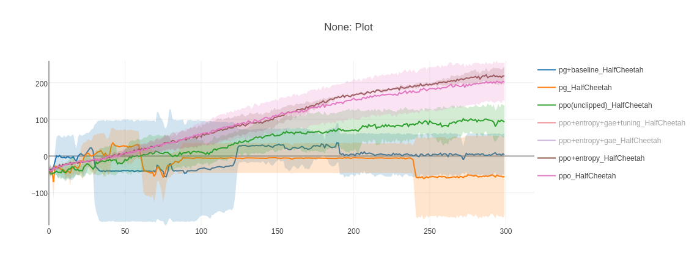
(a) HalfCheetah
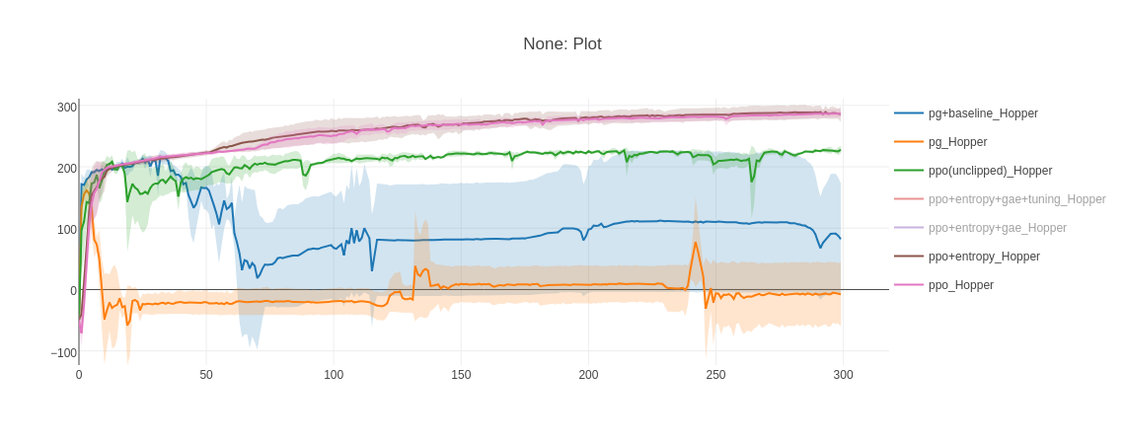
(b) Hopper
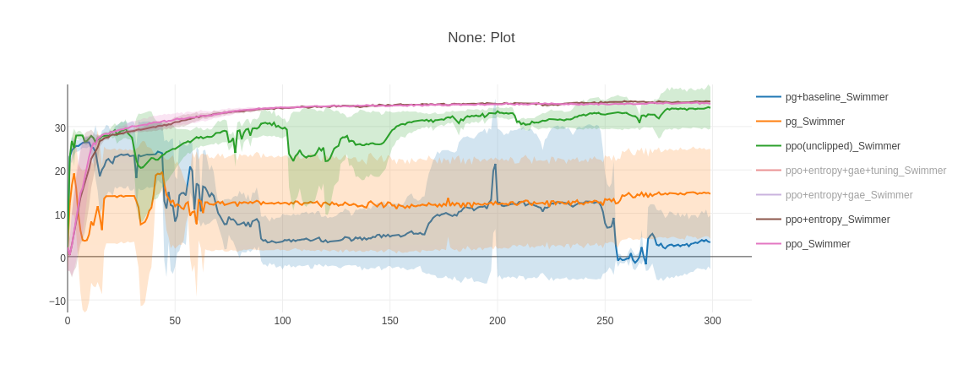
(c) Swimmer

1F.
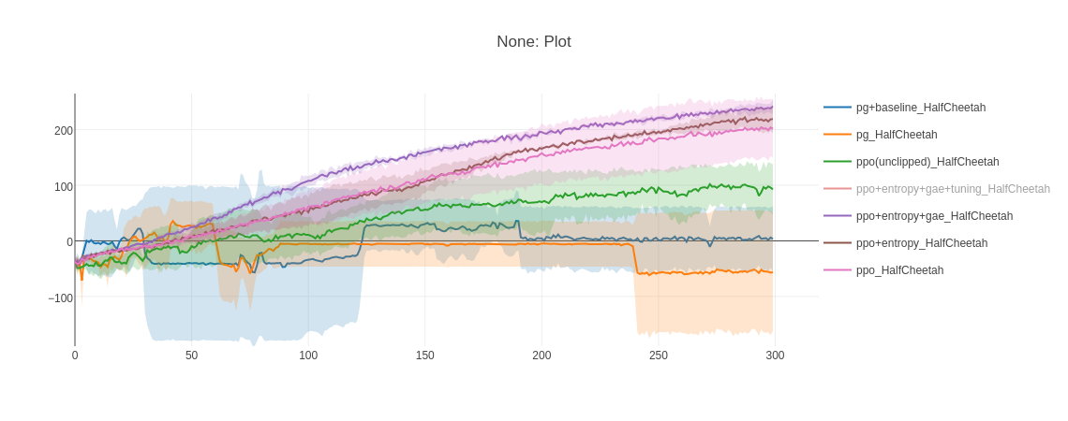
(a) HalfCheetah
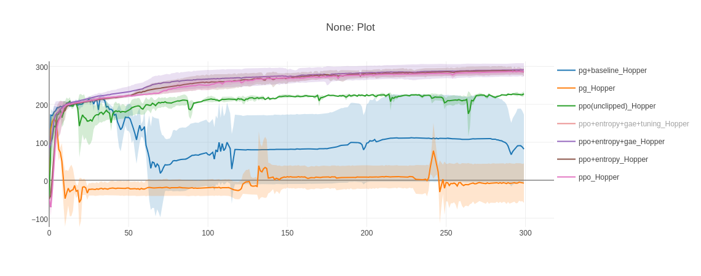
(b) Hopper (refer to Appendix 1FG for zoom-in to see improvement)

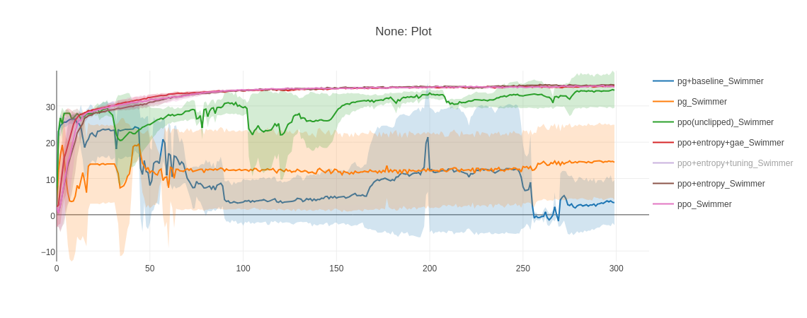
(c) Swimmer
1G. Extra Credits
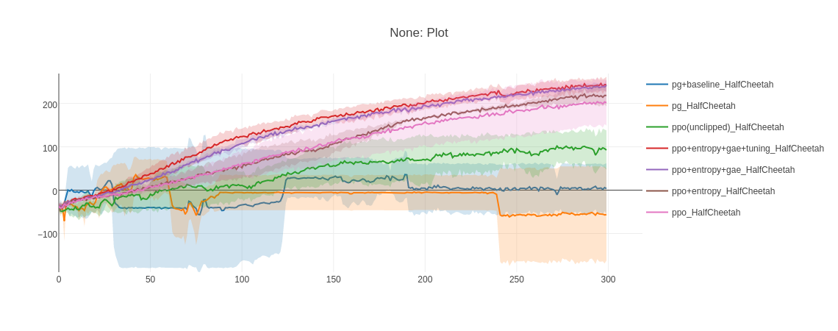
(a) HalfCheetah
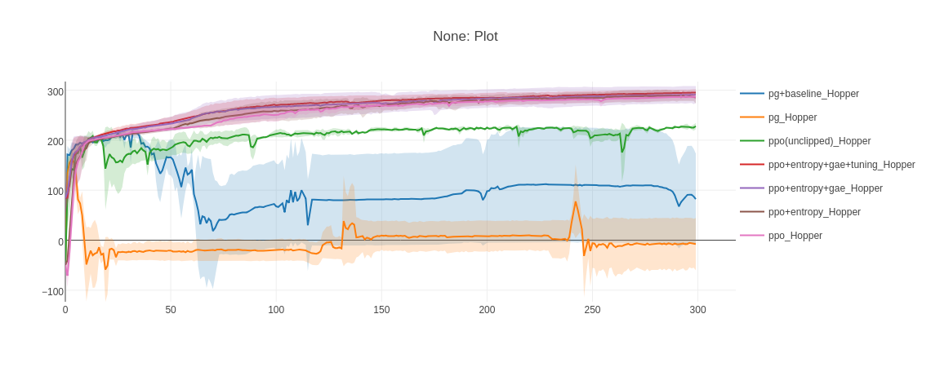
(b) Hopper (refer to Appendix 1FG for zoom-in to see improvement)
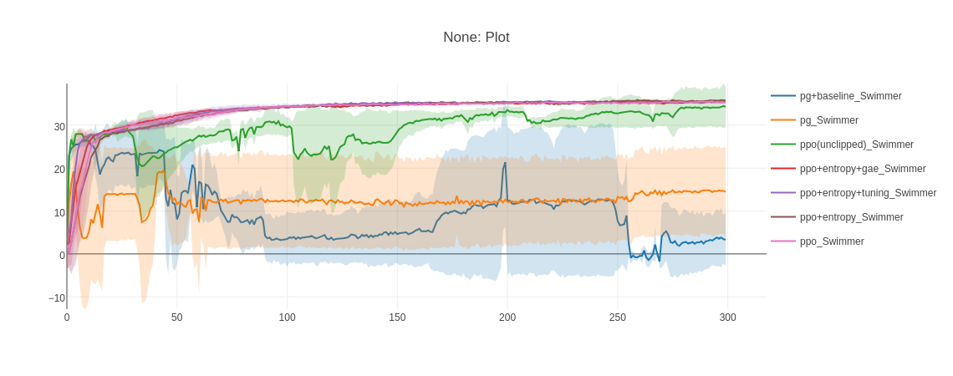
(c) Swimmer (refer to Appendix 1FG for zoom-in to see some improvement)
2A.
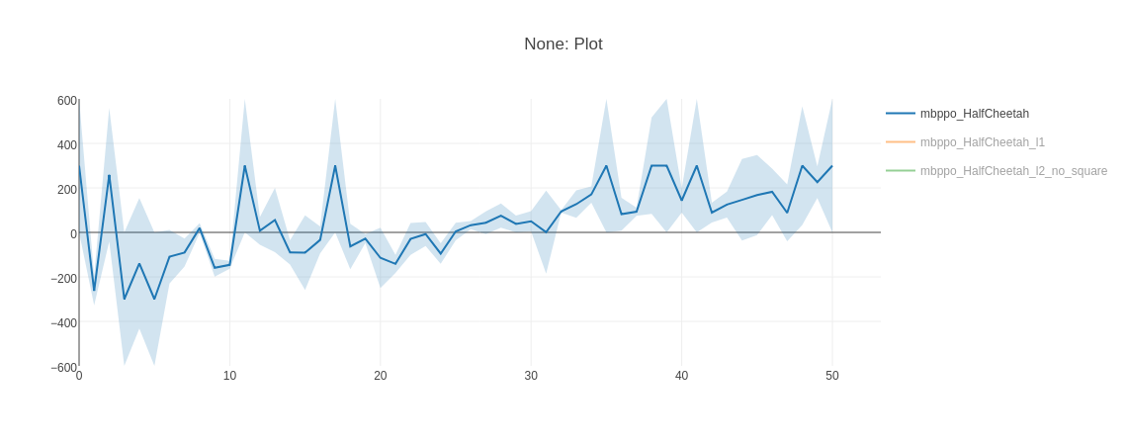
(a) HalfCheetah
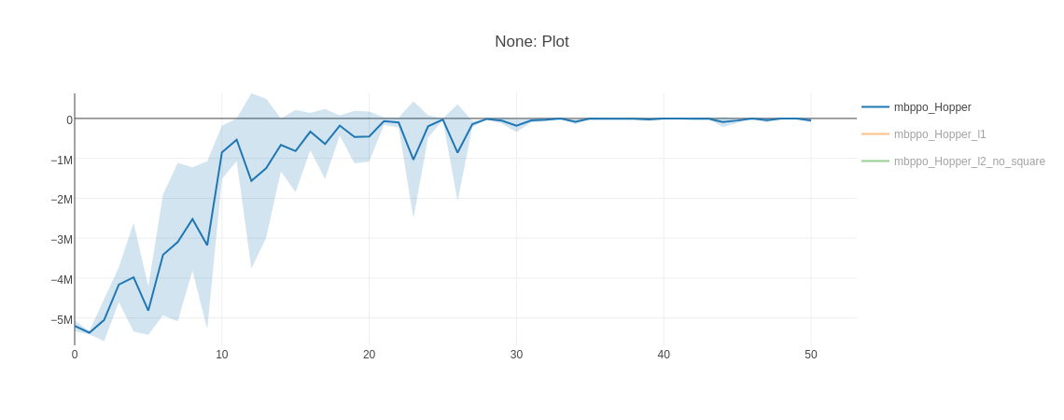
(b) Hopper
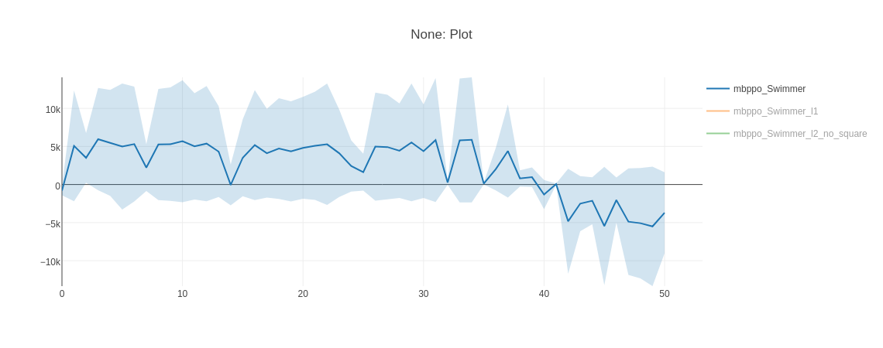
(c) Swimmer

2B. Extra Credits. Loss type 1
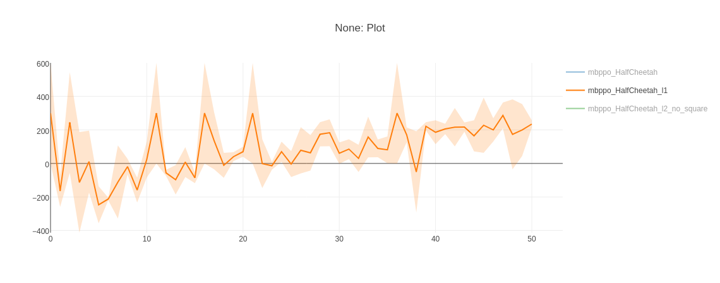
(a) Half Cheetah
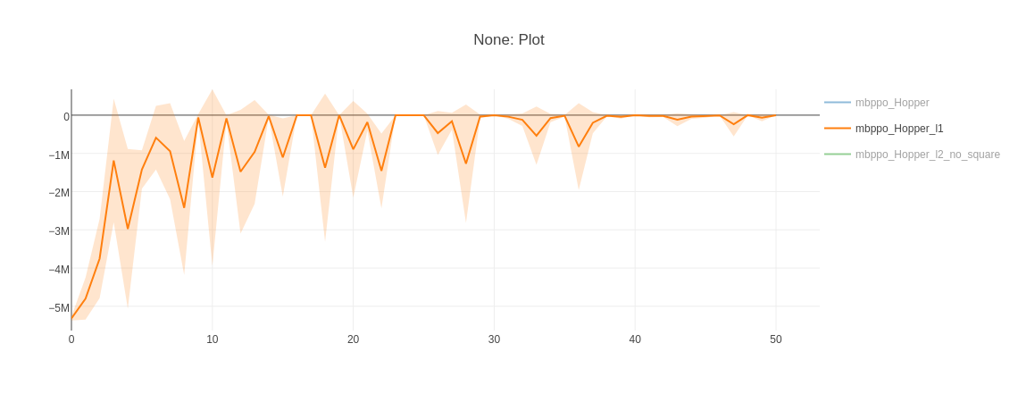
(b) Hopper
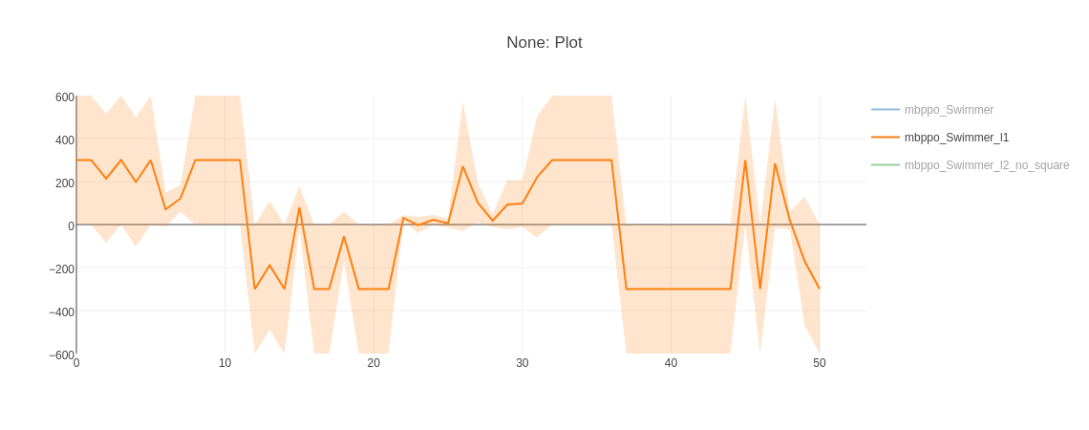
(c) Swimmer (clipped by 300)

Loss type 2
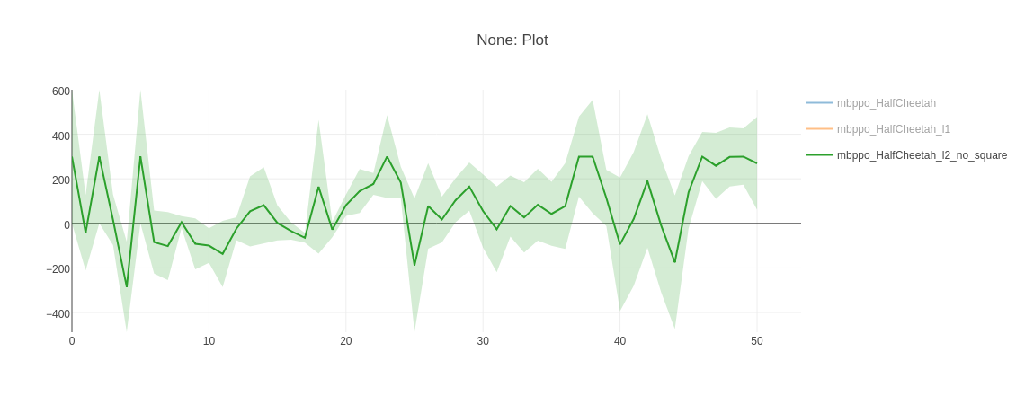
(a) Half Cheetah
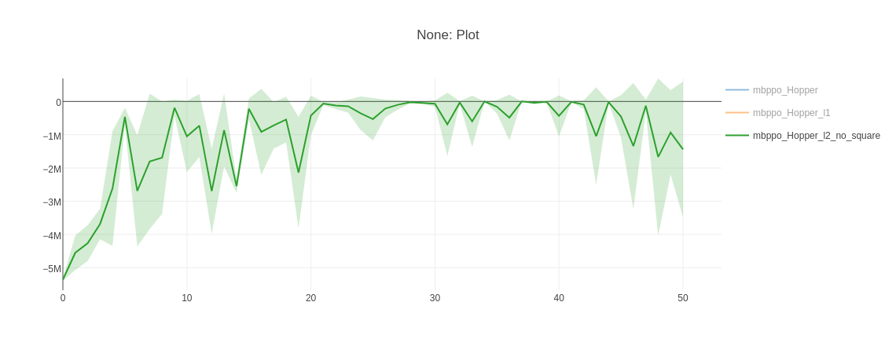
(b) Hopper
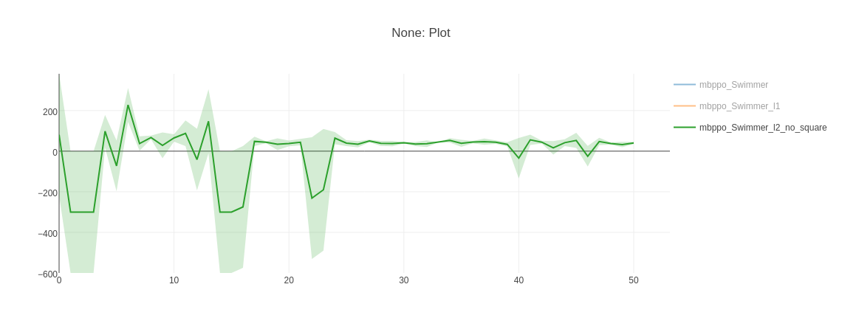
(c) Swimmer (clipped by 300)

3A.1 & 3A.2 Extra Credits
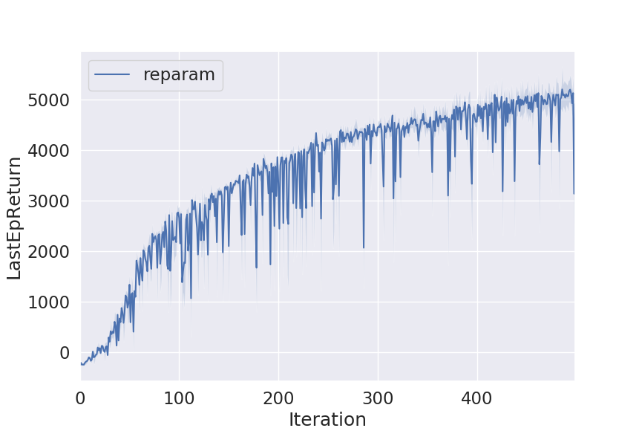

(a) HalfCheetah
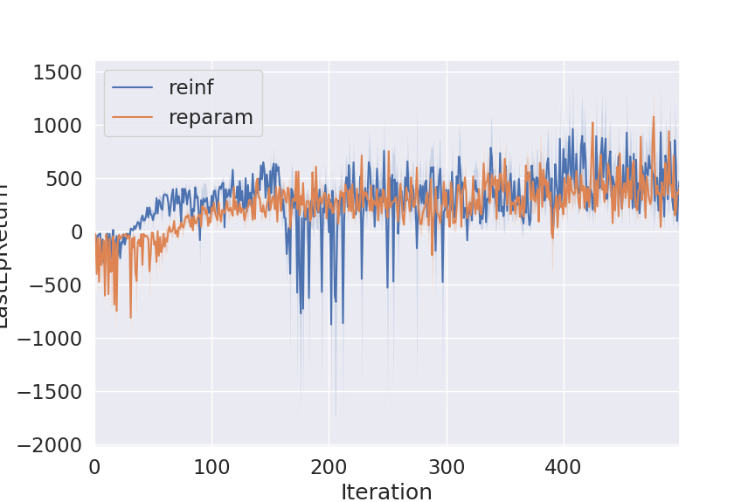

(b) Ant
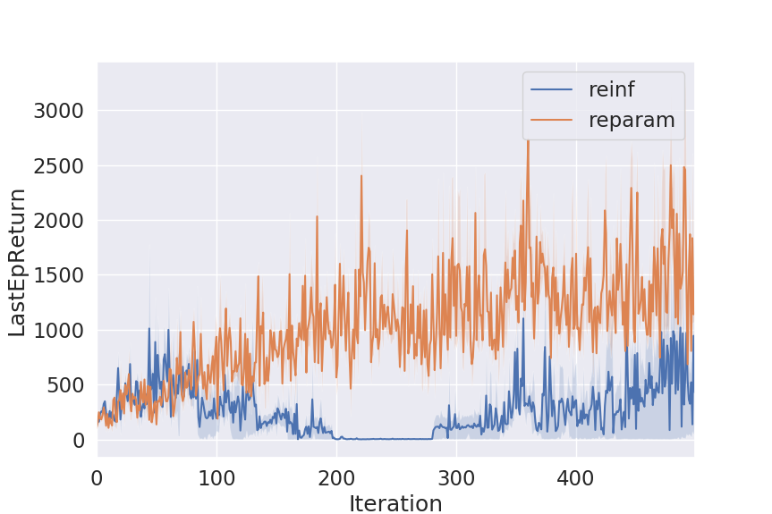

(c) Hopper
3B. Extra Credits
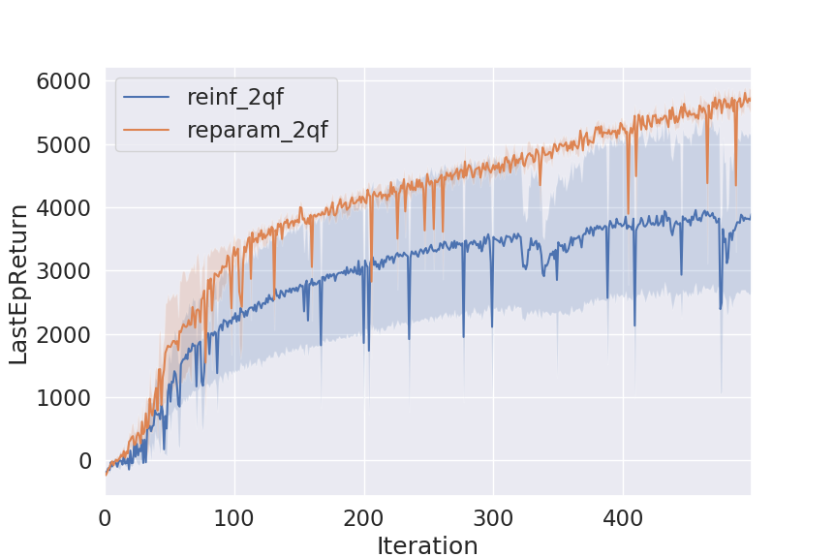

(a) HalfCheetah
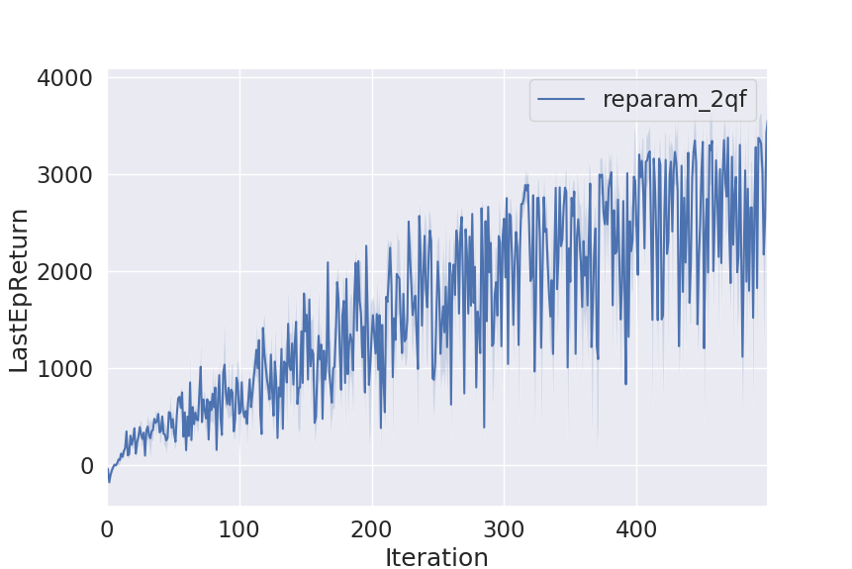

(b) Ant
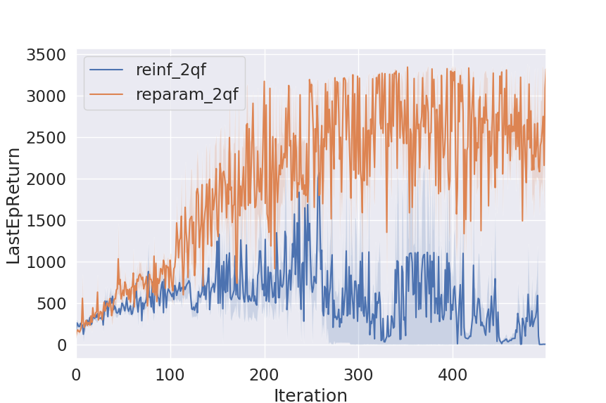

(c) Hopper
Appendix
1FG.
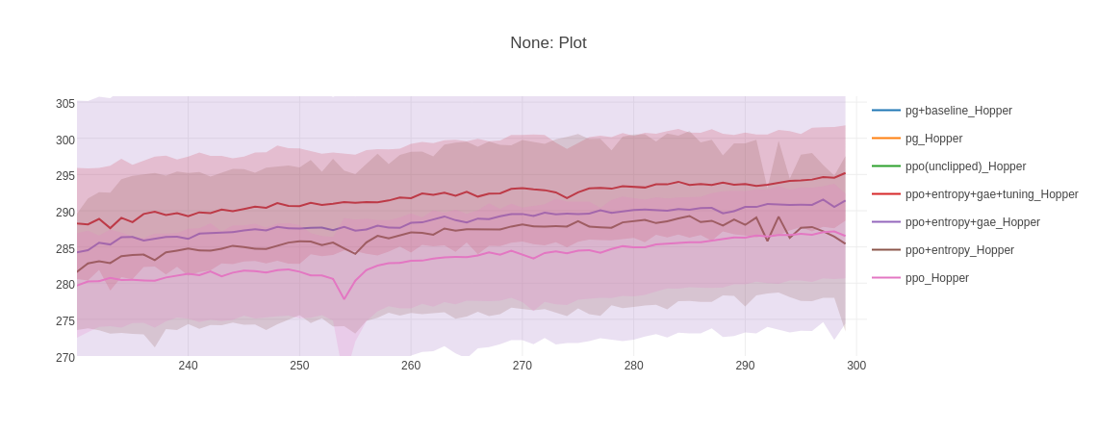
(b) Hopper

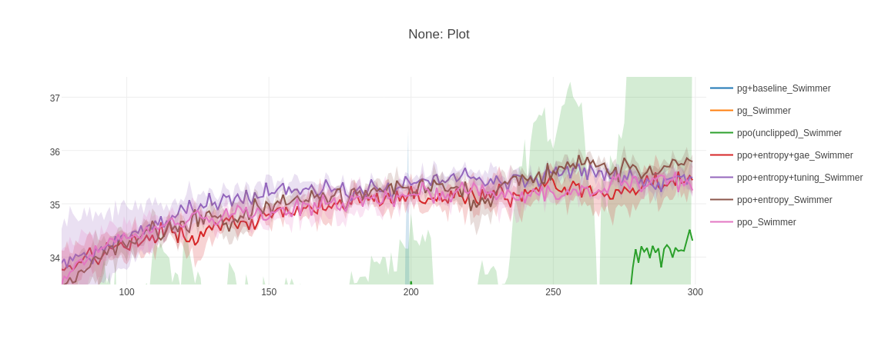
(c) Swimmer (tuning outperforms most time)

