**ZONE closing report**

**LIST OF CONTENTS**

LIST OF CONTENTS 1

1 THE DESCRIPTION OF THE PROJECT 2

2 RESULTS OF THE PROJECT 3

2.1 Description of the System 3

2.2 Description of the Hardware 3

2.3 Description of the Software 4

3 GENERAL EVALUATION OF THE PROGRESSION OF THE PROJECT 7

4 THE EXPERIENCES OF THE USED TOOLS AND METHODS 8

5 PERSONAL EXPERIENCES AND LEARNING 9

5.1 Vincent’s experiences 9

5.2 Ronan's experiences 9

6 SELF-EVALUATION OF THE STUDY MODULE 10

6.1 Vincnet’s self-evaluation 10

6.2 Ronan's self-evaluation 10

REFERENCES 10

**1 THE DESCRIPTION OF THE PROJECT**

In this project our aim was to create an application that would connect to a beacon and display messages based of the current telemetric conditions and tell you the weather of a location.

Description of the project phases and tasks is in the project plan (1).

Thanks to the layouts provided by android studio this project didn’t take too long to complete and we finished within the allotted time.

The documentation for the beacon did help as well when implementing the beacon to the app however we felt the documentation was not as extensive as we would have liked.

**2 RESULTS OF THE PROJECT**

**2.1 Description of the System**

The application screen of the product is shown in Figure 1. The system that we worked on, consisted of the application screen and the option bar.

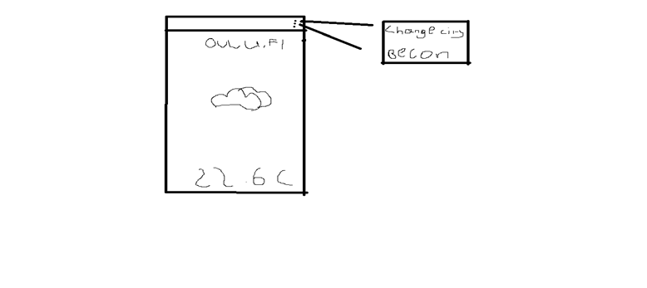

FIGURE 1. application diagram of the product

**2.2 Description of the Hardware**

The hardware required for the project was an Estimote Beacon, an Android Phone and a Computer with Android Studio Installed.

The Estimote Beacon was something the group members were not familiar with before the beginning of this project. It is a Bluetooth enabled beacon that allows the transfer of real time data such as temperature, accelerometer, light level, basic proximity, etc. The beacon is connected to the Estimote Cloud.

An Android Phone with developer mode enabled is also required to build and run the app you create.

Finally, a Laptop capable of building the app is required

**2.3 Description of the Software**

First, you must get an ape to update the real-time weather from an open source weather service online. You can see the api we used in Figure 2. The app home screen is shown in Figure 3.

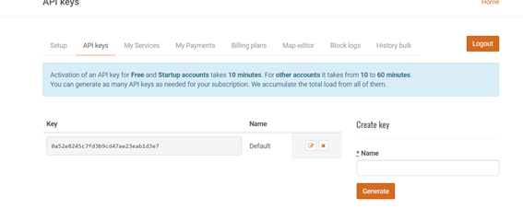

FIGURE 2. getting api for weather

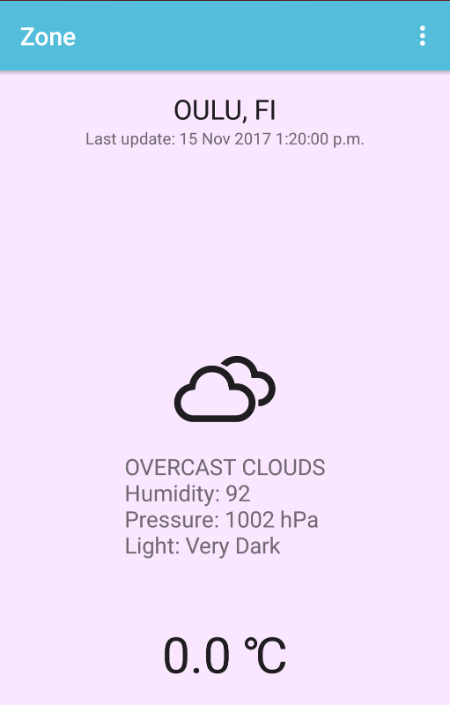

FIGURE 3. application screen for application

This application gives us data on the weather outside in any city in the world. The app uses the internet to put together all its information and displays on the main screen.

There was a lot of code required to implement this application as you can see in Figure 4.

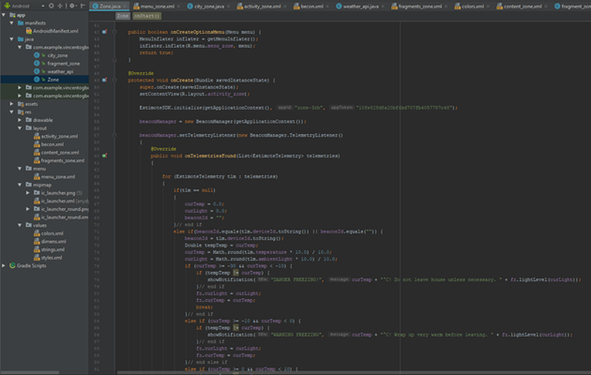

FIGURE 4. Activity diagram of the application program.

The code shown in figure 4 is the code for the main activity called Zone. In this class we use other classes and methods to run the functionality of the program. The bulk of the code and functionality is contained in this class.

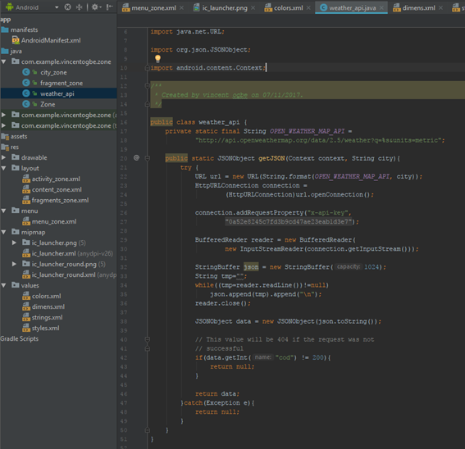

FIGURE 5. Activity diagram of the weather class program

The weather file contains the code used to get the api running and working with the other classes. This also demonstrates how we used the input location from the user to get weather data from other countries and send it to the Zone class to be displayed.

**3 GENERAL EVALUATION OF THE PROGRESSION OF THE PROJECT**

The detailed description of the work done is in the application time sheets. This project went mostly according to the original plan. The only difficulty we had with this project was with the beacons lack of functionality and that we couldn’t access some of the data stored in the Estimote Cloud such as the beacon’s location.

After we learned what we could and could not do with the beacon we split up into two groups to do two different sections of the project and at the end we joined the two programs together into one fully functioning program. While one worked on the weather and city input the other worked on the beacon implementation and all its functions and methods. We then came together and joined the two apps and made some minor edits, so they could work as part of the same app.

**4 THE EXPERIENCES OF THE USED TOOLS AND METHODS**

The hardware was relatively simple to set up and was done with minimal issue, however the hardware’s functionality was more limited that we had originally hoped. The software development environment was somewhat more difficult, neither of the team members had ever worked with Android Studio before and it was overwhelming initially. Both members had worked with the Java programming language before and so the language wasn’t daunting, however, the Gradle and xml resources was a new concept.

Although we had decided to use the Estimote Notification template Initially, we had experienced several issues setting it up, so we eventually decided to create our own project from scratch rather than use any of the given templates. This took some work to set-up, but it seems to have paid off in the long run as we managed to create an effective project and learn many of the Estimote concepts along the way.

We used Google Docs to write this report. This way we could work on the same file at the same time without having to cross-reference our edits and combine our work constantly. When the report was finished we exported it as a Work Document, fixed any formatting issues created by the conversion and exported it as a pdf.

**5 PERSONAL EXPERIENCES AND LEARNING**

**5.1 Vincent's experiences**

I really like this project and never thought that making apps was so easy. This project gave me a push to go learn more about Android Studio and what else it could do. I learned how to give an application internet access and how to take user input and search for information with it. While researching I learned how implement maps and locations settings, although I couldn't implement it effectively due to time constraints and because I still don't know too much about Android Studio, I'm looking forward to my next project. Although the project was relatively short I feel that I really learned a lot from this project.

**5.2 Ronan's experiences**

Although I ran into many issues throughout the course of this project I enjoyed the challenges I faced while at the same time learning new skills. I believe that learning the basics of Android Studio development will be of great use to me in my future career as it is a widely used standard for Android Application development. After completing the project, I believe that beacons like the Estimote Beacons used will only become more prevalent as time goes on, so learning the basic concepts and uses of the beacons was very helpful.

**6 SELF-EVALUATION OF THE STUDY MODULE**

**6.1 Vincent's self-evaluation**

I think that the project, based on the outcome, was successful. The project was completed in time and the work and reports seemed good. Overall, I think that it was a success and with a bit more time we could have made something greater. I was glad that Android Studio uses java as it is a language I am familiar with and I believe that is one reason the project was a success. I think we deserve a grade of A.

**6.2 Ronan's self-evaluation**

I believe that based on my initial skill set going into the project and the result of the project, we did extremely well. We finished the project within the provided time constraints and both members pulled their own weight with regards to the work. As I said above I did not know how to use Android Studio, so I also learned a lot throughout this project. With all of this in consideration I believe that a grade B or A.

**REFERENCES**

[**http://openweathermap.org/appid**](http://openweathermap.org/appid)