**Version 2**

Default except:

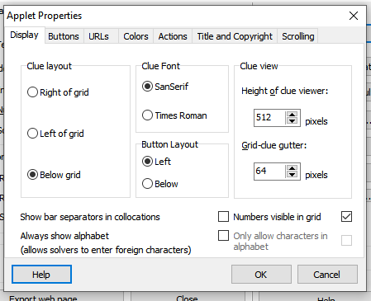

Version 003