PRIME HR SYSTEM
USER MANUAL
Schools Division Office I Pangasinan
Administrative User Guide

Table of Contents
System Login
Document Types (201 Files)
Leave Applications
Approved Leave Reports
Leave Balances
Leave Ledger
Leave Transactions
Office / Unit OPCRF
Employee IPCRF
Offices / Units
Profile Management
System Overview
Admin Dashboard
Leave Management
201 Files Management
OPCRF/IPCRF Submission
User Management
chool and District Management
Notifications
9. User Manual Generator

System Overview and Procedures

Step 1: System Home Dashboard
Overview of the main dashboard and navigation menu.
- Instructions: Review the interface and perform the necessary actions related to system home dashboard.
- Important Note: Ensure all required information is completed before submitting transactions.
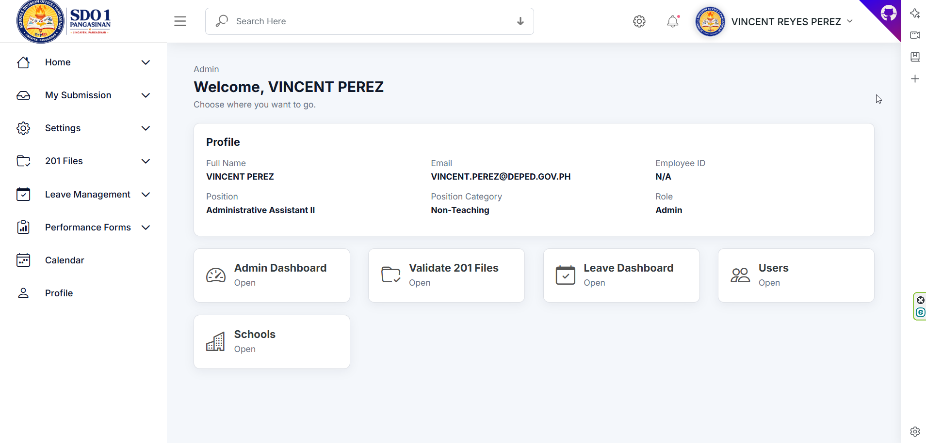
Figure 1. System Home Dashboard

Step 2: Admin Dashboard
Displays overall system statistics and summaries.
- Instructions: Review the interface and perform the necessary actions related to admin dashboard.
- Important Note: Ensure all required information is completed before submitting transactions.
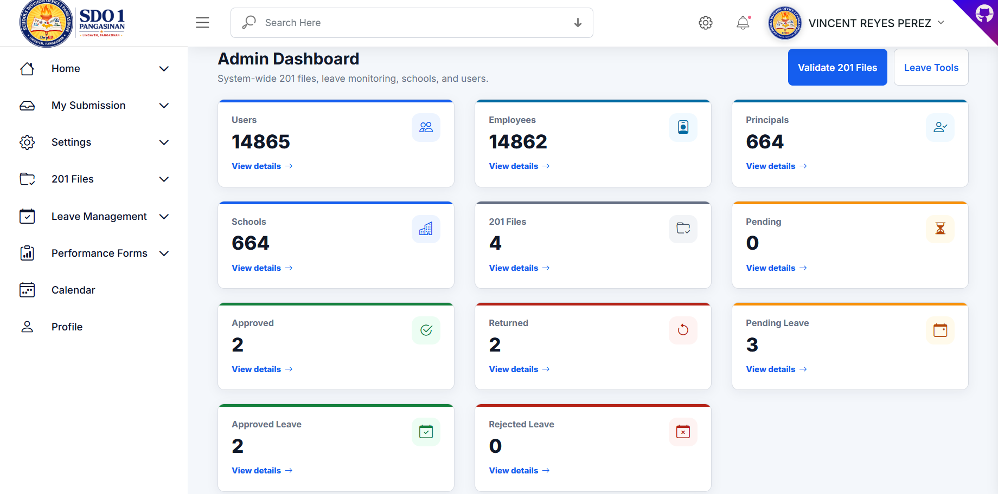
Figure 2. Admin Dashboard

Step 3: Recent Uploads and Status Summary
Shows upload summaries and validation status.
- Instructions: Review the interface and perform the necessary actions related to recent uploads and status summary.
- Important Note: Ensure all required information is completed before submitting transactions.
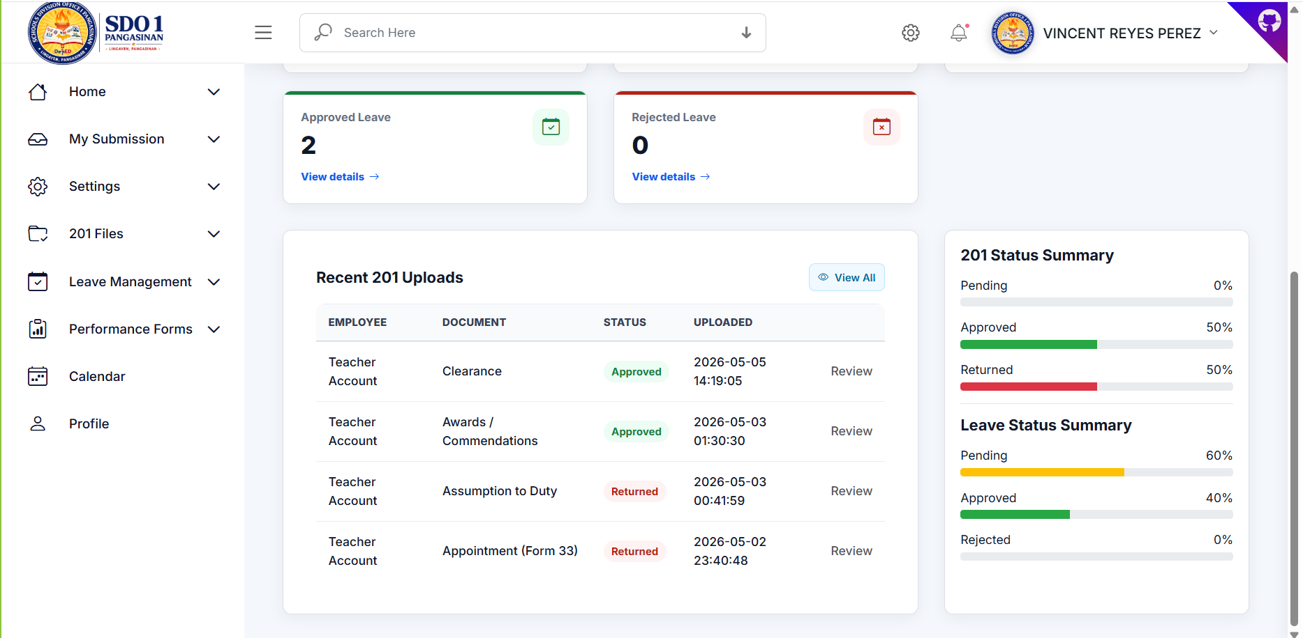
Figure 3. Recent Uploads and Status Summary

Step 4: Leave Credits Dashboard
Displays leave credit statistics and balances.
- Instructions: Review the interface and perform the necessary actions related to leave credits dashboard.
- Important Note: Ensure all required information is completed before submitting transactions.
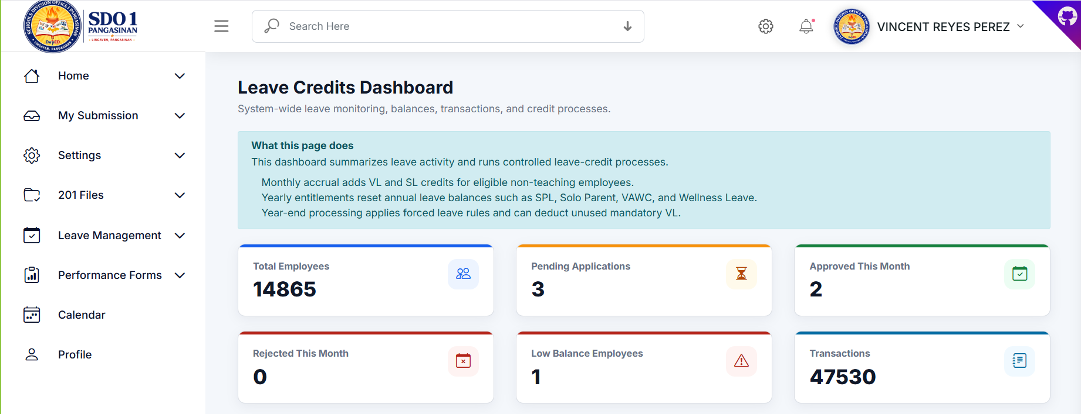
Figure 4. Leave Credits Dashboard

Step 5: Leave System Tools
Allows administrators to process leave accruals and yearly leave.
- Instructions: Review the interface and perform the necessary actions related to leave system tools.
- Important Note: Ensure all required information is completed before submitting transactions.
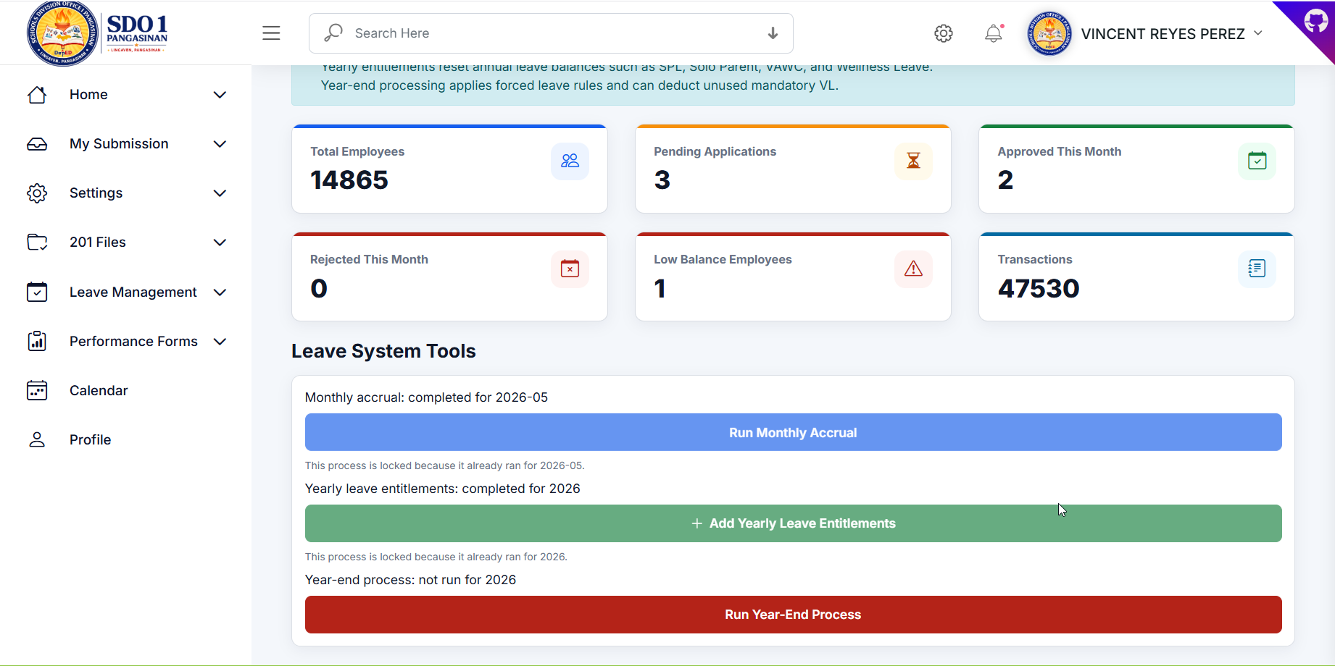
Figure 5. Leave System Tools

Step 6: My 201 Files
Employee document submission page.
- Instructions: Review the interface and perform the necessary actions related to my 201 files.
- Important Note: Ensure all required information is completed before submitting transactions.
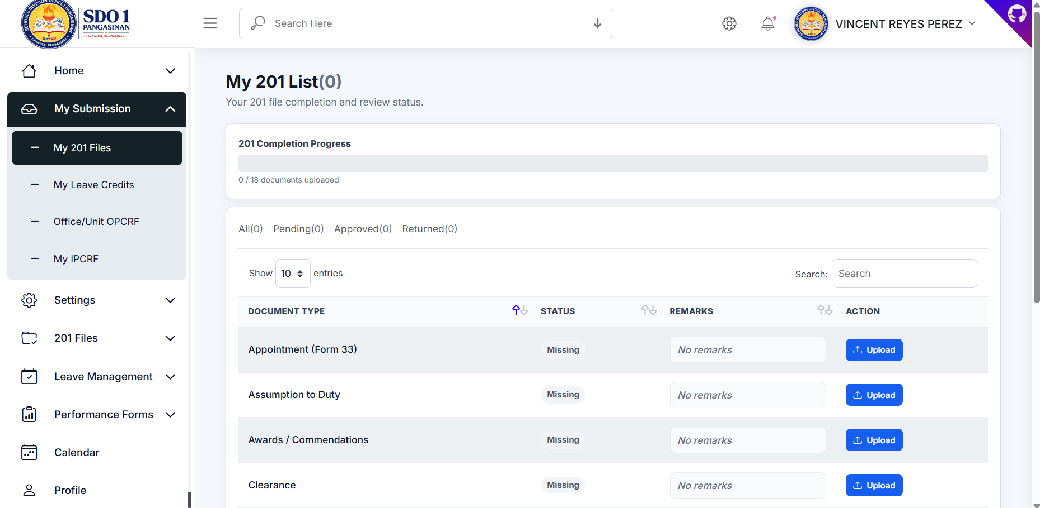
Figure 6. My 201 Files

Step 7: Upload Document Modal
Interface for uploading 201 files.
- Instructions: Review the interface and perform the necessary actions related to upload document modal.
- Important Note: Ensure all required information is completed before submitting transactions.
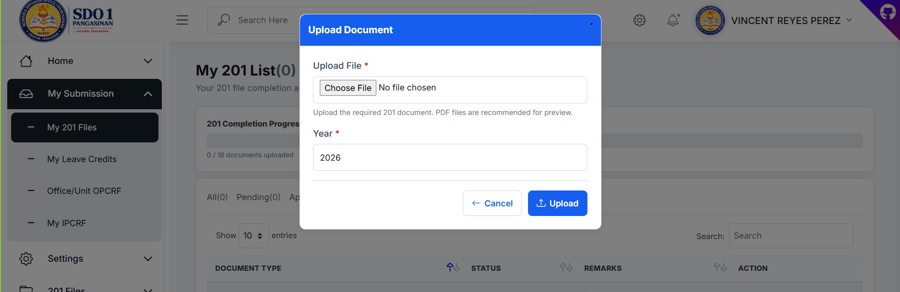
Figure 7. Upload Document Modal

Step 8: My Leave Balance
Displays available leave balances.
- Instructions: Review the interface and perform the necessary actions related to my leave balance.
- Important Note: Ensure all required information is completed before submitting transactions.
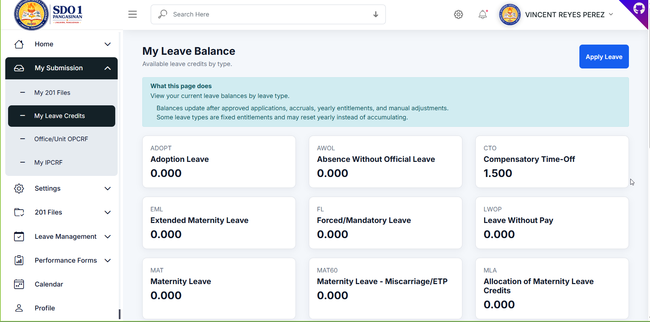
Figure 8. My Leave Balance

Step 9: Apply Leave Form
Used to submit leave applications.
- Instructions: Review the interface and perform the necessary actions related to apply leave form.
- Important Note: Ensure all required information is completed before submitting transactions.
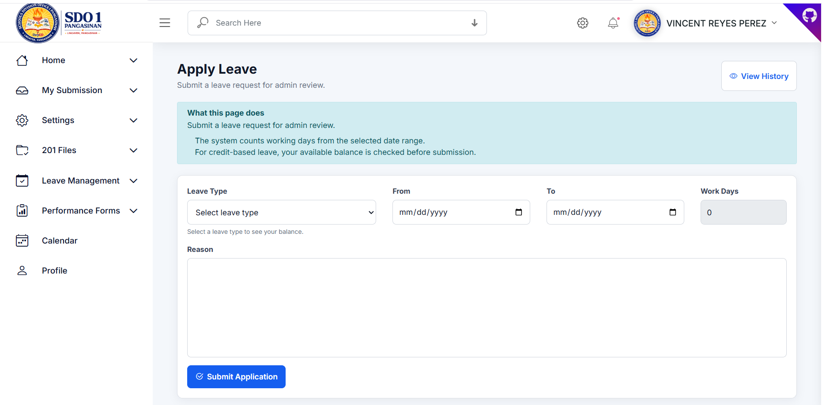
Figure 9. Apply Leave Form

Step 10: Office/Unit OPCRF
Displays OPCRF submissions and records.
- Instructions: Review the interface and perform the necessary actions related to office/unit opcrf.
- Important Note: Ensure all required information is completed before submitting transactions.
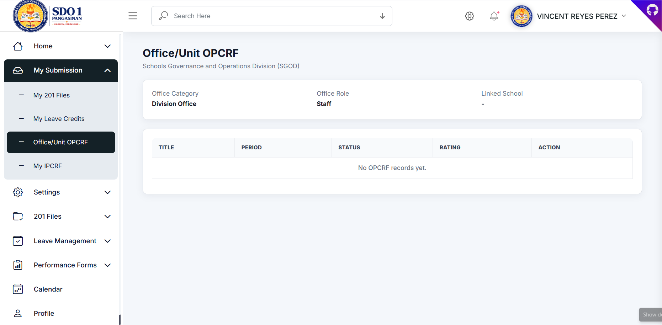
Figure 10. Office/Unit OPCRF

Step 11: My IPCRF
Displays employee IPCRF submissions.
- Instructions: Review the interface and perform the necessary actions related to my ipcrf.
- Important Note: Ensure all required information is completed before submitting transactions.
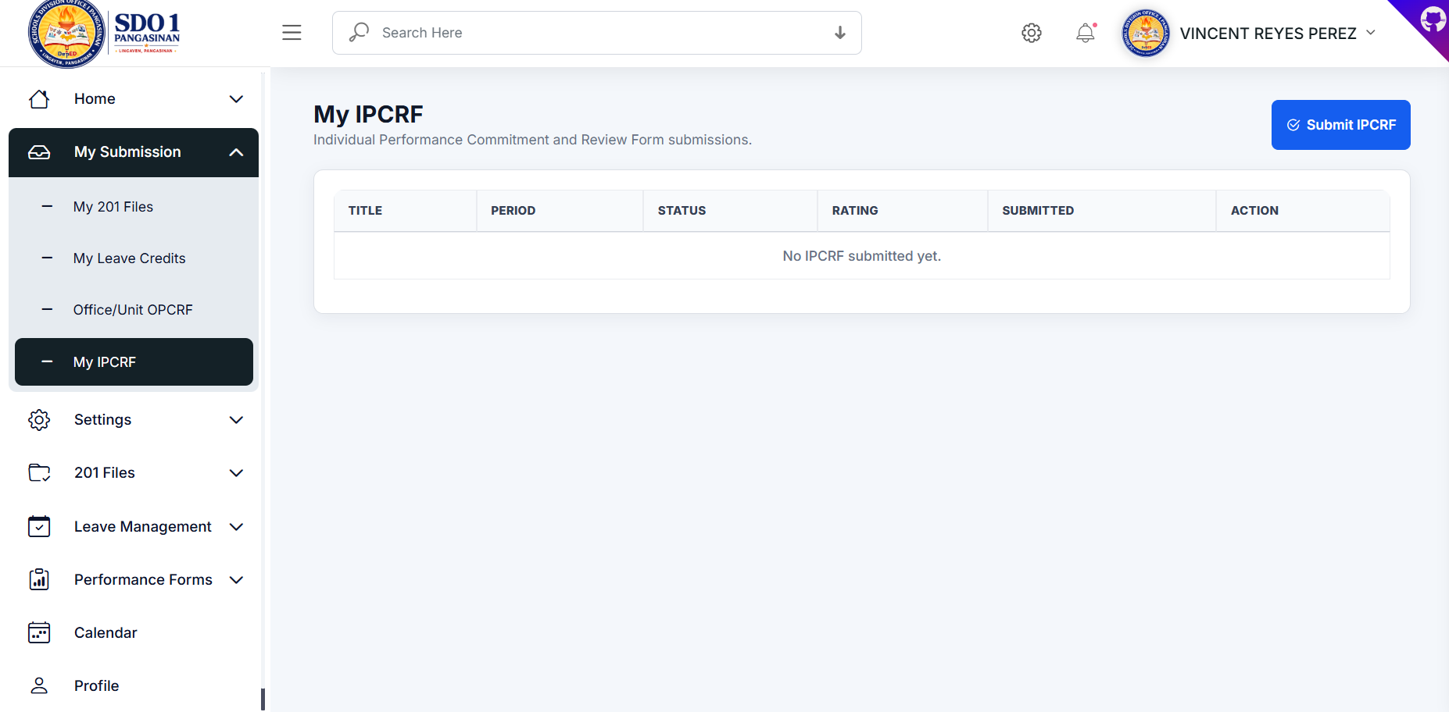
Figure 11. My IPCRF

Step 12: Submit IPCRF Modal
Allows employees to upload IPCRF files.
- Instructions: Review the interface and perform the necessary actions related to submit ipcrf modal.
- Important Note: Ensure all required information is completed before submitting transactions.
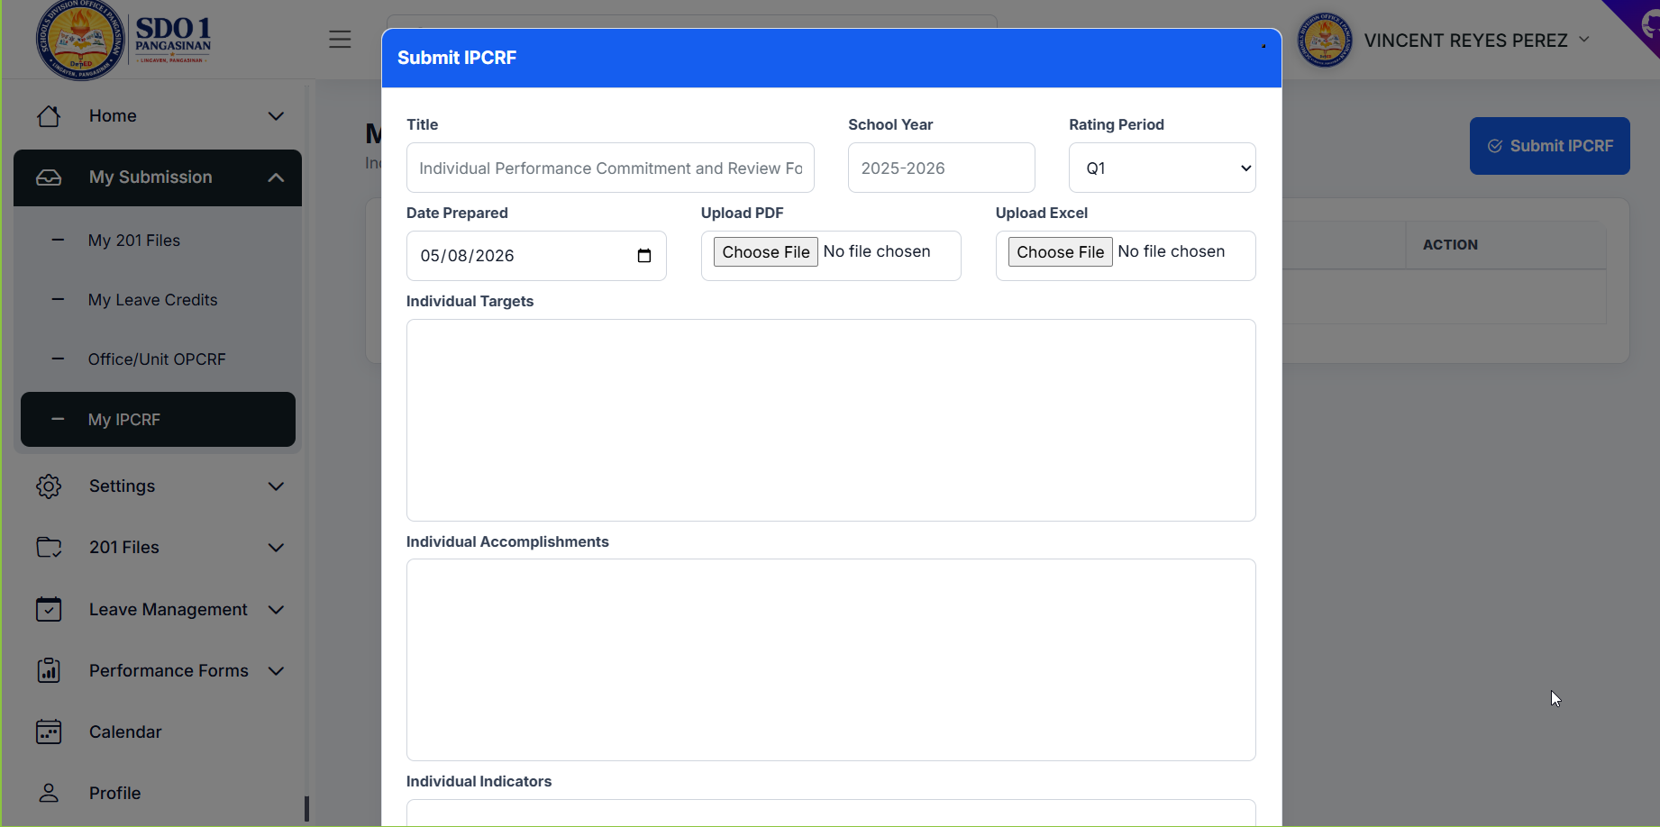
Figure 12. Submit IPCRF Modal

Step 13: User List Management
Displays and manages system users.
- Instructions: Review the interface and perform the necessary actions related to user list management.
- Important Note: Ensure all required information is completed before submitting transactions.
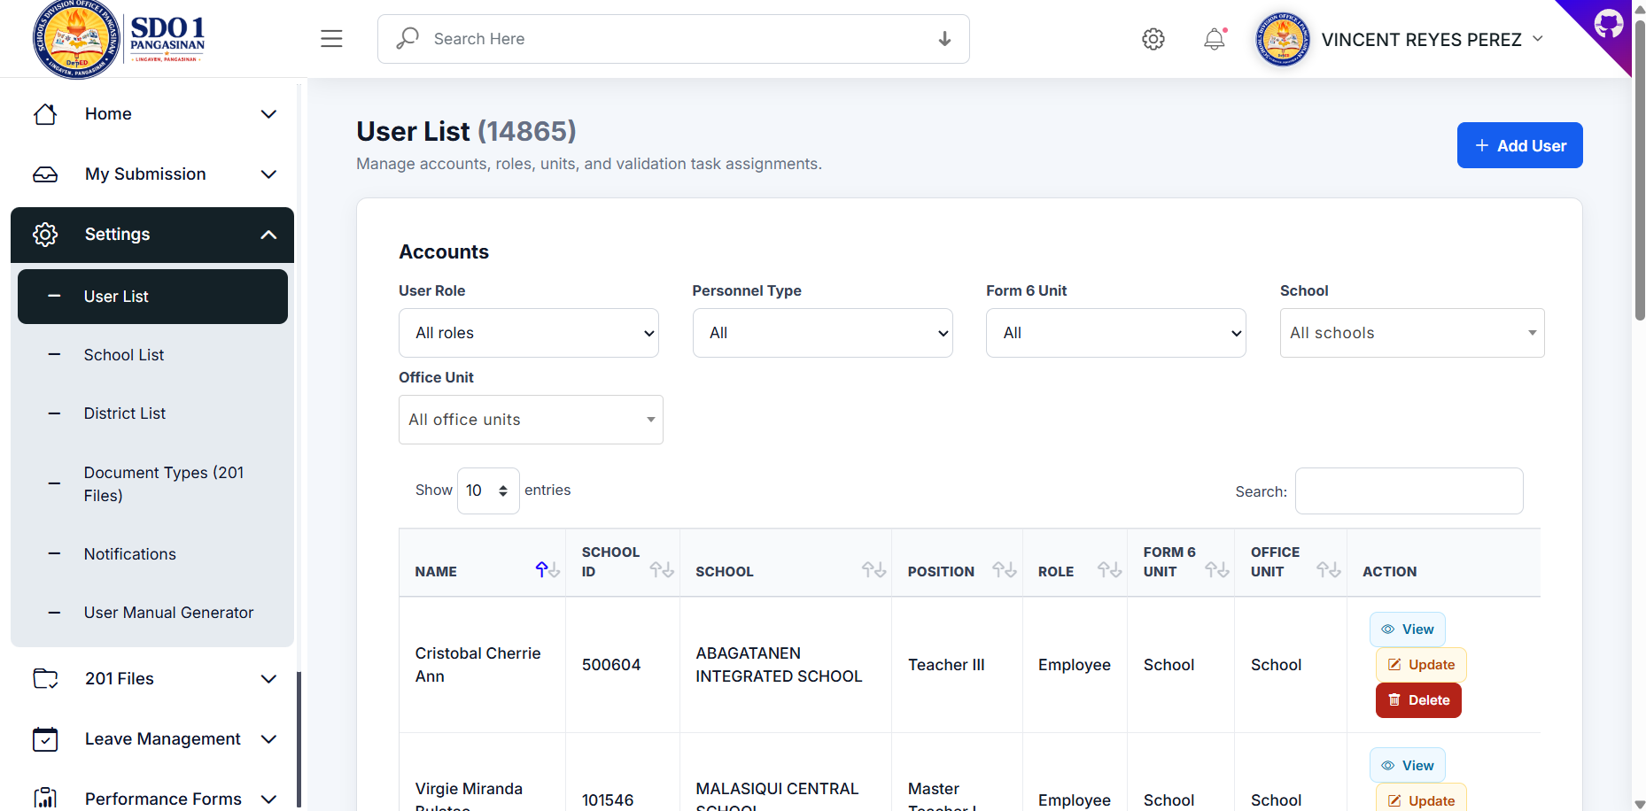
Figure 13. User List Management

Step 14: Add User Form
Form for adding new users.
- Instructions: Review the interface and perform the necessary actions related to add user form.
- Important Note: Ensure all required information is completed before submitting transactions.
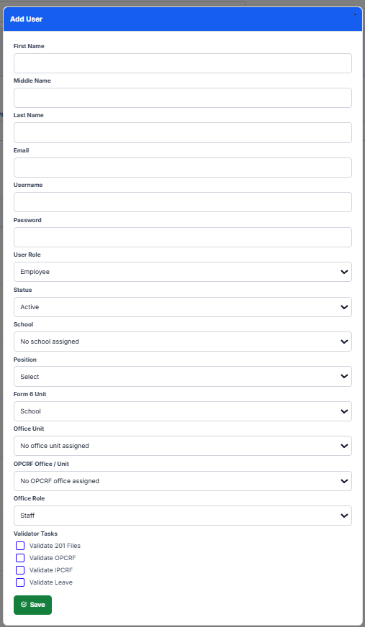
Figure 14. Add User Form

Step 15: School List
Displays registered schools.
- Instructions: Review the interface and perform the necessary actions related to school list.
- Important Note: Ensure all required information is completed before submitting transactions.
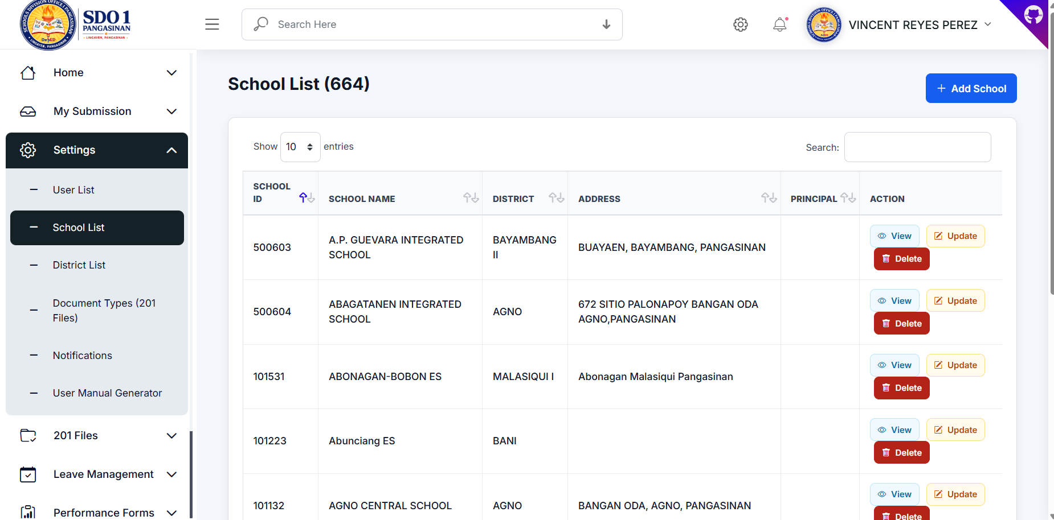
Figure 15. School List

Step 16: District List
Displays district records.
- Instructions: Review the interface and perform the necessary actions related to district list.
- Important Note: Ensure all required information is completed before submitting transactions.
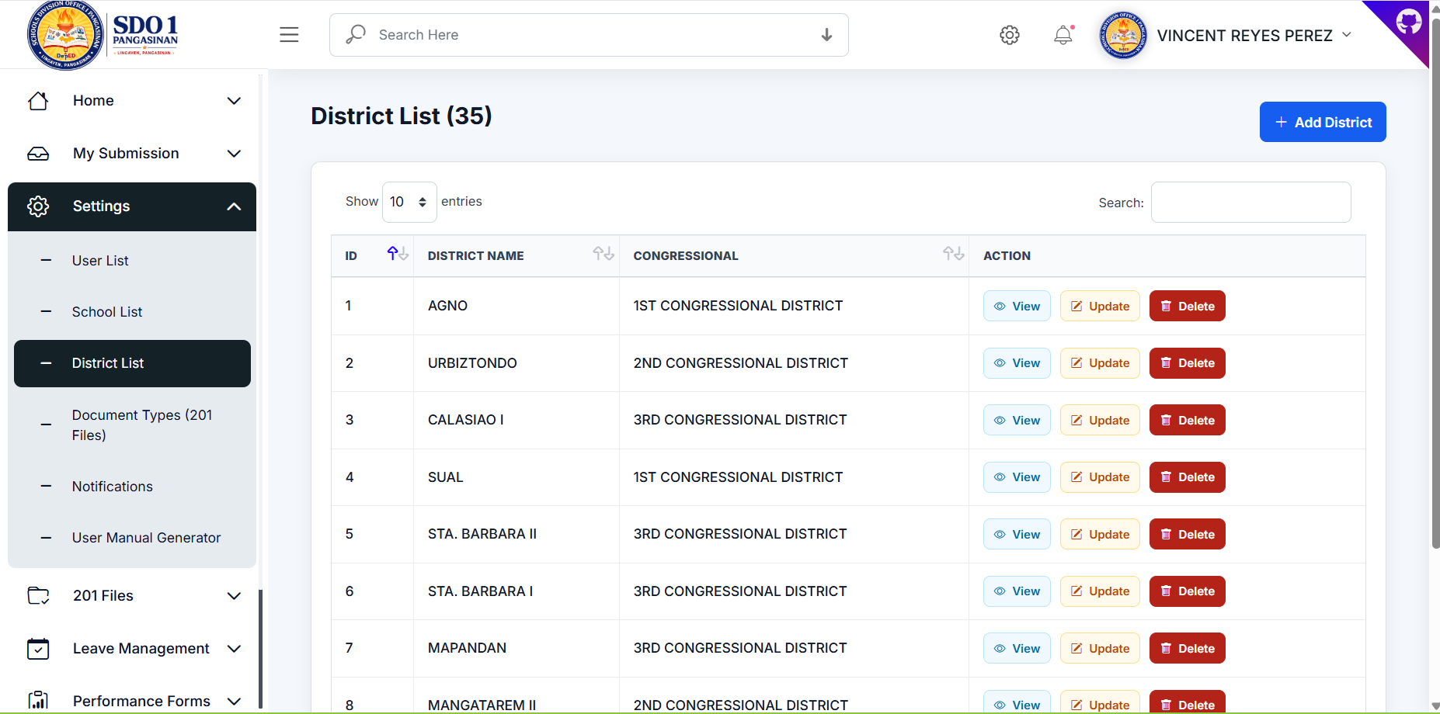
Figure 16. District List

Step 17: Document Types
Manage required 201 file document types.
- Instructions: Review the interface and perform the necessary actions related to document types.
- Important Note: Ensure all required information is completed before submitting transactions.
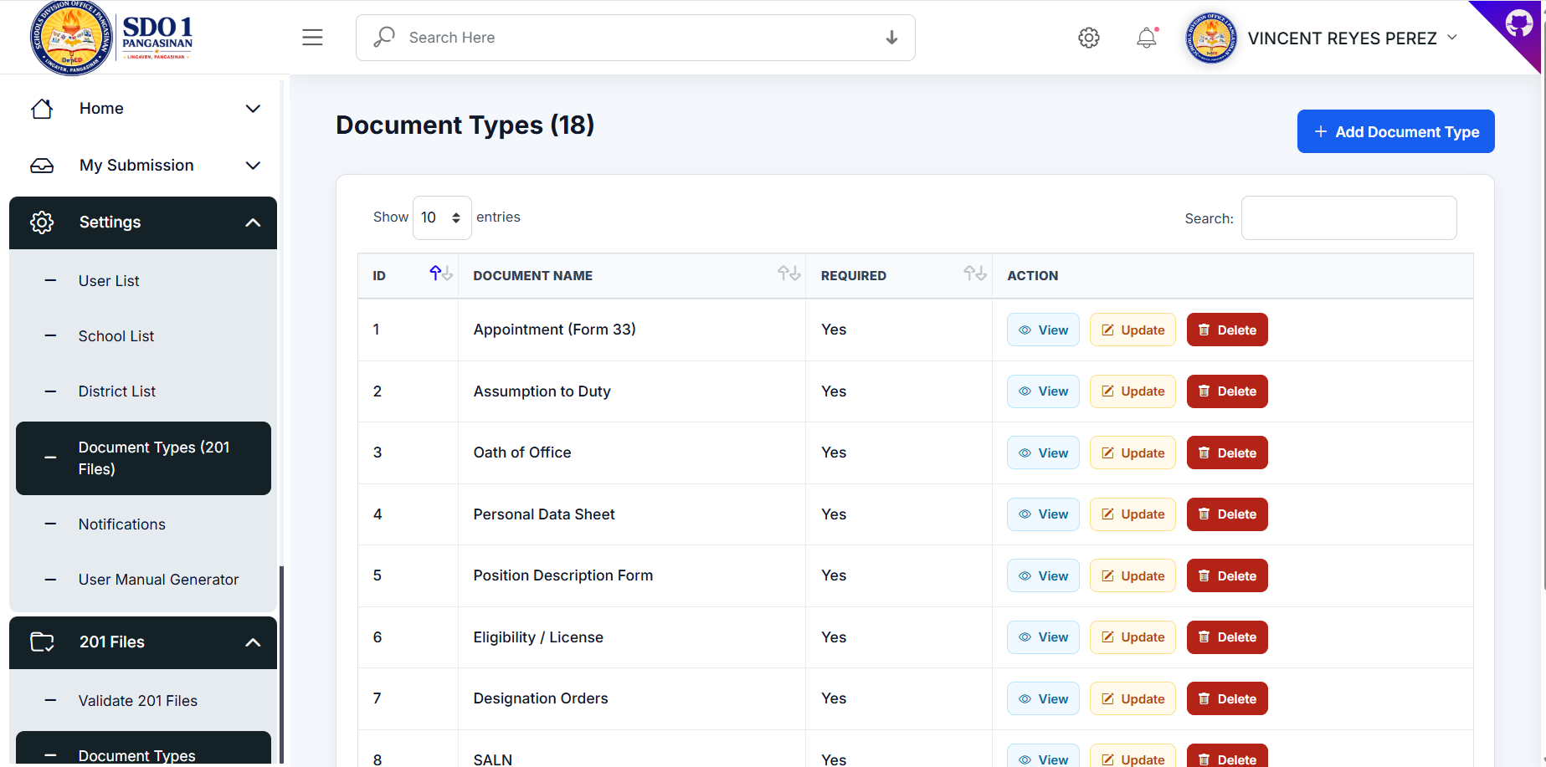
Figure 17. Document Types

Step 18: Notifications
Create and send notifications.
- Instructions: Review the interface and perform the necessary actions related to notifications.
- Important Note: Ensure all required information is completed before submitting transactions.
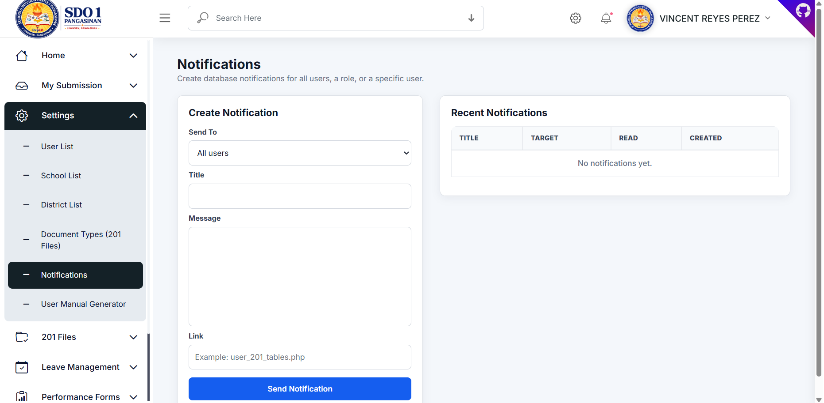
Figure 18. Notifications

Step 19: User Manual Generator
Generate downloadable Microsoft Word manuals.
- Instructions: Review the interface and perform the necessary actions related to user manual generator.
- Important Note: Ensure all required information is completed before submitting transactions.
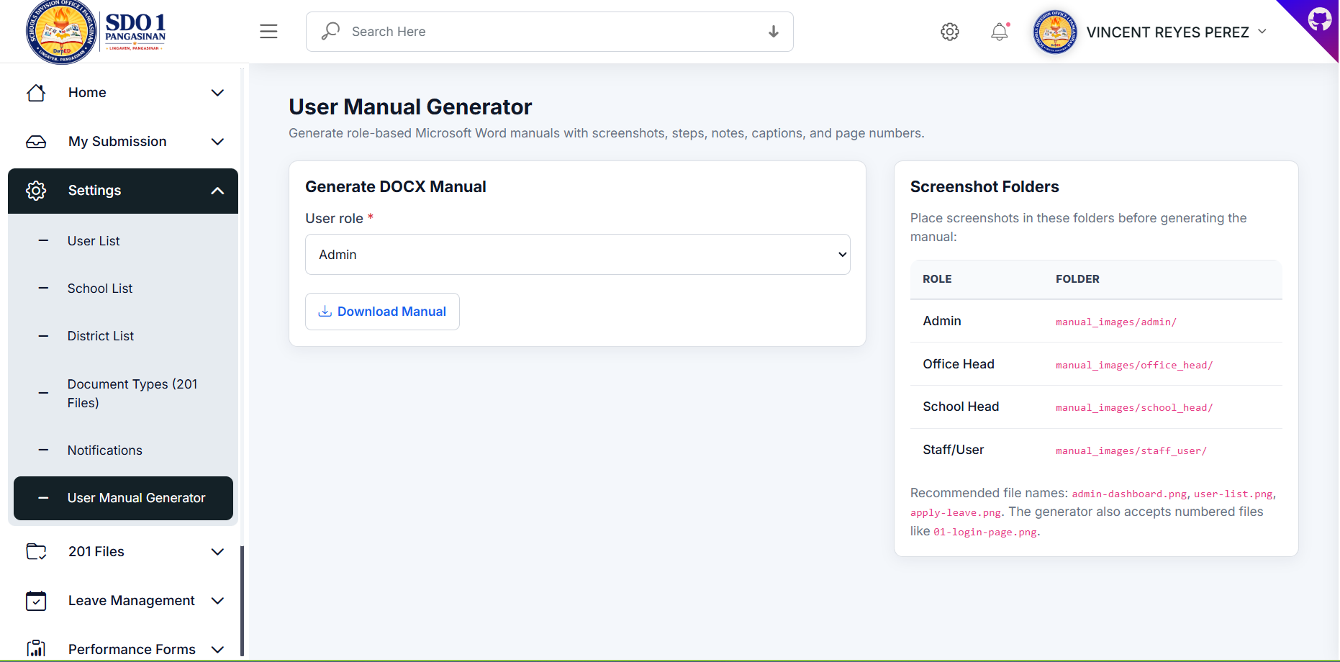
Figure 19. User Manual Generator

Step 20: Validate 201 Files
Review and validate uploaded employee files.
- Instructions: Review the interface and perform the necessary actions related to validate 201 files.
- Important Note: Ensure all required information is completed before submitting transactions.
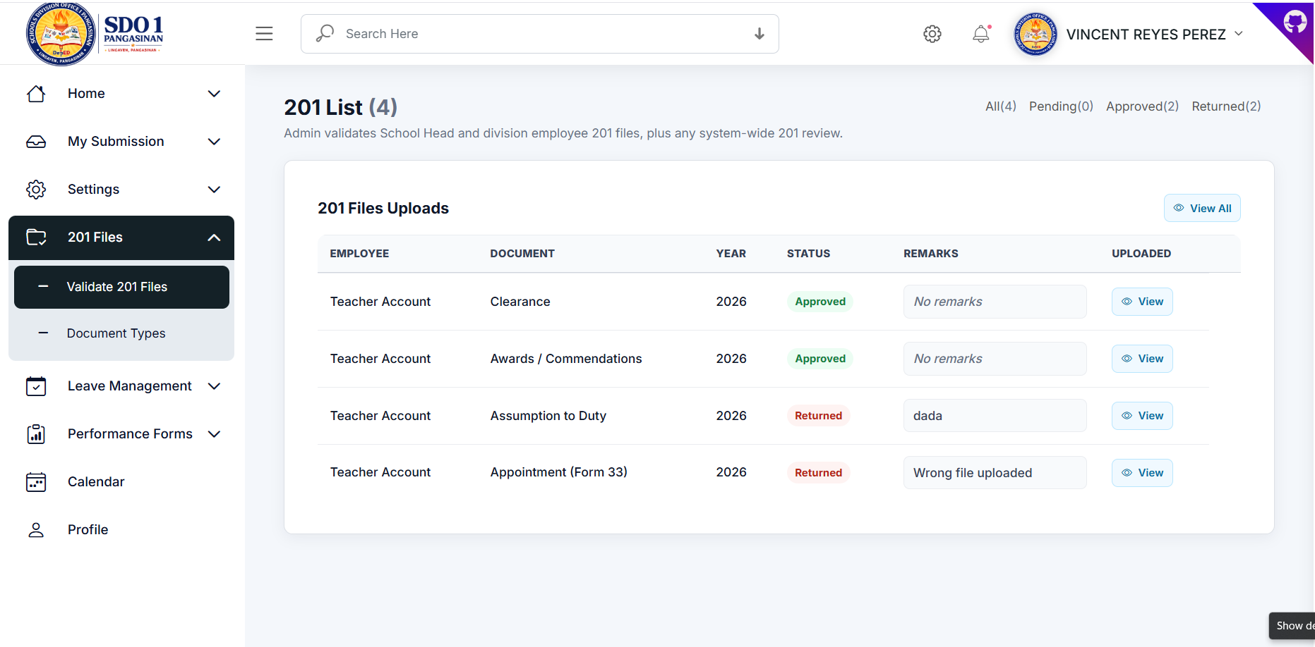
Figure 20. Validate 201 Files

