PRIMEHR SYSTEM USER MANUAL
Administrator Module
Schools Division Office I Pangasinan

Table of Contents
1. Login Page
2. Document Types (201 Files)
3. Leave Applications
4. Approved Leave Report
5. Approved Applications Table
6. Leave Balances
7. Leave Ledger
8. Leave Transactions
9. Office / Unit OPCRF
10. Add Office / Unit OPCRF
11. Employee IPCRF
12. Offices / Units
13. Add Office
14. User Profile

Step 1: Login Page
The login page is used by authorized personnel to securely access the PRIMEHR system using their DepEd email address and password.
- Open the corresponding module from the left sidebar navigation menu.
- Review or update the information shown on the page.
- Save changes or export reports when necessary.
Important Note: Ensure all information entered into the system is accurate before submission or approval.
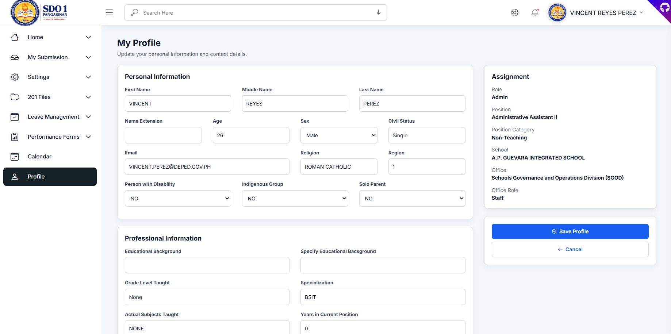
Figure 1. Login Page

Step 2: Document Types (201 Files)
This module manages all required employee 201 document types such as Appointment Forms, SALN, PDS, and other HR records.
- Open the corresponding module from the left sidebar navigation menu.
- Review or update the information shown on the page.
- Save changes or export reports when necessary.
Important Note: Ensure all information entered into the system is accurate before submission or approval.
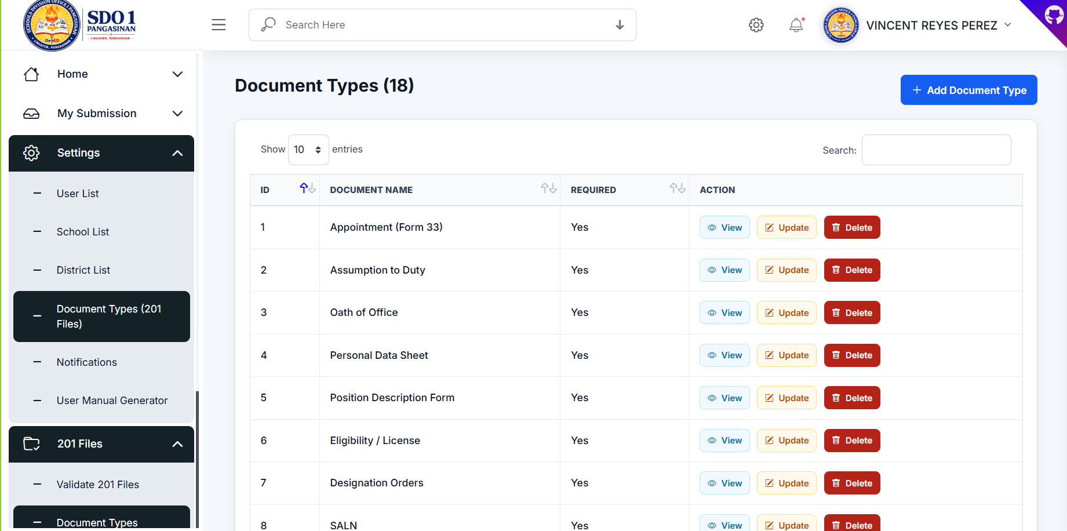
Figure 2. Document Types (201 Files)

Step 3: Leave Applications
Administrators can review, approve, reject, and monitor submitted leave applications.
- Open the corresponding module from the left sidebar navigation menu.
- Review or update the information shown on the page.
- Save changes or export reports when necessary.
Important Note: Ensure all information entered into the system is accurate before submission or approval.
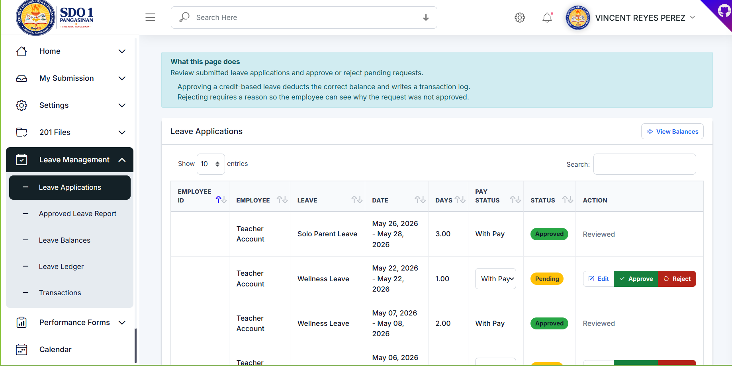
Figure 3. Leave Applications

Step 4: Approved Leave Report
This report page displays approved leave applications and provides filtering and export features.
- Open the corresponding module from the left sidebar navigation menu.
- Review or update the information shown on the page.
- Save changes or export reports when necessary.
Important Note: Ensure all information entered into the system is accurate before submission or approval.
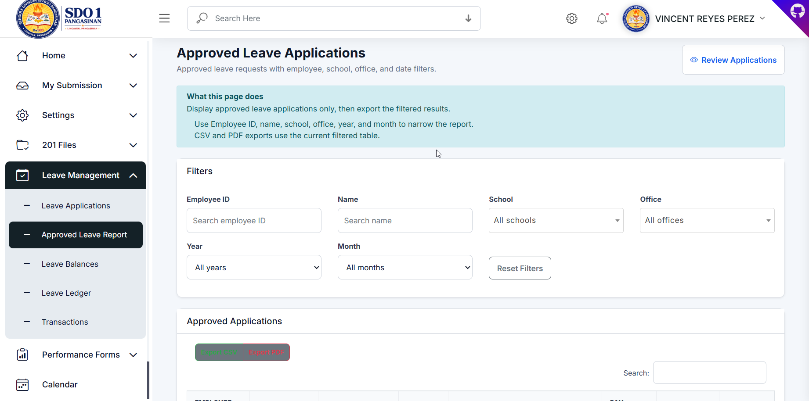
Figure 4. Approved Leave Report

Step 5: Approved Applications Table
The table lists approved applications together with leave details, dates, pay status, and downloadable Form 6.
- Open the corresponding module from the left sidebar navigation menu.
- Review or update the information shown on the page.
- Save changes or export reports when necessary.
Important Note: Ensure all information entered into the system is accurate before submission or approval.
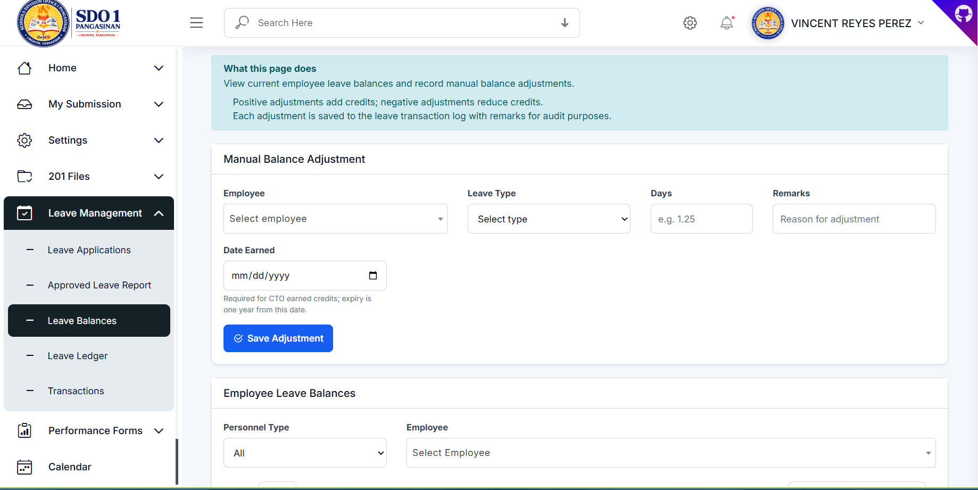
Figure 5. Approved Applications Table

Step 6: Leave Balances
This page allows manual adjustment and monitoring of employee leave balances.
- Open the corresponding module from the left sidebar navigation menu.
- Review or update the information shown on the page.
- Save changes or export reports when necessary.
Important Note: Ensure all information entered into the system is accurate before submission or approval.
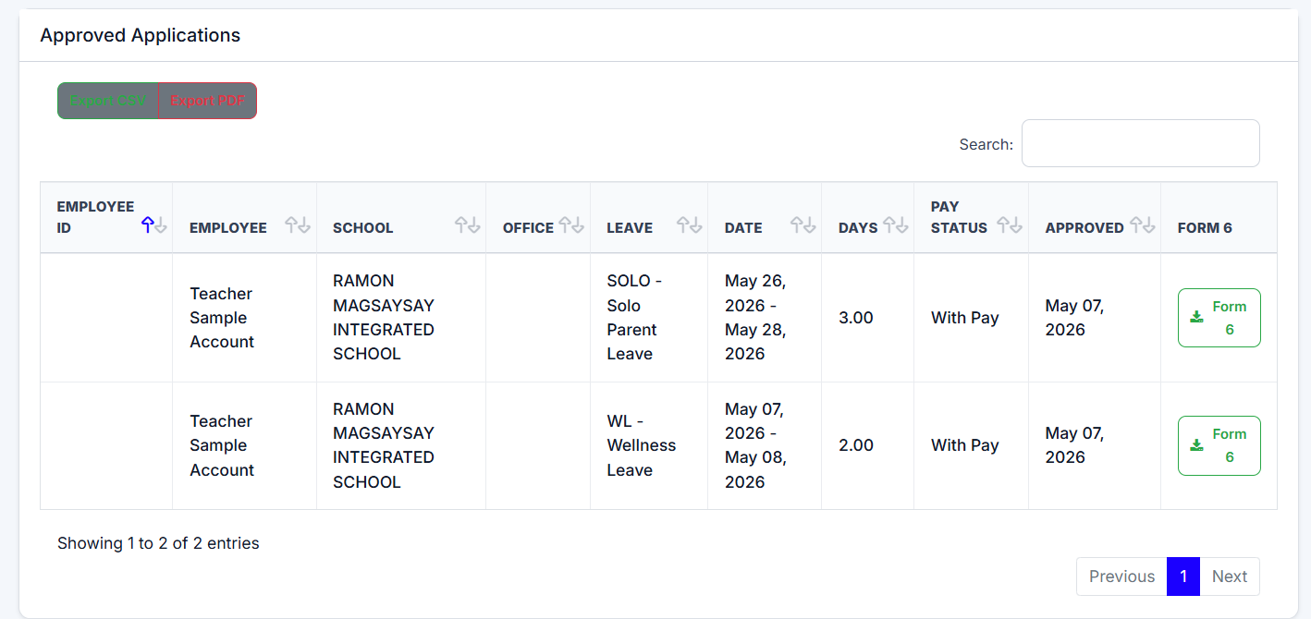
Figure 6. Leave Balances

Step 7: Leave Ledger
The leave ledger tracks employee leave credits, deductions, balances, and yearly transactions.
- Open the corresponding module from the left sidebar navigation menu.
- Review or update the information shown on the page.
- Save changes or export reports when necessary.
Important Note: Ensure all information entered into the system is accurate before submission or approval.
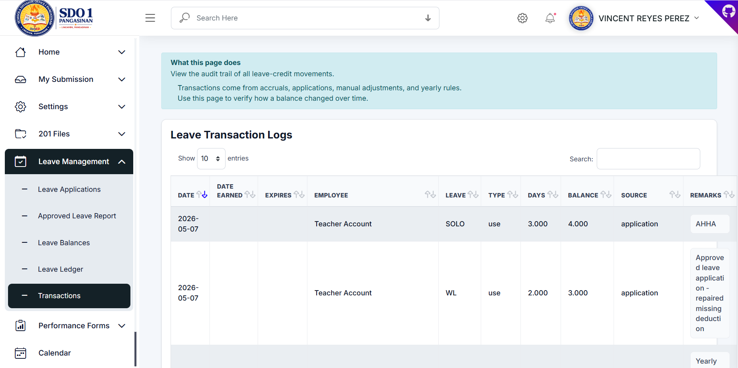
Figure 7. Leave Ledger

Step 8: Leave Transactions
All leave-related movements and adjustments are recorded in the leave transaction logs.
- Open the corresponding module from the left sidebar navigation menu.
- Review or update the information shown on the page.
- Save changes or export reports when necessary.
Important Note: Ensure all information entered into the system is accurate before submission or approval.
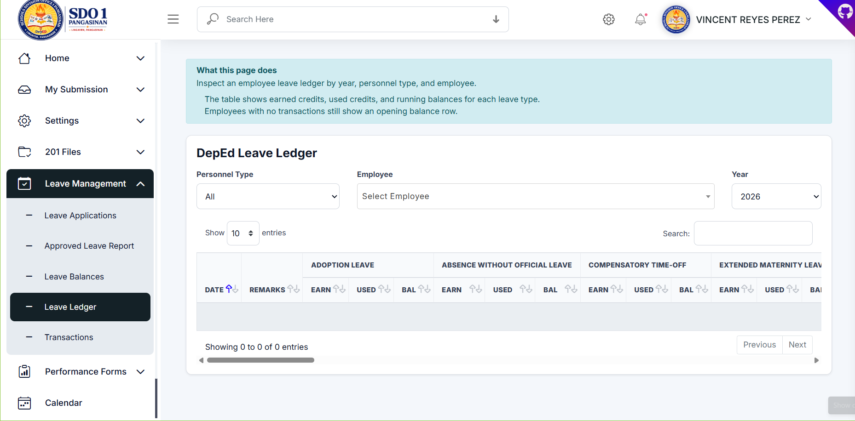
Figure 8. Leave Transactions

Step 9: Office / Unit OPCRF
This module manages office-level OPCRF submissions and performance tracking.
- Open the corresponding module from the left sidebar navigation menu.
- Review or update the information shown on the page.
- Save changes or export reports when necessary.
Important Note: Ensure all information entered into the system is accurate before submission or approval.
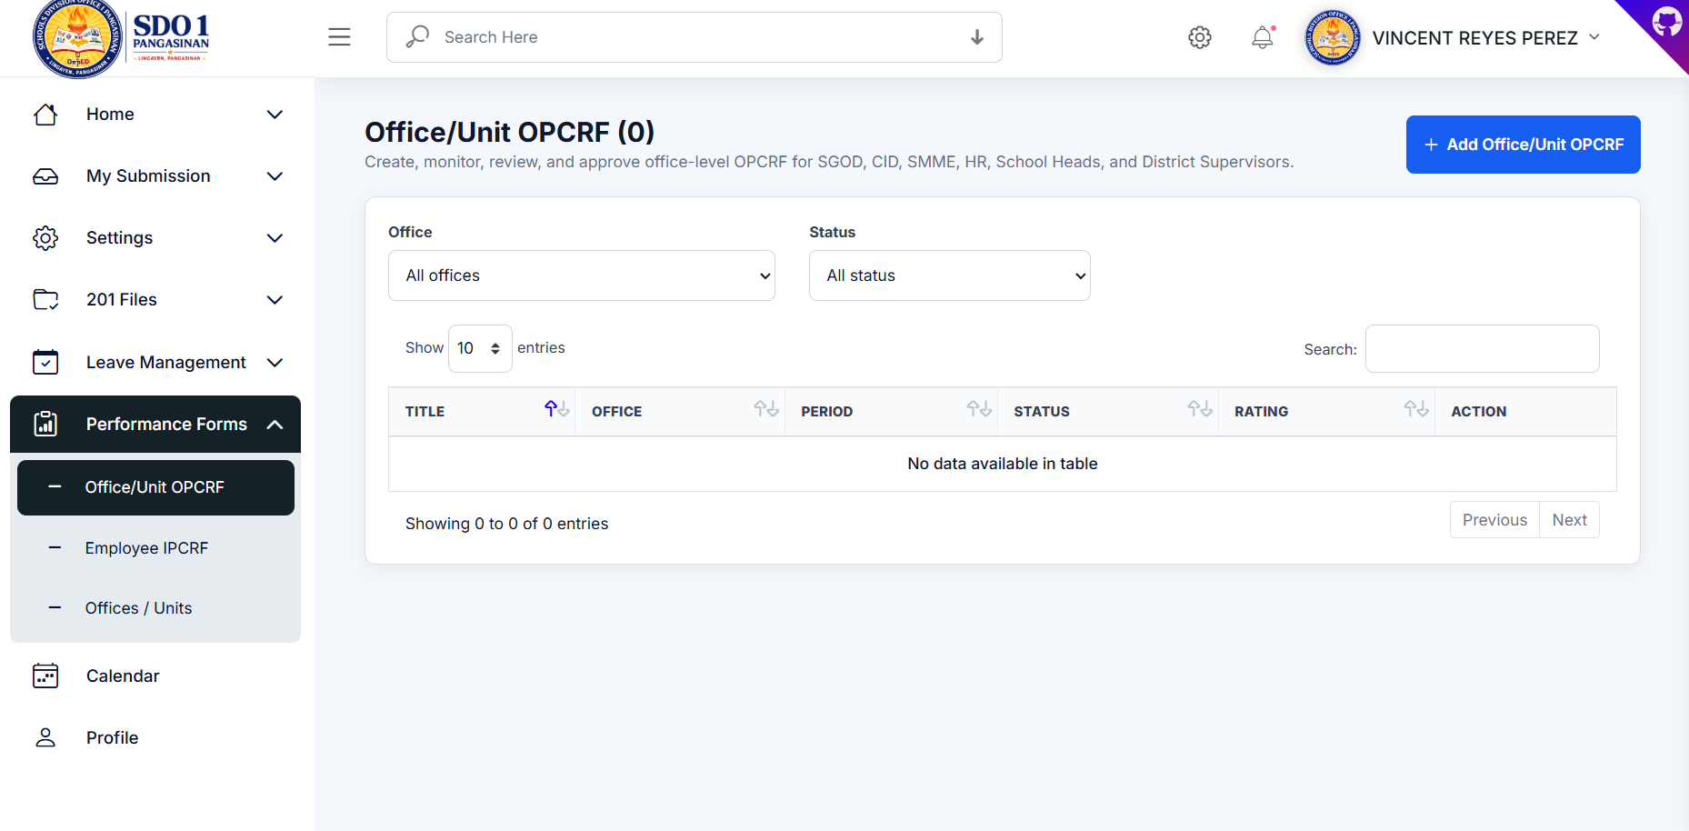
Figure 9. Office / Unit OPCRF

Step 10: Add Office / Unit OPCRF
Administrators can create OPCRF records by uploading PDF and Excel files together with office details.
- Open the corresponding module from the left sidebar navigation menu.
- Review or update the information shown on the page.
- Save changes or export reports when necessary.
Important Note: Ensure all information entered into the system is accurate before submission or approval.
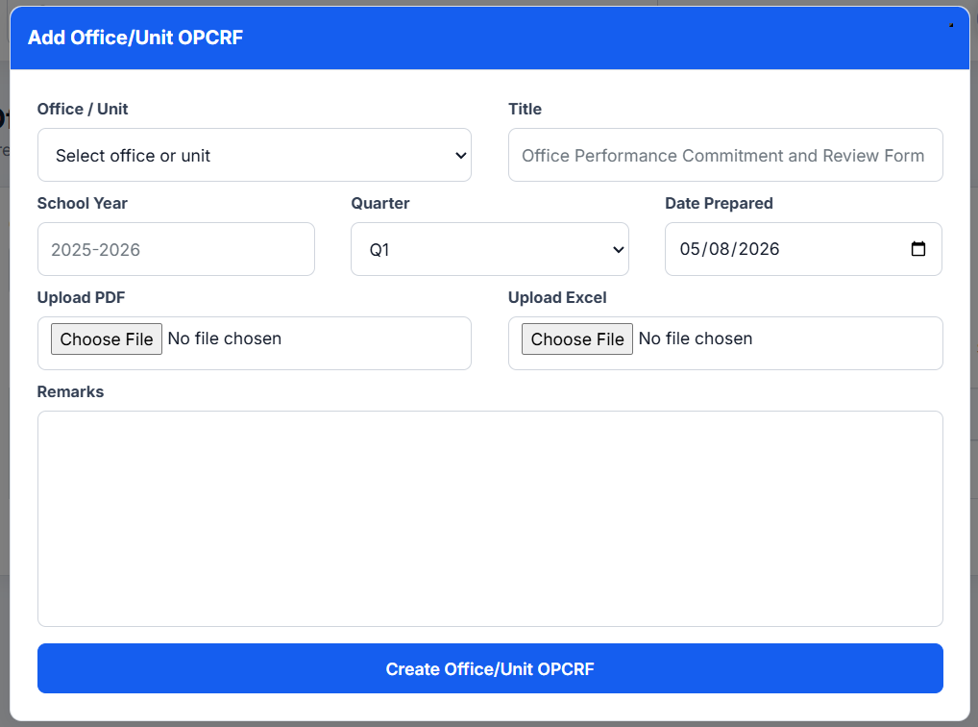
Figure 10. Add Office / Unit OPCRF

Step 11: Employee IPCRF
The Employee IPCRF module is used for monitoring and reviewing submitted IPCRF documents.
- Open the corresponding module from the left sidebar navigation menu.
- Review or update the information shown on the page.
- Save changes or export reports when necessary.
Important Note: Ensure all information entered into the system is accurate before submission or approval.
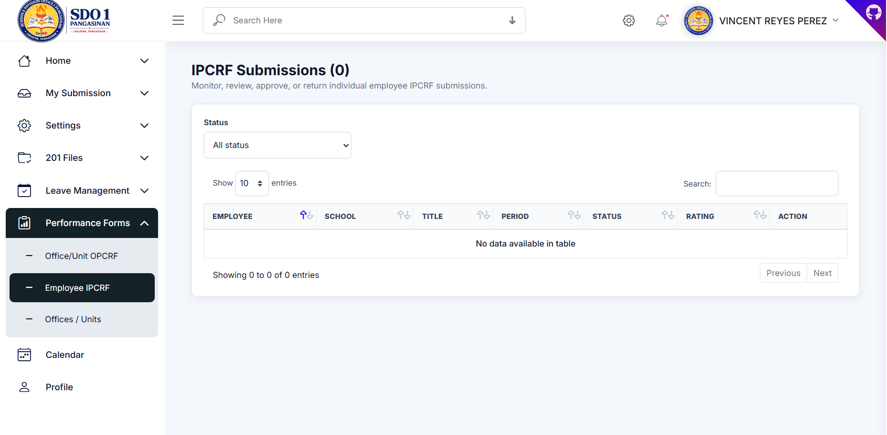
Figure 11. Employee IPCRF

Step 12: Offices / Units
This page manages offices, units, office heads, signatories, and submission roles.
- Open the corresponding module from the left sidebar navigation menu.
- Review or update the information shown on the page.
- Save changes or export reports when necessary.
Important Note: Ensure all information entered into the system is accurate before submission or approval.
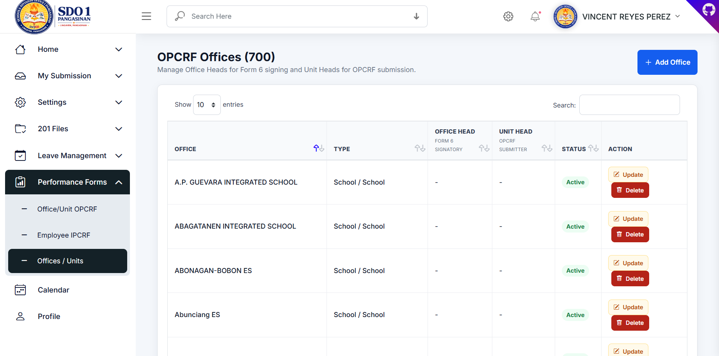
Figure 12. Offices / Units

Step 13: Add Office
Administrators can configure office information, office heads, linked schools, and unit submitters.
- Open the corresponding module from the left sidebar navigation menu.
- Review or update the information shown on the page.
- Save changes or export reports when necessary.
Important Note: Ensure all information entered into the system is accurate before submission or approval.
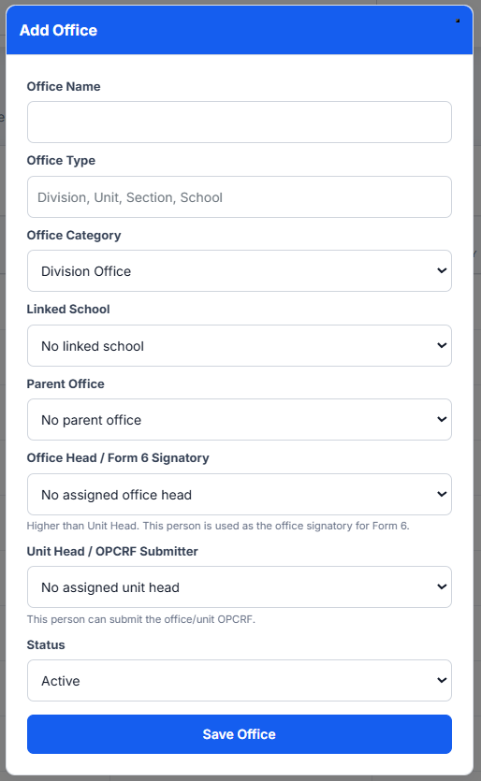
Figure 13. Add Office

Step 14: User Profile
Users can update personal, professional, and assignment information through the profile module.
- Open the corresponding module from the left sidebar navigation menu.
- Review or update the information shown on the page.
- Save changes or export reports when necessary.
Important Note: Ensure all information entered into the system is accurate before submission or approval.
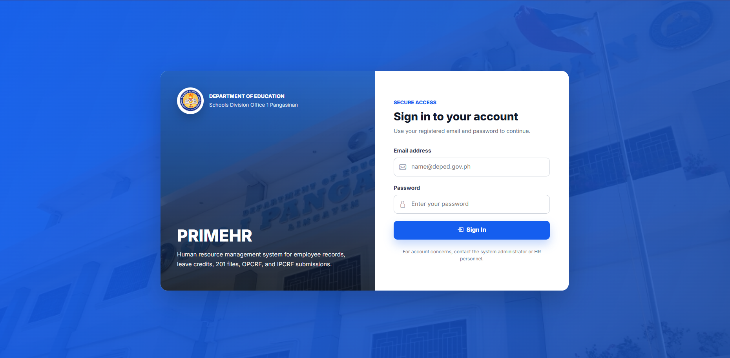
Figure 14. User Profile

