Final_Report_Rmd
2026-04-13

Introduction
The data used in this analysis come from the 2021 National Health Interview Survey, which examines relationships between demographic characteristics and health outcomes. This report focuses on variables such as age, weight, height, education level, and race/ethnicity to identify patterns and relationships among these factors. Understanding these associations can provide insight into broader public health trends and factors that influence overall well-being.

Methods
Missing values in the dataset were identified and removed based on the codebook to ensure a clean dataset for analysis. The education level variable (EDUCP_A) was recoded into more meaningful categories. Quantitative variables analyzed included age (AGEP_A), weight (WEIGHTLBTC_A), and height (HEIGHTTC_A), while qualitative variables included sex (SEX_A), race/ethnicity (HISPALLP_A), education level (EDUCP_A), general health status (PHSTAT_A), and life satisfaction (LSATIS4R_A). Both base R plotting functions and the ggplot2 package were used to create visualizations. Univariate, bivariate, and multivariate analyses were conducted to explore distributions and relationships among variables.

Results
Univariate analysis indicated that age, height, and weight were approximately normally distributed. 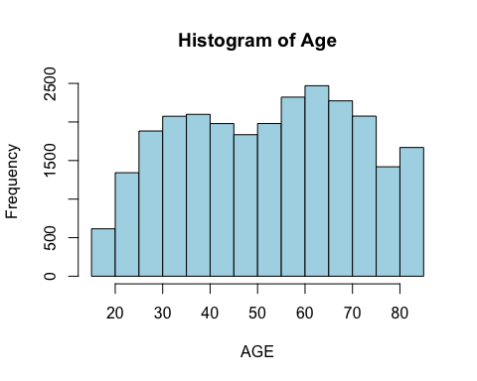 This suggests relatively symmetric distributions for these variables.
In contrast, categorical variables such as education level, life satisfaction, and health status showed variation in frequency across categories. 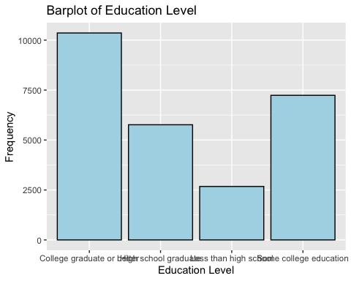 The bar chart shows that the distribution between education levels varies across categories with college graduates having the most frequency.
Bivariate analysis examined differences in age across sex and education levels, revealing noticeable variation between groups. 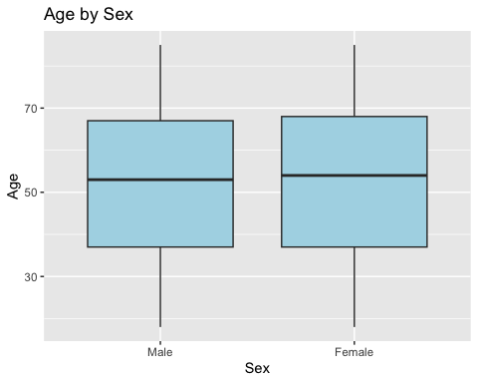 The boxplot shows variation in age distribution between males and females.
A clustered bar chart demonstrated the relationship between general health status and life satisfaction. 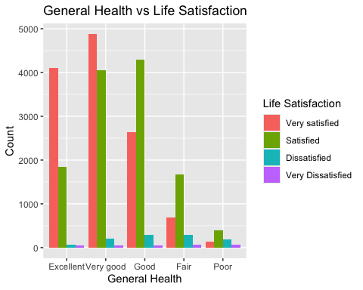 This shows that individuals reporting better overall health also tended to report higher life satisfaction.
A scatterplot of height versus weight showed a moderate positive correlation (r = 0.50). 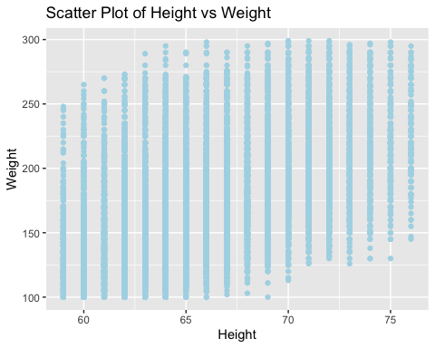
This indicates that taller individuals tend to weigh more. This relationship was consistent across both base R and ggplot2 visualizations.
Additionally, a scatterplot matrix created using the pairs.panels function illustrated relationships among age, height, and weight. 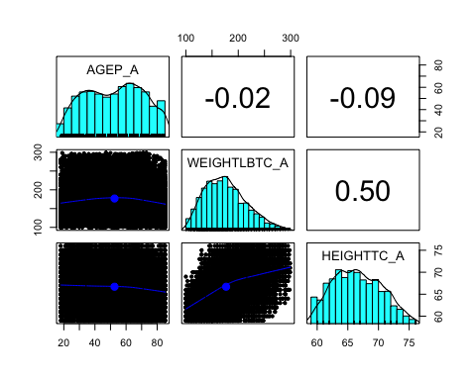 The matrix confirmed a positive association between height and weight, while showing little to no strong relationship between age and the other variables.

Discussion
The findings show that height is associated with weight; however, it is not strongly associated with age. The relationship between general health status and life satisfaction highlights the importance of overall health in an individual’s well-being. Individuals who reported better health also tended to report higher life satisfaction, suggesting a strong connection between physical health and quality of life. In public health, health is influenced by many factors such as access to care, economic stability, and environment, which may also contribute to these patterns. Although the analysis shows correlation, the dataset included some missing values, which may have affected the results. Additionally, because the data is observational, causation cannot be determined. Overall, the results are consistent with general expectations, particularly the positive relationship between height and weight, and provide useful insight into how demographic and health variables are related. ## Conclusion The analysis of the 2021 National Health Interview Survey showed key relationships among demographic and health variables, particularly between height and weight as well as between health status and life satisfaction. These findings highlight the importance of data analysis in understanding population health. Additionally, this report demonstrates how functions in R can be used to perform univariate, bivariate, and multivariate analyses. These approaches allow for clearer interpretation of data and provide useful insights for public health research.

