**Installations Required:**

Node-Red

Node-Red Dashboard

**Functions supported:**

mov, add, sub, mul, div, ld, str, nop

forwarding (for data hazards and dependencies)

Not Supported:

branching, stall

There are 3 registers (1,2,3) and 3 memory addresses (0,1,2) in this version.

**Instruction Set (Please follow format exactly for decode to work properly):**

mov dest,value ex: mov 1,2 puts value 2 in register 1

add dest,r1,r2 ex: add 3,1,2 adds contents of reg1 and reg2 and stores in reg3

sub dest,r1,r2 ex: sub 3,1,2 subtracts contents of reg2 from reg1 and stores in reg3

mul multiply - same format

div divide - same format

ld reg,addr ex: ld 1,0 loads value from address 0 into reg1

str addr,reg ex: str 0,2 stores value in reg2 at address 0

**Writing a program:**

Write instructions line by line in a txt file similar to this:

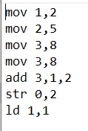

Linking program to flow:

To run the program on the simulator, first edit the “ProgramMemIn” node on the far left side of the flow as shown:

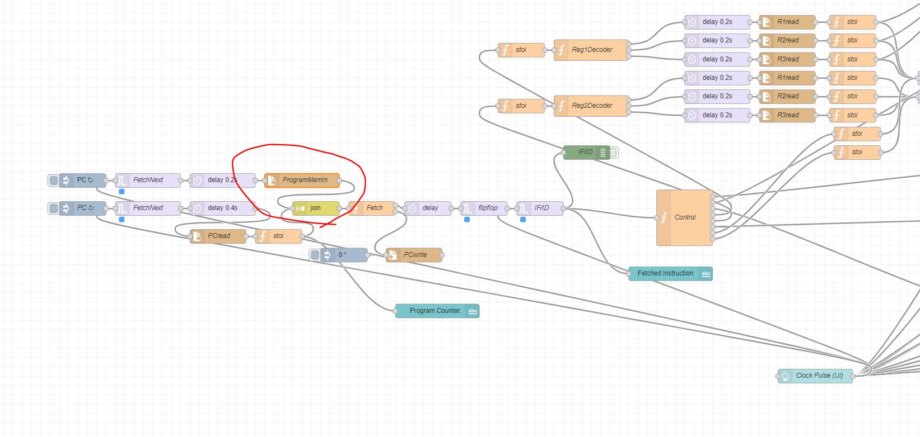

Next, add the path of the program .txt file as shown below (please use absolute path):

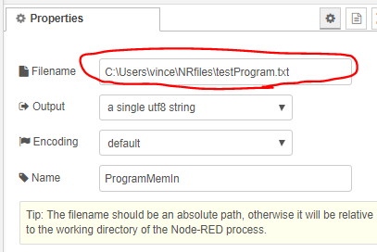

**Running the program:**

To run the simulator on the provided program, launch the dashboard as shown:

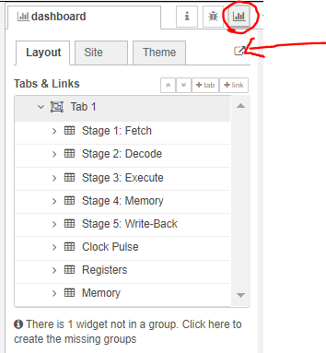

Then, press the clock pulse button to send a clock pulse to the CPU. Please allow enough time for all the values to update due to propagation delay before sending another pulse. Also, the first time the pulse is sent it will appear to do nothing since it should already be displaying the values from the first instruction in the pipeline.

