Report # 6+7

# Summary of BOLOS.

In general, both Bolsig+ and Bolos based on the method in paper of *Hagelaar et Pitchford* [1]. I read this paper, and compared with source-code of Bolos library. I point out some difference of operating condition between Bolsig+ and Bolos, as well as show which term was used in work of *HongTao Zheng* [2] and *Robby Aerts* [3] in Table 1.

|  |  |  |  |
| --- | --- | --- | --- |
|  | Bolsig+ | Bolos | Hongtao Zheng and Robby Aerts |
| Gas-phase Composition | Yes | Yes | Yes |
| Electron – Neutrals and Radicals collision | Yes | Yes | Yes |
| Electron – electron collision (need Ionization degree) | Yes | No | Is not stated |
| Electron – Ion collision (need Ionization degree) | Yes | No | Is not stated |
| Super-elastic (need Excited state temperature) | Yes | No | Is not stated |
| AC field (need Frequency) | Yes | Only DC | AC field |

Table 1 Term is taken into account in Bolsig+ and Bolos, which one was used in work of Hongtao Zheng and Robby Aerts

After simplifying the Boltzmann equation with some assumption, Bolsig+ solve the equation of electron energy distribution function $F_{0} (Eq.1)$, which take into account all collision term (*Equation 39* in reference [1])

|  |  |  |
| --- | --- | --- |
|  | $$\frac{∂}{∂ε}\left(\tilde{W}F_{0}-\tilde{D}\frac{∂F_{0}}{∂ε}\right)=\tilde{S}$$ | $$(Eq.1)$$ |

Where

|  |  |  |
| --- | --- | --- |
|  | $$\tilde{W}=-γε^{2}σ_{ε}-3a\frac{n}{N}A_{1}$$ | $$(Eq.2)$$ |
|  | $$\tilde{D}=\frac{γ}{3}{\left(\frac{E}{N}\right)}^{2}\frac{ε}{{\tilde{σ}}_{m}}+\frac{γk_{B}T}{e}ε^{2}σ_{ε}+2a\frac{n}{N}\left(A_{2}+ε^{3/2}A_{3}\right)$$ | $$(Eq.3)$$ |

The terms contain $A_{1}, A_{2}, A_{3}$ are terms regarding to electron-electron collision (*section 2.4* in reference [1]).

Bolos solve the same equation of electron energy distribution function $(Eq.1)$, but it doesn’t take account the e-e collision. I checked it in *solve.py* of Bolos.

|  |  |  |
| --- | --- | --- |
|  | $$\tilde{W}=-γε^{2}σ_{ε}$$ | $$(Eq.4)$$ |
|  | $$\tilde{D}=\frac{γ}{3}{\left(\frac{E}{N}\right)}^{2}\frac{ε}{{\tilde{σ}}_{m}}+\frac{γk_{B}T}{e}ε^{2}σ_{ε}$$ | $$(Eq.5)$$ |

*NOTE: To use Bolos for our simulation, we need to add the feature AC field into Bolos.

# Add AC field to Bolos

From the *equation 25* of ref. [1], I tried to add the feature of AC field into account of Bolos. I created a new *solve2.py* base on solve.py of Bolos, and the results of EEDF (electron energy distribution function) is reasonably compared with Bolsig+.

I tested this code with operating parameters in table 2, and results in table 3

|  |  |
| --- | --- |
| Parameters | Value |
| Gas Temperature (K) | 400 K |
| Gas Composition | CH4:0,5 – Ar:0.5 |
| Electric field / N (Td) | 100 Td $→$ 900 Td |
| Angular Frequency (m3.rad/s) | 0.10000E-11 |

Table 2 Operating Parameters

|  |  |  |  |
| --- | --- | --- | --- |
| Electric field / N (Td) | Mean Electron Energy (eV) | | Error |
| Bolsig+ | Our test |
| 100 | 0.0948 | 0.0945 | 0.32% |
| 200 | 0.114 | 0.1146 | 0.53% |
| 300 | 0.170 | 0.1457 | 14.29% |
| 400 | 0.472 | 0.4926 | 4.36% |
| 500 | 1.21 | 1.0041 | 17.02% |
| 600 | 2.10 | 2.0705 | 1.40% |
| 700 | 2.88 | 2.8720 | 0.28% |
| 800 | 3.49 | 3.4931 | 0.09% |
| 900 | 4.01 | 4.0079 | 0.05% |
| 1000 | 4.46 | 4.4587 | 0.03% |
| 1100 | 4.87 | 4.8711 | 0.02% |
| 1200 | 5.26 | 5.2586 | 0.03% |
| 1300 | 5.63 | 5.6300 | 0.00% |
| 1400 | 5.99 | 5.9904 | 0.01% |
| 1500 | 6.34 | 6.3435 | 0.06% |
| 1600 | 6.69 | 6.6914 | 0.02% |
| 1700 | 7.03 | 7.0357 | 0.08% |
| 1800 | 7.37 | 7.3778 | 0.11% |
| 1900 | 7.71 | 7.7186 | 0.11% |
| 2000 | 8.05 | 8.0587 | 0.11% |

Table 3 The comparison between Bolsig+ and our code

The plots of EEDF are below:

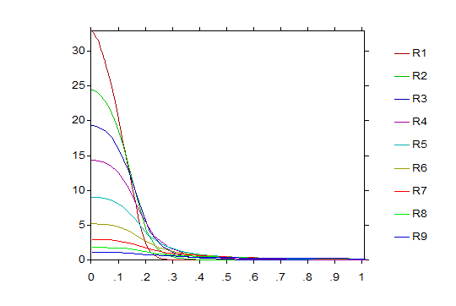

Figure 1 EEDF of Bolsig+ from 100Td to 900 Td

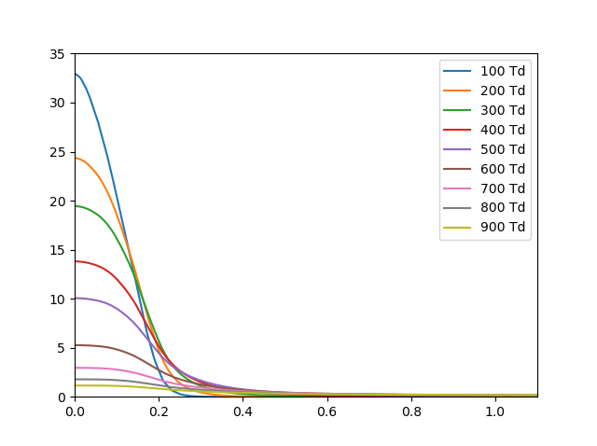

Figure 2 EEDF of our code from 100Td to 900 Td.

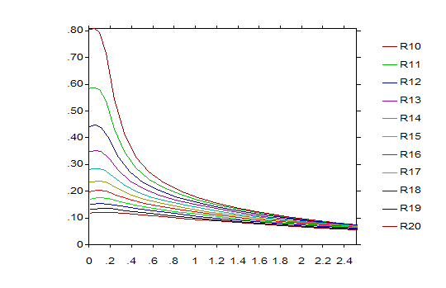

Figure 3 EEDF of Bolsig+ from 1000Td to 2000 Td

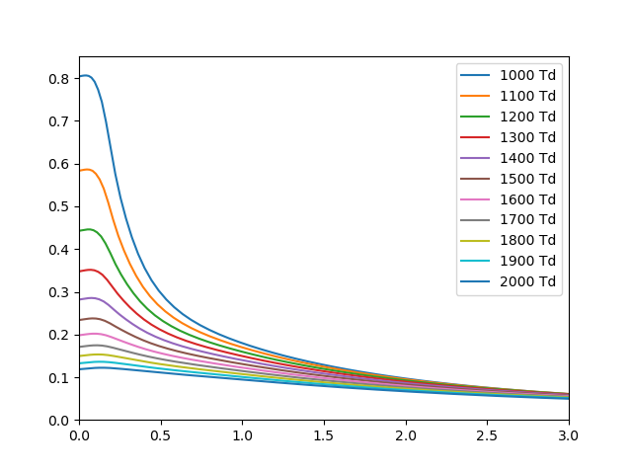

Figure 4 EEDF of our code from 1000Td to 2000 Td

*Conclude: In general, our code could take the AC field into account, and there is big error of mean electron energy in range of Electric field / N from 300 Td – 500 Td.

However, we can use it to calculate the rate coefficients, the result only has error in the range of low mean energy in some case. I point out some case in the figure below.

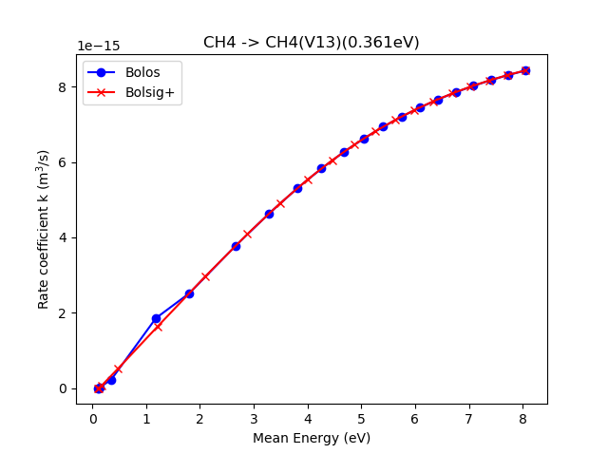

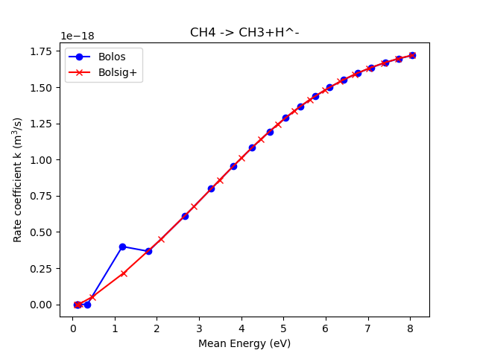

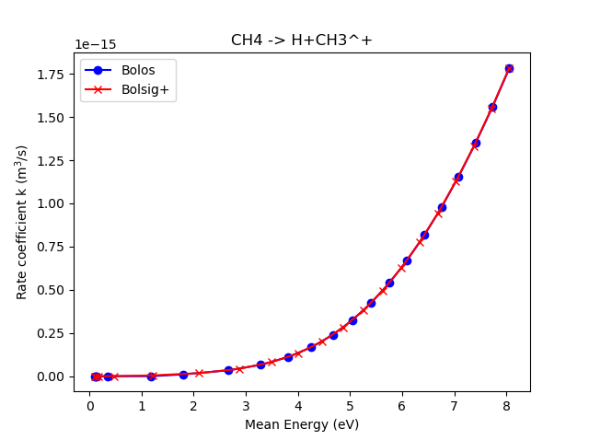

# Fit curve code

After we have the data of rate coefficients, we need to convert it into a common form and easy to use in Cantera. Therefore, I wrote a script to get Arrhenius form of rate coefficients, using *scipy.optimizer.fit_curve()* which based on the method of least squares of error.

$$χ^{2}=\sum{{\left(y_{data}-y_{fit}\right)}^{2}}→min$$

First time, I used directly Arrhenius equation (Eq. 6), however, in some case, iterative solver of *scipy.optimizer.fit_curve()* reach maximum iteration and doesn’t get the convergence value. Because the initial value (guess value) is not good.

|  |  |  |
| --- | --- | --- |
|  | $$k=AT^{β}\exp\left(-\frac{E_{a}}{RT}\right)$$ Or $$k=AT^{β}\exp\left(-\frac{T_{a}}{T}\right)$$ | $$(Eq.6)$$ |

Second time, I convert the Arrhenius equation into logarithm form (Eq. 7), the solver converge rapidly, but the result is not good (Fig. 5).

|  |  |  |
| --- | --- | --- |
|  | $$\ln{k}=\ln{A}+β\ln{T}-\frac{E_{a}}{RT}$$ | $$(Eq.7)$$ |

Finally, I use hybrid-method. Firstly, I used the log logarithm form to get rapidly the reasonable guess value, then I used original Arrhenius equation to fit. The final result is very good !

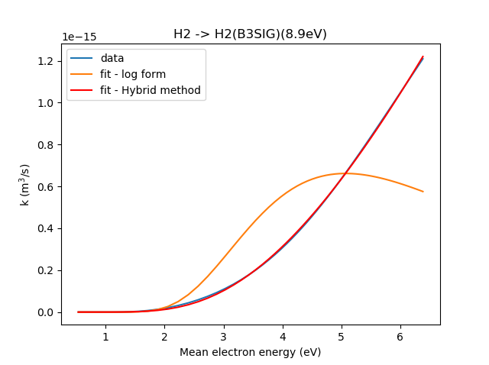

Figure 5 Fitting curve

# Governing Equation in 0-D plasma model

We consider a 0D reactor in a volume $V$, without surface-reaction.

* Global Mass balance Equation:

$$\frac{d}{dt}\left(ρ\right)+∇\left(ρv\right)=0$$

Integrate in all volume V, we have

$$\frac{d}{dt}\left(ρV\right)={\dot{m}}^{*}-\dot{m}=0$$

Where: ${\dot{m}}^{*}$ is mass flow at inlet, $\dot{m}$ is mass flow at outlet.

* Species Conservation Equation:

$$\frac{d}{dt}\left(ρY_{k}\right)+∇\left(ρvY_{k}\right)={\dot{ω}}_{k}W_{k}$$

Integrate in all volume V, we have

$$\left(ρV\right)\frac{dY_{k}}{d_{t}}={\dot{m}}^{*}\left(Y_{k}^{*}-Y_{k}\right)+{\dot{ω}}_{k}VW_{k} (Eq.8)$$

Where: ${\dot{ω}}_{k}$ is molar reaction rate of species k, $W_{k}$ is atomic weight of species k, $Y_{k}^{*}$ is mass fraction at inlet of species k, $Y_{k}$ is mass fraction at outlet of species k.

* State Equation
$$p=\sum_{k=1}^{K}{\frac{ρY_{k}RT}{W_{k}}}$$

* Electron Energy Equation:

The transient form of the electron energy balance equates the time-rate-of-change of the electron swarm’s internal energy $u_{e}$, to the net flow of electron enthalpy $h_{e}$ into and out of the reactor, accounting for net chemical production rates, collisions losses $Q_{loss}^{elas},Q_{loss}^{inel}$, and power deposition $Q_{source}$ from externally applied electromagnetic fields [4].

$$\frac{d}{dt}\left(ρ_{e}Vu_{e}\right)=\left({{\dot{m}}_{e}^{*}h_{e}^{*}-\dot{m}}_{e}h_{e}\right)+{\dot{ω}}_{e}W_{e}{\tilde{h}}_{e}V+Q_{source}-Q_{loss}^{elas}-Q_{loss}^{inel} (Eq.9)$$

Where:

* Electron density: $ρ_{e}=ρY_{e}$ and Mass Flow rate of electron ${\dot{m}}_{e}=\dot{m}Y_{e}$
* ${\tilde{h}}_{e}=\frac{5}{2}\frac{R}{W_{e}}T$, Refers to the electron enthalpy of newly created electrons in the gas-phase, when electrons are formed from the ionization of a relatively cold neutral, the electron is assumed to originate close to the neutral temperature.
* ${\dot{ω}}_{e}$ Molar reaction rate of creating electron from ionization reactions.
* Internal Energy $u_{e}=h_{e}-\frac{p}{ρ}=\frac{5}{2}\frac{R}{W_{e}}T_{e}-\frac{R T_{e}}{W_{e}}=\frac{3}{2}\frac{R}{W_{e}}T_{e}$
* Heat capacity $c_{v,e}=\frac{3}{2}\frac{R}{W_{e}};c_{p,e}=\frac{5}{2}\frac{R}{W_{e}}$

Ep.9 is rewritten:

$$\left(ρV\right)\frac{d}{dt}\left(Y_{e}c_{v,e}T_{e}\right)=\left({\dot{m}}^{*}Y_{e}^{*}c_{p,e}T_{e}^{*}-\dot{m}Y_{e}c_{p,e}T_{e}\right)+{\dot{ω}}_{e}W_{e}Vc_{p,e}T+Q_{source}-Q_{loss}^{elas}-Q_{loss}^{inel}$$

$$\left(ρV\right)\left[Y_{e}c_{v,e}\frac{dT_{e}}{dt}+T_{e}c_{v,e}\frac{dY_{e}}{dt}\right]=\left({\dot{m}}^{*}Y_{e}^{*}\frac{5}{2}\frac{R}{W_{e}}T_{e}^{*}-\dot{m^{*}}Y_{e}\frac{5}{2}\frac{R}{W_{e}}T_{e}\right) \\ +{\dot{ω}}_{e}W_{e}Vc_{p,e}T+Q_{source}-Q_{loss}^{elas}-Q_{loss}^{inel} \left(Eq.10\right)$$

Take (Eq.10) subtract (Eq.8) multiplied by $c_{p,e}T_{e}$ for electron, we have a equation same as Equation (4) of Hongtao’s paper. However, *Hongtao et al.* didn’t take the energy required to thermalize new electrons into account.

$$\left(ρV\right)\left[Y_{e}c_{v,e}\frac{dT_{e}}{dt}-{\frac{R}{W_{e}}T}_{e}\frac{dY_{e}}{dt}\right]=\dot{m^{*}}Y_{e}^{*}c_{p,e}\left(T_{e}^{*}-T_{e}\right)+{\dot{ω}}_{e}W_{e}Vc_{p,e}\left(T-T_{e}\right)+Q_{source}-Q_{loss}^{elas}-Q_{loss}^{inel}$$

Where:

$Q_{loss}^{elas}=\frac{3VRρ_{e}}{W_{e}}\left(T_{e}-T\right)\sum_{k=1;k≠e}^{K_{g}}{\frac{W_{e}}{W_{k}}ν_{ek}}$. With $ν_{ek}$ is the momentum-transfer collision frequency between the electrons and the kth heavy species. The plasma-reactor model calculates the momentum-transfer collision frequencies from momentum-transfer collision cross sections specified [4]. I think Bolsig+ and Bolos could calculate it

$Q_{loss}^{inel}=V\sum_{r=1}^{I_{ei}}{ΔH_{r}q_{r}}$, represents the summation of electron energy loss per electron-impact reactions. The total number of electron-impact (i.e., electron-temperature dependent) reactions $I_{ei}$, $q_{r}$ is the net rate of progress of the r-th reaction (this is rate coefficient calculated from Bolsig+ or Bolos for inelastic reactions), $ΔH_{r}$ is the net enthalpy change of the reaction, which can be determined from species’ thermochemistry.

# Conclusion

Up till now, we have had a program to solve Boltzmann equation, which can take AC electric field into account. However, It doesn’t take effects of e-e collisions (an option in Bolsig+). Moreover, I am not sure that the authors Hongtao Zheng and Robby took or not the e-e collisions into account in their work.

We could calculate the rate coefficients of electron – impact reactions and these result is reasonable compared with Bolsig+. We also could convert these rate coefficient into Arrhenius form.

*NEXT WORKS:

- I will continue find the way to determine the unknown parameters of Energy Equation e.g. , .

- I will focus on writing a program to solve Electron Energy Equation.

*I also would need your advice for my next works.

# References

|  |  |
| --- | --- |
| [1] | G. J. M. Hagelaar, L. C. Pitchford, "Solving the Boltzmann equation to obtain electron transport coefficients and rate coefficients for fluid models," *Plasma Sources Science and Technology,* no. 14, p. 722, 2005. |
| [2] | Liu, Hongtao Zheng and Quian, "Kinetic Study of Nonequilibrium Plasma-ssisted Methane Steam Reforming," *Mathematical Problems in Engineering,* 2014. |
| [3] | Robby Aerts, Tom Martens, and Annemie Bogaerts, "Influence of Vibrational States on CO2 Splitting by Dielectric Barrier Discharges," *Physical Chemistry,* no. 116, pp. 23257-23273, 2012. |
| [4] | ANSYS Chemkin Theory Manual 17.0 (15151), Reaction Design, San Diego, 2015, p. 168. |

Link:

Gantt chart: <https://docs.google.com/spreadsheets/d/1pgTm9QTVgA2n_2NetLwpwnbW8kADJNP6VqgRpcv_keI/edit?usp=sharing>