April 7, 2018

Test 1: Center to robot’s left

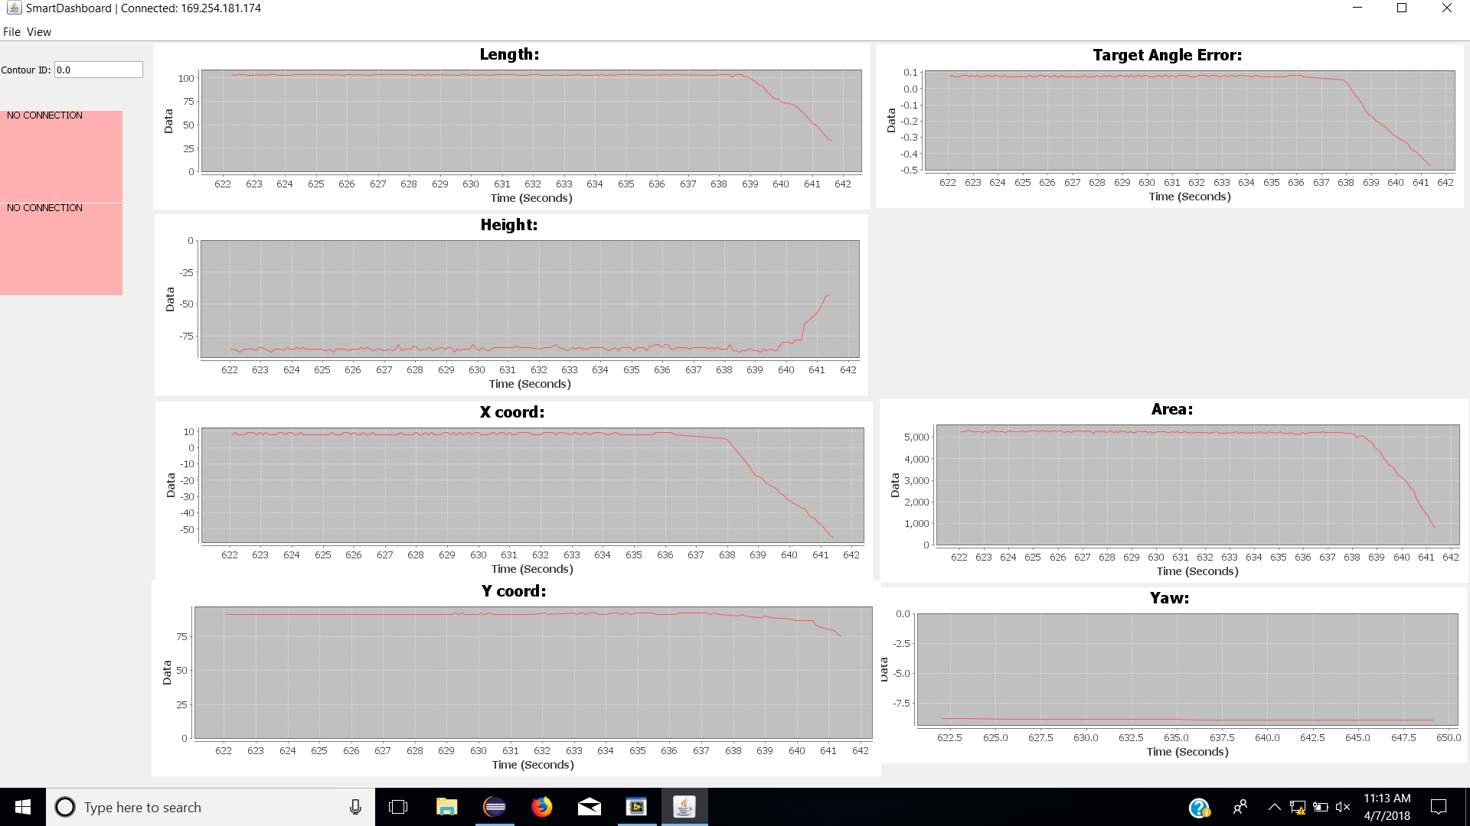

Test 2: Center to robot’s right

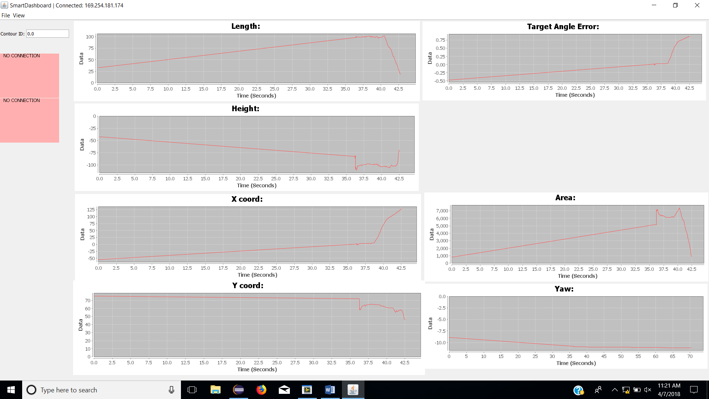

Test 3: Center to away from robot

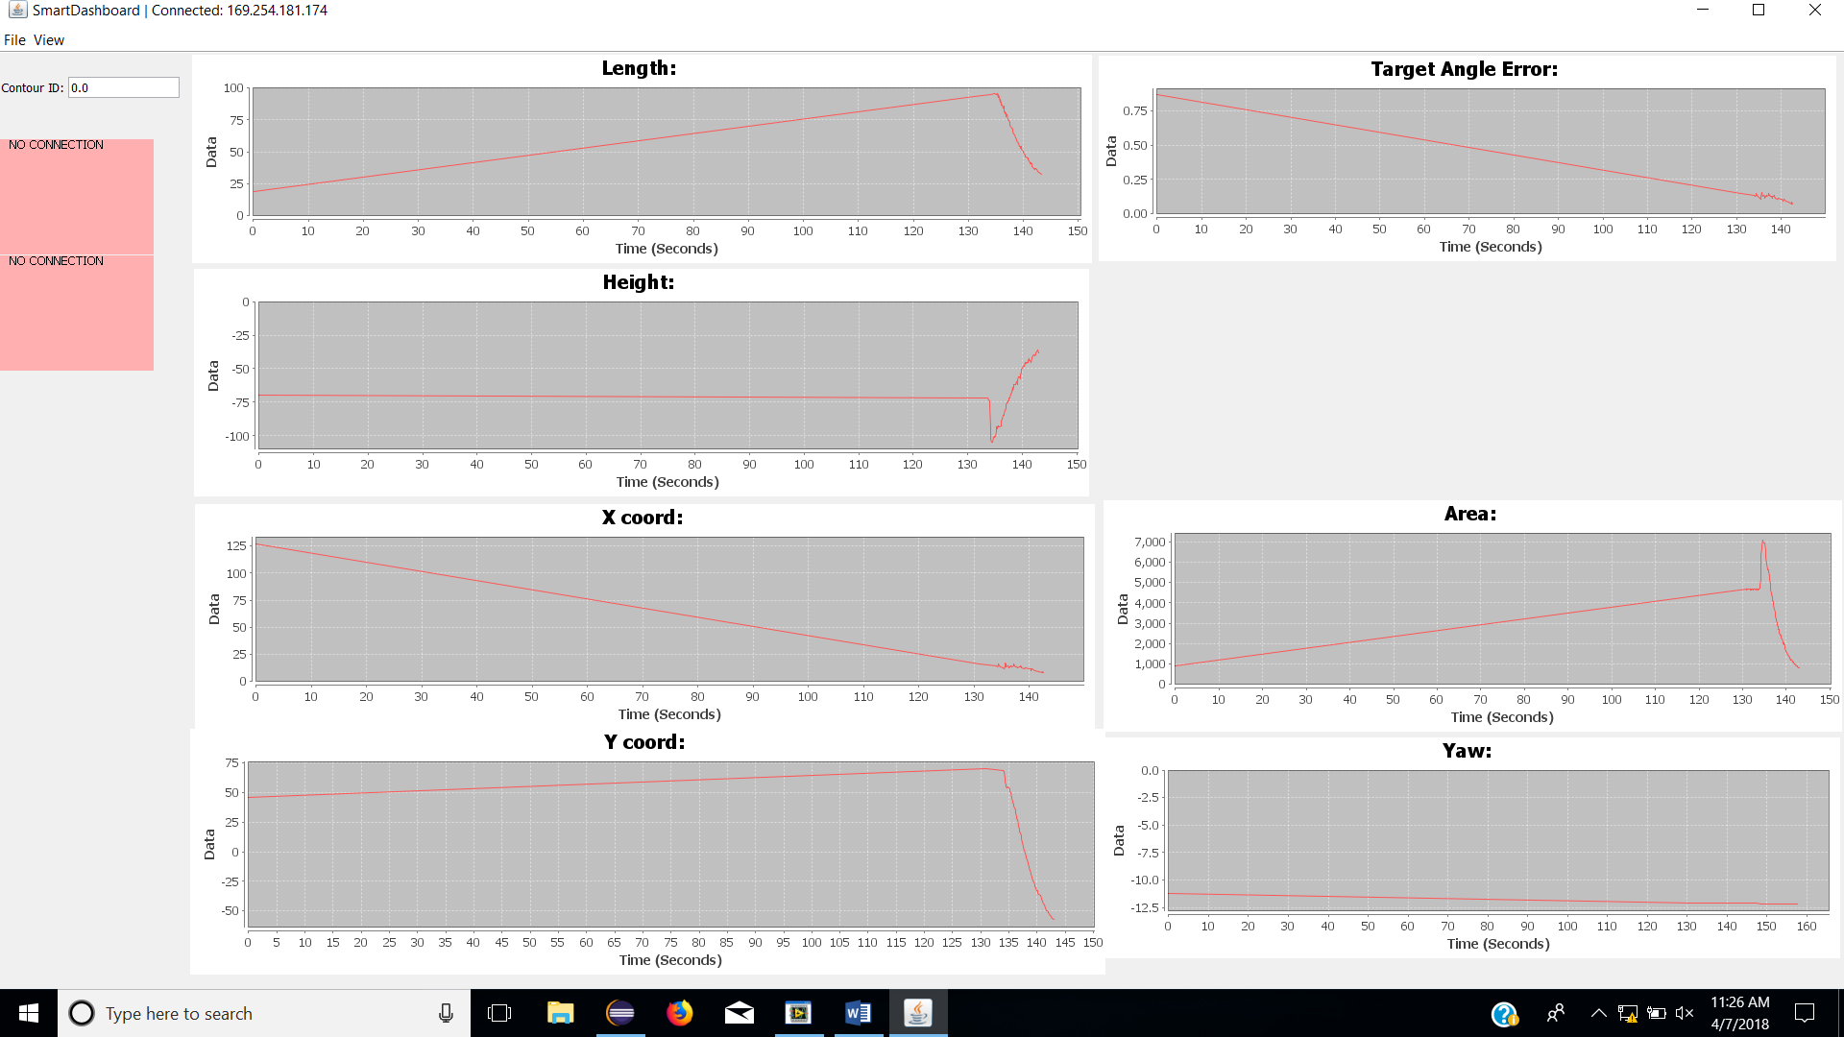

Test 4: Center to approach robot

