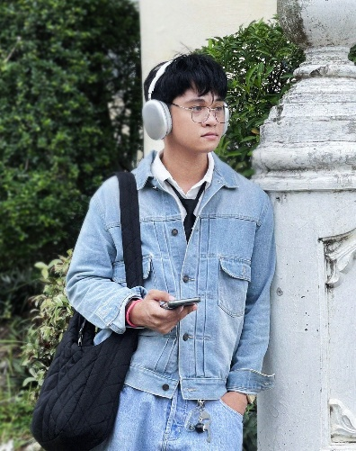





Education
Bachelor of Multimedia Arts - Cum Laude

Cagayan State University

Skills
• Creative
• Animation
• Communication
• Design
• Efficiency
• Editing
• Digital Art
• Adobe After Effects
• Video Editing
• Creative Direction
• Motion Design
• Teamwork
• Adobe Photoshop
• Collaboration

Achievements
Award/Achievements
Proficient in 3D Animation

Award/Achievements
Proficient in Video editing

Professional Overview
Creative and versatile Multimedia Arts Instructor and freelance Animator/3D Generalist with a strong foundation in digital arts, visual storytelling, and motion design. Over the years, I have cultivated a diverse skill set in 2D/3D animation, visual effects, and multimedia production, delivering high-impact content across various platforms. As an educator, I am passionate about guiding students through both the technical and conceptual aspects of multimedia arts, fostering innovation and practical excellence. As a freelance artist, I collaborate with clients to bring ideas to life through compelling animations and immersive 3D visuals, ensuring each project meets both creative and technical standards. Known for my attention to detail, adaptability, and commitment to continuous learning in the ever-evolving digital media landscape.

Work Experience

Motion Graphic Artist

Smarter Multimedia Services | 2023 – present
- With a diverse professional background, I bring proven expertise in project management, collaboration, and problem-solving.
- I stay updated with industry trends, reflecting my commitment to continuous improvement.
- Eager to leverage this experience in new opportunities, I am poised to contribute effectively and drive success in future endeavors.

College Professor

Cagayan State University | 2022 – 2025
Teaching Multimedia System, History of Graphic Design, Color Theory, 3D Modeling and Texturing, Fundamentals in Film and Video Production, Digital Sound Production, 3D Rendering and Lighting, Post Production and Techniques, 3D Rigging and Animation.

3D Generalist/Animator
Freelance 2022 – present
- Proficient in industry-standard software like Blender. My expertise spans character animation, visual effects, and realistic rendering.
- With a proven track record of meeting deadlines and surpassing client expectations, I offer a unique blend of artistic flair and technical precision.
- Mentored junior artists on best practices when creating 3D models or animations.

09217610424
vincentvparaggua@gmail.com
San Pablo, Isabela 3329
https://www.facebook.com/VinCreatesss/

Contact
VINCENT PARAGGUA
MULTIMEDIA ARTIST/3D GENERALIST/animator

