**Software Security via Program Analysis**

**Protect Against hack (HW3)**

Yu-Sheng Wang (bqk3dj)

**Pre-Work**

* Change the makefile: Add debug information (-g) and remove optimization

* Disable/Enable Randomize:

echo 0 | sudo tee /proc/sys/kernel/randomize_va_space

* Change *collision* to *s_collision & r_collision* in flappybird.cpp via macros.

**Pintool Program**

Search *s_collision* in *flappyBird.S*. The return value %eax is stored in -0xe4(%rbp).

Trace instructions at 1c5d & 1d03.

**Profile**

For the located instructions, we monitor the values via the following code snippets.

Through profiling, we can find the memory addresses of variable *collision* (0x7fffffffd85c) and *isOver* (0x7fffffffd824).

  
  
Now, we modify the memories of *isOver* and *collision* via Pintool. The bird won’t die when hitting the piles or the ground.

**Method 1**

At method 1, we keep changing the memory address of the critical variable via dynamically allocating memeories with random size.

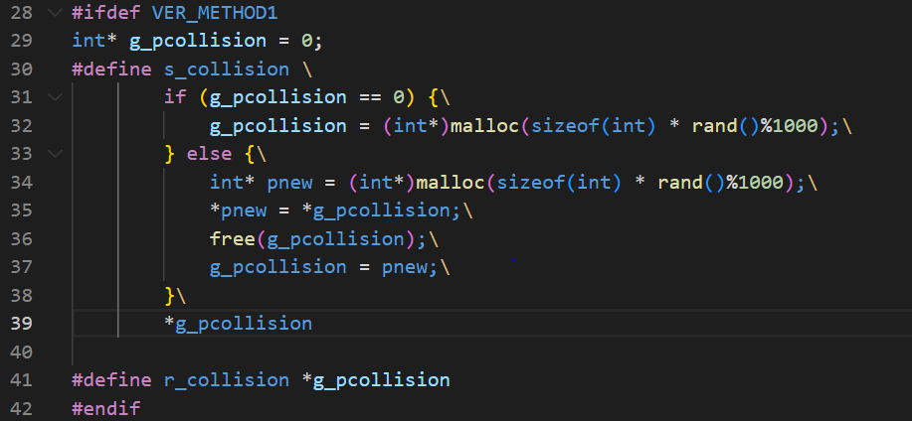

Look into the dump file and trace the instruction at 0x1d6e.



Profile the memory address via Pintool, we can see that the memory address changes every time it’s being called.

Even if we try to modify the value in memory address 0x555555584f20, the hacking fails and the bird dies when hitting the ground/piles. It’s because the critical variables keep changing their memory addresses via malloc and free.

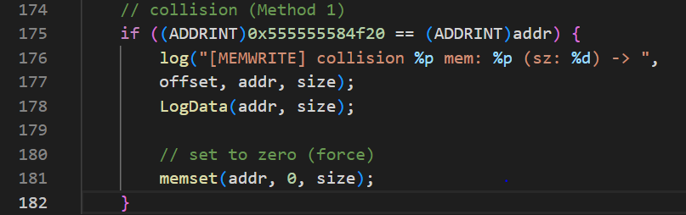

The Pintool locates the correct memory address but loses track after.



**Method 2**

In method 2, we record the critical value to another global variable when the value is called/modified. The program can detect the hacking behavior by checking whether the value is the same between the local and global ones.

Now, we profile again with Pintool and identify the instruction at 0x1ca9 where the value of *collision* is modified. In a real application, the modification of g_s_collision should happen somewhere else so that the hacker would not notice. The memory is located at 0x7fffffffd84c.

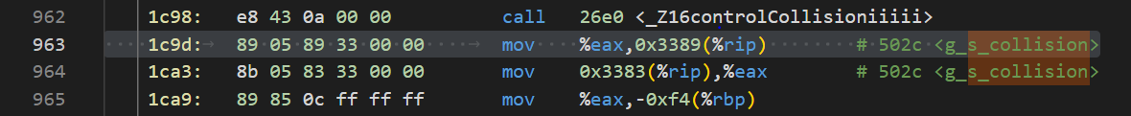



Now, we launch the attack via Pintool.

Run the game, and we can find out that the program exits and report corrupted when hitting the piles.

