## A. MODEL SUMMARY

### A1. Background on you/your team

* Competition Name: M5 Forecasting - Accuracy
* Team Name: monsaraida
* Private Leaderboard Score: 0.53583
* Private Leaderboard Place: 4th
* Name: Masanori Miyahara (Kaggle name: monsaraida)
* Location: Japan
* Email: monsaraida@gmail.com

### A2. Background on you/your team

* What is your academic/professional background?
  + I got my master’s degree in computer science
* Did you have any prior experience that helped you succeed in this competition?
  + After completing graduate school, I have worked as a software engineer in a Japanese company.
* What made you decide to enter this competition?
  + Kaggle is one of my hobbies. I like table competitions, so I decided to participate in this competition.
* How much time did you spend on the competition?
  + About 100 hours.

### A3. Summary

* General features (sales, calendar, price, id), nothing special
* 10 stores x 4 weeks = 40 LightGBM models
* Practical solution (no blending/recursive modeling/multiplier)
* Used Python
* 16.5 hours to train and predict
* 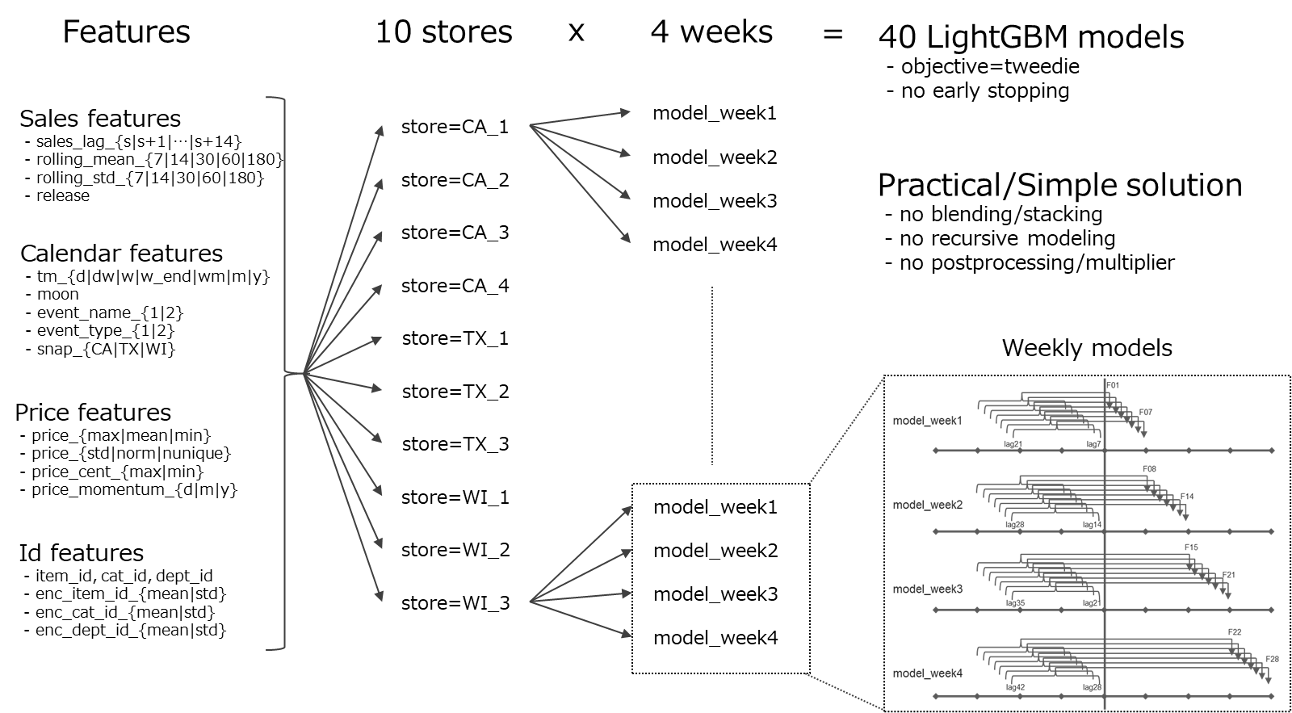

### A4. Features Selection / Engineering

* What were the most important features?

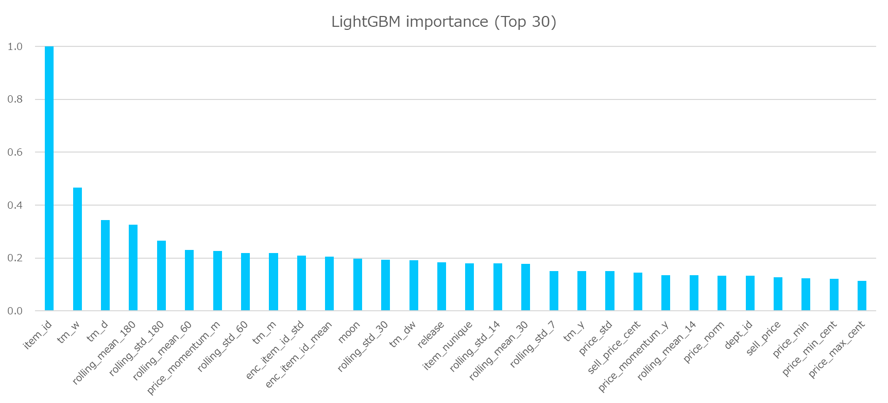

* How did you select features?
  + No feature selection
* Did you make any important feature transformations?
  + No
* Did you find any interesting interactions between features?
  + No
* Did you use external data? (if permitted)
  + No

### A5. Training Method(s)

* What training methods did you use?
  + LightGBM
  + No parameter tuning, just use the following parameters which is used in a public notebook
    - 'boosting_type': 'gbdt'
    - 'objective': 'tweedie'
    - 'tweedie_variance_power': 1.1
    - 'metric': 'rmse'
    - 'subsample': 0.5
    - 'subsample_freq': 1
    - 'learning_rate': 0.03
    - 'num_leaves': 2 ** 11 – 1
    - 'min_data_in_leaf': 2 ** 12 – 1
    - 'feature_fraction': 0.5
    - 'max_bin': 100
    - 'n_estimators': 1400
    - 'boost_from_average': False
* Did you ensemble the models?
  + No

### A6. Interesting findings

* What was the most important trick you used?
  + I kept my solution simply and practically
* What do you think set you apart from others in the competition?
  + I correctly recognized the difficulty of the problem (=validation scores varied significantly over the period, see below chart)

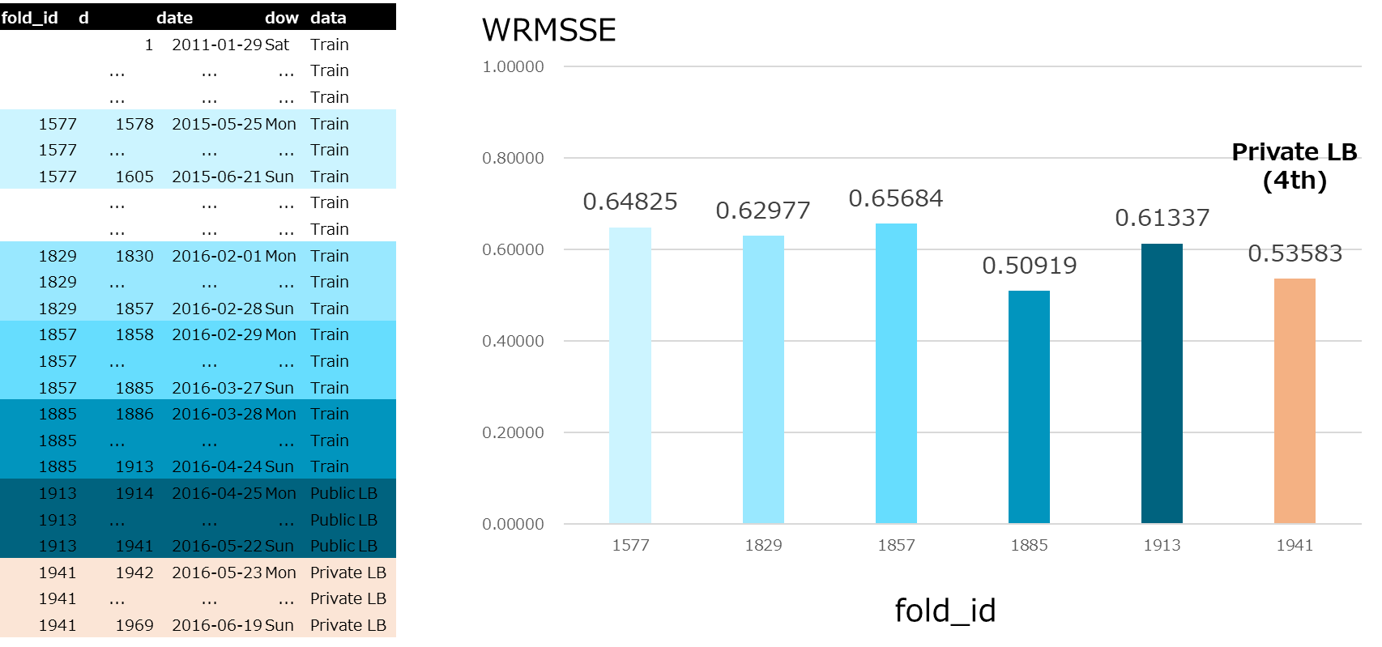

### A7. Simple Features and Methods

* My solution is simple enough
* If customers would like to reduce computational time, they can use 10 stores models instead of 10 stores x 4 weeks models

### A8. Model Execution Time

* How long does it take to train your model?
  + 16 hours
* How long does it take to generate predictions using your model?
  + 10 minutes

### A9. References

[Notebooks]

https://www.kaggle.com/kyakovlev/m5-simple-fe

https://www.kaggle.com/kyakovlev/m5-lags-features

https://www.kaggle.com/kyakovlev/m5-custom-features

https://www.kaggle.com/kyakovlev/m5-three-shades-of-dark-darker-magic

https://www.kaggle.com/dhananjay3/wrmsse-evaluator-with-extra-features

[Discussions]

Few thoughts about M5 competition

https://www.kaggle.com/c/m5-forecasting-accuracy/discussion/138881

Evaluation metric

https://www.kaggle.com/c/m5-forecasting-accuracy/discussion/133834

Three shades of Dark

https://www.kaggle.com/c/m5-forecasting-accuracy/discussion/144067

Moon Phase. Odd, yet helpful feature.

https://www.kaggle.com/c/m5-forecasting-accuracy/discussion/154776