*SORTING*

*Sorting a file……..a ps file or a member of a pds file.*

*We have to write in the command line ----------- sort column position no of bytes increase/decrease -----------------and the press enter*

*This means the 7 bytes name in the 1st column will get arranged in increasing or decreasing order.*

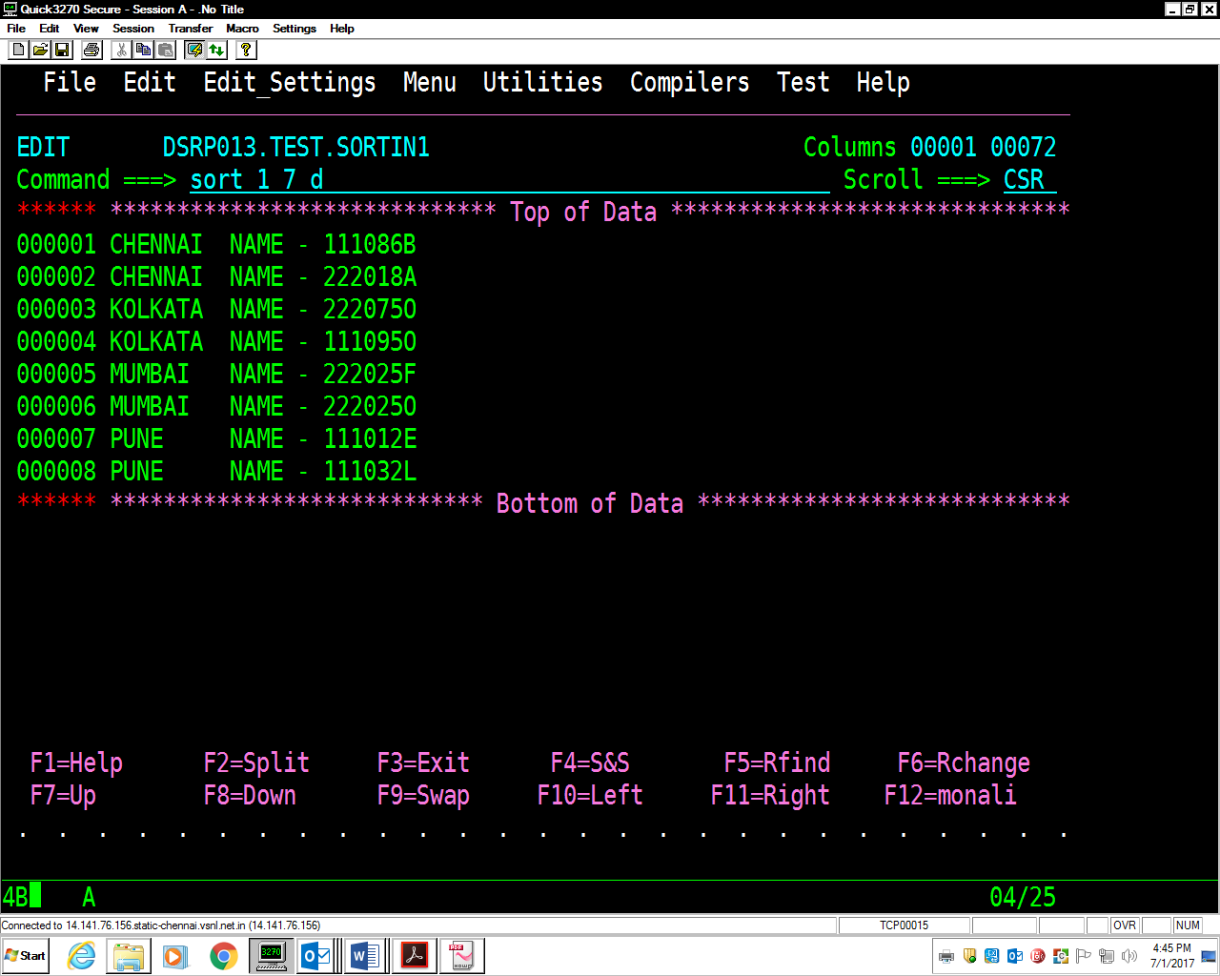

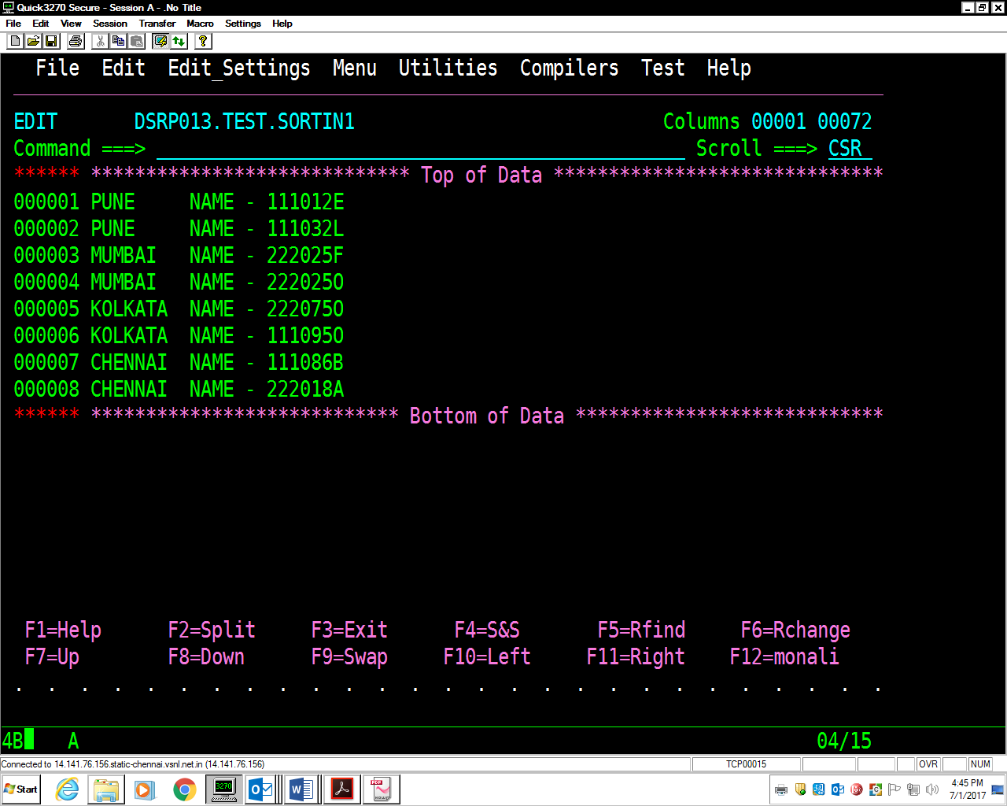

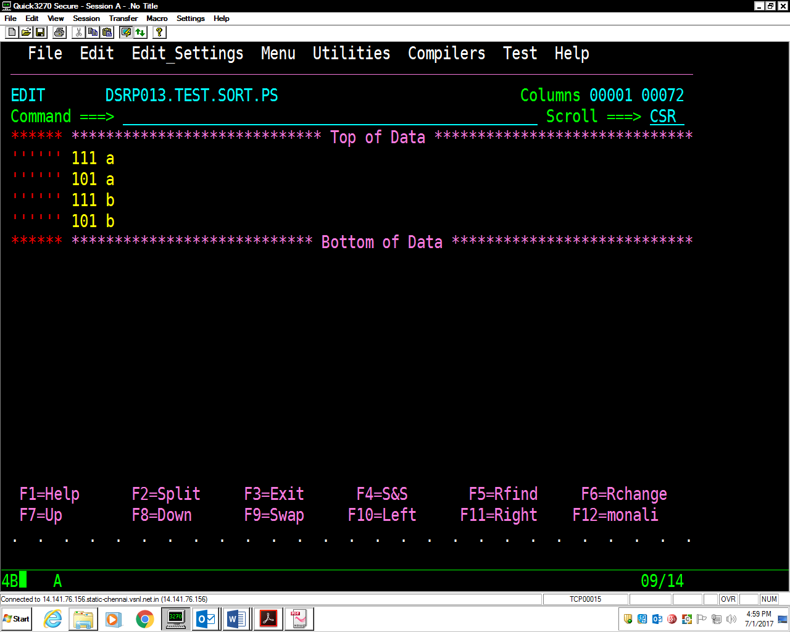

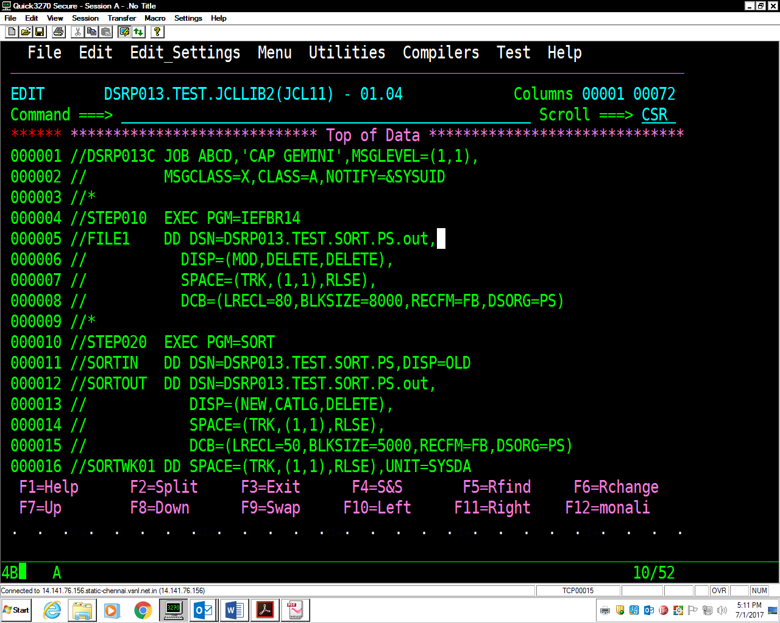

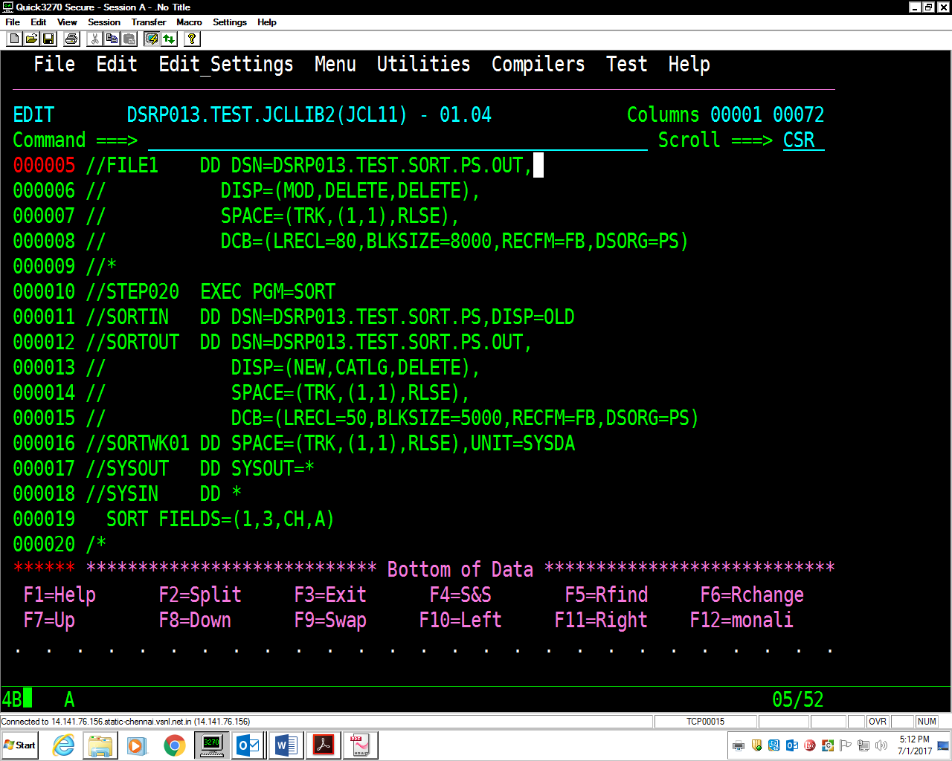

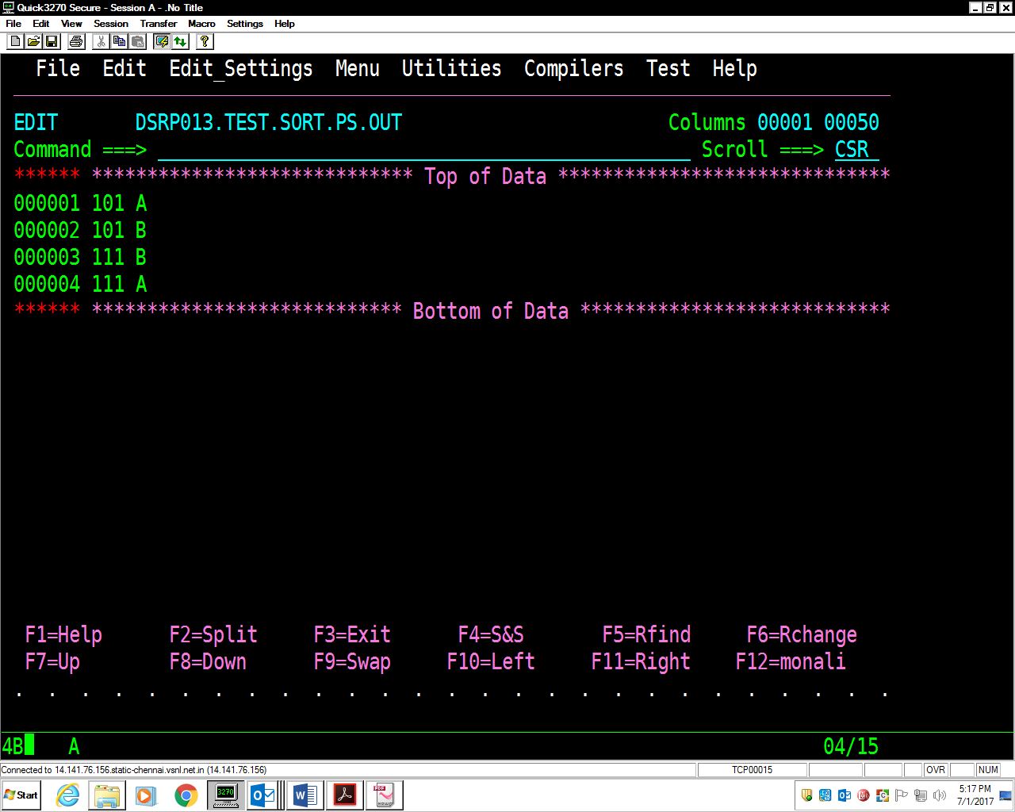

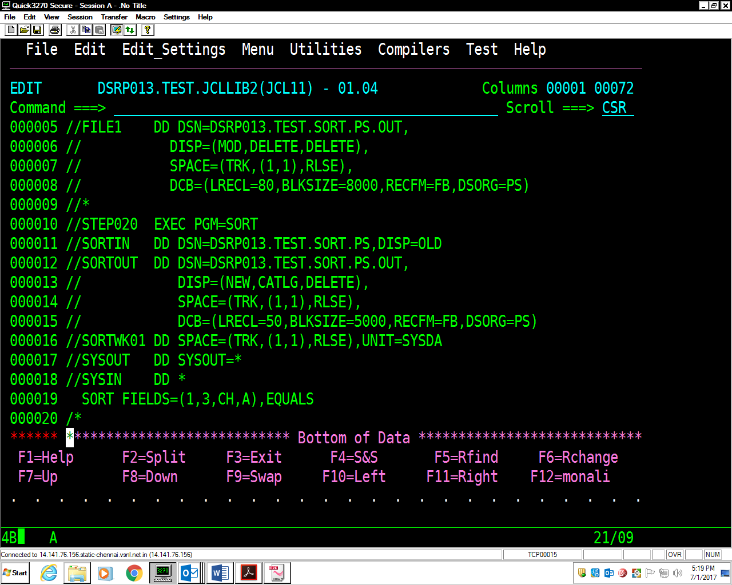

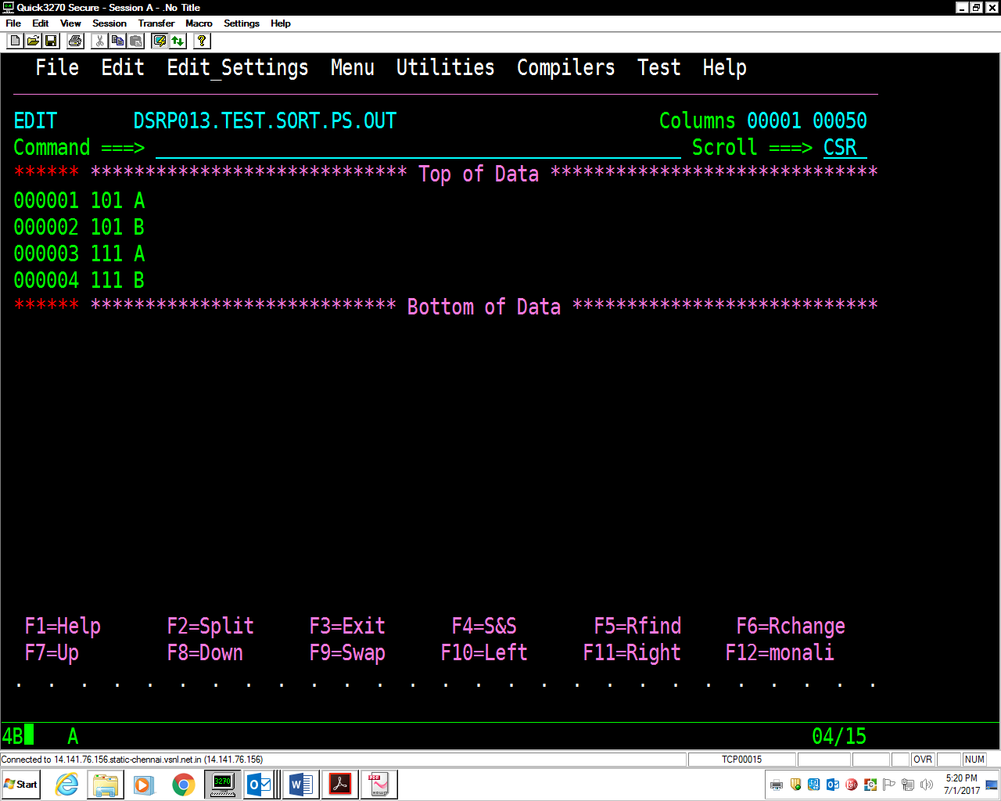

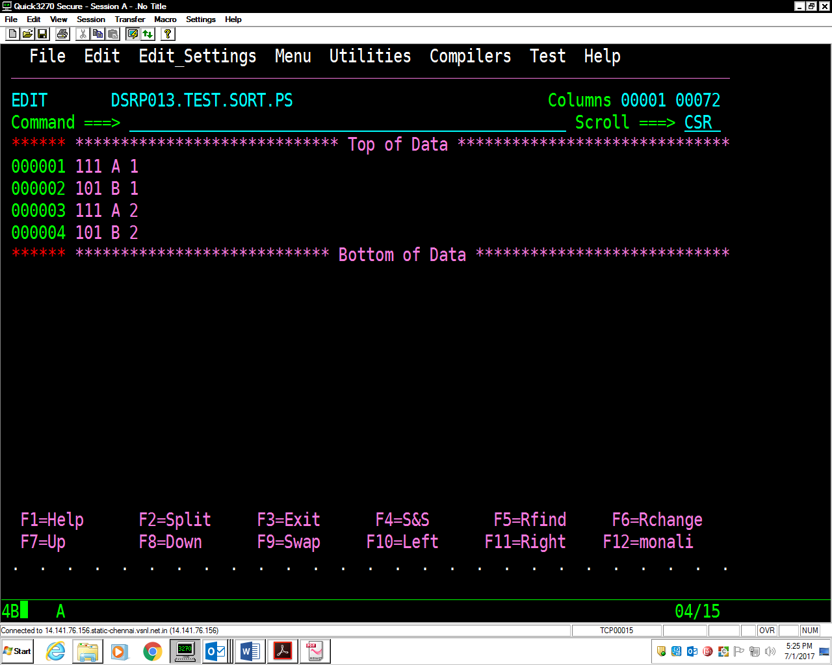

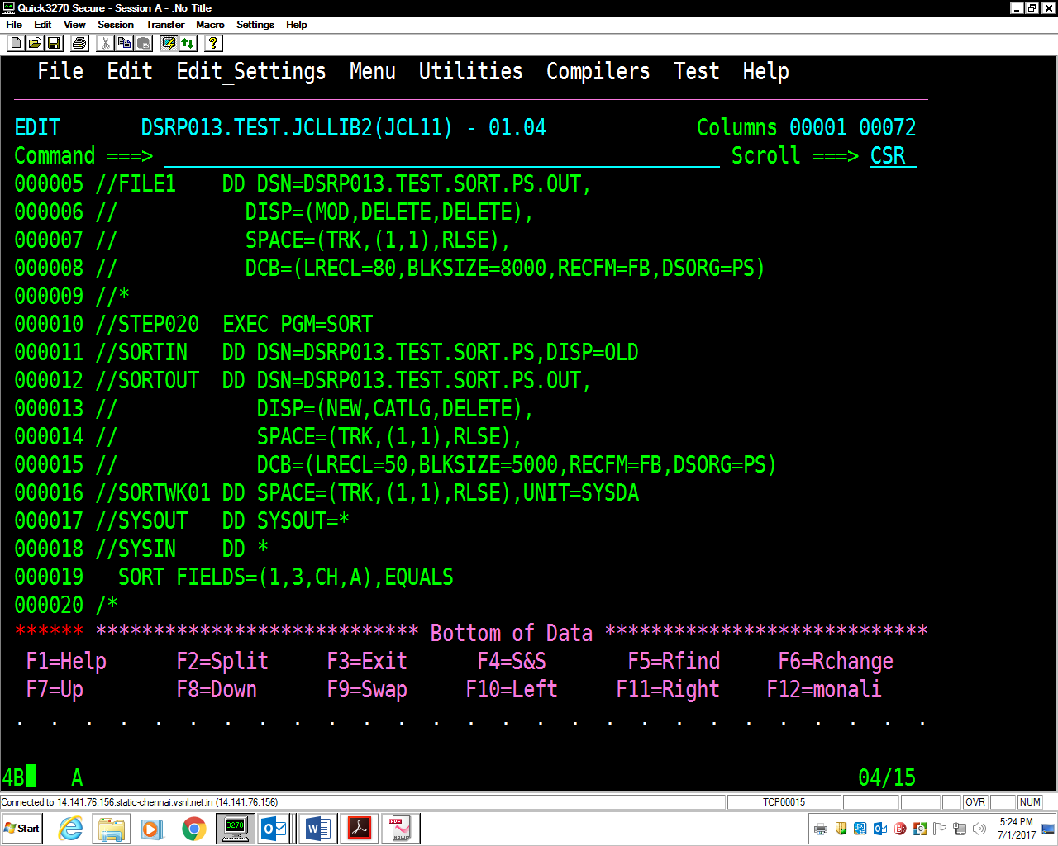

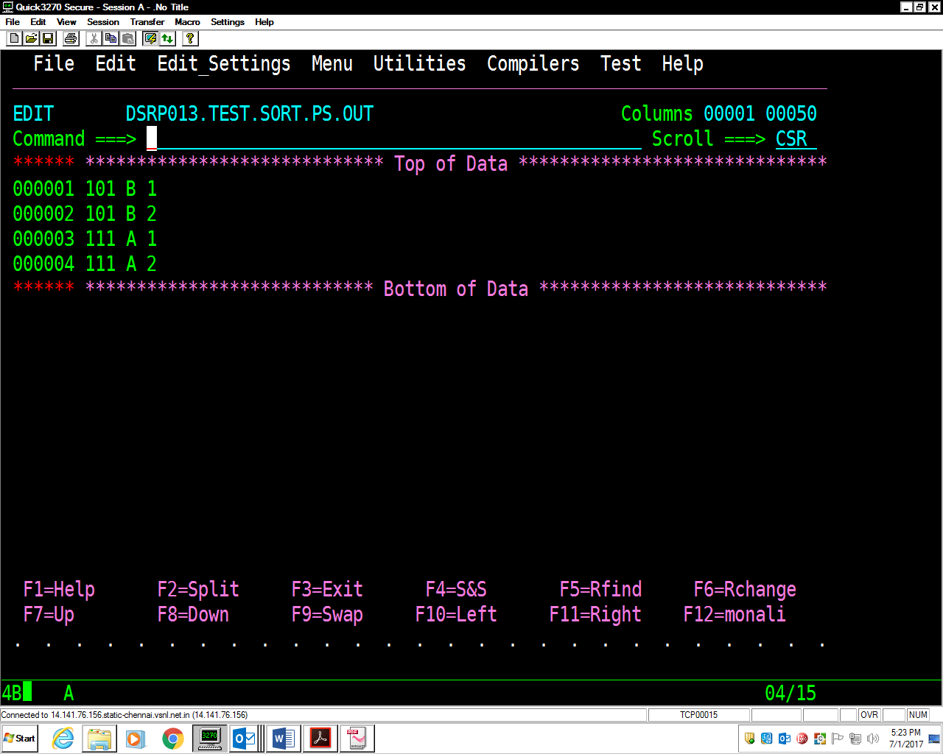

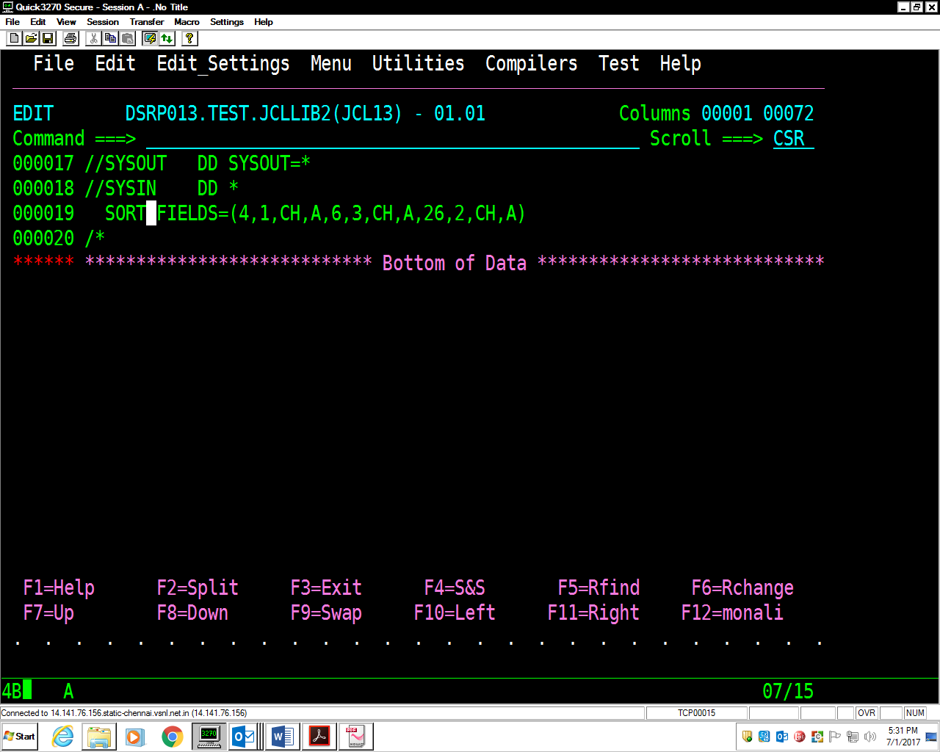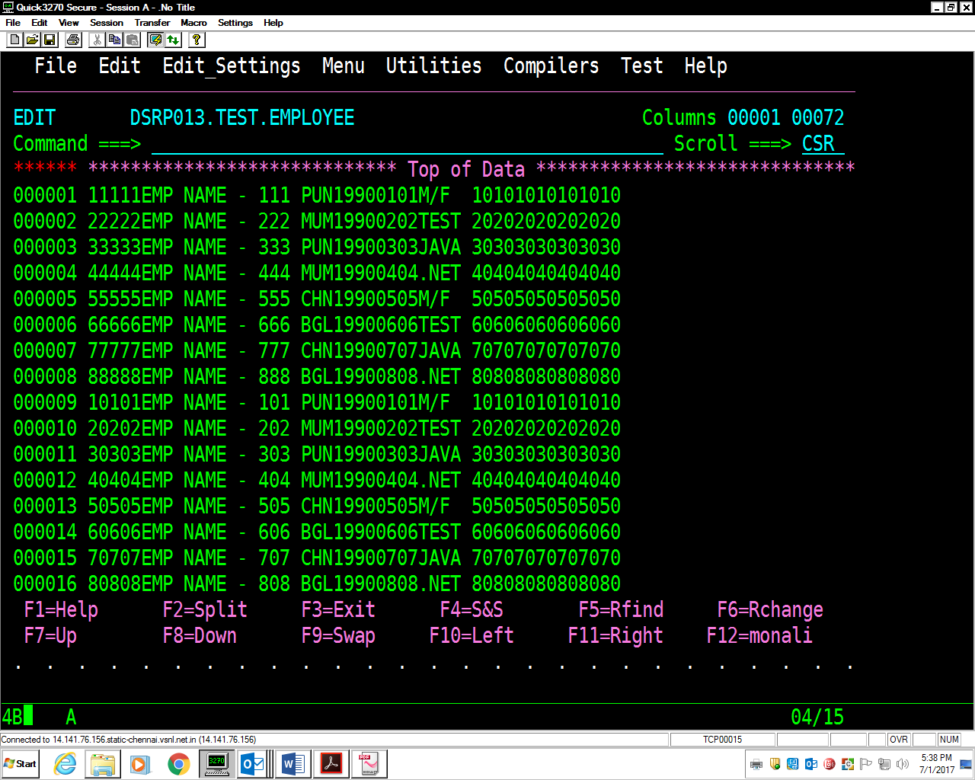

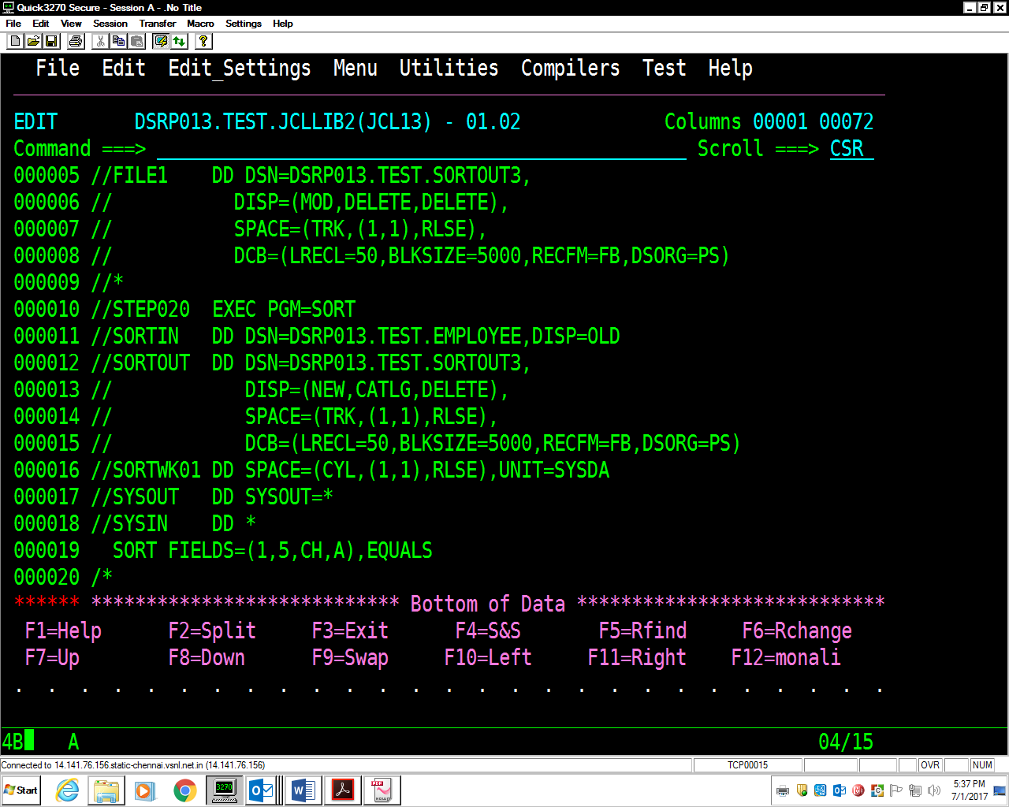

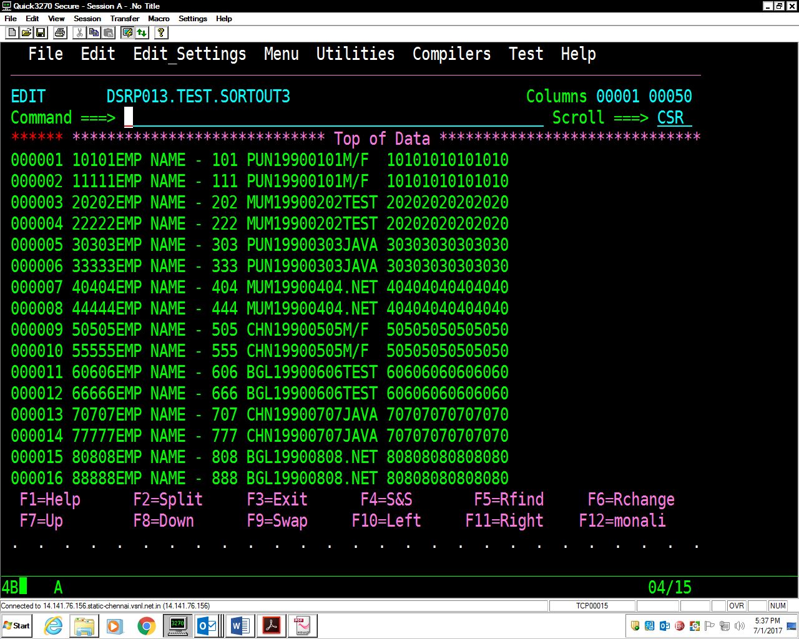

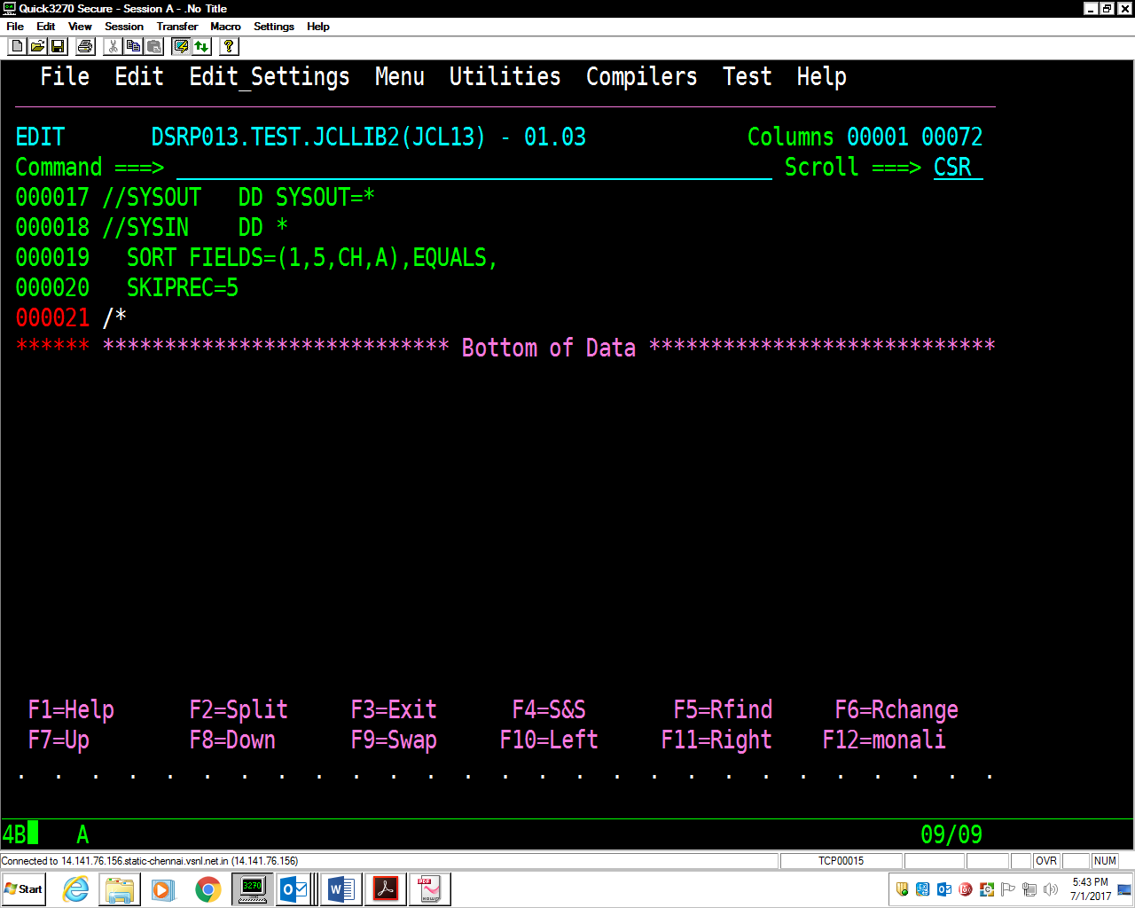

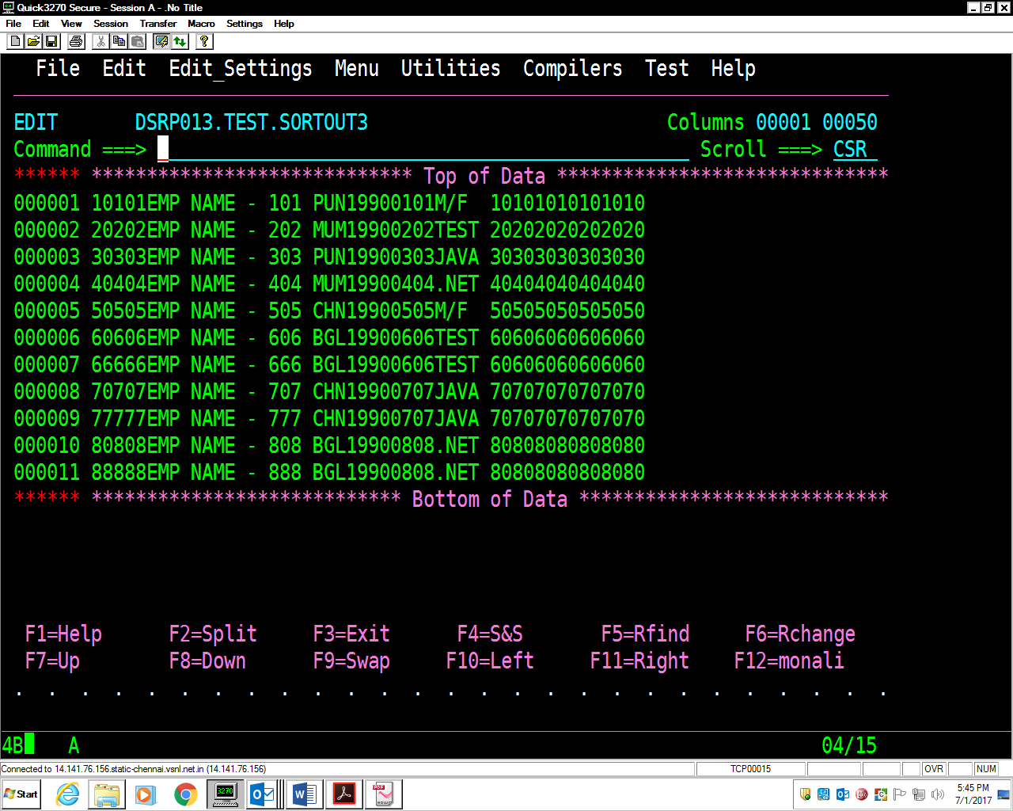

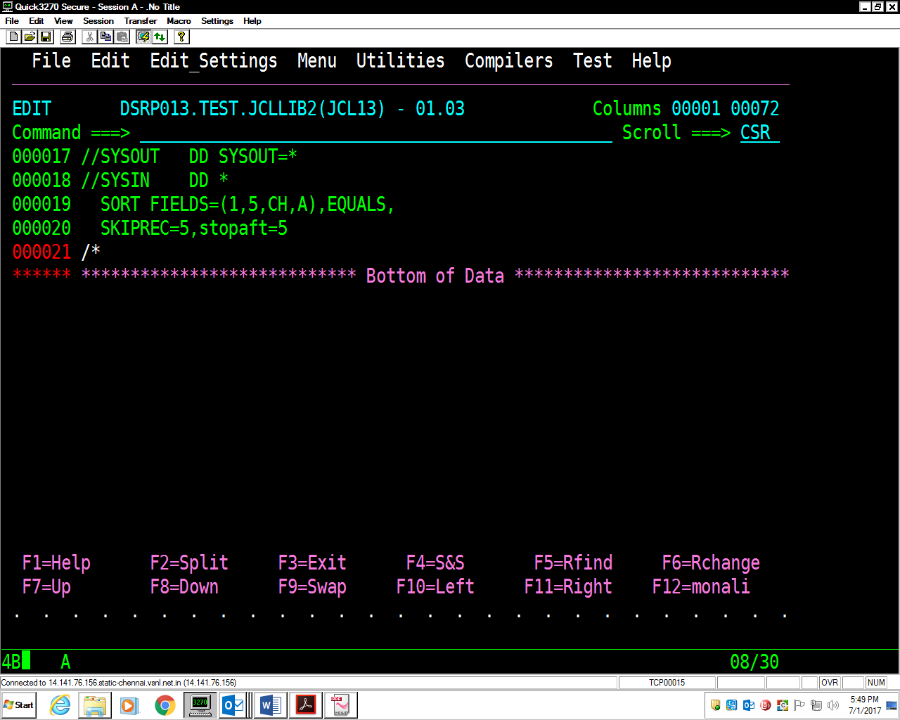

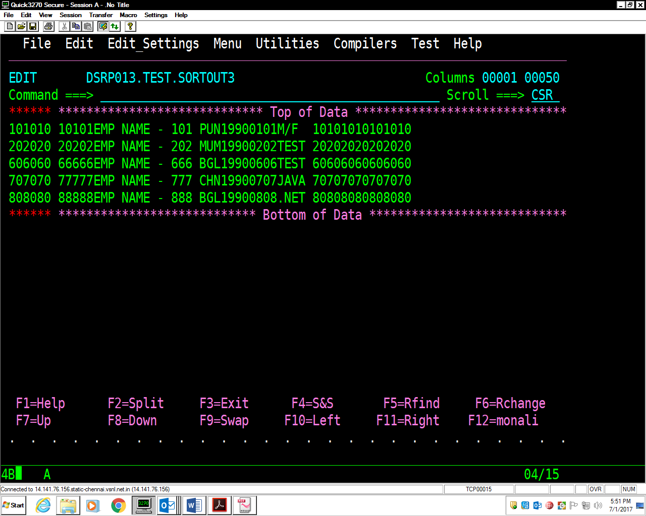

*000001 //DSRP013C JOB ABCD,'CAP GEMINI',MSGLEVEL=(1,1),*

*000002 // MSGCLASS=X,CLASS=A,NOTIFY=&SYSUID*

*000003 //\**

*000004 //STEP010 EXEC PGM=IEFBR14*

*000005 //FILE1 DD DSN=DSRP013.TEST.SORTOUT3,*

*000006 // DISP=(MOD,DELETE,DELETE),*

*000007 // SPACE=(TRK,(1,1),RLSE),*

*000008 // DCB=(LRECL=50,BLKSIZE=5000,RECFM=FB,DSORG=PS)*

*000009 //\**

*000010 //STEP020 EXEC PGM=SORT*

*000011 //SORTIN DD DSN=DSRP013.TEST.EMPLOYEE,DISP=OLD*

*000012 //SORTOUT DD DSN=DSRP013.TEST.SORTOUT3,*

*000013 // DISP=(NEW,CATLG,DELETE),*

*000014 // SPACE=(TRK,(1,1),RLSE),*

*000015 // DCB=(LRECL=50,BLKSIZE=5000,RECFM=FB,DSORG=PS)*

*000016 //SORTWK01 DD SPACE=(CYL,(1,1),RLSE),UNIT=SYSDA*

*000017 //SYSOUT DD SYSOUT=\**

*000018 //SYSIN DD \**

*000019 SORT FIELDS=(1,5,CH,A),EQUALS,*

*000020 SKIPREC=5,STOPAFT=5*

*000021 /\**

DSRP013.MONALI.JCL(JCLOUT) - 01.04

\*\*\*\*\*\*\*\*\*\*\*\*\*\*\*\*\*\*\*\*\*\*\*\*\*\*\*\*\* Top of Data \*\*\*\*\*\*\*\*\*\*\*\*\*\*\*\*\*\*

//DSRP013C JOB 1234,'MONALI',MSGLEVEL=(1,1),

// MSGCLASS=X,CLASS=A,NOTIFY=&SYSUID

//\*

//STEP010 EXEC PGM=IEFBR14

//FILE1 DD DSN=DSRP013.ITEM.FILE.REV1,

// DISP=(MOD,DELETE,DELETE),

// SPACE=(TRK,(1,1),RLSE),

// DCB=(LRECL=80,BLKSIZE=8000,RECFM=FB,DSORG=PS)

//\*

//STEP020 EXEC PGM=SORT

//SORTIN DD DSN=DSRP013.ITEM.FILE.SEQ,DISP=OLD

//SORTOUT DD DSN=DSRP013.ITEM.FILE.REV1,

// DISP=(NEW,CATLG,DELETE),

// SPACE=(TRK,(1,1),RLSE),

// DCB=(LRECL=80,BLKSIZE=8000,RECFM=FB,DSORG=PS)

//SORTWK01 DD SPACE=(CYL,(1,1),RLSE),UNIT=SYSDA

//SYSOUT DD SYSOUT=\*

//SYSIN DD \*

SORT FIELDS=(1,2,CH,D)

OUTREC FIELDS=(1:18,2,3:1,17)

/\*

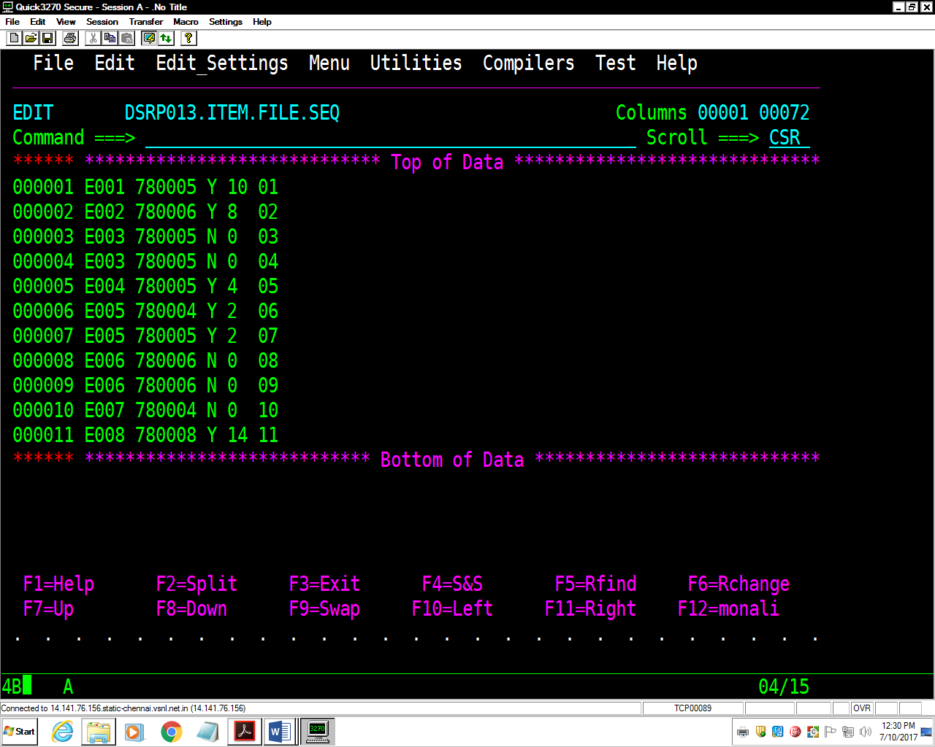

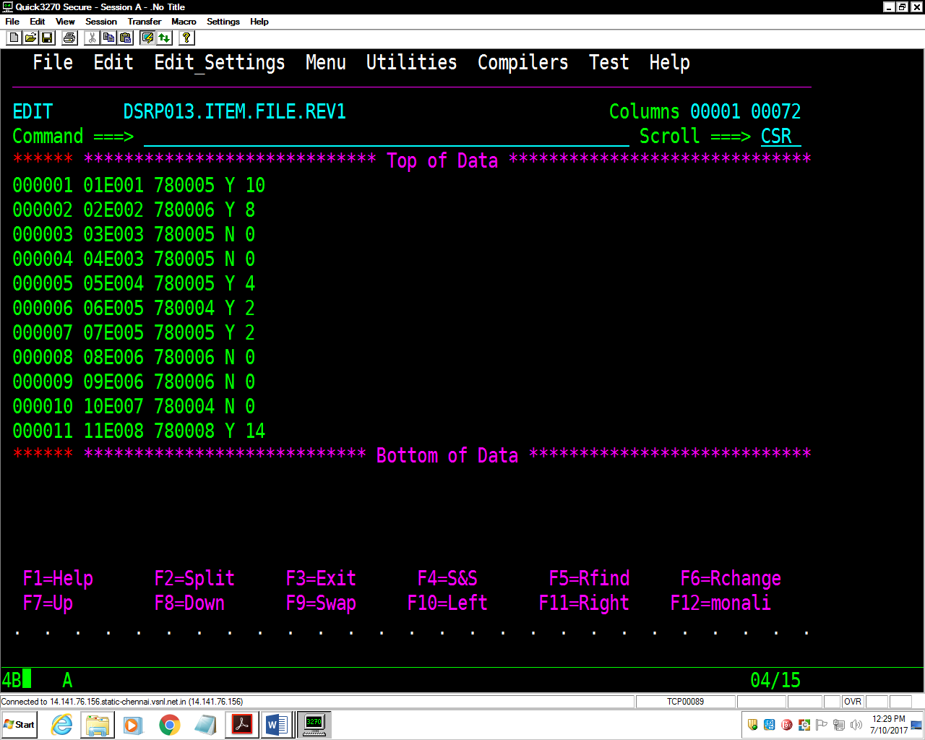

DSRP013.MONALI.JCL(JCLOUT) - 01.04

//FILE1 DD DSN=DSRP013.ITEM.FILE.REV2,

// DISP=(MOD,DELETE,DELETE),

// SPACE=(TRK,(1,1),RLSE),

// DCB=(LRECL=80,BLKSIZE=8000,RECFM=FB,DSORG=PS)

//\*

//STEP020 EXEC PGM=SORT

//SORTIN DD DSN=DSRP013.ITEM.FILE.SEQ,DISP=OLD //SORTOUT DD DSN=DSRP013.ITEM.FILE.REV2,

// DISP=(NEW,CATLG,DELETE),

// SPACE=(TRK,(1,1),RLSE),

// DCB=(LRECL=80,BLKSIZE=8000,RECFM=FB,DSORG=PS)

//SORTWK01 DD SPACE=(CYL,(1,1),RLSE),UNIT=SYSDA

//SYSOUT DD SYSOUT=\*

//SYSIN DD \*

SORT FIELDS=(18,2,CH,D)

OUTREC FIELDS=(1:18,2,4:1,4,9:6,6,16:13,1,18:15,2,52X)

/\*

