**Software Engineering Project**

Di Napoli Vincenzo [v.dinapoli6@studenti.unisa.it](mailto:v.dinapoli6@studenti.unisa.it)

Fasulo Sabato [s.fasulo5@studenti.unisa.it](mailto:s.fasulo5@studenti.unisa.it)

Giso Alfonso [a.giso@studenti.unisa.it](mailto:a.giso@studenti.unisa.it)

#1 Sprint Results

**Scientific Programmable Calculator**

# Burndown Chart

# Starfish Retrospective

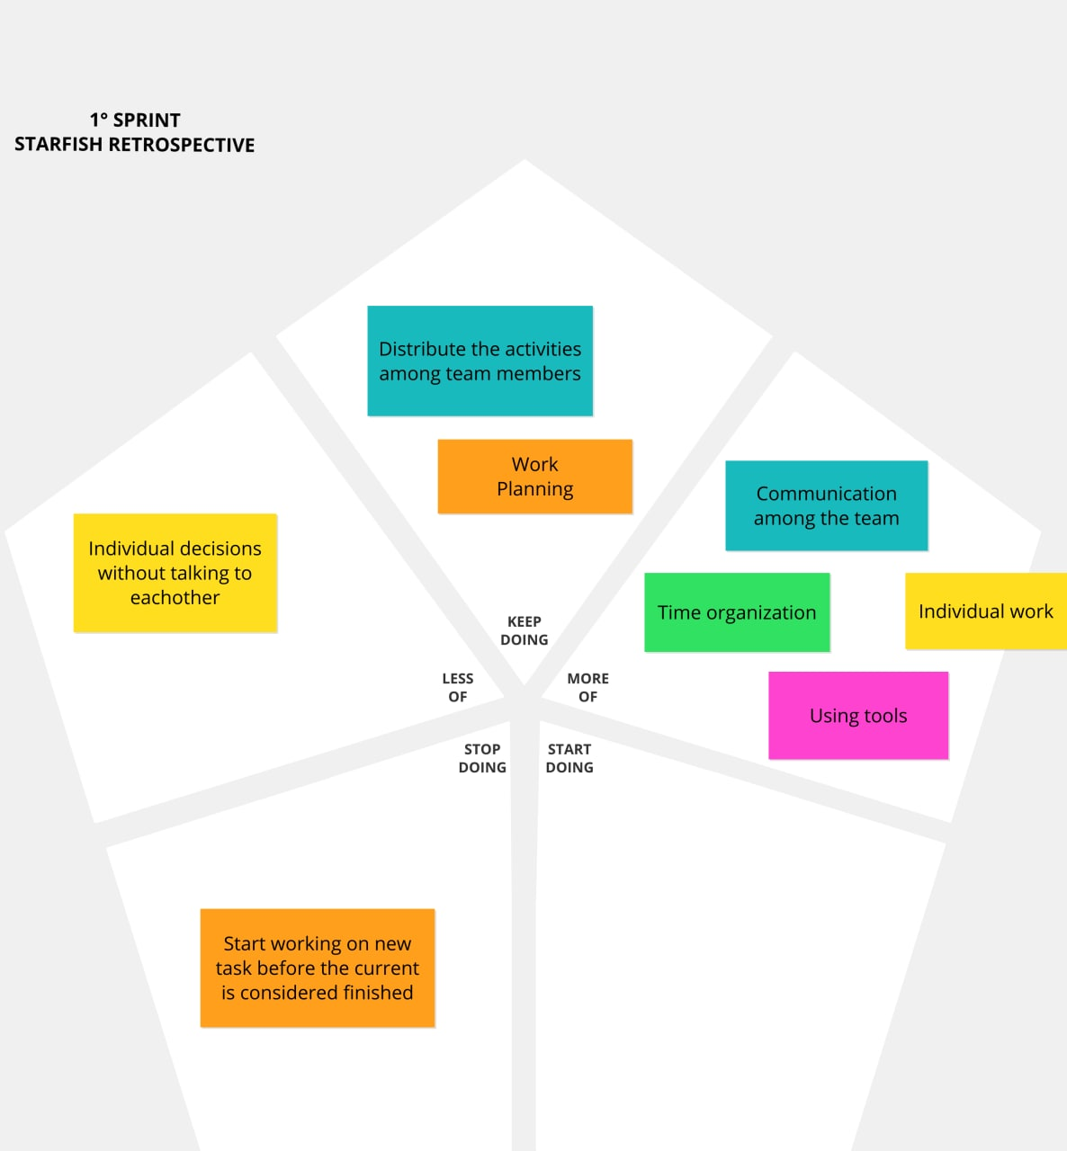

# 

# Project Status

This is the status of the project at the end of the first sprint.

