**Online Shopping Site**

**DESCRIPTION**: The Online Application is a web-based application, which helps user to find and shop latest varieties of products easily with different styles that are available in the market through online. It is a user-friendly website where user can shop through mobile or laps with reasonable prices so that user can save their time as well as money.

1. Home Page
2. Product Search facility
3. Product Detail Page
4. Add to Cart functionality
5. Place Order

**PRILIMINARY DESIGN**: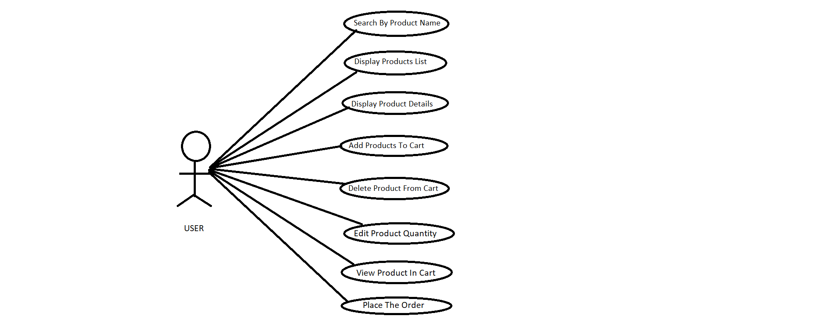

**SPECIFICATION OF USECASES**:

**1.Use Case Name:** Homepage

|  |  |
| --- | --- |
| **Home Page** | |
| **Element** | **Details** |
| Actor | User |
| Trigger | User view the home page |
| Pre Conditions | Run the application |
| Post Conditions | User successfully run the application and view the home page |
| Normal Course | 1.Home page will be displayed.  2.User will search the products in search bar. |

**2.Use Case Name:** Search Product By Name

|  |  |
| --- | --- |
| **Search Product By Name** | |
| **Element** | **Details** |
| Actor | User |
| Trigger | Products will be displayed according to search by name of the product |
| Pre Conditions | product details should be present in DB |
| Post Conditions | It displays the product details according to search by name from the DB |
| Normal Course | 1.Search bar is displayed to search product by name  2. Enter a product name in the search bar  3.It will display the product details according to search |

**3.Use Case Name:** Product Details

|  |  |
| --- | --- |
| **Product Details** | |
| **Element** | **Details** |
| Actor | User |
| Trigger | User wants to select one product from all the displayed products. |
| Pre Conditions | Runs the application and view the details of product. |
| Post Conditions | It displays the product details based on selection. |
| Normal Course | 1.The product details are displayed by the name.  2.Based on selection of product it displays the details of the particular product. |

**4.Use Case Name:** Add To Cart

|  |  |
| --- | --- |
| **Add Cart Details** | |
| **Element** | **Details** |
| Actor | User |
| Trigger | New cart details need to added |
| Pre Conditions | Cart details was not present in DB |
| Post Conditions | New cart details will added into DB |
| Normal Course | 1.User click the Add New Cart  2.Empty Add cart form will be displayed  3.User fill the cart by selecting a product  4.Details has to be submitted to server  5.Message will displayed after successful adding of cart |

**5.Use Case Name:** Display Cart Details

|  |  |
| --- | --- |
| **Display Cart Details** | |
| **Element** | **Details** |
| Actor | User |
| Trigger | All cart details need to be displayed |
| Pre Conditions | Cart details should be present in DB |
| Post Conditions | It displays the all details in the DB |
| Normal Course | 1.User click the Add Cart  2. Add cart details will be displayed |

**6.Use Case Name:** Delete From Cart

|  |  |
| --- | --- |
| **Add Cart Details** | |
| **Element** | **Details** |
| Actor | User |
| Trigger | Cart details need to deleted |
| Pre Conditions | Cart details existing already in DB |
| Post Conditions | Existing cart details will be deleted in DB |
| Normal Course | 1.User click the Add Cart  2. Add cart form will be displayed  3.User delete the cart by selecting a product  4.Details has to be submitted to server  5.Product can be deleted from cart |

**7.Use Case Name:** Edit Quantity From Cart

|  |  |
| --- | --- |
| **Edit Cart Details** | |
| **Element** | **Details** |
| Actor | User |
| Trigger | Quantity can be edited |
| Pre Conditions | product details should be present in DB |
| Post Conditions | It displays the edited details of the product |
| Normal Course | 1.User click the edit cart.  2.Edit form will be displayed.  3.Edit the details and click on save button.  4.Product details can be edited in cart. |

**8.Use Case Name:** Place Order

|  |  |
| --- | --- |
| **Place Order** | |
| **Element** | **Details** |
| Actor | User |
| Trigger | User can place the order for the product |
| Pre Conditions | Product should be selected and added in cart |
| Post Conditions | The order will be placed. |
| Normal Course | 1.User clicks on the place order button.  2.Order is placed and message is displayed. |

**Database Tables:**

1.Product Category

|  |  |  |
| --- | --- | --- |
| **Field Name** | **Data Type** | **Remark** |
| Category Id | int | Primary Key |
| Category Name | Varchar(50) |  |

2.Products

|  |  |  |
| --- | --- | --- |
| **Field Name** | **Data Type** | **Remark** |
| Product Id | int | Primary Key |
| Category Id | int | Foreign Key |
| Product Name | Varchar(50) |  |
| Picture | Varchar(50) |  |
| price | Varchar(50) |  |
| Quantity | int |  |
| Content | Varchar(50) |  |

3.Cart

|  |  |  |
| --- | --- | --- |
| **Field Name** | **Data Type** | **Remarks** |
| Product Id | int |  |
| Product Name | Varchar(50) |  |
| Picture | Varchar(50) |  |
| Price | Varchar(50) |  |
| Quantity | int |  |

**APPENDICES:**

**1.Home Page**



**2.Search By Product Name:**

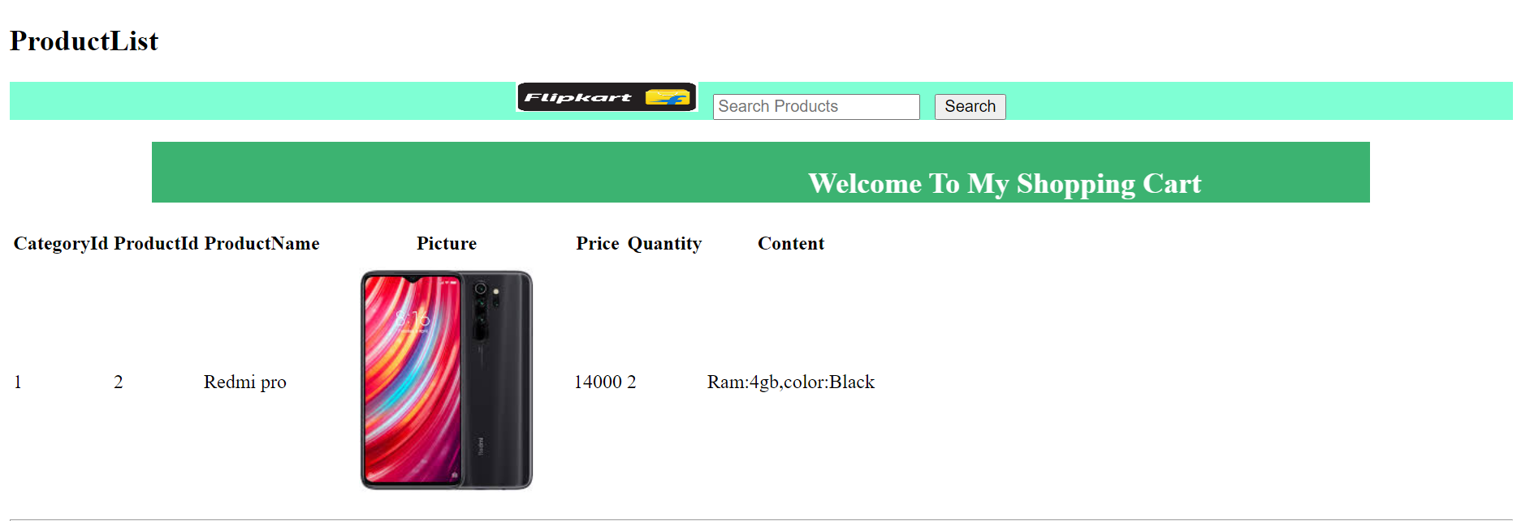

**3.Product Details**

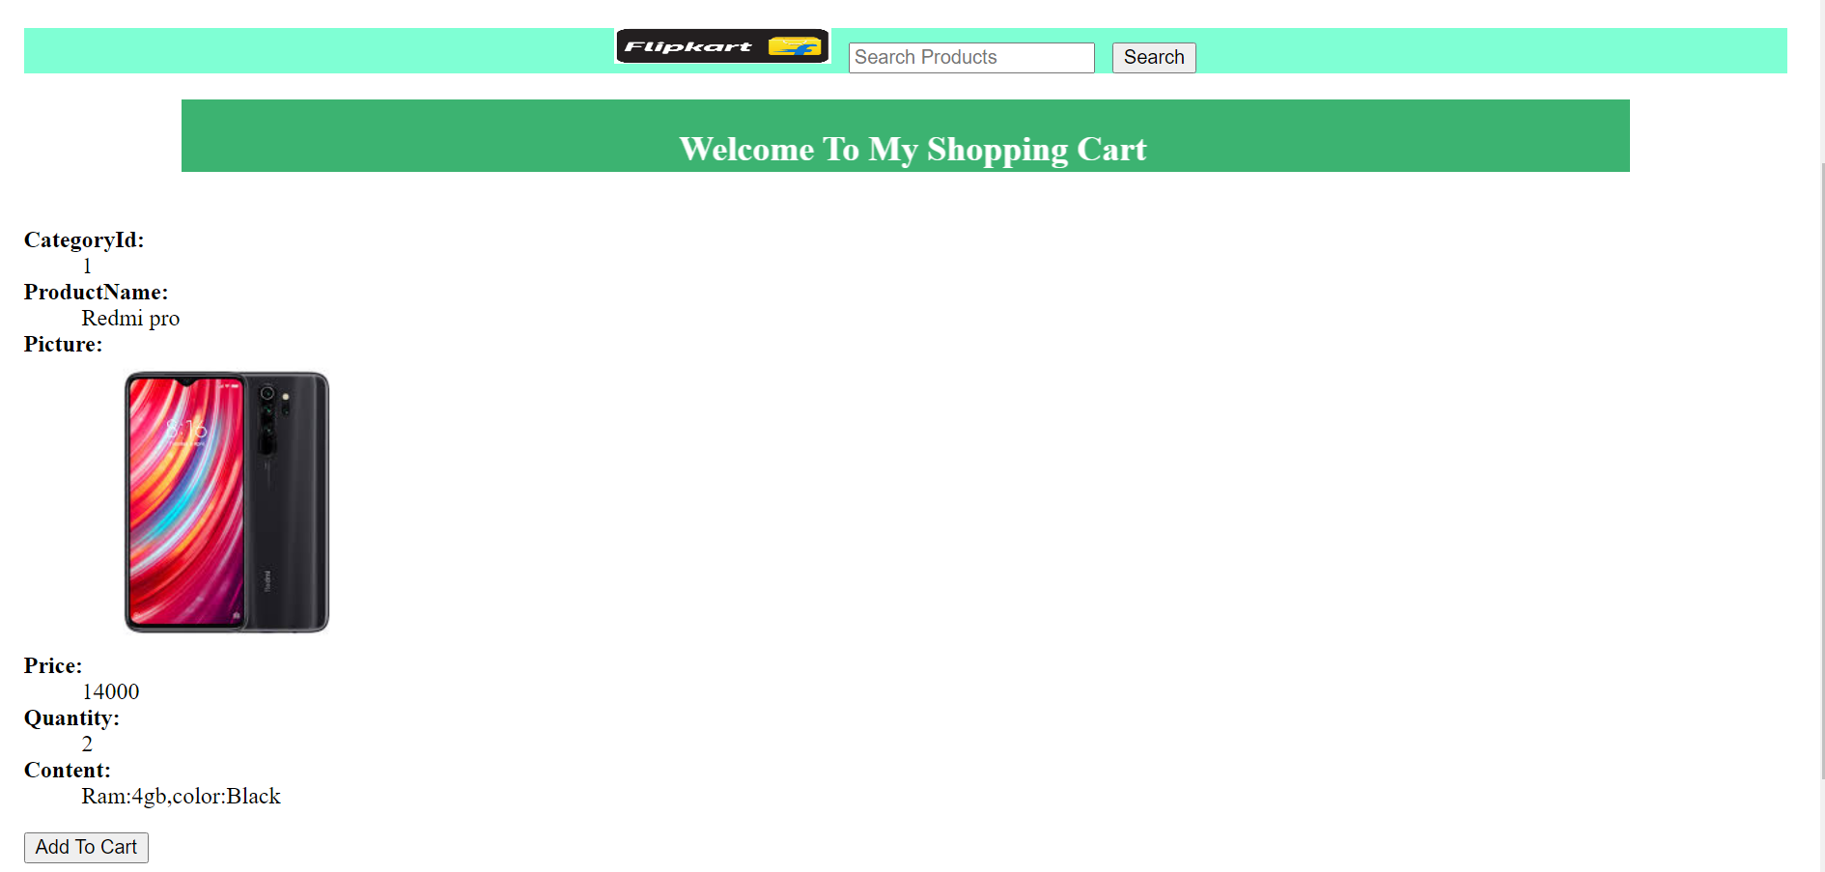

**4.Add To Cart**

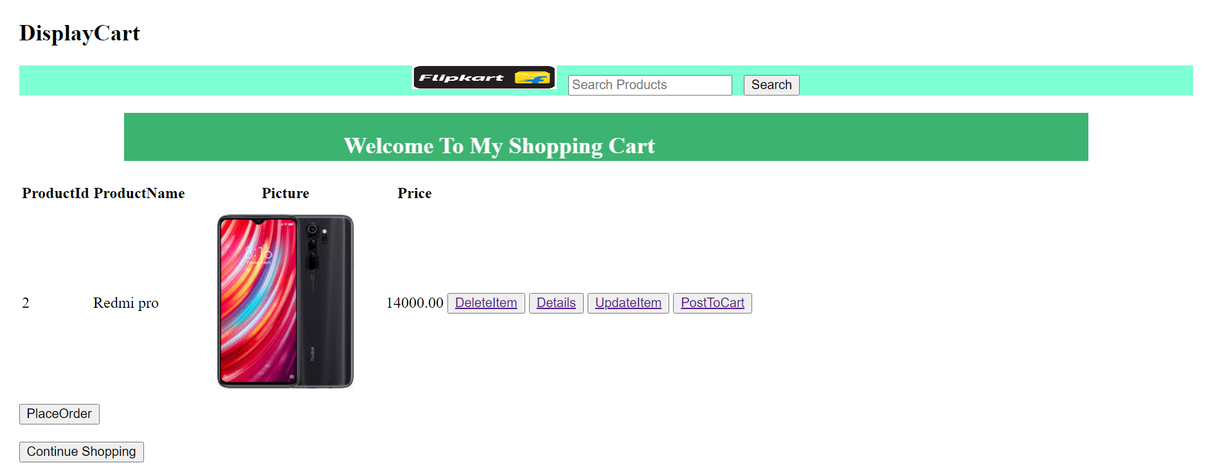

**5.View Details**

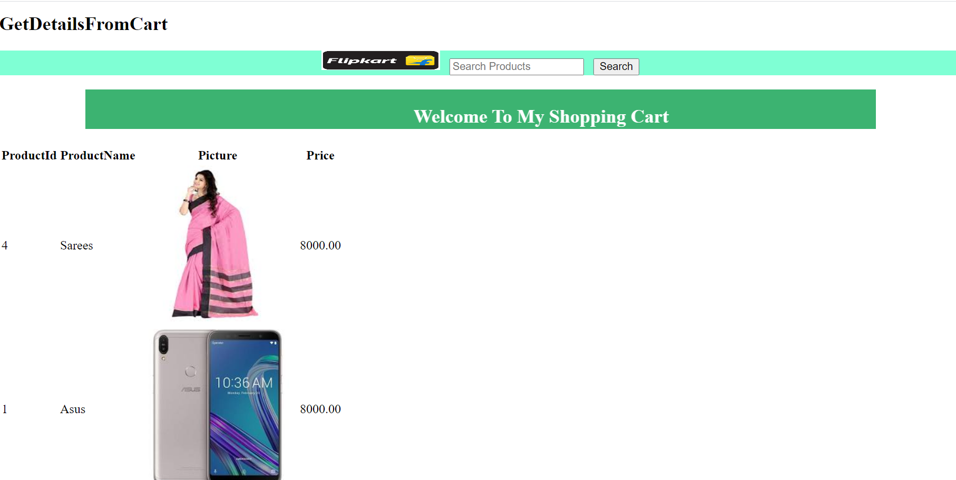

**6.Delete From Cart**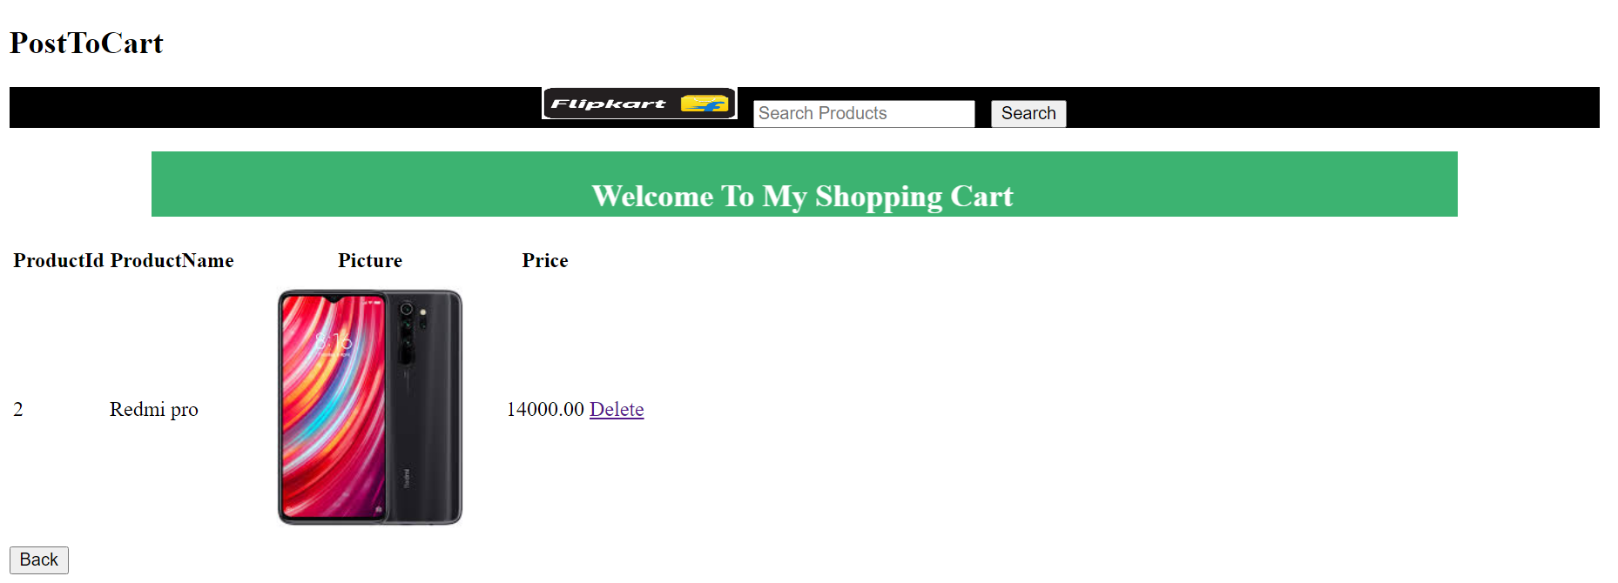

**7.Update Quantity**

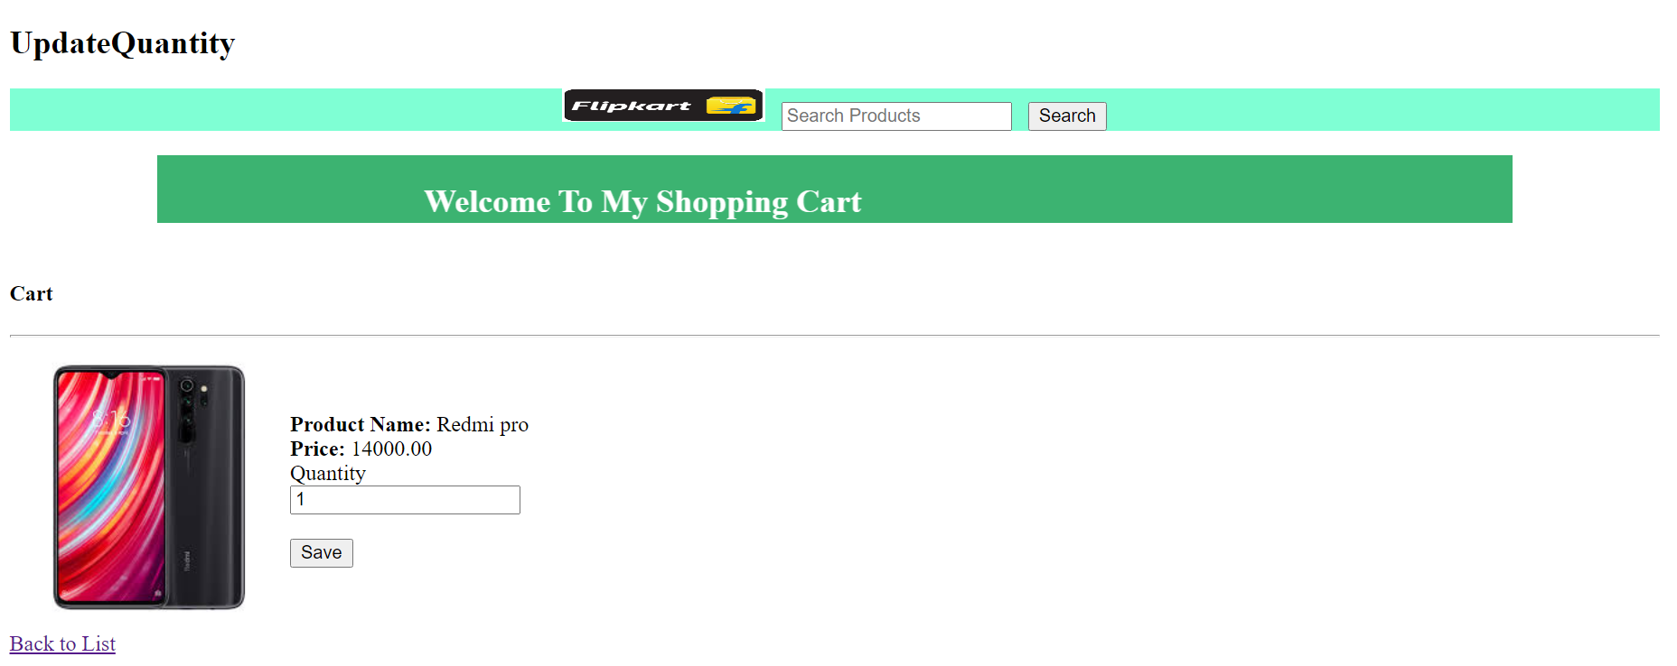

**8.Place Order**

