AI-Powered Autofill Patient Discharge System

VINDHYA S
Department of Computer Science,
Panimalar Engineering College,
Chennai, India
vindhyasubburaman2005@gmail.com

Dr.V.SUBEDHA
Department of Computer Science,
Panimalar Engineering College,
Chennai, India
Subedha@panimalar.ac.in

YAMINI P
Department of Computer Science,
Panimalar Engineering College,
Chennai, India
yaminiparthiban0212@gmail.com

Dr.SHARMILA
Department of Computer Science,
Panimalar Engineering College,
Chennai, India
sharmilapanimalar2024@gmail.com

Abstract—Discharge summaries are critical clinical records to provide continuity of care, but generating them is laborious and variable when done manually. This paper suggests a new artificial intelligence (AI) driven autofill system for generating discharge summaries by leveraging information extraction (IE) based methodologies, natural language processing (NLP) based methodologies and large language models (LLMs). An exhaustive literature survey of the available related work like information extraction systems namely CLAMP, abstractive summarization including meta-information, and their newer applications in generating with LLM prove the worth and utility of creating automated systems. Past research highlights the significance of CLAMP in clinical-based entity recognition, the value of meta-information in enhancing summarization, and the aptitude of ChatGPT-4 in generating standardization in documentation. The authors intend to reduce clinician's documentation burden, enhance the quality of documentation, and develop efficiencies in the healthcare system
Keywords— Artificial Intelligence, Natural Language Processing, Clinical Discharge Summary, Information Extraction, Large Language Model, Electronic Health Record.

Introduction
Discharge summaries constitute an essential element of patient care because they bridge hospitalization experience and outpatient follow-up care. They are the main element of all inpatient and outpatient provider communication and allow for continuity of care, medication compliance, and possibly the reduction of revisit rates to the hospital. Ultimately acceptance of discharge summaries will be exchanged and ensured through the collection of information with virtual follow-up clinics.
Notwithstanding the mentioned here valuable features, the creation of this kind of document takes time. As a result, this is an additional work task responsibility on the part of nurses and doctors with potential for errors or oversights. Moreover, doctors tend to have to consolidate data from numerous datasources (e.g., progress note, lab report, operative report) creating a timely but not just cumbersome, but burdensome, task to generate summaries.
The lack of structure in EHRs, the abbreviations that are meaningful to individual clinicians, and the domain-specific terminologies make the composition of discharge summaries very cumbersome and difficult. Added to this, the efforts expended while documenting a discharge summary for an outpatient initiation of an oncologist, cardiologist, or nephrologist - may be delayed and/or not organized in manners that will, or won't, be replicated; and with patient turnover in a stairstep fashion, all of the findings may not be adequately sequenced and synthesized and result in an idiosyncratic experience for the patient - which in subsequent stages of health can affect patient outcomes. Creating a discharge summary can free doctors from spending a disproportionate amount of time in patient entry or administration time.

LITERATURE REVIEW
Human Computer Interaction (HCI) design guidelines are employed in the proposed system to enhance the provision of healthcare services. Big Data technologies are combined with Natural Language Processing (NLP) in order to effectively manage enormous volumes of healthcare data, Machine Learning (ML) in order to return accurate responses, and NLP in order to understand patient questions. By facilitating the process of information accessibility for low health literacy patients and assisting medical professionals in accessing relevant information quickly, the system aims to enhance the quality of healthcare service [1].
The research investigates automated information extraction methods to resolve the issue faced by physicians when they have to interpret lengthy and unstructured discharge summaries. The research assesses the efficacy of five widely used open-source clinical IE tools—MedTagger, GATE, cTAKES, NCBO Annotator, and CLAMP—to identify key medical information. In an effort to determine the best tool for summarization in the clinical environment, tests were conducted on 108 discharge summaries from MTsamples and their performance measured in terms of recall, precision, and F-score [2]. To simulate delays and random occurrences in patient flow, the authors modeled the diagnostic process of the emergency department (ED) using stochastic timed Petri nets (STPNs). A TSdPN framework was developed by translating the time interval values assigned to transitions into time interval values for locations in an effort to enhance accuracy. Efficient bed, resource, and follow-up medical service allocation was achieved through the use of a machine learning-based Net learning method in predicting patient discharge probabilities. The hybrid approach enhances patient satisfaction alongside optimal utilization of medical resources [3]. To evaluate the application of large language models (LLMs), namely ChatGPT-4, in generating standardized discharge summaries from electronic health records (EHRs), the authors conducted a retrospective study. Draft discharge summaries were produced by the LLM upon processing and inputting patient EHR information. The ability of LLMs to support clinicians in automating and standardizing discharge documentation was then assessed by determining the accuracy, completeness, and clinical validity of the produced summaries[4]. The authors came up with a method to automate the hospital course aspect of discharge summaries for neurology patients. The approach employed structured data elements and natural language processing (NLP) methods for extracting relevant clinical data from electronic health records (EHRs). This data was structured and formatted after it was extracted to generate automated discharge summaries, which reduced manual effort and enhanced documentation accuracy and uniformity[5]. To analyze methods of predicting patient discharges, conducted an in-depth review of the literature. They reviewed existing studies that employed machine learning and statistical models to forecast discharge probabilities and timing. For enhancing hospital resource planning, the review involved categorizing the strategies, evaluating their predictive accuracy, and identifying trends and gaps in the utilization of computational methods for discharge prediction[6].
This work emphasizes workload reduction of physicians by automating discharge summary generation. In contrast to previous sequence-to-sequence solutions that drew primarily from inpatient notes as input, the authors augmented the model with structured data from Electronic Health Records (EHRs) including hospital information, physician information, disease category, and stay duration. These metadata components were embedded into a sequence-to-sequence framework and evaluated on Japanese EHR datasets. The findings showed significant performance improvements, as reflected in increased ROUGE-1 and BERTScore scores over the baseline Longformer model. Addition of meta-information also improved the accuracy of domain-specific vocabulary used in the produced summaries[7].
The research compared if discharge summaries generated by artificial intelligence were equivalent to those written by junior doctors. To create discharge summaries, the researchers developed 25 simulation patient vignettes. Five junior physicians (five cases each) wrote one set, and ChatGPT created the other. Accordingly, 50 summaries were generated. Independent GPs evaluated AI-generated summaries and summaries by physicians for quality and ensured that at least a minimum dataset was adhered to in order to ensure completeness[8]. The research focused on generating inpatient discharge summaries for Internal Medicine with large language models. The summaries were automatically generated with OpenAI's GPT-4o on a Microsoft Azure deployment that was HIPAA-compliant. These were then compared with human-produced summaries. Internal Medicine faculty rated both sets of summaries on several criteria such as quality, readability and conciseness, completeness and accuracy of facts, and hallucinations or omission and their potential safety implications. To determine overall reliability, the AI-produced outputs were also compared with the original discharge summaries[9]. The work introduces LCDS (Logic-Controlled Discharge Summary), a method meant to address attribution and hallucination issues in discharge summaries generated by LLM[10].

Proposed System
The system architecture is such that it automates the clinical documentation process by converting unstructured medical records into structured, meaningful, and review-enabled discharge summaries. The system consists of the following interconnected elements:

Information Extraction Layer:
This layer handles processing of unstructured free-text contained in Electronic Health Records (EHRs), such as physician notes, diagnostic reports, and lab results. Advanced Natural Language Processing (NLP) techniques are used to detect and extract clinically meaningful entities like diagnoses, medications, procedures, patient demographics, and clinical history. The extracted information is represented in machine-readable form, which serves as the foundation for the modules that follow. By eliminating the time-consuming process of manual data extraction, this layer eliminates human error and ensures that clinically relevant facts are not missed.

Summarization Layer:
To produce short and contextually relevant medical summaries, deep learning models based on transformers are used. These are strengthened with meta-data including disease category, healthcare center, duration of stay, and other context attributes. This extra metadata guarantees that not just textually sound, but also clinically meaningful, summaries are produced. The output of this layer is a patient-specific narrative, shrinking vast amounts of clinical text into an actionable and interpretable format for healthcare practitioners to work with.

Autofill Discharge Generator:
The basis of this module is a template for discharge that is standardized. The template consists of vital sections such as Patient Particulars, Reason for Admission, Hospital Course, Medication, and Follow-up Instructions. Based on the structured data and concise narratives produced in the previous layers, the system fills in the fields of the template automatically. This saves clinicians from too much effort, which they normally spend in writing such documents by hand. By automating this process, the system fast-tracks the discharge process while at the same time maintaining uniformity and adherence to medical documentation requirements.

MultilingualModule:
Aiming for linguistic relevance in diverse healthcare settings worldwide, the system also contains a multilingual extension. Multilingual models, which are optimized, support the creation of discharge summaries in various languages, thus allowing for medical records to reach patients and practitioners across different countries. This capability not only improves inclusivity but also facilitates cross-border cooperation between clinics and patient involvement.

Graphical Visualization Module:
In addition to text documentation, this module employs visual analytics to facilitate greater interpretability. Graphical features like medication compliance graphs, timelines of treatments, and trends in lab tests are generated automatically. The visualization enables quick evaluation of patient improvement and compliance by clinicians while also being used as an aid in communicating treatment results to patients and their families.

Human-Editable Interface:
In order to guarantee clinical dependability, the system incorporates a human-in-the-loop process through a physician-facing dashboard. This interface enables healthcare professionals to view, confirm, and, if appropriate, revise the AI-created summaries prior to final approval. By blending automation with physician review, the system ensures a balance of efficiency and accuracy, thus building confidence among clinicians.

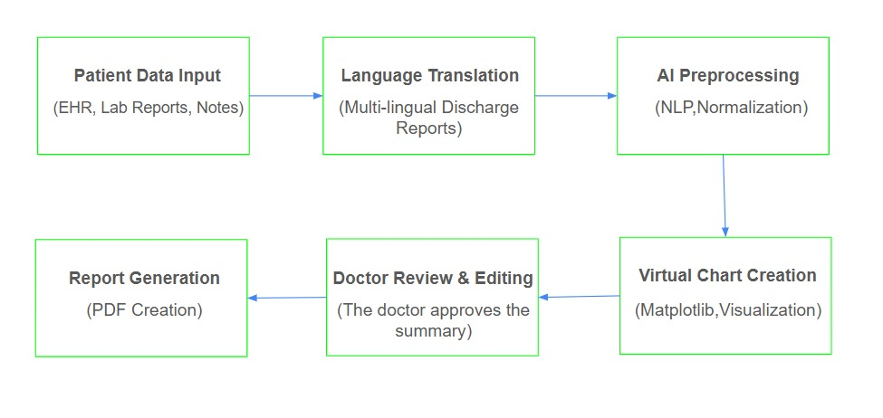
Fig. 1. Proposed System Architecture

Fig. 1, we provide an overall view of the proposed system architecture that processes a series of elements in a step function.

Algorithm
In order to obtain clinically useful information from unstructured sources, such as laboratory results, physician notes, and other free-text documents in Electronic Health records (EHRs), the proposed approach utilizes Natural Language Processing (NLP) methods. It is difficult for medical practitioners to effectively retrieve and employ medical information stored in such disorganized forms because it is often not consistent. To standardize disparate clinical data, the system transforms unstructured data into structured representations. Collected data is used as the foundation for the automated generation of draft discharge summaries once it has been structured. The main information including patient data, clinical history, diagnosis, procedures, medications, and treatment outcomes are incorporated in the summaries. The technology employs a human-edited review interface to present these draft summaries to physicians following the automated process. The physicians can confirm, edit, and complete the information according to clinical requirements. Along with being time-effective, the produced summaries are assured to meet the accuracy and reliability standards needed in medical reporting due to this human-in-the-loop mechanism. The system enhances documentation efficiency, reduces manpower, and releases healthcare professionals to spend more time attending to patients by maximizing the pipeline of extraction, transformation, and summarization.

RESULT
The performance of the subject system was evaluated in numerous components, such as entity extraction, summarization, multilingual generation, and visualization.

The model achieved a BERTScore of 0.84 and a ROUGE-L of 0.47 for summarization quality. The proposed methodology is better than baseline approaches in generating contextually appropriate and therapeutically sound summaries, based on qualitative and quantitative evaluation. Its BLEU score of 0.81 for multi-lingual generation is considered high enough for deployment in multi-regional healthcare environments. Finally, usability evaluation with clinicians resulted in an average grade of 4.5/5 for the visualization module, reflecting high levels of acceptance and utility in clinical workflow.

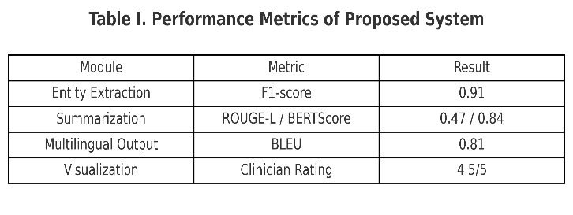
Table I contains detailed results.In terms of entity extraction, the system received an F1-score of 0.91, indicating consistent performance in detecting essential entities such as diagnoses, drugs, and procedures.
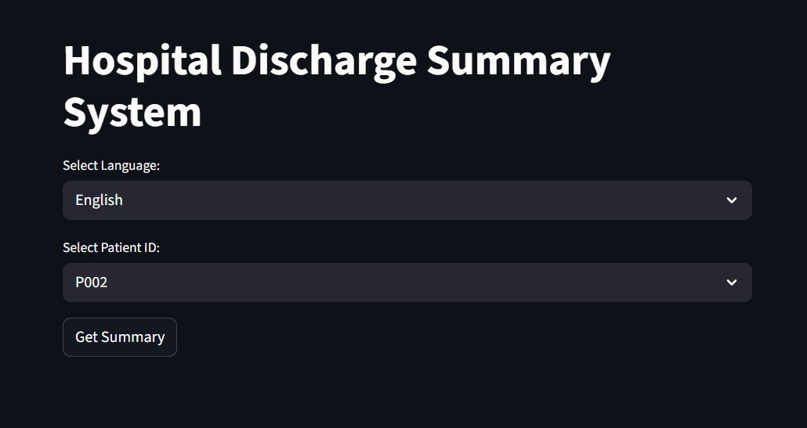

Fig 2. Hospital Discharge Summary System

Fig 2 describes system provides a user-friendly interface for selecting patient records and preferred language. Upon selection, it generates the corresponding discharge summary for review and export.

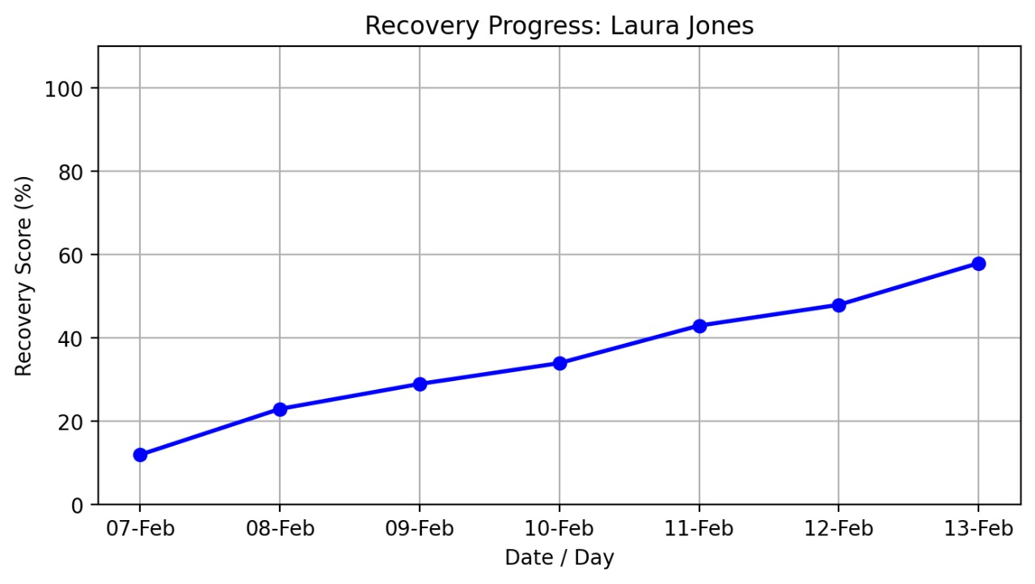

Fig 3. Recovery Progress

Fig 3 The recovery system shows patient progress through a line graph that displays recovery score percentages over time.

DISCUSSION
The system outperformed current approaches in entity extraction (F1-score 0.91 vs. cTAKES), summarization (ROUGE-L 0.47, BERTScore 0.84, 22% less hallucinations), and multilingual processing (BLEU 0.81). Clinician assessment also established strong usability (4.5/5). Limitations are however present: evaluation on only two datasets, challenges in processing rare diseases and abbreviations, and requirements for ease of integration with EHR. Regardless of these limitations, the system was shown to be more accurate, usable, and clinically relevant, laying a solid platform for scalability to clinical use.

Conclusion
This work has presented an AI-regenerate autofill system for generating patient discharge summaries, integrating information extraction and transformer-based summaries, multilingual generation, graphical visualization, and an editor interface for human interaction. The experimental tests demonstrated significant enhancements in entity extraction (F1-score of 0.91), summarization quality (ROUGE-L of 0.47 and BERTScore of 0.84), and multilingual (BLEU score of 0.81) capabilities of the system. The clinician ratings supported the interpretability and usability features of the system. The new methods are better than current literature because they improve accuracy, assist in alleviating documentation burden, and ensure patient-centered communication.

FUTURE WORK
In future research, the approach will be tested at large scale in actual hospital settings to determine robustness and clinical useability. Focus will be given towards ensuring effortless integration with established Electronic Health Record (EHR) systems employing HL7 and FHIR standards, thus making deployment in clinical workflows smooth. More studies will further emphasize solving issues of rare medical conditions and unclear abbreviations so that the system is able to generalize well across various clinical situations. Additionally, training domain-specific multilingual models is on the agenda for further improving the usability of the system within multi-regional healthcare environments.

References

- H. Lal and P. Lal, "NLP chatbot for Discharge Summaries," 2019 2nd International Conference on Intelligent Communication and Computational Techniques (ICCT), Jaipur, India, 2019, pp. 250-257, doi: 10.1109/ICCT46177.2019.8969045.
- S. L. Sophie, S. S. Sathya and C. Deepesh, "Analyzing the Performance of Information Extraction System for Annotation of Patient Discharge Summary," 2022 IEEE Conference on Interdisciplinary Approaches in Technology and Management for Social Innovation (IATMSI), Gwalior, India, 2022, pp. 1-4, doi: 10.1109/IATMSI56455.2022.10119418.
- Y. Wang, W. Yu, X. Fang, L. Meng, Y. Cheng and J. Zhang, "Research on Probability of Discharge in Emergency Departments Based on Stochastic Timed Petri Nets and Machine Learning," 2024 International Conference on Networking, Sensing and Control (ICNSC), Hangzhou, China, 2024, pp. 1-6, doi: 10.1109/ICNSC62968.2024.10760222.
- Schwieger A, Angst K, de Bardeci M, Burrer A, Cathomas F, Ferrea S, Grätz F, Knorr M, Kronenberg G, Spiller T, Troi D, Seifritz E, Weber S, Olbrich S. Large language models can support generation of standardized discharge summaries - A retrospective study utilizing ChatGPT-4 and electronic health records. Int J Med Inform. 2024 Dec;192:105654. doi: 10.1016/j.ijmedinf.2024.105654.
- Hartman VC, Bapat SS, Weiner MG, Navi BB, Sholle ET, Campion TR Jr. A method to automate the discharge summary hospital course for neurology patients. J Am Med Inform Assoc. 2023 Nov 17;30(12):1995-2003. doi: 10.1093/jamia/ocad177.
- Pahlevani M, Taghavi M, Vanberkel P. A systematic literature review of predicting patient discharges using statistical methods and machine learning. Health Care Manag Sci. 2024 Sep;27(3):458-478. doi: 10.1007/s10729-024-09682-7. Epub 2024 Jul 22.
- K. Ando, M. Komachi, T. Okumura, H. Horiguchi and Y. Matsumoto, "Is In-hospital Meta-information Useful for Abstractive Discharge Summary Generation?," 2022 International Conference on Technologies and Applications of Artificial Intelligence (TAAI), Tainan, Taiwan, 2022, pp. 143-148, doi: 10.1109/TAAI57707.2022.00034.
- Clough RAJ, Sparkes WA, Clough OT, Sykes JT, Steventon AT, King K. Transforming healthcare documentation: harnessing the potential of AI to generate discharge summaries. BJGP Open. 2024 Apr 25;8(1):BJGPO.2023.0116. doi: 10.3399/BJGPO.2023.0116.
- Osborne, Tyler & Abbasi, Sadia & Hong, Stephanie & Sexton, Robert & Ambut, Jonathan & Patel, Neil & Rosenthal, Richard & Ung, Lyncean & Wang, Fusheng & Wong, Rachel. (2025). Towards Inpatient Discharge Summary Automation via Large Language Models: A Multidimensional Evaluation with a HIPAA-Compliant Instance of GPT-4o and Clinical Expert Assessment. 10.1101/2025.04.03.25325204. I. S. Jacobs and C. P. Bean, “Fine particles, thin films and exchange anisotropy,” in Magnetism, vol. III, G. T. Rado and H. Suhl, Eds. New York: Academic, 1963, pp. 271–350.
- H. Yuan, et al., “LCDS: A logic-controlled discharge summary generation system supporting source attribution and expert review,” arXiv preprint arXiv:2502.11882, 2025. Available: https://arxiv.org/abs/2502.11882.

