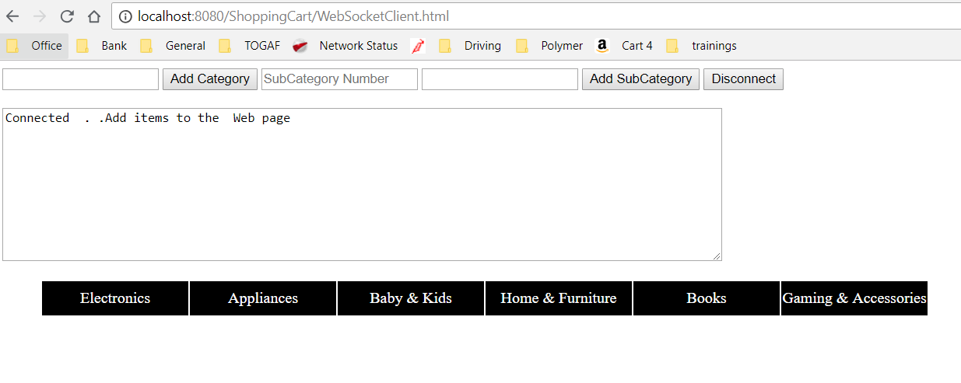

Adding main category, enter the category(clothing) and press add category

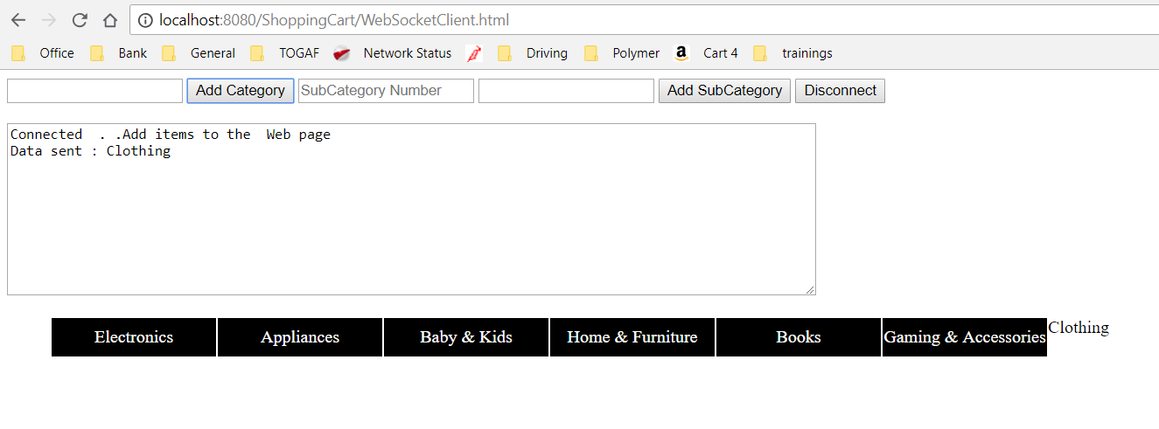

Adding Subcategory:

Enter the position (3) & Subcategory then press Add Subcategory, the sub category added to 3rd menu main category.

