GitHub URL’s:

1. File Service: <https://github.com/vindukatta/vehicle-service>
2. Cucumber Selenium Test: <https://github.com/vindukatta/vehicle-test-v3>

Run commands:

File Service: starts the jetty server

mvn compile exec:java

mvn clean compile test

Cucumber Test:

mvn clean compile test

**File Service:**

Developed using Jersey Rest API and run on jetty

1. Maven build successful
2. Start Jetty server, this is mandatory for the successful test run as rest api will not be available if server is down.
3. Rest api service to return file name list, content type and size ()

<http://localhost:7003/getFiles/>

1. Rest api service to return actual file

<http://localhost:7003/getFiles/getExcelFile?fileName=VehicleExcel.xlsx>

1. RestAssured Test case to check the availability of service

**Cucumber Test:**

1. Maven build successful, goals defined
2. Followed Page Object Model
3. Read excel file through Restful service
4. Read excel data through Apache POI
5. Cucumber feature integrated

**Screenshots:**

Start Jetty:

mvn compile exec:java

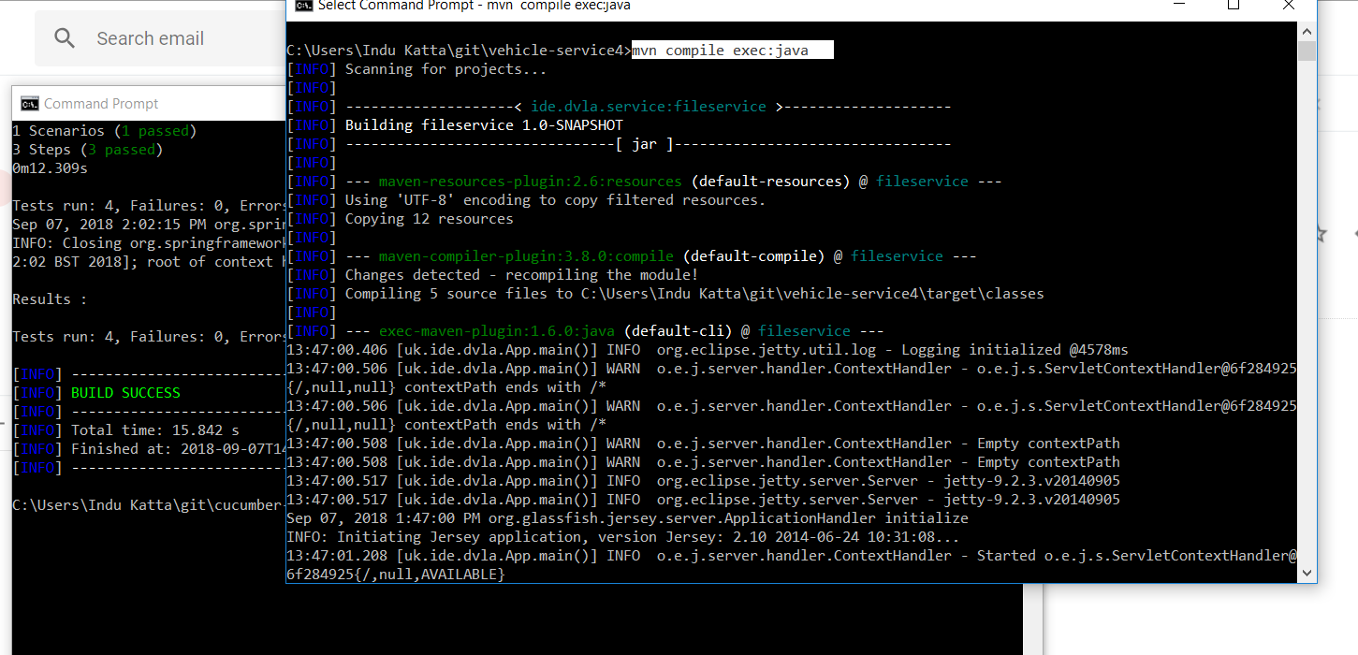

File Service:

<http://localhost:7003/getFiles/>

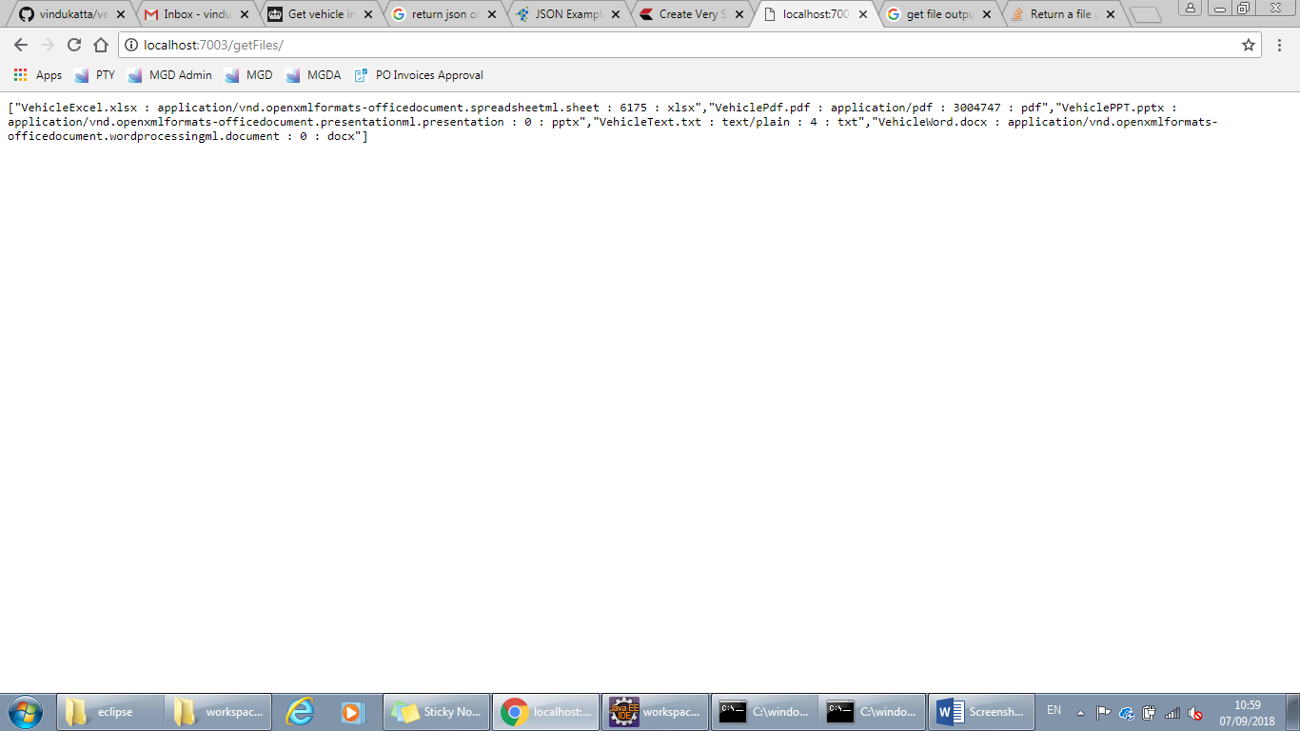

<http://localhost:7003/getFiles/getExcelFile?fileName=VehicleExcel.xlsx>

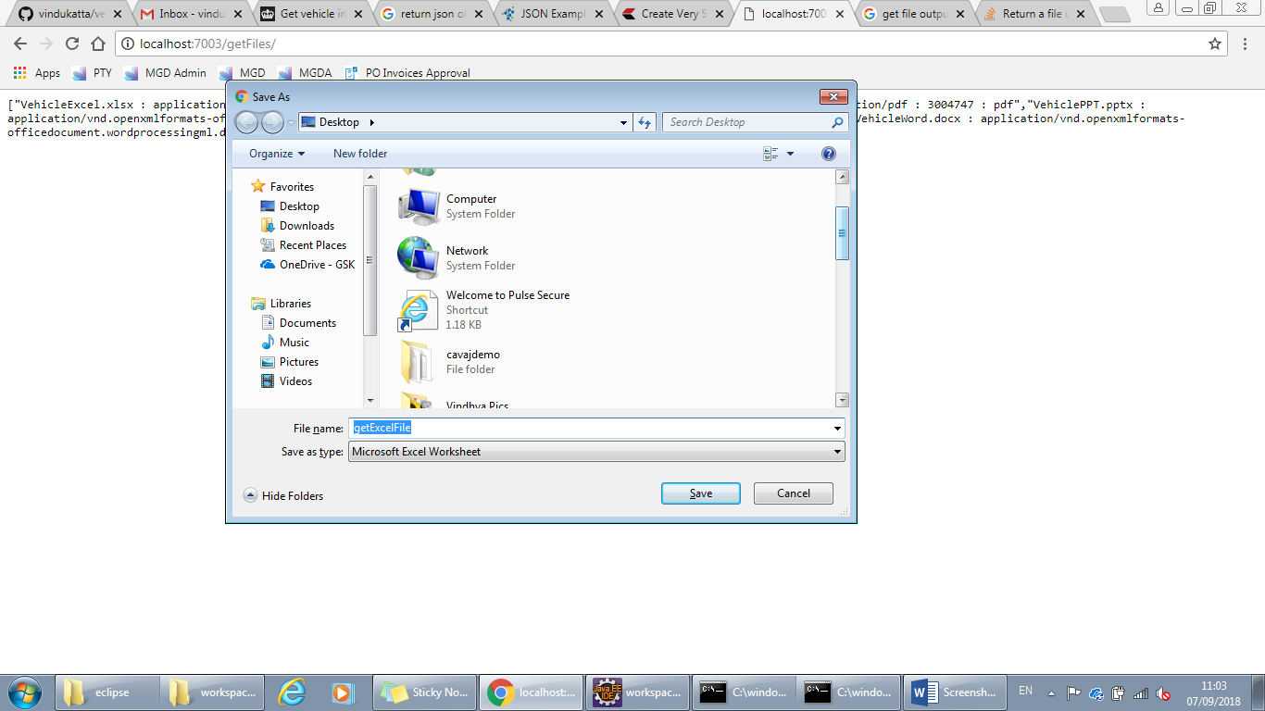

RestAssured Test Case

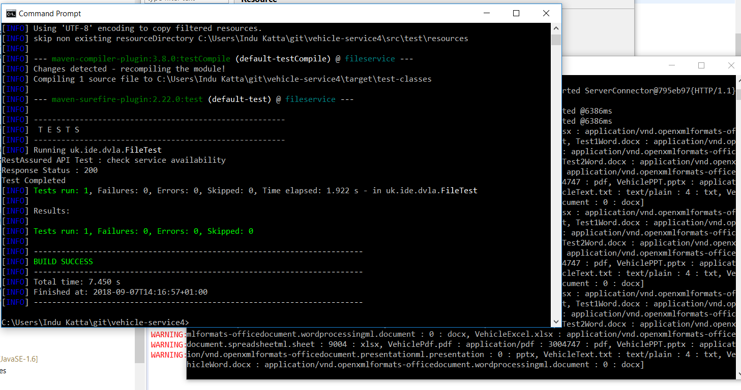

**Cucumber Test:**

