Your active configuration is: [cloudshell-12671]student_01_aa87e43f697b@cloudshell:**~ (qwiklabs-gcp-01-ef7bfe80dae0)**$ gcloud compute networks create griffin-dev-vpc --subnet-mode=customCreated [https://www.googleapis.com/compute/v1/projects/qwiklabs-gcp-01-ef7bfe80dae0/global/networks/griffin-dev-vpc].NAME SUBNET_MODE BGP_ROUTING_MODE IPV4_RANGE GATEWAY_IPV4griffin-dev-vpc CUSTOM REGIONALInstances on this network will not be reachable until firewall rulesare created. As an example, you can allow all internal traffic betweeninstances as well as SSH, RDP, and ICMP by running:$ gcloud compute firewall-rules create <FIREWALL_NAME> --network griffin-dev-vpc --allow tcp,udp,icmp --source-ranges <IP_RANGE>$ gcloud compute firewall-rules create <FIREWALL_NAME> --network griffin-dev-vpc --allow tcp:22,tcp:3389,icmpstudent_01_aa87e43f697b@cloudshell:**~ (qwiklabs-gcp-01-ef7bfe80dae0)**$ gcloud compute networks subnets create griffin-dev-wp --network=griffin-dev-vpc --region=us-central1 --range=192.168.16.0/20Created [https://www.googleapis.com/compute/v1/projects/qwiklabs-gcp-01-ef7bfe80dae0/regions/us-central1/subnetworks/griffin-dev-wp].NAME REGION NETWORK RANGEgriffin-dev-wp us-central1 griffin-dev-vpc 192.168.16.0/20student_01_aa87e43f697b@cloudshell:**~ (qwiklabs-gcp-01-ef7bfe80dae0)**$ gcloud compute networks subnets create griffin-dev-mgmt --network=griffin-dev-vpc --region=us-central1 --range=192.168.32.0/20Created [https://www.googleapis.com/compute/v1/projects/qwiklabs-gcp-01-ef7bfe80dae0/regions/us-central1/subnetworks/griffin-dev-mgmt].NAME REGION NETWORK RANGEgriffin-dev-mgmt us-central1 griffin-dev-vpc 192.168.32.0/20student_01_aa87e43f697b@cloudshell:**~ (qwiklabs-gcp-01-ef7bfe80dae0)**$

student_01_aa87e43f697b@cloudshell:**~ (qwiklabs-gcp-01-ef7bfe80dae0)**$ gsutil -m cp -r gs://cloud-training/gsp321/dm .Copying gs://cloud-training/gsp321/dm/prod-network.jinja...Copying gs://cloud-training/gsp321/dm/prod-network.yaml.../ [2/2 files][ 721.0 B/ 721.0 B] 100% DoneOperation completed over 2 objects/721.0 B.student_01_aa87e43f697b@cloudshell:**~ (qwiklabs-gcp-01-ef7bfe80dae0)**$ cd dmstudent_01_aa87e43f697b@cloudshell:**~/dm (qwiklabs-gcp-01-ef7bfe80dae0)**$ vi prod-network.yamlstudent_01_aa87e43f697b@cloudshell:**~/dm (qwiklabs-gcp-01-ef7bfe80dae0)**$

student_01_aa87e43f697b@cloudshell:~/dm (qwiklabs-gcp-01-ef7bfe80dae0)$ gcloud deployment-manager deployments create advanced-configuration --config prod-network.yaml

The fingerprint of the deployment is b'GgEwdHUM43G8oYN1EdCg2w=='

Waiting for create [operation-1611666477696-5b9cd57e646f9-29c8f54b-4feef5fb]...done.

Create operation operation-1611666477696-5b9cd57e646f9-29c8f54b-4feef5fb completed successfully.

NAME TYPE STATE ERRORS INTENT

griffin-prod-mgmt gcp-types/compute-v1:subnetworks COMPLETED []

griffin-prod-vpc gcp-types/compute-v1:networks COMPLETED []

griffin-prod-wp gcp-types/compute-v1:subnetworks COMPLETED []

student_01_aa87e43f697b@cloudshell:~/dm (qwiklabs-gcp-01-ef7bfe80dae0)$

student_01_aa87e43f697b@cloudshell:~/dm (qwiklabs-gcp-01-ef7bfe80dae0)$ gcloud compute firewall-rules create griffin-dev-firewall --direction=INGRESS --priority=1000 --network=griffin-dev-vpc --action=ALLOW --rules=icmp,tcp:22,tcp:3389 --source-ranges=0.0.0.0/0

Creating firewall...⠹Created [https://www.googleapis.com/compute/v1/projects/qwiklabs-gcp-01-ef7bfe80dae0/global/firewalls/griffin-dev-firewall].

Creating firewall...done.

NAME NETWORK DIRECTION PRIORITY ALLOW DENY DISABLED

griffin-dev-firewall griffin-dev-vpc INGRESS 1000 icmp,tcp:22,tcp:3389 False

student_01_aa87e43f697b@cloudshell:~/dm (qwiklabs-gcp-01-ef7bfe80dae0)$

student_01_aa87e43f697b@cloudshell:~/dm (qwiklabs-gcp-01-ef7bfe80dae0)$ gcloud compute firewall-rules create griffin-prod-firewall --direction=INGRESS --priority=1000 --network=griffin-prod-vpc --action=ALLOW --rules=icmp,tcp:22,tcp:3389 --source-ranges=0.0.0.0/0

Creating firewall...⠹Created [https://www.googleapis.com/compute/v1/projects/qwiklabs-gcp-01-ef7bfe80dae0/global/firewalls/griffin-prod-firewall].

Creating firewall...done.

NAME NETWORK DIRECTION PRIORITY ALLOW DENY DISABLED

griffin-prod-firewall griffin-prod-vpc INGRESS 1000 icmp,tcp:22,tcp:3389 False

student_01_aa87e43f697b@cloudshell:~/dm (qwiklabs-gcp-01-ef7bfe80dae0)$

35.224.235.80

qwiklabs-gcp-01-f94acc951bfb:us-central1:griffin-dev-db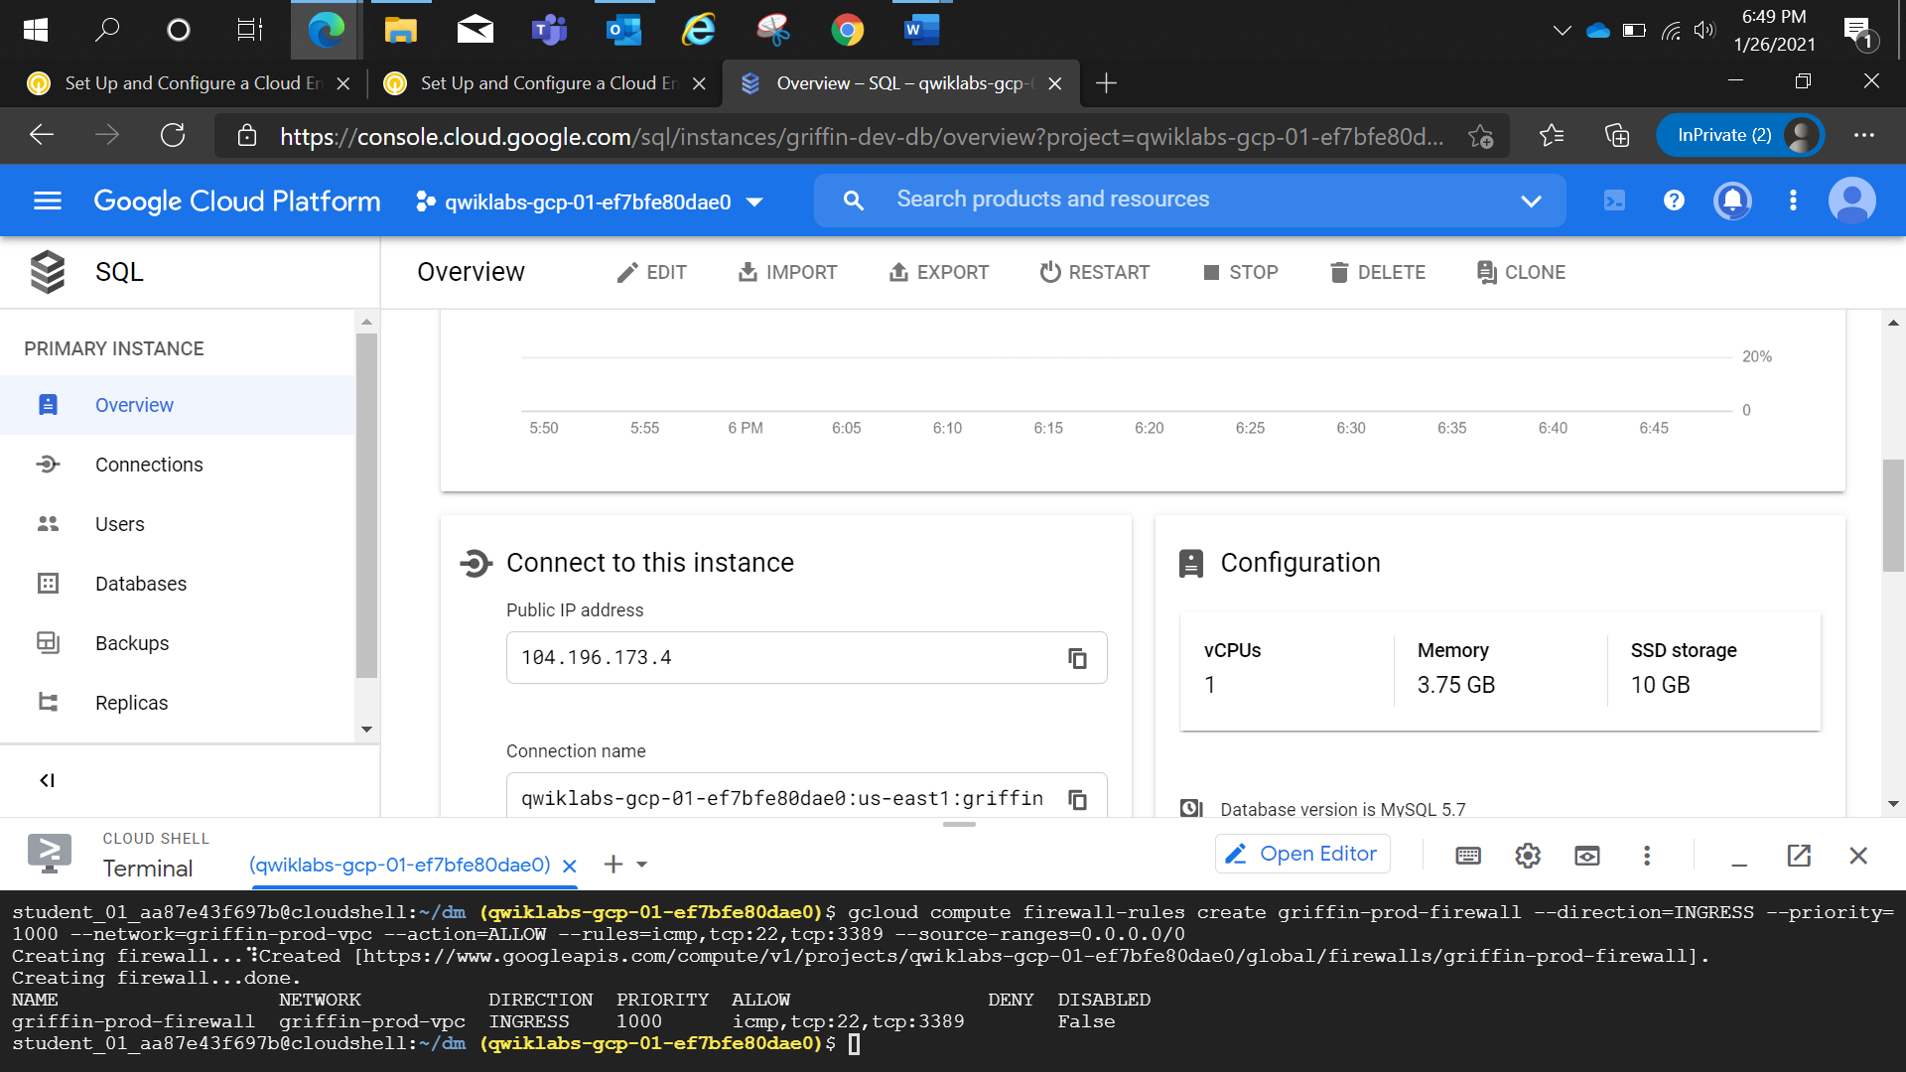

student_01_aa87e43f697b@cloudshell:~/dm (qwiklabs-gcp-01-ef7bfe80dae0)$ gcloud sql connect griffin-dev-db --user=root --quiet

Allowlisting your IP for incoming connection for 5 minutes...done.

Connecting to database with SQL user [root].Enter password:

Welcome to the MySQL monitor. Commands end with ; or \g.

Your MySQL connection id is 77

Server version: 5.7.30-google-log (Google)

Copyright (c) 2000, 2020, Oracle and/or its affiliates. All rights reserved.

Oracle is a registered trademark of Oracle Corporation and/or its

affiliates. Other names may be trademarks of their respective

owners.

Type 'help;' or '\h' for help. Type '\c' to clear the current input statement.

mysql> CREATE DATABASE wordpress;

Query OK, 1 row affected (0.24 sec)

student_01_992fd1f4a1e1@cloudshell:~ (qwiklabs-gcp-01-f94acc951bfb)$ gsutil -m cp -r gs://cloud-training/gsp321/wp-k8s .

Copying gs://cloud-training/gsp321/wp-k8s/wp-deployment.yaml...

Copying gs://cloud-training/gsp321/wp-k8s/wp-env.yaml...

Copying gs://cloud-training/gsp321/wp-k8s/wp-service.yaml...

- [3/3 files][ 2.1 KiB/ 2.1 KiB] 100% Done

Operation completed over 3 objects/2.1 KiB.

student_01_992fd1f4a1e1@cloudshell:~ (qwiklabs-gcp-01-f94acc951bfb)$ ls

dm README-cloudshell.txt wp-k8s

student_01_992fd1f4a1e1@cloudshell:~ (qwiklabs-gcp-01-f94acc951bfb)$ cd wp-k8s

student_01_992fd1f4a1e1@cloudshell:~/wp-k8s (qwiklabs-gcp-01-f94acc951bfb)$ ls -lrt

total 12

-rw-r--r-- 1 student_01_992fd1f4a1e1 student_01_992fd1f4a1e1 209 Jan 27 03:59 wp-service.yaml

-rw-r--r-- 1 student_01_992fd1f4a1e1 student_01_992fd1f4a1e1 1653 Jan 27 03:59 wp-deployment.yaml

-rw-r--r-- 1 student_01_992fd1f4a1e1 student_01_992fd1f4a1e1 318 Jan 27 03:59 wp-env.yaml

student_01_992fd1f4a1e1@cloudshell:~/wp-k8s (qwiklabs-gcp-01-f94acc951bfb)$

student_01_992fd1f4a1e1@cloudshell:~/wp-k8s (qwiklabs-gcp-01-f94acc951bfb)$ gcloud container clusters get-credentials griffin-dev --zone us-central1-c --project qwiklabs-gcp-01-f94acc951bfb

Fetching cluster endpoint and auth data.

kubeconfig entry generated for griffin-dev.

student_01_992fd1f4a1e1@cloudshell:~/wp-k8s (qwiklabs-gcp-01-f94acc951bfb)$ gcloud iam service-accounts keys create key.json \

> --iam-account=cloud-sql-proxy@$GOOGLE_CLOUD_PROJECT.iam.gserviceaccount.com

created key [0e148cce9cb2015e8b09baed8b51bf6704d0cb05] of type [json] as [key.json] for [cloud-sql-proxy@qwiklabs-gcp-01-f94acc951bfb.iam.gserviceaccount.com]

student_01_992fd1f4a1e1@cloudshell:~/wp-k8s (qwiklabs-gcp-01-f94acc951bfb)$ kubectl create secret generic cloudsql-instance-credentials \

> --from-file key.json

secret/cloudsql-instance-credentials created

student_01_992fd1f4a1e1@cloudshell:~/wp-k8s (qwiklabs-gcp-01-f94acc951bfb)$ ls

key.json wp-deployment.yaml wp-env.yaml wp-service.yaml

student_01_992fd1f4a1e1@cloudshell:~/wp-k8s (qwiklabs-gcp-01-f94acc951bfb)$ kubectl apply -f wp-env.yaml

persistentvolumeclaim/wordpress-volumeclaim created

secret/database created

student_01_992fd1f4a1e1@cloudshell:~/wp-k8s (qwiklabs-gcp-01-f94acc951bfb)$

student_01_992fd1f4a1e1@cloudshell:~/wp-k8s (qwiklabs-gcp-01-f94acc951bfb)$ gcloud iam service-accounts keys create key.json \

> --iam-account=cloud-sql-proxy@$GOOGLE_CLOUD_PROJECT.iam.gserviceaccount.com

created key [0e148cce9cb2015e8b09baed8b51bf6704d0cb05] of type [json] as [key.json] for [cloud-sql-proxy@qwiklabs-gcp-01-f94acc951bfb.iam.gserviceaccount.com]

student_01_992fd1f4a1e1@cloudshell:~/wp-k8s (qwiklabs-gcp-01-f94acc951bfb)$ kubectl create secret generic cloudsql-instance-credentials \

> --from-file key.json

student_01_992fd1f4a1e1@cloudshell:~/wp-k8s (qwiklabs-gcp-01-f94acc951bfb)$ ls

key.json wp-deployment.yaml wp-env.yaml wp-service.yaml

student_01_992fd1f4a1e1@cloudshell:~/wp-k8s (qwiklabs-gcp-01-f94acc951bfb)$ kubectl -f apply wp-deployment.yaml

Error: flags cannot be placed before plugin name: -f

student_01_992fd1f4a1e1@cloudshell:~/wp-k8s (qwiklabs-gcp-01-f94acc951bfb)$ kubectl apply -f wp-deployment.yaml

deployment.apps/wordpress created

student_01_992fd1f4a1e1@cloudshell:~/wp-k8s (qwiklabs-gcp-01-f94acc951bfb)$ kubectl apply -f wp-service.yaml

service/wordpress created

student_01_992fd1f4a1e1@cloudshell:~/wp-k8s (qwiklabs-gcp-01-f94acc951bfb)$