**DATA VIZUALIZATION ON SIMULATED IRAQI TOURISM DATASET**

The Simulated Data set of Iraqi tourism places Data Set is a collection of data related to various tourist places in Iraq. The dataset contains information such as ID, city, place names, latitude, and longitude, as well as ratings for various amenities and features at each place.

Upon analysing the Simulated Data set of Iraqi tourism places Data Set, several observations can be made. Firstly, the dataset contains information for various tourist places located in different cities of Iraq. The ID attribute can be used to uniquely identify each place.

The Latitude and Longitude attributes provide the geographical location of each place, which can be used to plot the places on a map. This information can be useful for travelers to plan their itinerary

The dataset also contains ratings for various amenities and features at each place, such as accommodation, entertainment, historical significance, natural beauty, and restaurants. These ratings can be used to compare and rank different places based on their overall appeal and suitability for tourists Furthermore, the dataset can be used to perform exploratory data analysis to gain insights into the distribution of tourist places across different cities in Iraq, and the distribution of ratings for various amenities and features. This information can be useful for policymakers to make informed decisions related to the promotion and development of the tourism industry in Iraq.

# SOURCE CODE:

library(shiny) library(shinythemes) library(leaflet) library(leaflet.extras)

# Load the data from the CSV file data <- read.csv("places.csv")

# Define the UI for the Shiny app ui <- fluidPage(

theme = shinytheme("cerulean"), tags$head(

tags$link(rel = "stylesheet", type = "text/css", href = "custom.css")

),

titlePanel("Vineeth Krishna 20BDS0387"), sidebarLayout(

sidebarPanel(

selectInput("city", "Select a city:", unique(data$City))

),

mainPanel( tabsetPanel( type = "tabs", tabPanel(

"Map", leafletOutput("map")

),

tabPanel( "Bar Chart",

plotOutput("cityChart")

),

tabPanel( "Scatter Plot",

plotOutput("latLngPlot")

),

tabPanel( "Heatmap",

leafletOutput("heatmap")

)

)

)

)

)

# Define the server for the Shiny app server <- function(input, output) {

# Filter the data by the selected city filtered_data <- reactive({ data[data$City == input$city, ]

})

# Create the map with markers for each place output$map <- renderLeaflet({ leaflet(filtered_data()) %>%

addTiles() %>%

addMarkers(lng = ~Longitude, lat = ~Latitude, popup = ~`Placenames`)

})

# Create the bar chart showing the number of places in each city output$cityChart <- renderPlot({

city_counts <- table(data$City)

barplot(city_counts, main = "Number of places in each city",sub = "Vineeth Krishna 20BDS0387", xlab = "City", ylab = "Number of places")

})

# Create the scatter plot showing the relationship between latitude and longitude output$latLngPlot <- renderPlot({

plot(data$Longitude, data$Latitude, xlab = "Longitude", ylab = "Latitude", main = "Scatter plot of Latitude and Longitude", sub = "Vineeth Krishna 20BDS0387")

})

# Create the heatmap showing the density of places in each city output$heatmap <- renderLeaflet({

leaflet(filtered_data()) %>% addTiles() %>%

addHeatmap(lng = ~Longitude, lat = ~Latitude, blur = 20, max = 0.5) #addHeatmapPlugin(lng = ~Longitude, lat = ~Latitude, blur = 20, max = 0.5) #addHeatmapOptions(lng = ~Longitude, lat = ~Latitude, blur = 20, max = 0.5)

})

}

# Run the Shiny app shinyApp(ui, server)

# OUTPUT DASHBOARD:

A Map Visualization of the cities based on their latitude and longitude positions

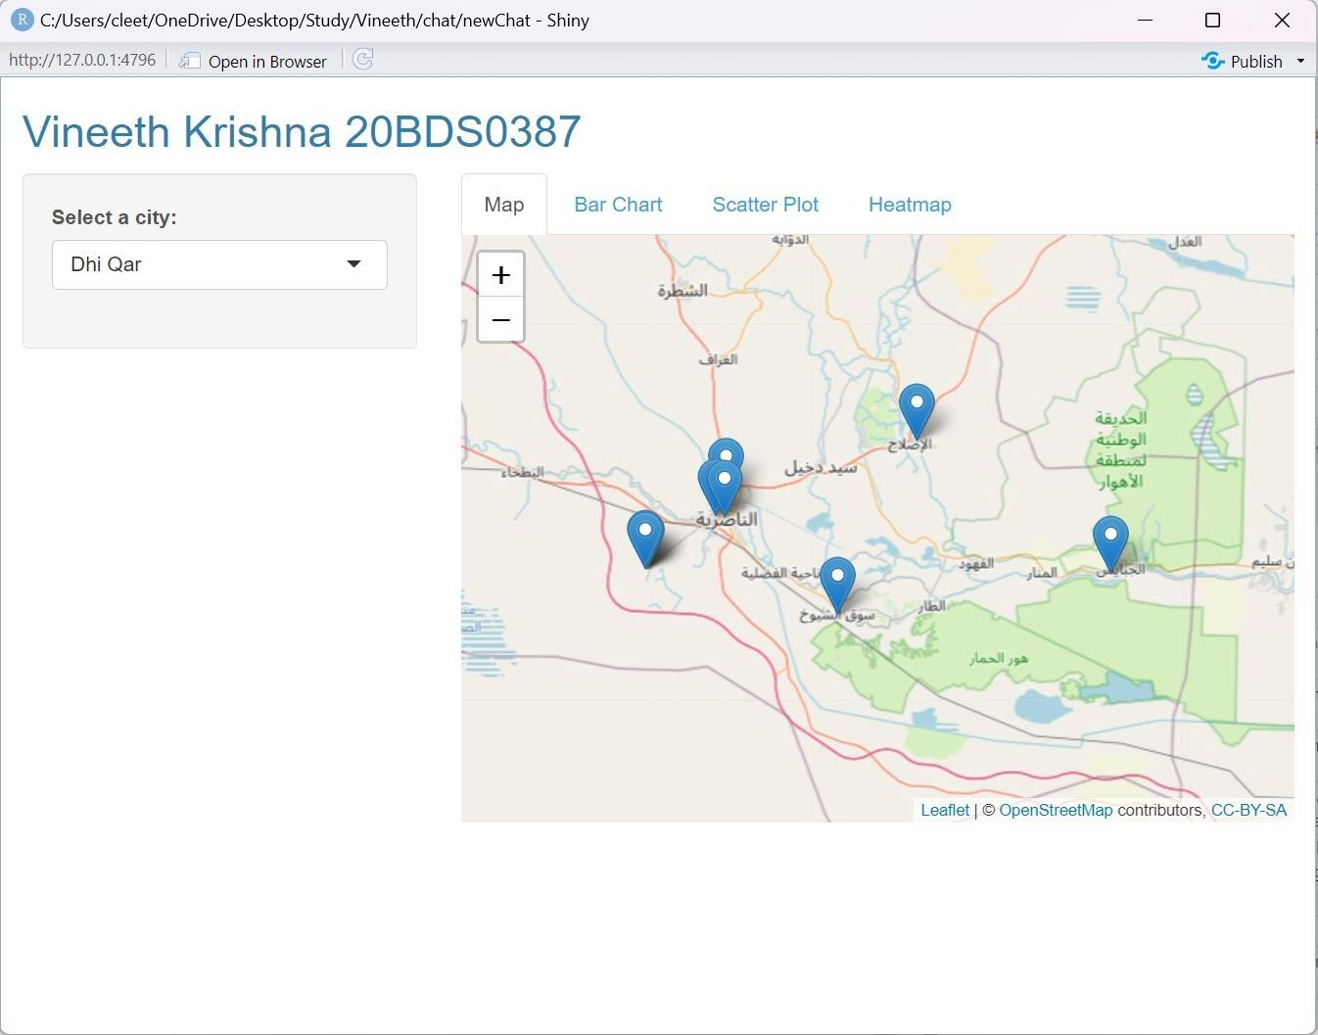

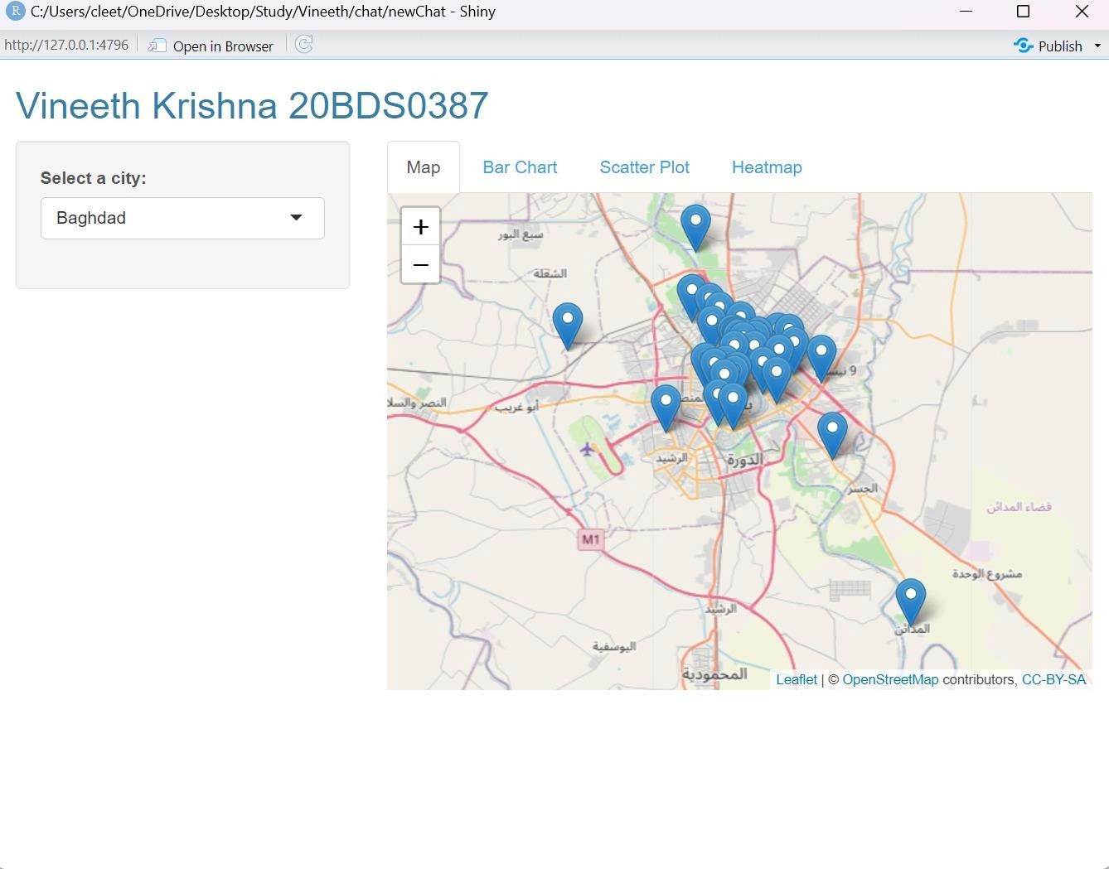

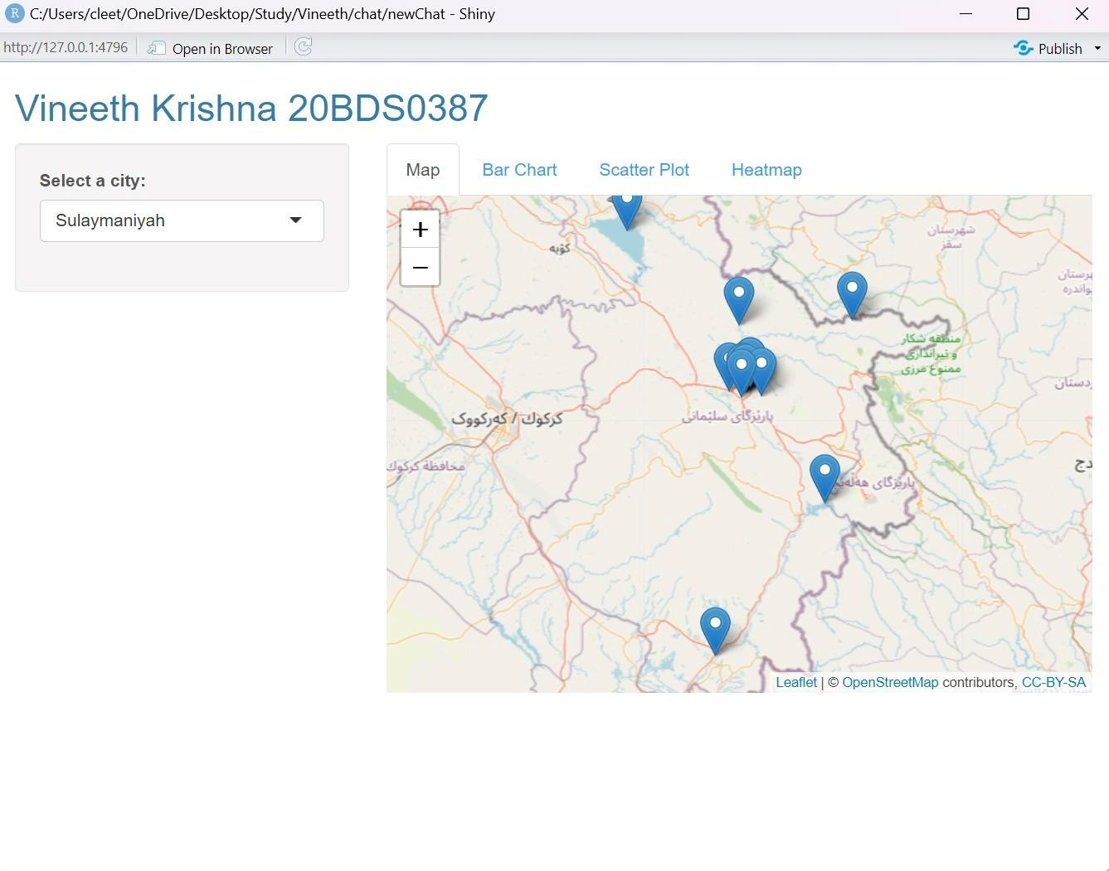

# Scatter plot based on the latitude and longitude

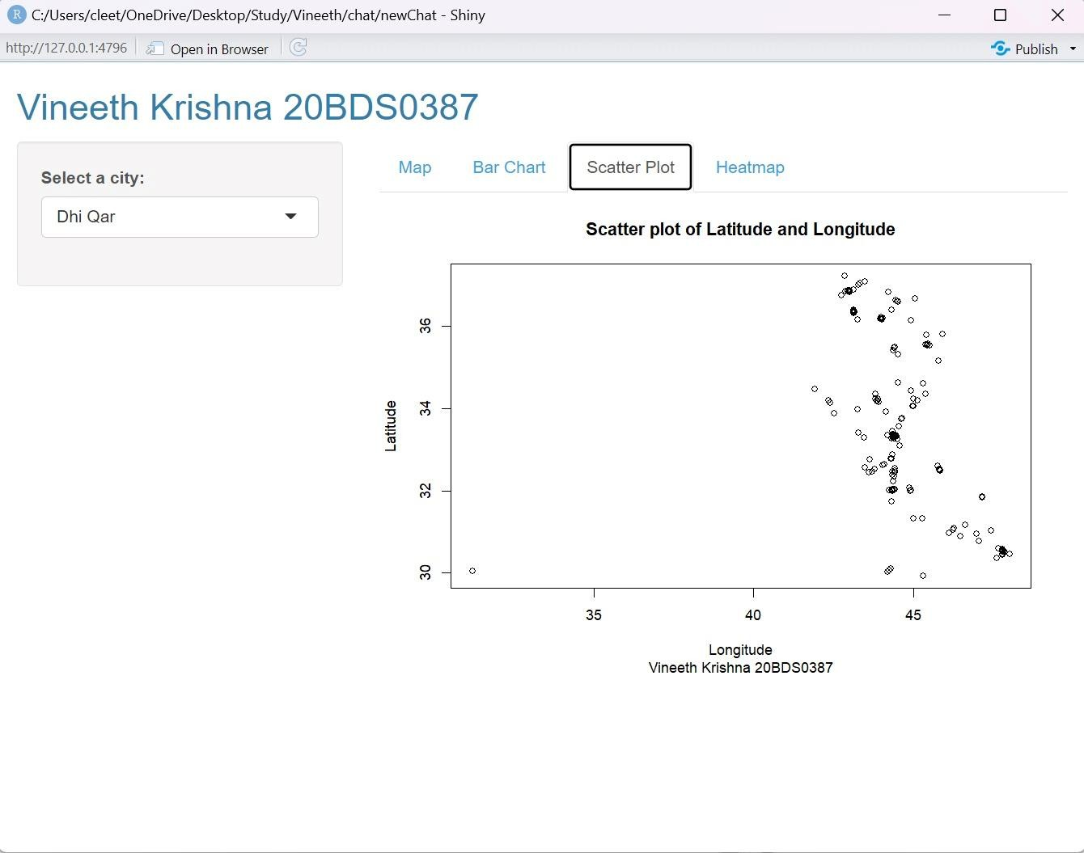

Bar plot based on the places in each Cities:

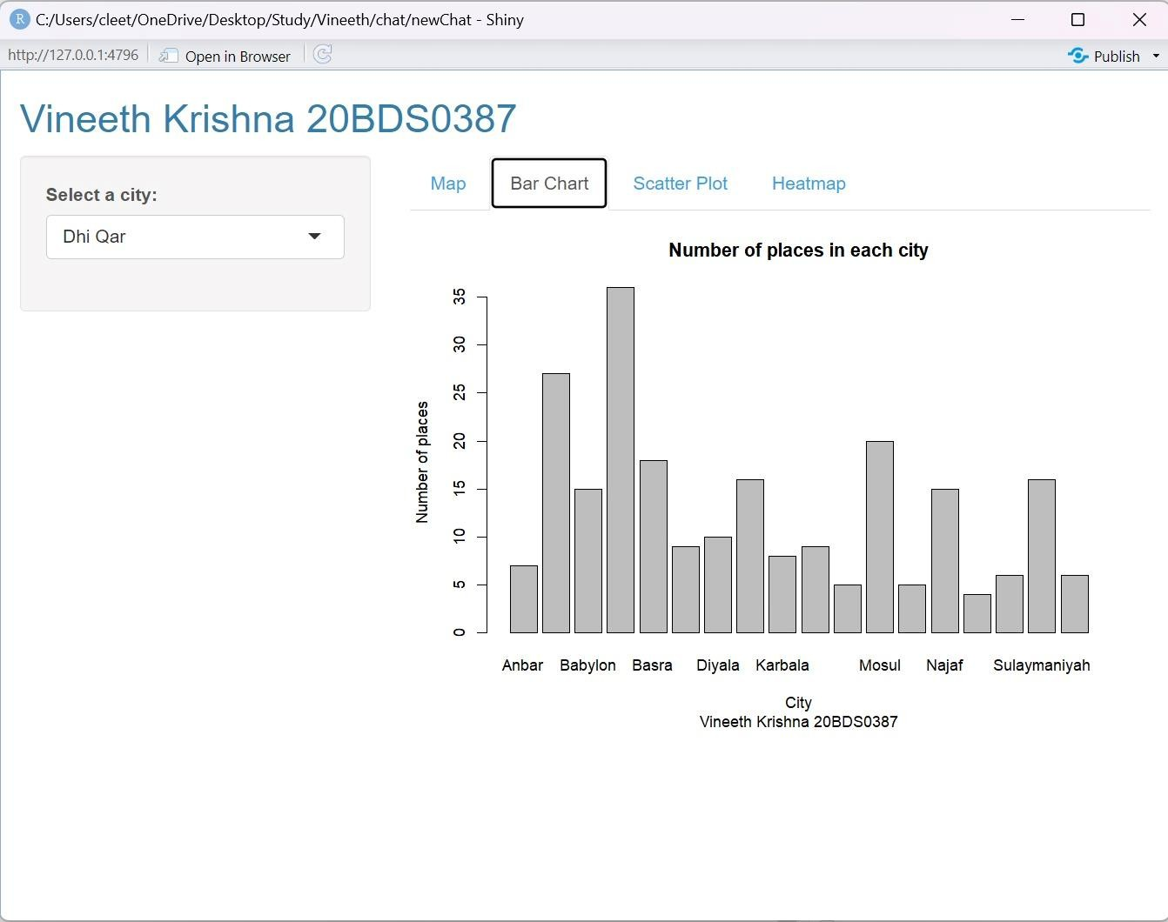

# Heatmap Vizualization of the Number of places located in each cities:

