Grocery Classification: CNN vs. Vision Transformer
Vineela Goli
CS 5330 - Pattern Recognition and Computer Vision - Northeastern University
ABSTRACT
Classifying grocery items from photos is more challenging than it looks. Many fruits and vegetables look nearly identical, and real-world images bring in lighting issues, background clutter, and angle variation that a clean dataset won't prepare you for. This project compares two image classification approaches on a 36-class fruit and vegetable dataset: a pretrained ResNet18 fine-tuned with transfer learning, and a Vision Transformer (ViT) that is built and trained from scratch.
ResNet18 hit 97.49% test accuracy in just 15 epochs using a two-phase fine-tuning strategy, while the ViT needed 35 epochs to reach 90.81%. Both models were also tested on real photos taken on a smart phone to see how they hold up outside the training distribution. The results made it clear that transfer learning has a strong edge on a dataset this size. It achieved faster convergence and more stable training. That said, the ViT got surprisingly close for something trained entirely from scratch, and with pretrained weights or more data, the gap could shrink significantly.
I. INTRODUCTION
Classifying food and grocery items from images is an interesting problem as many categories share similar colors, shapes, and textures such as red potatoes and beets, for instance, or apples and pomegranates, making fine-grained visual distinctions necessary. At the same time, real-world images introduce lighting variation, clutter (blackened bananas), and viewpoint changes (bell pepper) that controlled datasets do not capture. These are exactly the kinds of problems that make this task relevant to real applications like smart grocery apps or automated checkout.
The popular approach to image classification has been the Convolutional Neural Network (CNN). CNNs exploit spatial locality through shared convolutional filters and have proven to be remarkably effective even when pretrained on large datasets such as ImageNet and fine-tuned on smaller domain-specific collections. Vision Transformers (ViTs) offer a competitive alternative, applying the self-attention mechanism from natural language processing directly to sequences of image patches. ViTs achieve state-of-the-art results on large benchmarks but are known to require significantly more data or pretraining than CNNs to reach comparable performance on smaller datasets.
This project builds and compares these two approaches on a 36-class collection of fruit and vegetable images from Kaggle [5]. The goal is to understand the practical tradeoffs between a well-established CNN baseline and a transformer architecture trained from scratch, both in terms of final accuracy and training dynamics. Both models are additionally tested on real photographs taken outside the training distribution to assess generalization.
II. RELATED WORK
Touvron et al. [1] address one of the biggest practical problems with the original ViT: Dosovitskiy et al. [2] trained on JFT-300M, a private Google dataset of 303 million images, which made ViTs essentially unusable for anyone without massive computation infrastructure. DeiT shows that a pure transformer with no convolutional layers can be trained on ImageNet alone and still reach 81.8% top-1 accuracy, or 83.4% when a CNN teacher is used to guide training through a distillation token added alongside the standard class token. This is relevant to our project because we trained our ViT from scratch on a 36-class grocery dataset that is orders of magnitude smaller than ImageNet and saw exactly the kind of slow convergence and accuracy fluctuation that the lack of pretraining and large-scale data causes only reaching 90.81% after 35 epochs. A natural next step would be to start with a pretrained DeiT checkpoint (trained on ImageNet-1K) or a ViT-B/16 checkpoint (trained on ImageNet-21K) and fine-tune on the grocery dataset instead.
Klasson, Zhang, and Kjellström introduce a grocery image classification dataset of 5,125 natural images across 81 fine-grained product classes grouped into 42 coarse-grained categories that covered fruits, vegetables, juice, milk, and yogurt. All images were taken with a smartphone camera in real grocery stores, which is the same kind of real-world setting as the phone camera photos we used to evaluate our models. The dataset uses a two-level class hierarchy where visually similar fine-grained varieties like Golden Delicious or Royal Gala apples share a single coarse-grained label, which mirrors exactly the kind of intra-class ambiguity we saw in our project: apple was the hardest class for our ViT at 50.0% accuracy and 90.0% on ResNet18. This paper provides a peer-reviewed benchmark for the same domain and capture conditions we worked with.
Bossard, Guillaumin, and Van Gool introduce Food-101, a benchmark of 101,000 images across 101 food categories with a fixed split of 750 training and 250 manually reviewed test images per class. Their method mines discriminative image regions using Random Forests and achieves 50.76% average accuracy outperforming prior part-mining approaches, though CNN-based methods on the same dataset already did better, which the authors acknowledge. The paper's core finding is that fine-grained food recognition is genuinely hard. Training images were not cleaned and contained noise including wrong labels and misleading colors, reflecting the messiness of real food imagery. This is directly relevant to our project because we ran into the same kind of difficulty where banana was the hardest class for ResNet at 77.8%, potato was hard for both models (80% ResNet, 70% ViT), and apple dropped to just 50% on the ViT, all cases where visual similarity to other classes or within-class color and texture variation caused failures. Food-101 also uses per-class accuracy breakdown as its evaluation method, which is the same approach we use in this project, and sets up our 36-class fruit and vegetable task within a well-established and difficult recognition problem.
III. METHODS
A. Dataset
All experiments use the Fruit and Vegetable Image Recognition Dataset by K.Seth sourced from Kaggle [5]. The dataset contains images of 36 fruit and vegetable categories including apple, banana, beetroot, bell pepper, carrot, and watermelon, among others. The training split comprises 98 batches and the test split 12 batches at a batch size of 32.
Preprocessing:
- Train: Resize (256x256) → RandomCrop (224×224) → RandomHorizontalFlip → Normalize
- Test: Resize (256x256) → CenterCrop (224×224) → Normalize
- Normalization uses ImageNet mean [0.485, 0.456, 0.406] and std [0.229, 0.224, 0.225]
B. Model 1 - ResNet18 with Transfer Learning
The first model is a ResNet18 loaded with pretrained ImageNet weights from torchvision. The final fully connected layer is replaced with a linear layer mapping 512 features to 36 classes. Training is completed in two phases:
Phase | Epochs | LR | Layers trained
Head only | 10 | 1e-3 | FC head only (base frozen)
Full fine-tune | 5 | 1e-4 | All layers unfrozen
Table 1: ResNet18 Architecture
Optimizer: Adam; Loss: Cross-Entropy Loss
C. Model 2 - Vision Transformer from Scratch
The second model is a Vision Transformer adapted from the architecture described in Table 2. Each 224×224 image is divided into 196 non-overlapping 16×16 patches using nn.Unfold, then projected into a 192-dimensional embedding space via a linear layer. Learnable positional embeddings are added before the sequence is passed through a stack of transformer encoder blocks.
Hyperparameter | Value
Patch size / stride | 16×16 (non-overlapping)
Number of tokens | 196 (14×14 grid)
Embedding dim | 192
Encoder depth | 6 layers
Attention heads | 6 (32 dim/head)
Feedforward dim | 384
Dropout | 0.1
Pooling | Mean token pooling (no CLS token)
Table 2: Vision Transformer Architecture
After the encoder, tokens are averaged across the sequence dimension and passed through a two-layer classification head with GELU activation. The model is trained from scratch for 35 epochs using AdamW (lr=1e-3, weight decay=1e-4) with NLL loss and a cosine annealing learning rate schedule. An initial 20-epoch run was extended to 35 after the model had not yet converged.
Optimizer: AdamW; Loss: NLLLoss; Scheduler: CosineAnnealingLR
D. Evaluation
Both models are evaluated on per-epoch test accuracy, final test accuracy, and per-class accuracy across all 36 categories. A side-by-side visual comparison is produced on a held-out test batch of 8 images. Both models are also tested on real-world grocery photographs taken on a phone camera and stored in a separate folder outside the training distribution.
IV. EXPERIMENTS AND RESULTS
A. ResNet18 Training Dynamics
The two-phase training strategy proved highly effective. During Phase 1, test accuracy climbed from 79.67% at epoch 1 to 92.48% at epoch 10, with train loss dropping from 2.33 to 0.43. Phase 2 fine-tuning pushed accuracy to a final value of 97.49% by epoch 5, with train loss reaching 0.10. The loss curves (Figure 1) show clean, monotonic convergence with no sign of overfitting.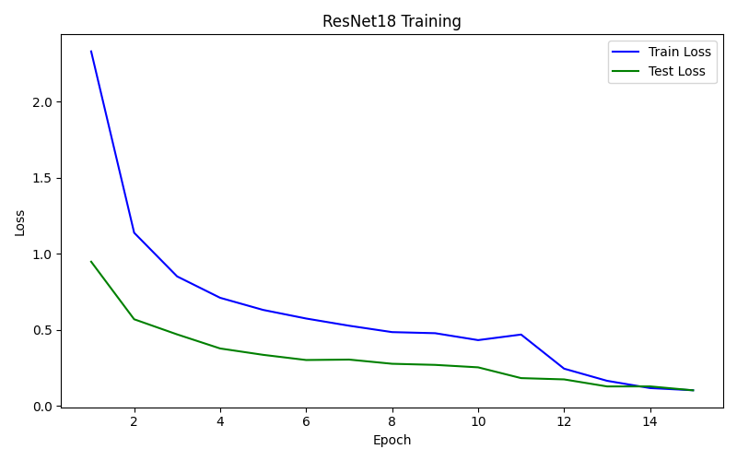
Figure 1: Results of Train/Test Loss of ResNet18 Training
B. ViT Training Dynamics
The ViT required substantially more epochs to converge. An initial 20-epoch run reached only 78.27% test accuracy. Extended training to 35 epochs improved this to 90.81%, with train loss falling from 2.96 to 0.69. The training curves (Figure 2) are noisier than ResNet's, with test accuracy fluctuating by several percentage points between consecutive epochs which is consistent with the known instability of training ViTs from scratch on small datasets.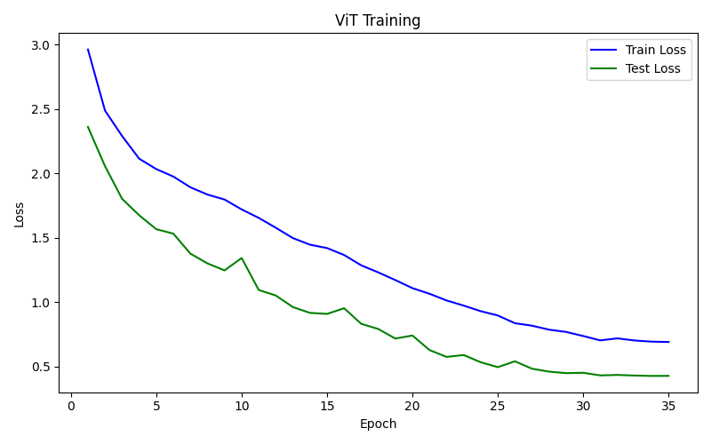
Figure 2: Results of Train/Test Loss of ViT Training
C. Per-Class Accuracy
ResNet18 achieved 100% accuracy on 29 of 36 classes. The seven classes below 100% were banana (77.8%), potato (80.0%), apple (90.0%), bell pepper (90.0%), carrot (90.0%), corn (90.0%), and sweetcorn (90.0%). Table 3 shows the ResNet18 per-class accuracy detail of all classes.
Class | Correct | Total | Accuracy
apple | 9 | 10 | 90.0%
banana | 7 | 9 | 77.8%
beetroot | 10 | 10 | 100.0%
bell pepper | 9 | 10 | 90.0%
cabbage | 10 | 10 | 100.0%
capsicum | 10 | 10 | 100.0%
carrot | 9 | 10 | 90.0%
cauliflower | 10 | 10 | 100.0%
chilli pepper | 10 | 10 | 100.0%
corn | 9 | 10 | 90.0%
cucumber | 10 | 10 | 100.0%
eggplant | 10 | 10 | 100.0%
garlic | 10 | 10 | 100.0%
ginger | 10 | 10 | 100.0%
grapes | 10 | 10 | 100.0%
jalepeno | 10 | 10 | 100.0%
kiwi | 10 | 10 | 100.0%
lemon | 10 | 10 | 100.0%
lettuce | 10 | 10 | 100.0%
mango | 10 | 10 | 100.0%
onion | 10 | 10 | 100.0%
orange | 10 | 10 | 100.0%
paprika | 10 | 10 | 100.0%
pear | 10 | 10 | 100.0%
peas | 10 | 10 | 100.0%
pineapple | 10 | 10 | 100.0%
pomegranate | 10 | 10 | 100.0%
potato | 8 | 10 | 80.0%
raddish | 10 | 10 | 100.0%
soy beans | 10 | 10 | 100.0%
spinach | 10 | 10 | 100.0%
sweetcorn | 9 | 10 | 90.0%
sweetpotato | 10 | 10 | 100.0%
tomato | 10 | 10 | 100.0%
turnip | 10 | 10 | 100.0%
watermelon | 10 | 10 | 100.0%
Table 3: Per-class accuracy of ResNet18 Training
The ViT showed wider variance: 28 of 36 classes reached 90% or above, while apple (50.0%), lettuce (50.0%), potato (70.0%), and banana (77.8%) were the most problematic. Categories with strong and distinctive visual features such as watermelon, pomegranate, soy beans have reached 100% on both models. The per-class accuracy detail is described in Table 4.
Class | Correct | Total | Accuracy
apple | 5 | 10 | 50.0%
banana | 7 | 9 | 77.8%
beetroot | 10 | 10 | 100.0%
bell pepper | 9 | 10 | 90.0%
cabbage | 10 | 10 | 100.0%
capsicum | 8 | 10 | 80.0%
carrot | 10 | 10 | 100.0%
cauliflower | 10 | 10 | 100.0%
chilli pepper | 9 | 10 | 90.0%
corn | 9 | 10 | 90.0%
cucumber | 9 | 10 | 90.0%
eggplant | 9 | 10 | 90.0%
garlic | 10 | 10 | 100.0%
ginger | 9 | 10 | 90.0%
grapes | 10 | 10 | 100.0%
jalepeno | 8 | 10 | 80.0%
kiwi | 9 | 10 | 90.0%
lemon | 10 | 10 | 100.0%
lettuce | 5 | 10 | 50.0%
mango | 9 | 10 | 90.0%
onion | 10 | 10 | 100.0%
orange | 10 | 10 | 100.0%
paprika | 8 | 10 | 80.0%
pear | 10 | 10 | 100.0%
peas | 9 | 10 | 90.0%
pineapple | 10 | 10 | 100.0%
pomegranate | 10 | 10 | 100.0%
potato | 7 | 10 | 70.0%
raddish | 10 | 10 | 100.0%
soybeans | 10 | 10 | 100.0%
spinach | 9 | 10 | 90.0%
sweetcorn | 8 | 10 | 80.0%
sweetpotato | 10 | 10 | 100.0%
tomato | 10 | 10 | 100.0%
turnip | 10 | 10 | 100.0%
watermelon | 10 | 10 | 100.0%
Table 4: Per-class accuracy of ViT Training
D. Side-by-Side Comparison and Real-World Photos
On a random test batch of 8 images, both models agreed and were correct on 5, one model was correct on 2, and both were wrong on 1 (Figure 3).
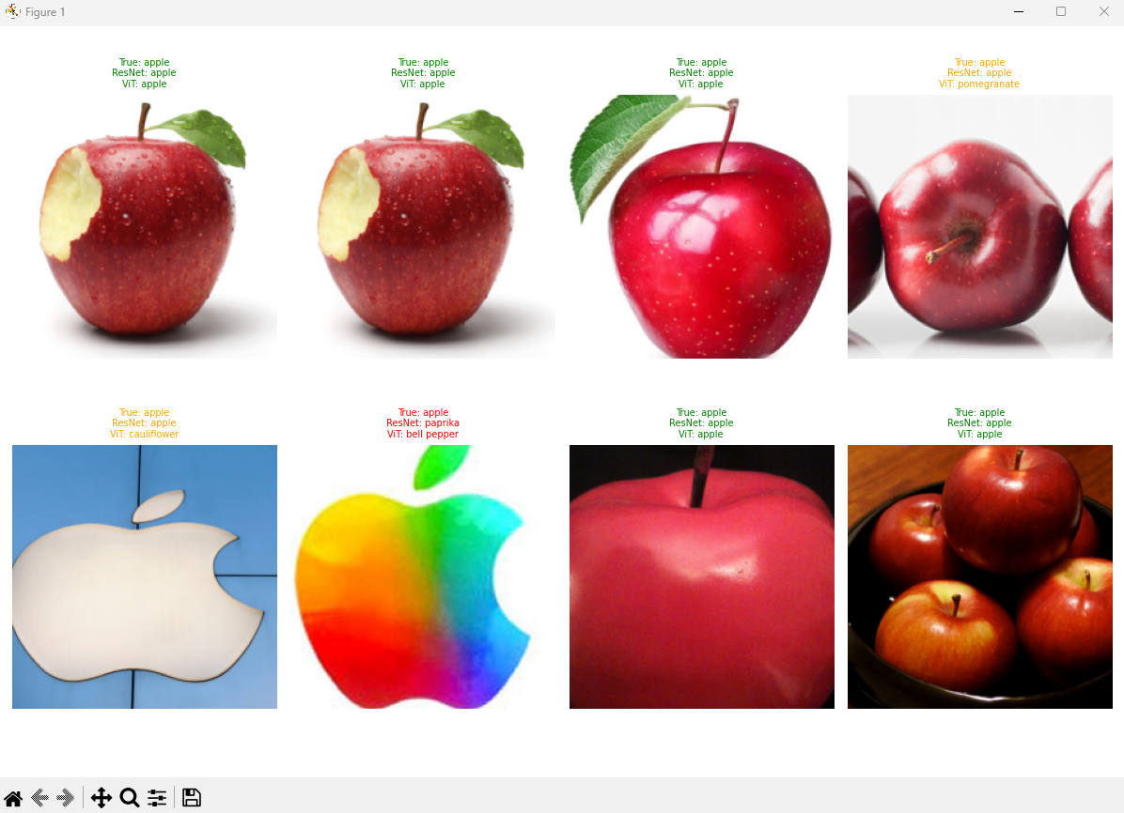
Figure 3: Results of ResNet18 vs ViT on test batch of 8 images
On five real-world phone camera photographs, ResNet18 classified all 5 correctly while the ViT correctly classified 2 of 5 (Figure 4):
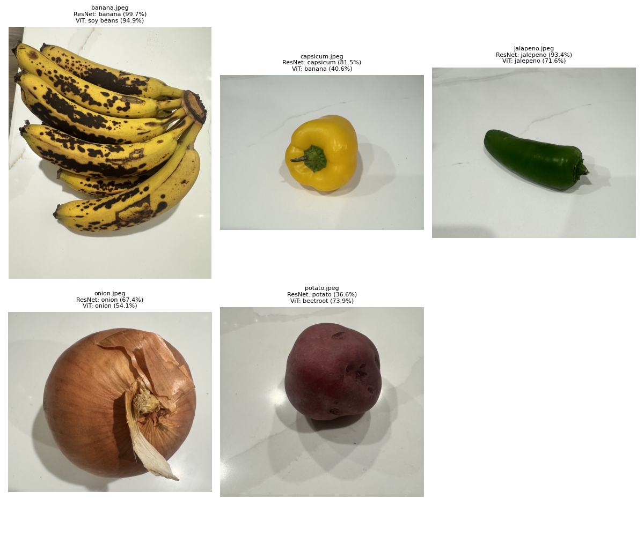
Figure 4: Results of ResNet18 vs ViT on real-world grocery images
V. DISCUSSION AND SUMMARY
The results show a clear winner, ResNet18. A 97.49% final accuracy versus 90.81% for the ViT is a substantial difference, and ResNet18 achieved it in only 15 total epochs compared to 35 for the ViT. This aligns with the finding from Dosovitskiy [2] that transformers require substantially more data or pretraining to match CNN performance. The grocery dataset is not nearly large enough to fully learn the global relationships that ViTs rely on.
The categories where both models struggled (apple, potato, banana) tend to be visually ambiguous or similar to other classes. Apple images varied across red and green varieties, potato shared texture with turnip, beets and sweet potato, banana had several color variations. These cases likely require higher resolution, stronger augmentation, or fine-grained attention mechanisms to resolve reliably.
The real-world photo test further exposed the superiority of ResNet18’s performance. ViT was sensitive to background clutter, variation in color and non-standard lighting whereas ResNet18 was able to successfully categorize all 5 real-world images.
The next natural step could include exploring pretrained ViT weights (e.g., ViT-B/16 from ImageNet-21k) rather than training from scratch, which would likely close or even reverse the accuracy gap. Adding stronger augmentation techniques could also make the models more robust to real-world variation.
Metric | ResNet18 | ViT (scratch)
Test accuracy | 97.49% | 90.81%
Total epochs | 15 | 35
Classes at 100% | 29/36 | 18/36
Real-photo accuracy | 5/5 | 2/5
Training approach | Transfer learning | From scratch
Table 5: Summary of ResNet18 and ViT Results

References
[1] H. Touvron, M. Cord, M. Douze, F. Massa, A. Sablayrolles, and H. Jégou, "Training Data-Efficient Image Transformers & Distillation Through Attention," in Proc. 38th Int. Conf. Machine Learning (ICML), PMLR, vol. 139, 2021, pp. 10347–10357
[2] A. Dosovitskiy, L. Beyer, A. Kolesnikov, D. Weissenborn, X. Zhai, T. Unterthiner, M. Dehghani, M. Minderer, G. Heigold, S. Gelly, J. Uszkoreit, and N. Houlsby, "An Image is Worth 16x16 Words: Transformers for Image Recognition at Scale," in Proc. Int. Conf. Learning Representations (ICLR), 2021.
[3] M. Klasson, C. Zhang and H. Kjellström, "A Hierarchical Grocery Store Image Dataset With Visual and Semantic Labels," 2019 IEEE Winter Conference on Applications of Computer Vision (WACV), Waikoloa, HI, USA, 2019, pp. 491-500, doi: 10.1109/WACV.2019.00058.
[4] Bossard, L., Guillaumin, M., Van Gool, L. (2014). Food-101 – Mining Discriminative Components with Random Forests. In: Fleet, D., Pajdla, T., Schiele, B., Tuytelaars, T. (eds) Computer Vision – ECCV 2014. ECCV 2014. Lecture Notes in Computer Science, vol 8694. Springer, Cham.
[5] K. Seth, "Fruit and Vegetable Image Recognition Dataset," Kaggle,2020. https://www.kaggle.com/datasets/kritikseth/fruit-and-vegetable-image-recognition

