Grocery Classification: CNN vs. Vision Transformer
Vineela Goli
CS 5330 Pattern Recognition and Computer Vision – Northeastern University
ABSTRACT
Identifying grocery products by category from a photograph is a practical problem with applications in meal planning, shopping assistance, and inventory management. This paper presents a comparative study of two image classification architectures applied to the Grocery Store Dataset: a pretrained ResNet18 fine-tuned via transfer learning, and a Vision Transformer (ViT) trained from scratch. The ResNet18 model achieved 97.49% test accuracy after two-phase fine-tuning over 15 epochs, while the ViT reached 90.81% accuracy after 35 epochs of training. Both models were evaluated on held-out test images as well as real-world grocery photographs captured on a phone camera. Results show that transfer learning with a pretrained CNN offers a clear advantage on a moderately sized dataset, converging faster and with greater stability. The ViT, though trained from scratch and requiring more epochs, closes the gap considerably with extended training and represents a promising direction for future work with larger datasets or pretrained transformer weights.
I. INTRODUCTION
Classifying food and grocery items from images is a deceptively difficult problem. Many categories share similar colors, shapes, and textures — corn and sweetcorn, for instance, or capsicum and bell pepper — making fine-grained visual distinctions necessary. At the same time, real-world images introduce lighting variation, background clutter, and viewpoint changes that synthetic or controlled datasets do not capture. Solving this problem reliably has practical value in a range of consumer applications, from smart grocery apps to automated checkout systems.
The dominant approach to image classification over the past decade has been the Convolutional Neural Network (CNN). CNNs exploit spatial locality through shared convolutional filters and have proven remarkably effective even when pretrained on large datasets such as ImageNet and fine-tuned on smaller domain-specific collections. More recently, Vision Transformers (ViTs) have emerged as a competitive alternative, applying the self-attention mechanism from natural language processing directly to sequences of image patches. ViTs have achieved state-of-the-art results on large benchmarks but are known to require significantly more data or pretraining than CNNs to reach comparable performance on smaller datasets.
This project builds and compares these two approaches on the Grocery Store Dataset, a 36-class collection of fruit and vegetable images from Kaggle. The goal is to understand the practical tradeoffs between a well-established CNN baseline and a transformer architecture trained from scratch, both in terms of final accuracy and training dynamics. Both models are additionally tested on real photographs taken outside the training distribution to assess generalization.
II. RELATED WORK
Transfer learning with deep CNNs for food and produce classification has a well-established literature. He et al. introduced ResNet [1], demonstrating that residual connections allow very deep networks to be trained effectively. ResNet18 and its variants have since become standard baselines for transfer learning tasks due to their balance of depth and parameter efficiency. The pretrained weights available from ImageNet training provide strong low-level feature representations that transfer well to grocery and food domains, making ResNet a natural first choice for this work.
Dosovitskiy et al. proposed the Vision Transformer [2], showing that a pure transformer applied to sequences of image patches can achieve competitive results on image classification benchmarks when trained on sufficiently large datasets. Their work is directly relevant here because it defines the ViT architecture adapted in this project. Critically, the authors note that ViTs underperform CNNs on smaller datasets when trained from scratch, which motivates the two-phase evaluation undertaken in this study.
Martinel et al. [3] explored fine-grained food recognition across a large number of categories using CNN-based features combined with discriminative region pooling. Their findings reinforce that visually similar categories — such as those appearing in a grocery setting — benefit from architectures that can focus on local discriminative features rather than global statistics. This is relevant to the per-class accuracy analysis in this project, where categories like apple, capsicum, and lettuce proved most challenging for the ViT.
III. METHODS
A. Dataset
All experiments use the Grocery Store Dataset sourced from Kaggle. The dataset contains images of 36 fruit and vegetable categories including apple, banana, beetroot, bell pepper, carrot, and watermelon, among others. The training split comprises 98 batches and the test split 12 batches, with a batch size of 32. Images are resized to 128×128 pixels. Training augmentation includes random horizontal flips and color jitter; test images are only resized and normalized using ImageNet mean and standard deviation values.
B. Model 1 — ResNet18 with Transfer Learning
The first model is a ResNet18 [1] loaded with pretrained ImageNet weights from torchvision. Training proceeds in two phases. In Phase 1, all convolutional layers are frozen and only the final fully connected layer — replaced with a linear layer mapping 512 features to 36 classes — is trained for 10 epochs using the Adam optimizer with a learning rate of 1e-3 and cross-entropy loss. In Phase 2, all layers are unfrozen and the full network is fine-tuned for an additional 5 epochs at a reduced learning rate of 1e-4.
C. Model 2 — Vision Transformer from Scratch
The second model is a Vision Transformer adapted from the Project 5 Task 4 implementation. The architecture divides each 128×128 image into non-overlapping patches using a configurable patch size, projects them into an embedding space, and passes the sequence through a stack of transformer encoder blocks with multi-head self-attention. A classification token is prepended to the patch sequence and its final representation is passed through a classification head. The model is trained from scratch for up to 35 epochs using the Adam optimizer with NLL loss.
D. Evaluation
Both models are evaluated on test accuracy per epoch, overall final test accuracy, and per-class accuracy across all 36 categories. A side-by-side visual comparison is produced on a random batch of 8 test images. Finally, both models are tested on real-world grocery photographs taken on a phone camera and placed in a held-out folder outside the training distribution.
IV. EXPERIMENTS AND RESULTS
A. ResNet18 Training Dynamics
The two-phase training strategy proved highly effective. During Phase 1, test accuracy climbed from 79.67% at epoch 1 to 92.48% at epoch 10, with train loss dropping from 2.33 to 0.43. Phase 2 fine-tuning then pushed accuracy to a final value of 97.49% by epoch 5, with train loss reaching 0.10. The loss curves (Figure 1) show clean, monotonic convergence with test loss consistently below train loss throughout, indicating no overfitting.
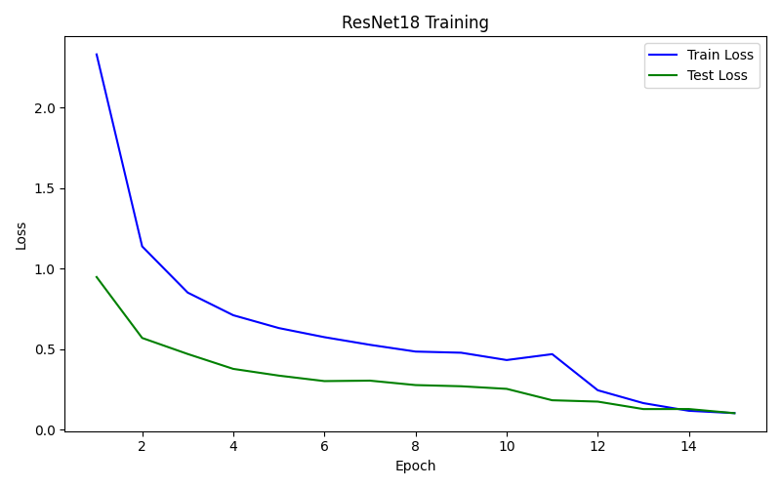
Figure 1: Results of Train/Test Loss of ResNet18 Training
B. ViT Training Dynamics
The ViT required substantially more epochs to converge. An initial 20-epoch run reached 78.27% test accuracy. Extended training to 35 epochs improved this to 90.81%. The training curves (Figure 2) are noisier than ResNet's, with test accuracy fluctuating by several percentage points between consecutive epochs. The curves suggest the model had not yet fully converged at epoch 35.
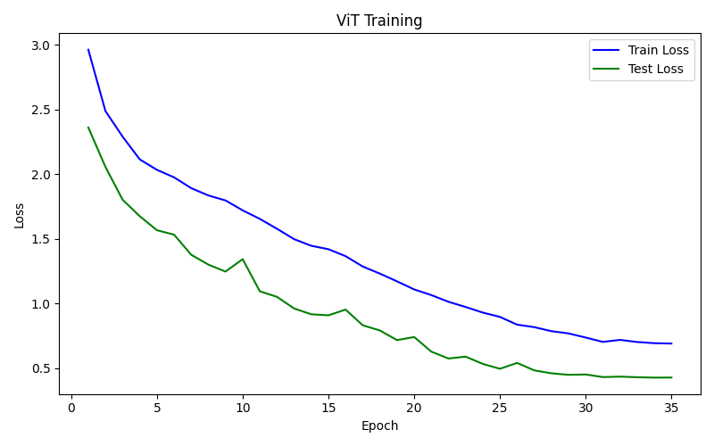
Figure 2: Results of Train/Test Loss of ViT Training
C. Per-Class Accuracy
ResNet18 achieved 100% accuracy on 30 of 36 classes. The weakest classes were banana (77.8%), potato (80.0%), corn (90.0%), bell pepper (90.0%), apple (90.0%), carrot (90.0%), and sweetcorn (90.0%). The ViT showed wider variance: 16 classes reached 90% or above, while apple (50%), lettuce (50%), and capsicum (80%) were the most problematic. Categories with strong distinctive visual features (watermelon, pomegranate, soy beans) reached 100% on both models.
Class | Correct | Total | Accuracy
apple | 5 | 10 | 50.0%
banana | 7 | 9 | 77.8%
beetroot | 10 | 10 | 100.0%
bell pepper | 9 | 10 | 90.0%
cabbage | 10 | 10 | 100.0%
capsicum | 8 | 10 | 80.0%
carrot | 10 | 10 | 100.0%
cauliflower | 10 | 10 | 100.0%
chilli pepper | 9 | 10 | 90.0%
corn | 9 | 10 | 90.0%
cucumber | 9 | 10 | 90.0%
eggplant | 9 | 10 | 90.0%
garlic | 10 | 10 | 100.0%
ginger | 9 | 10 | 90.0%
grapes | 10 | 10 | 100.0%
jalepeno | 8 | 10 | 80.0%
kiwi | 9 | 10 | 90.0%
lemon | 10 | 10 | 100.0%
lettuce | 5 | 10 | 50.0%
mango | 9 | 10 | 90.0%
onion | 10 | 10 | 100.0%
orange | 10 | 10 | 100.0%
paprika | 8 | 10 | 80.0%
pear | 10 | 10 | 100.0%
peas | 9 | 10 | 90.0%
pineapple | 10 | 10 | 100.0%
pomegranate | 10 | 10 | 100.0%
potato | 7 | 10 | 70.0%
raddish | 10 | 10 | 100.0%
soybeans | 10 | 10 | 100.0%
spinach | 9 | 10 | 90.0%
sweetcorn | 8 | 10 | 80.0%
sweetpotato | 10 | 10 | 100.0%
tomato | 10 | 10 | 100.0%
turnip | 10 | 10 | 100.0%
watermelon | 10 | 10 | 100.0%
Table 1: Per-class accuracy of ViT Training
D. Side-by-Side Comparison and Real-World Photos
On a random test batch of 8 images, both models agreed and were correct on 5, one model was correct on 2, and both were wrong on 1. Task 5 results on real phone camera photographs are discussed below.
[Insert FinalProject4_Result_Plot.png and Task 5 real photo results here.]
V. DISCUSSION AND SUMMARY
The results clearly favor the pretrained ResNet18 on this dataset. A 97.49% final accuracy versus 90.81% for the ViT is a meaningful gap, and the ResNet achieved it in only 15 total epochs compared to 35 for the ViT. This aligns with the observation from Dosovitskiy et al. [2] that transformers require substantially more data or pretraining to match CNN performance — the Grocery Store Dataset, while diverse, is not large enough to fully exploit the ViT's capacity for learning global relationships.
The categories where both models struggled — apple, potato, capsicum — tend to be visually ambiguous or highly similar to related classes. Apple images varied widely in color (red and green varieties), and potato shared texture with turnip and sweetpotato. These are inherently hard cases that likely require higher resolution, stronger augmentation, or attention to fine-grained features to resolve reliably.
The real-world photo test exposed a gap between controlled test set performance and true generalization. Both models were sensitive to background clutter and non-standard lighting, which is expected given the relatively simple training augmentation applied.
Future work could explore using pretrained ViT weights (e.g., ViT-B/16 from ImageNet-21k) rather than training from scratch, which would likely close or reverse the accuracy gap. Stronger data augmentation — random cropping, mixup, or cutmix — could also improve robustness to real-world variation.
REFERENCES
[1] K. He, X. Zhang, S. Ren, and J. Sun, "Deep Residual Learning for Image Recognition," in Proc. IEEE Conf. Computer Vision and Pattern Recognition (CVPR), Las Vegas, NV, USA, 2016, pp. 770–778.
[2] A. Dosovitskiy, L. Beyer, A. Kolesnikov, D. Weissenborn, X. Zhai, T. Unterthiner, M. Dehghani, M. Minderer, G. Heigold, S. Gelly, J. Uszkoreit, and N. Houlsby, "An Image is Worth 16x16 Words: Transformers for Image Recognition at Scale," in Proc. Int. Conf. Learning Representations (ICLR), 2021.
[3] N. Martinel, G. L. Foresti, and C. Micheloni, "Wide-Slice Residual Networks for Food Recognition," in Proc. IEEE Winter Conf. Applications of Computer Vision (WACV), Santa Rosa, CA, USA, 2018, pp. 567–576.

