DATA ANALYTICS WITH TABLEAU

PULUSU BABY VINEELA

ASSIGNMENT – 4

Task - 1:

FIXED LOD:

A FIXED LOD expression in Tableau computes a value using a specific dimension(s) regardless of the visualization's level of detail. This means that even if you are aggregating data at a certain level of detail in your visualization, a FIXED LOD expression will compute the value based on the specified dimension(s) independently. Essentially, this expression calculates the total sales for each unique combination of Category and Region in your dataset, independently of any other dimensions or filters applied to your visualization.

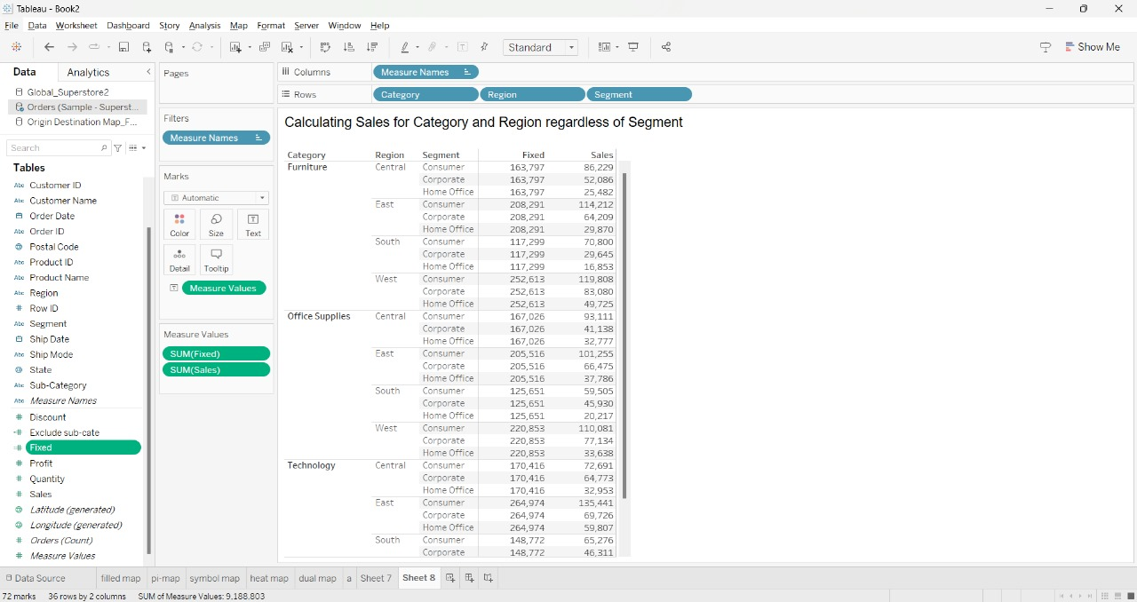

Fig:1

EXCLUDE LOD:

The EXCLUDE LOD (Level of Detail) expression is used to compute a value while excluding a specific dimension from the computation. This means that the calculation will be performed at a level of detail that excludes the specified dimension. Essentially, this expression calculates the total profit across all Sub-Categories, regardless of how Sub-Categories are aggregated in your visualization. It allows you to see the total profit at a higher level of granularity than Sub-Categories. Top of Form

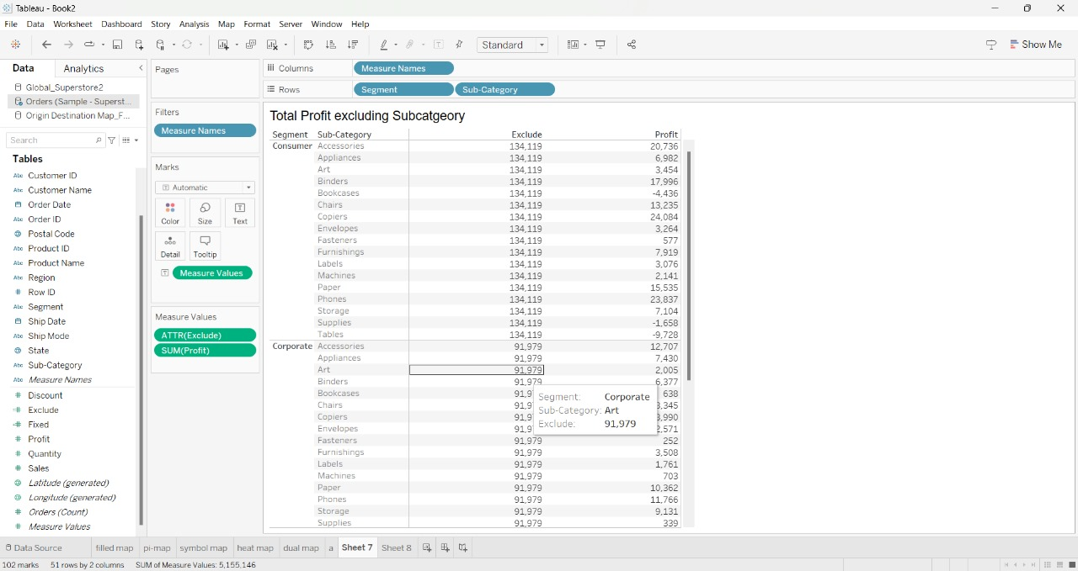

Fig:2

Task - 2:

Dual Maps:

Dual maps combine synchronized Google maps, Google Street View into one embeddable control. These maps are free to use.

Combines a heat map and a symbol map to visualize sales data effectively. This allows viewers to gain insights into sales patterns both geographically and by the size of sales.

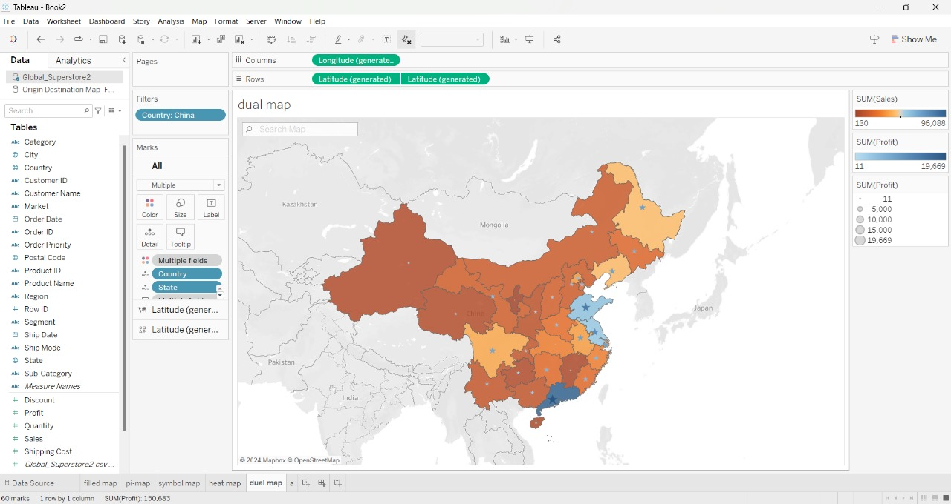

Fig:3

Heat Map:

Heat map is a visual representation of set of values in a specific order.

Tableau to visualize sales data geographically, allowing you to identify patterns and trends across different locations.

It is a geographical representation of profit in each state on geo map:

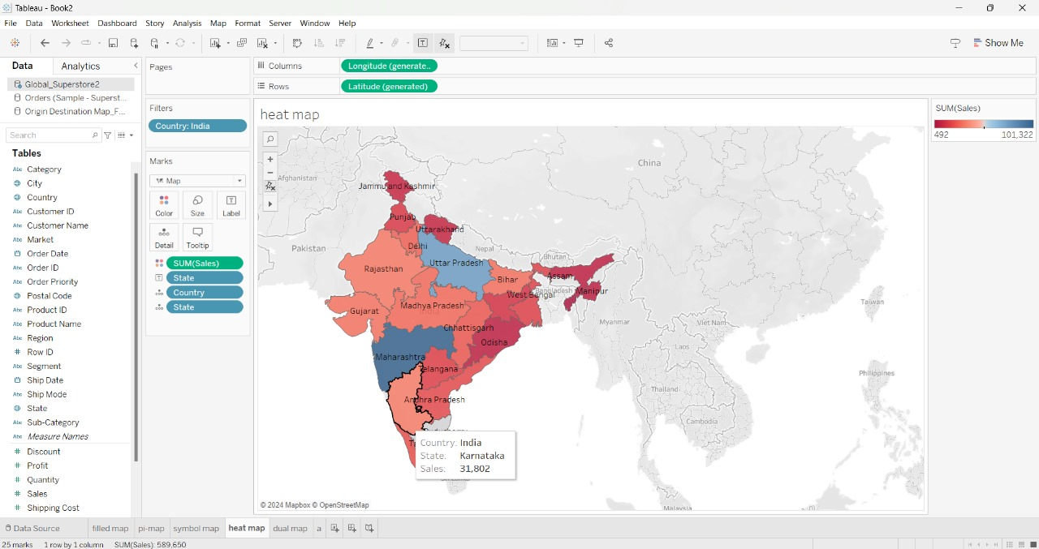

Fig:4

Task - 3:

PARAMETERS:

In this visualization we created the parameter of top sales sub-categories by clicking the dropdown option beside the search box. We added measure values such as Top 15, Top 10 and Top 5 to parameters. Now we took the sales into the Column and Sub-Category into the row. and dragged the Sub-Category into filters and in top option selected created parameter that is top Sales it shows top sales Sub-Category and from parameter clicked on show parameter .

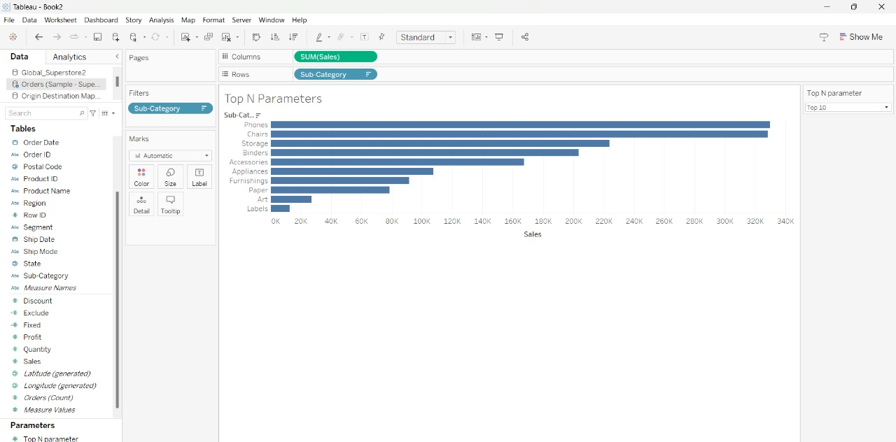

Fig:5