WEEK-2

**JUnit Testing Exercises**

**Exercise 1: Setting Up JUnit**

CalculatorTest.java:

package com.example;

import static org.junit.Assert.assertEquals;

import org.junit.Test;

public class CalculatorTest {

    @Test

    public void testAddition() {

        int result = 2 + 3;

        assertEquals(5, result);

    }

}

**Output:**

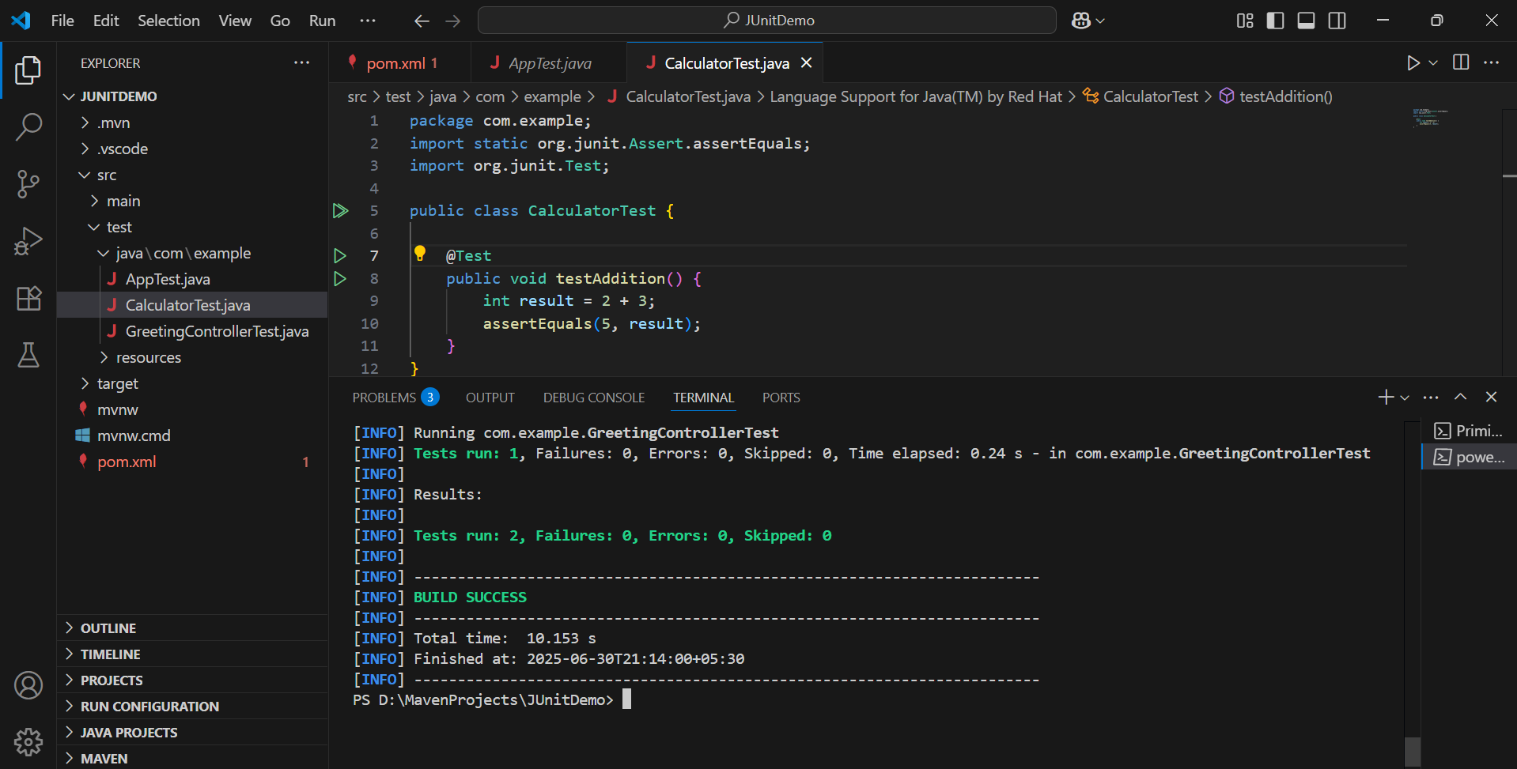

**Exercise 3: Assertions in Junit**

AssertionsTest.java:

package com.example;

import static org.junit.Assert.assertEquals;

import static org.junit.Assert.assertFalse;

import static org.junit.Assert.assertNotNull;

import static org.junit.Assert.assertNull;

import static org.junit.Assert.assertTrue;

import org.junit.Test;

public class AssertionsTest {

    @Test

    public void testAssertions() {

        // Assert equals

        assertEquals(5, 2 + 3);

        // Assert true

        assertTrue(5 > 3);

        // Assert false

        assertFalse(5 < 3);

        // Assert null

        assertNull(null);

        // Assert not null

        assertNotNull(new Object());

    }

}

**Output:**

