WEEK-7

**9. ReactJS-HOL**

**ListofPlayers.js:**import React from 'react';

function ListofPlayers({ players }) {

  return (

    <div>

      {players.map((item) => (

        <li key={item.name}>Mr. {item.name} <span>{item.score}</span></li>

      ))}

    </div>

  );

}

export default ListofPlayers;

**Scorebelow70.js:**  
import React from 'react';

function Scorebelow70({ players }) {

  const players70 = [];

  players.map((item) => {

    if (item.score < 70) {

      players70.push(item);

    }

    return null;

  });

  return (

    <div>

      {players70.map((item) => (

        <li key={item.name}>Mr. {item.name} <span>{item.score}</span></li>

      ))}

    </div>

  );

}

export default Scorebelow70;

**ListofIndianPlayers.js:**  
import React from 'react';

function ListofIndianPlayers({ IndianPlayers }) {

  return (

    <div>

      {IndianPlayers.map((player, index) => (

        <li key={index}>Mr. {player}</li>

      ))}

    </div>

  );

}

export default ListofIndianPlayers;

**OddPlayers.js:**  
import React from 'react';

export function OddPlayers([first, , third, , fifth]) {

  return (

    <div>

      <li>First: {first}</li>

      <li>Third: {third}</li>

      <li>Fifth: {fifth}</li>

    </div>

  );

}

export function EvenPlayers([, second, , fourth, , sixth]) {

  return (

    <div>

      <li>Second: {second}</li>

      <li>Fourth: {fourth}</li>

      <li>Sixth: {sixth}</li>

    </div>

  );

}

**App.js:**import React from 'react';

import ListofPlayers from './Components/ListofPlayers';

import Scorebelow70 from './Components/Scorebelow70';

import { OddPlayers, EvenPlayers } from './Components/OddPlayers';

import ListofIndianPlayers from './Components/ListofIndianPlayers';

function App() {

  const flag = true;

  const players = [

    { name: "Jack", score: 50 },

    { name: "Michael", score: 70 },

    { name: "John", score: 40 },

    { name: "Ann", score: 61 },

    { name: "Elisabeth", score: 61 },

    { name: "Sachin", score: 95 },

    { name: "Dhoni", score: 100 },

    { name: "Virat", score: 84 },

    { name: "Jadeja", score: 64 },

    { name: "Raina", score: 75 },

    { name: "Rohit", score: 80 }

  ];

  const IndianTeam = ["Sachin", "Dhoni", "Virat", "Rohit", "Yuvaraj", "Raina"];

  const T20Players = ["First Player", "Second Player", "Third Player"];

  const RanjiTrophyPlayers = ["Fourth Player", "Fifth Player", "Sixth Player"];

  const IndianPlayers = [...T20Players, ...RanjiTrophyPlayers];

  if (flag === true) {

    return (

      <div>

        <h1>List of Players</h1>

        <ListofPlayers players={players} />

        <hr />

        <h1>List of Players having Scores Less than 70</h1>

        <Scorebelow70 players={players} />

      </div>

    );

  } else {

    return (

      <div>

        <div>

          <h1>Indian Team</h1>

          <h1>Odd Players</h1>

          <OddPlayers {...[IndianTeam]} />

          <hr />

          <h1>Even Players</h1>

          <EvenPlayers {...[IndianTeam]} />

        </div>

        <hr />

        <div>

          <h1>List of Indian Players Merged:</h1>

          <ListofIndianPlayers IndianPlayers={IndianPlayers} />

        </div>

      </div>

    );

  }

}

export default App;

**Output if flag = true:  
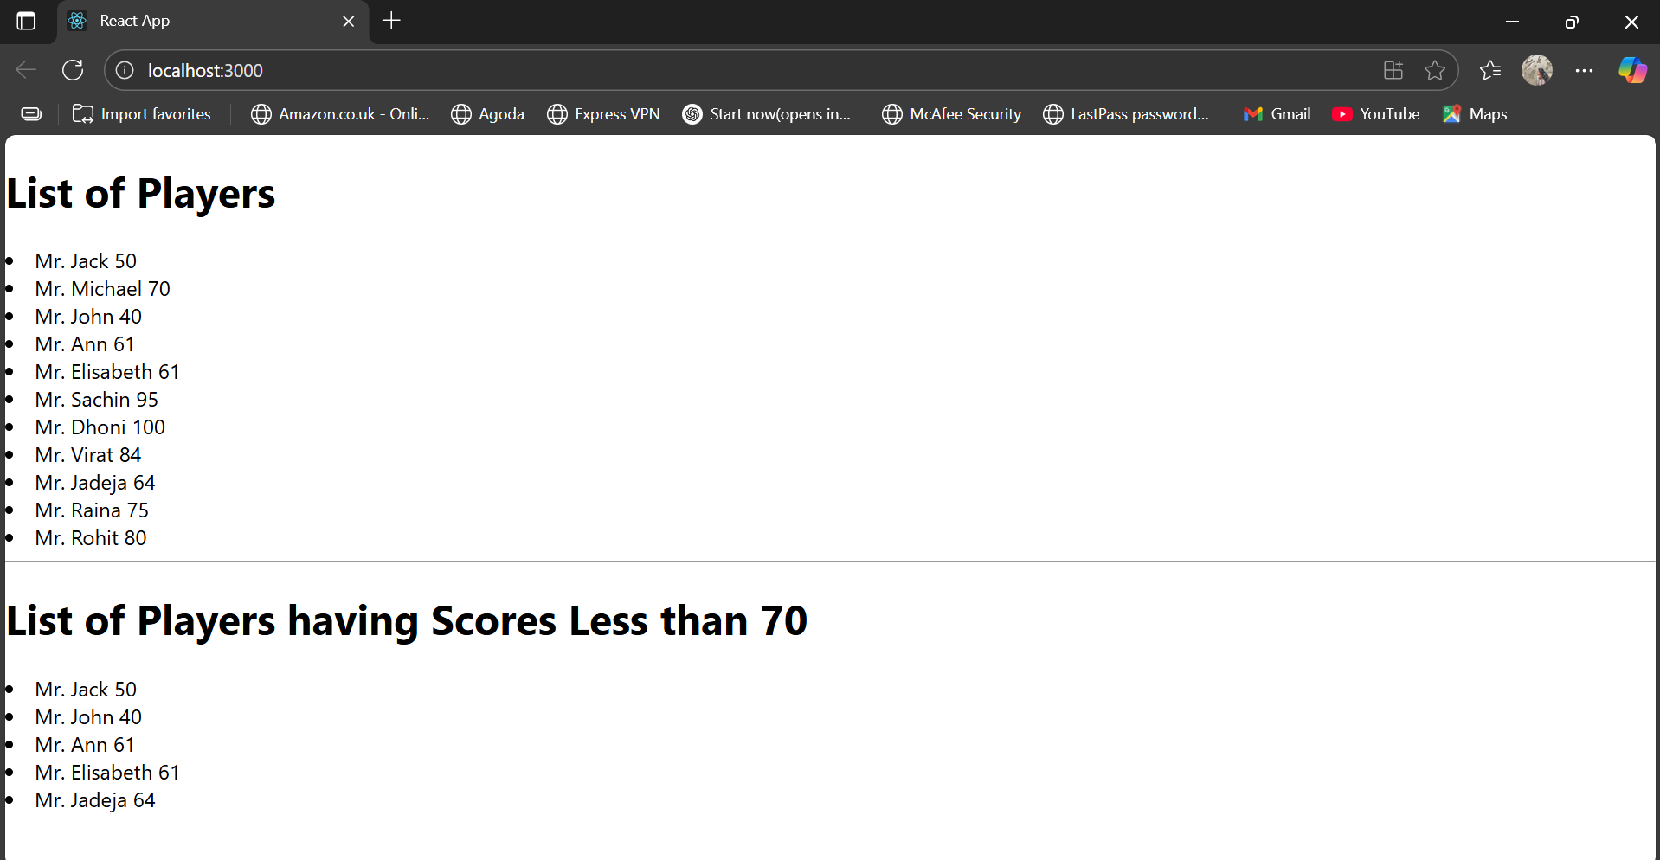**

**Output if flag = false:**

