Phase 3 — Step-by-step Implementation (Data Modeling & Relationships)

# Step 1 — Plan Objects & Fields

* 1.1 Identify standard objects to use: Case, Account, Contact, User, Queue.
* 1.2 Define custom objects: RoutingRule c, PriorityMatrix c, Feedback c.
* 1.3 List required custom fields (Category c, Severity c, Assigned_Agent c, Resolution_Time c, External_Reference_ID c).

# Step 2 — Create Fields in Setup

* 2.1 Go to Setup  Object Manager  Case  Fields & Relationships  New.
* 2.2 Add Category c as Picklist (values: Billing, Technical, Account Access, etc.).
* 2.3 Add Severity c as Picklist (Low, Medium, High, Critical).
* 2.4 Add Assigned_Agent c as Lookup(User) and Resolution_Time c as Number.
* 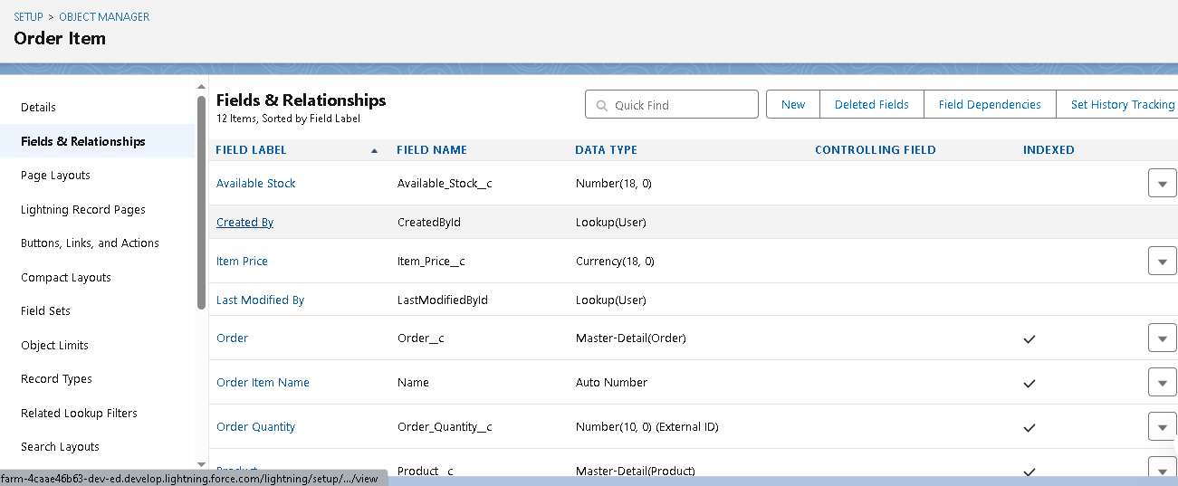

# Step 3 — Configure Record Types

* 3.1 Setup  Object Manager  Case  Record Types  New.
* 3.2 Create 'Customer Support Case', 'Internal IT Request', 'Escalated Case'.
* 3.3 Assign Record Types to profiles (Support Agent, Manager) and set default picklists per type.

# Step 4 — Customize Page Layouts

* 4.1 Setup  Object Manager  Case  Page Layouts  Edit the main layout.
* 4.2 Add fields: Category c, Severity c, Assigned_Agent c, Resolution_Time c.
* 4.3 Add Related Lists: Feedback, Routing History, CaseAssignment c.

# Step 5 — Create Compact Layouts

* 5.1 Setup  Object Manager  Case  Compact Layouts  New.
* 5.2 Include: Case Number, Category, Severity, Status, Assigned Agent for mobile highlights.
* 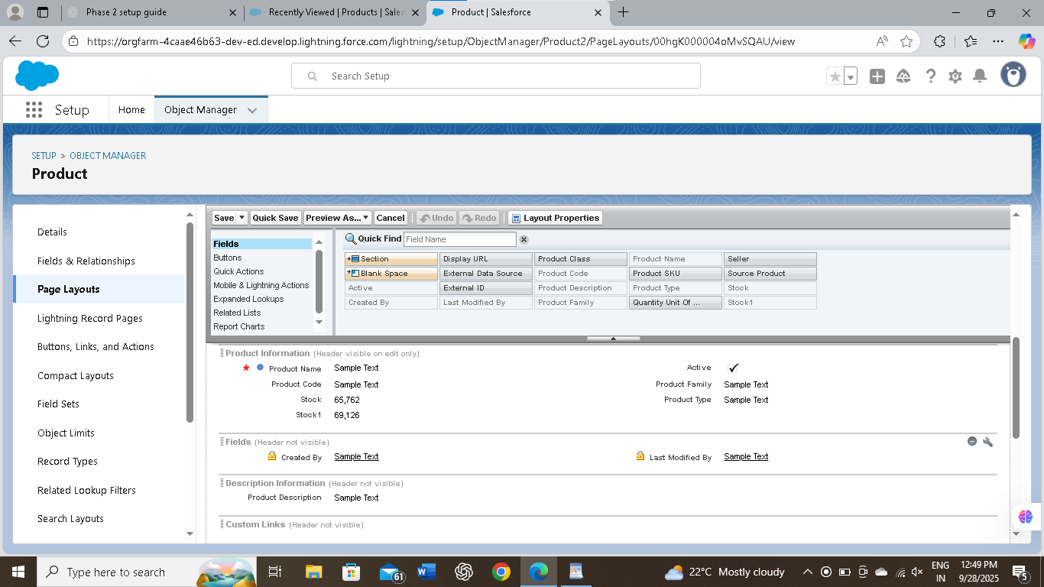

# Step 6 — Define Relationships

* 6.1 Create Master-Detail: Feedback c  Case (child records deleted with parent).
* 6.2 Create Lookup: Case  User (Assigned_Agent c), Case  Account, Case  Contact.
* 6.3 Use hierarchical on User to model manager  agent reporting if needed.

# Step 7 — Create Junction Object for Flexible Routing

* 7.1 Create CaseAssignment c with two lookup fields: Case c and RoutingRule c.
* 7.2 Add CaseAssignment c related lists to Case and RoutingRule page layouts.
* 7.3 Use it so a single case can match multiple routing rules and vice versa.

# Step 8 — Schema Builder Validation

* 8.1 Open Setup  Schema Builder.
* 8.2 Drag required objects onto canvas and visually confirm relationships.
* 8.3 Save and note any orphaned fields or missing links for cleanup.

# Step 9 — External Objects & Integration Mapping (Optional)

* 9.1 Create Named Credential and External Data Source for external ticket/chat platforms.
* 9.2 Expose External_Case_Data x and map External_Reference_ID c to external IDs.
* 9.3 Test read-only/external lookups before relying on them in routing logic.

# Step 10 — Testing & Sample Data

* 10.1 Create sample Accounts, Contacts, Cases, RoutingRule c, and CaseAssignment c records.
* 10.2 Simulate case creation with different Category and Severity values.
* 10.3 Verify case is routed to correct Queue/Assigned_Agent c per rules.

# Step 11 — Data Import & External ID Mapping

* 11.1 Use Data Loader or Import Wizard to bulk import Accounts/Contacts using External_Reference_ID c as External ID.
* 11.2 Map products or third-party records to Salesforce records using External IDs.
* 11.3 Validate imported records and correct any mapping errors.

# Step 12 — Profiles, Permissions & Deployment

* 12.1 Assign Record Types and Page Layouts to profiles (Support Agent, Manager).
* 12.2 Create Permission Sets for access to custom objects/fields as needed.
* 12.3 Deploy from sandbox to production using Change Sets or SFDX; run post-deployment smoke tests.

# Step 13 — Monitoring, Reports & Feedback Loop

* 13.1 Build reports: Cases by Queue, Average Resolution_Time c by Category, RoutingRule matches.
* 13.2 Create dashboards for support managers (backlog, SLA breaches, agent workload).
* 13.3 Use Feedback c data to refine PriorityMatrix c and routing criteria iteratively.