Phase 4 — Process Automation (Step-by-step)

# Step 1 — Plan Automations & Objectives

* 1.1 Identify key automation goals: faster assignment, SLA enforcement, automatic escalation, and reporting.
* 1.2 Map events that trigger automations: Case creation, status changes, SLA breaches, customer replies.
* 1.3 Choose tools: Record-Triggered Flows (preferred), Assignment Rules, Omni-Channel, Entitlements & Milestones.

# Step 2 — Create Validation Rules (Data Integrity)

* 2.1 Setup  Object Manager  Case  Validation Rules  New.
* 2.2 Example: Require Category on new cases:

Formula: AND(ISPICKVAL(Status, 'New'), ISBLANK(TEXT(Category c))) Error: 'Please select a Category for new cases.'

* 2.3 Example: Prevent closing without resolution:

Formula: AND(ISPICKVAL(Status, 'Closed'), ISBLANK(Resolution_Notes c))

Error: 'Add resolution notes before closing this case.'

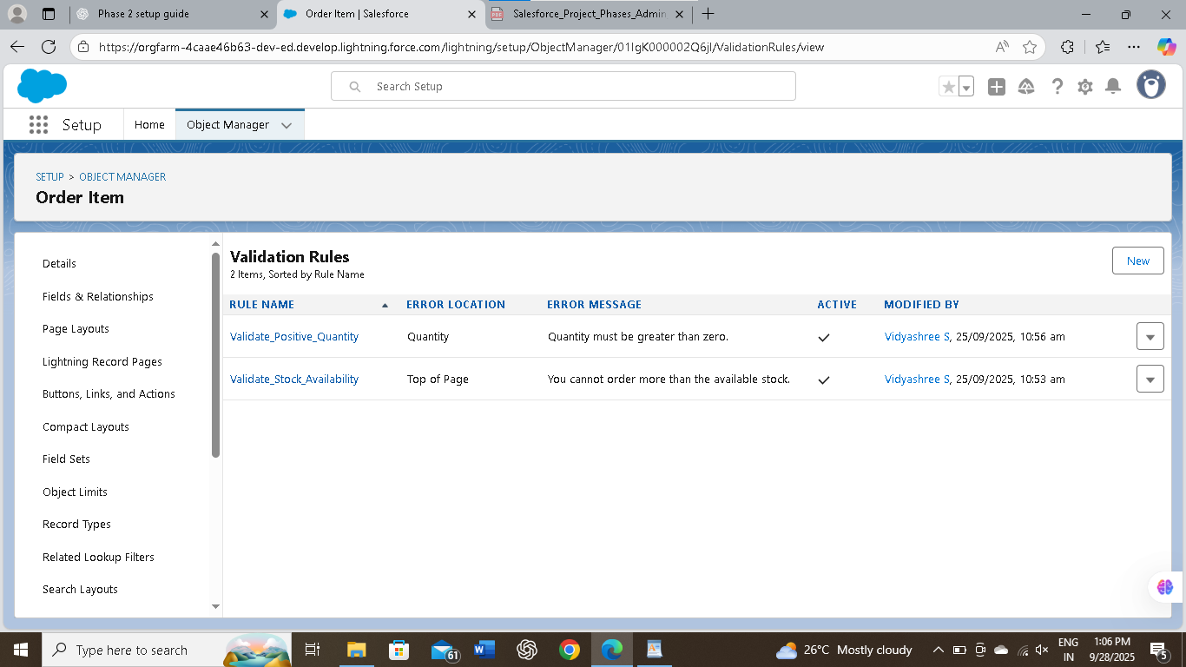

# Step 3 — Build Case Assignment Rules (basic routing)

* 3.1 Setup  Case Assignment Rules  New Rule  Name it (e.g., 'Initial Routing').
* 3.2 Add Rule Entries with order: criteria by Category, Severity, Product, or Account Type.
* 3.3 For each entry, set Assignment To  Queue or User and enable 'Assign using active assignment rule' on case creation where needed.
* 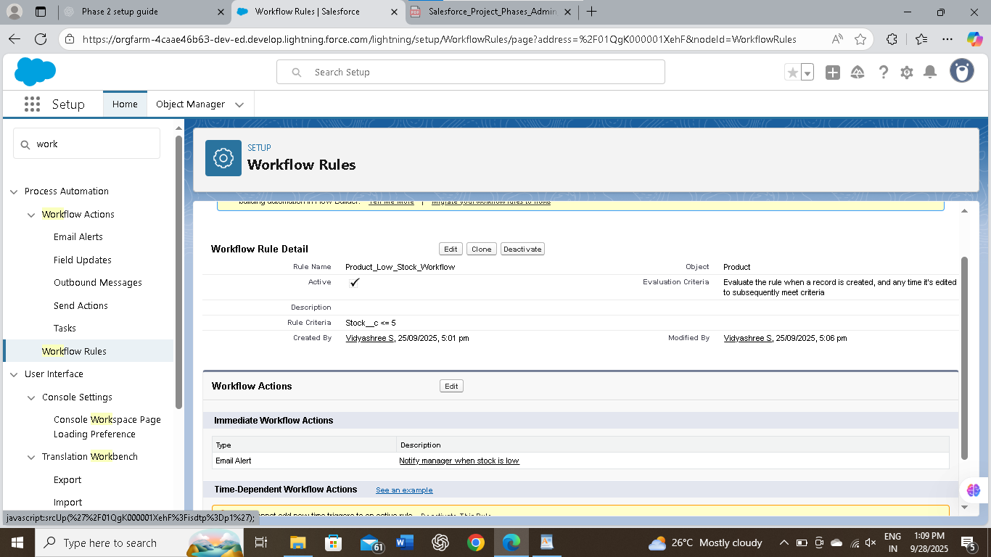
* 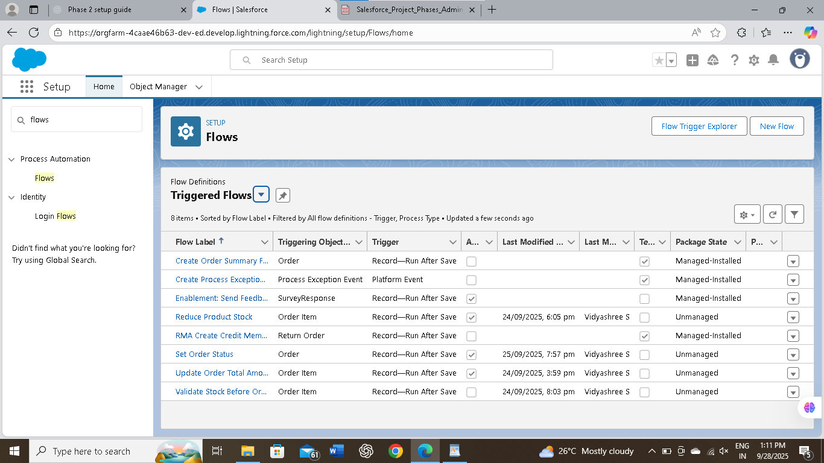

# Step 4 — Set Up Omni■Channel & Routing Configs (real-time agent routing)

* 4.1 Setup  Omni-Channel  Service Channels  New (Service Channel = 'Cases').
* 4.2 Setup  Omni-Channel  Routing Configurations  New (set routing model: Least Active, Most Available, or Priority).
* 4.3 Create Presence Statuses & Presence Configurations; set user capacities and assign to agents.
* 4.4 Create Queues (Support Tier 1, Tier 2, Escalation) and associate them with Routing Configurations.

# Step 5 — Create Skills for Skills■based Routing (optional)

* 5.1 Setup  Skills  New Skill (e.g., 'Billing', 'Technical', 'Spanish').
* 5.2 Assign Skills to Users (Agent Profiles) and to Cases using a lookup or custom field.
* 5.3 Use Routing Configs that respect Skills for match-based routing via Omni-Channel.

# Step 6 — Build Record■Triggered Flows for Smart Assignment

* 6.1 Setup  Flows  New  Record-Triggered Flow (Case)  Trigger on Create and Update (as needed).
* 6.2 Add Decision element to evaluate Category, Severity, SLA and custom RoutingRule c matches.
* 6.3 Use Update Records (Change Owner) to assign OwnerId to User or Queue OR use 'Change Record Owner' action.
* 6.4 Create a CaseAssignment c record (log) for audit: fields Case c, RoutingRule c, AssignedTo c.
* 6.5 Optionally call 'Send Notification' actions or create Tasks for the newly assigned agent.

# Step 7 — Implement SLA Enforcement with Entitlements & Milestones

7.1 Setup  Entitlements  New Entitlement Process (e.g., 'Standard Support SLA').

* 7.2 Create Milestones: 'First Response' (1 hour), 'Resolve' (72 hours).
* 7.3 Configure Milestone Actions: Email Alert, Post-Update, or Escalate Owner when missed.
* 7.4 Attach Entitlement to Cases automatically via Flow or Process when case meets criteria.

# 

# Step 8 — Time■Based Flows & Escalation Paths

* 8.1 Use Scheduled Paths in Record-Triggered Flows for time-based checks (e.g., 30 min, 4 hours).
* 8.2 Scheduled Path example: If First Response milestone not completed within 60 minutes  Update Owner to Escalation Queue and send notification.
* 8.3 Alternatively, use Case Escalation Rules (Setup  Case Escalation Rules) for classic time-based escalations.
* 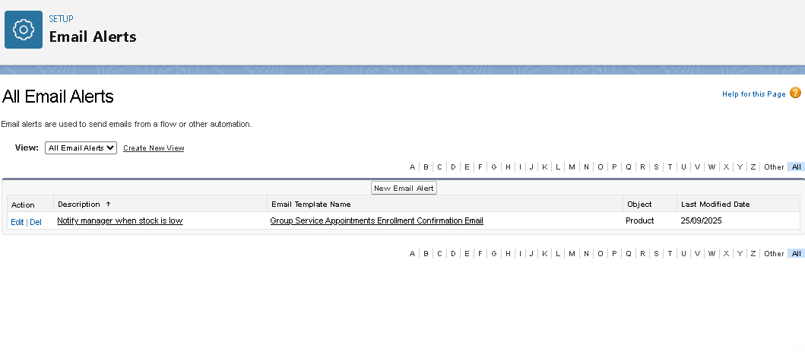

# Step 9 — Approval Process for Special Exceptions

* 9.1 Setup  Approval Processes  Case  New Approval Process (e.g., 'Refund/Escalation Approval').
* 9.2 Define entry criteria (Case Type = 'Refund' OR Severity = 'Critical').
* 9.3 Define Approvers (Manager) and post-approval actions (Change Status to 'Escalated' or assign to specialist).

# Step 10 — Notifications, Email Alerts & Templates

* 10.1 Create Email Templates (Classic or Lightning Email Templates) for assignments and SLA breach alerts.
* 10.2 Setup  Email Alerts  New: Tie to Flow or Escalation actions.
* 10.3 Create Custom Notifications (Setup  Notifications) and use Flow action 'Send Custom Notification' for in-app alerts.

# Step 11 — Auto■Tasks & Follow■ups

* 11.1 Use Flow to Create Task on case assignment (Subject: 'Acknowledge Case', Due Date: Today + 1 hour).
* 11.2 Auto-create follow-up tasks when milestones are missed to ensure handoff tracking.

# Step 12 — Testing (Sandbox) & Test Cases

* 12.1 Create a matrix of test cases: combinations of Category, Severity, Account Type, and Customer SLA.
* 12.2 Test each path: assignment rule, flow decision branch, Omni-Channel routing, scheduled path escalation, and approval flow.
* 12.3 Verify audit logs: CaseAssignment c entries, Owner changes, email notifications, and milestones triggered.

# Step 13 — Reports, Dashboards & Monitoring

* 13.1 Build Reports: 'Unassigned Cases by Queue', 'SLA Breaches', 'Average First Response Time by Agent', 'RoutingRule Matches'.
* 13.2 Create Dashboards for Support Managers to monitor backlog, SLA breaches, and agent load.
* 13.3 Schedule report subscriptions and alerts for SLA breach thresholds

# Step 14 — Deploy, Train & Iterate

* 14.1 Migrate Flows, Assignment Rules, Email Templates from Sandbox to Production using Change Sets or SFDX.
* 14.2 Provide agent training documentation and run a pilot with a small team.
* 14.3 Collect feedback (Feedback c) and iterate on RoutingRule c and PriorityMatrix c regularly.

# Step 15 — Security, Permissions & Rollback Plan

* 15.1 Ensure profiles and permission sets allow 'Assign Cases', 'Run Flows', 'Edit Case' as required.
* 15.2 Set Flow version management and maintain rollback procedures (deactivate new flow versions if needed).
* 15.3 Keep backups of critical configuration metadata and document changes.