Intelligent Case Routing for Faster Customer Support

# Phase 7: Integration & External Access

* Named Credentials – Secure authentication storage for APIs.
* External Services – Connect Salesforce to external APIs (OpenAPI schema).
* Web Services (REST/SOAP) – Consume or expose Salesforce data.
* 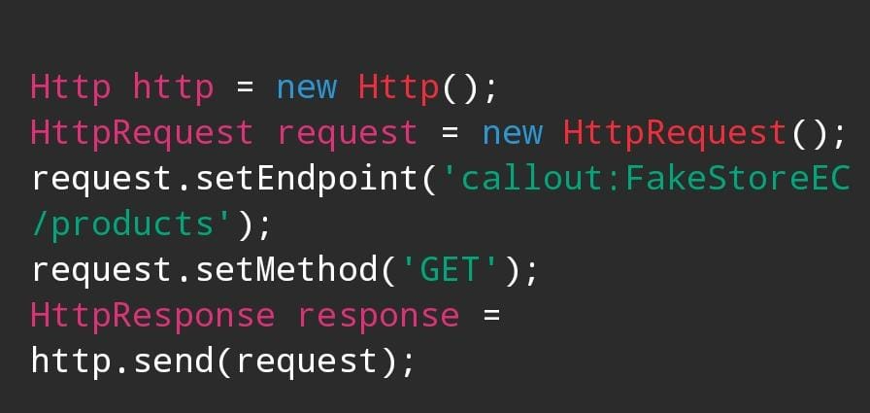
* Callouts – Trigger external APIs from Apex or Flows.
* Platform Events – Event-driven routing in real-time.
* Change Data Capture – Keep Salesforce and external data in sync.
* Salesforce Connect – Access external databases without duplication.
* API Limits – Monitor and optimize API consumption.
* OAuth & Authentication – Secure Connected Apps for integrations.
* Remote Site Settings – Whitelist external endpoints for callouts.

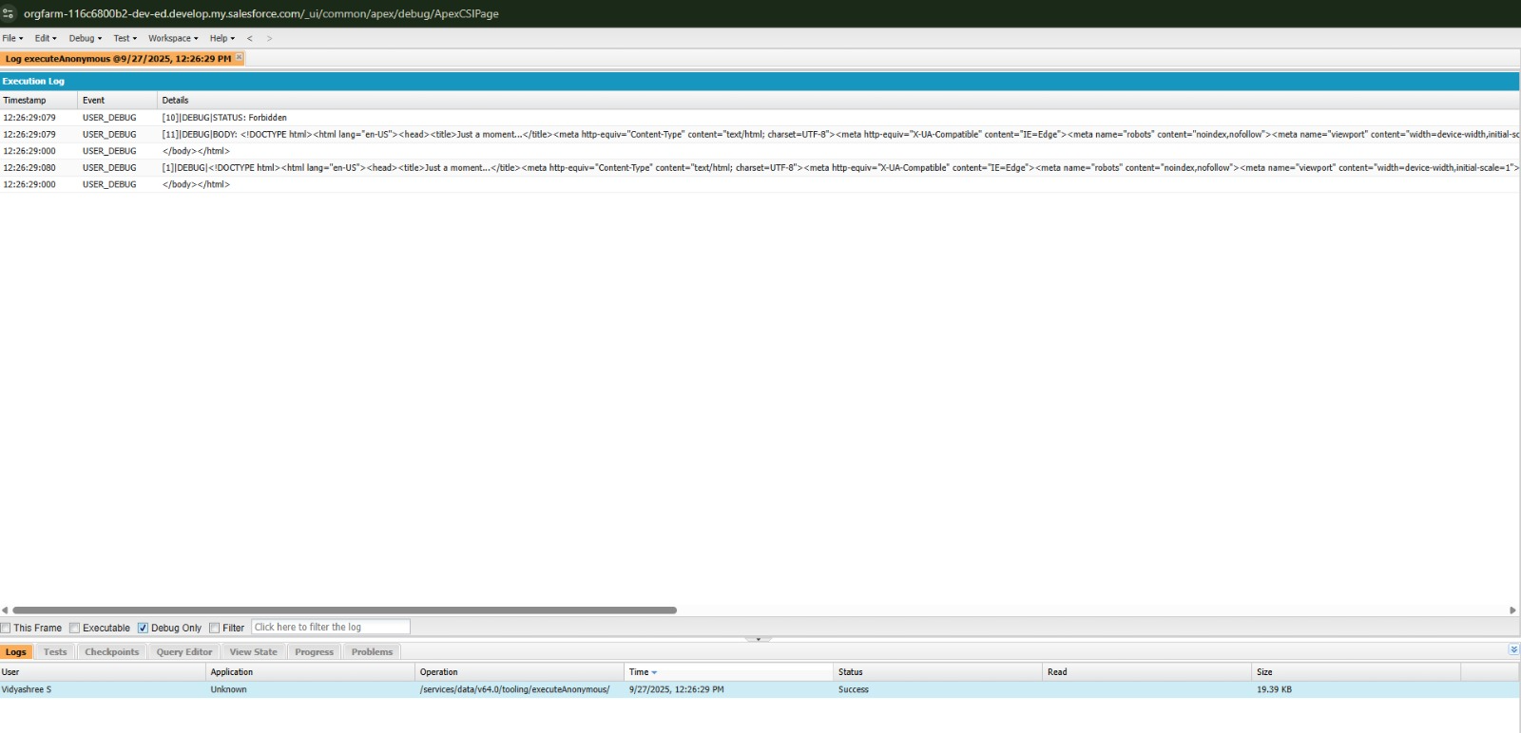

# Phase 8: Data Management & Deployment

* Data Import Wizard – Simple CSV imports for test/training data.
* Data Loader – Bulk uploads/exports for historical cases.
* Duplicate Rules – Prevent duplicate cases affecting routing.
* Data Export & Backup – Regular exports for disaster recovery.
* 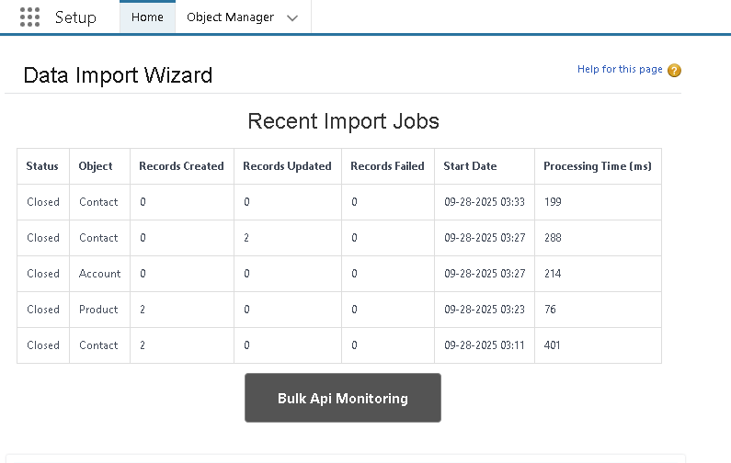
* Change Sets – Deploy routing automation between environments.
* Unmanaged vs Managed Packages – Choose packaging for reuse.
* ANT Migration Tool – Automate metadata deployments.
* VS Code & SFDX – Modern CI/CD and source control integration.
* 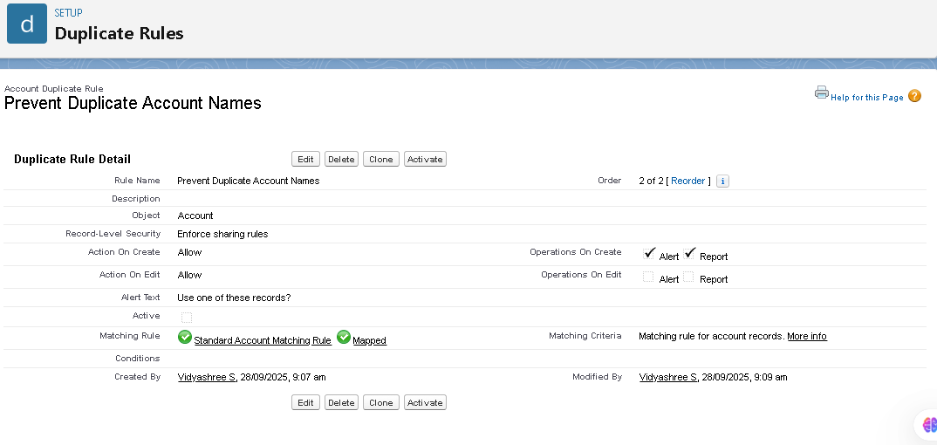

# Phase 9: Reporting, Dashboards & Security Review

* Reports – Tabular, Summary, Matrix, and Joined for routing analysis.
* Report Types – Custom report types for routing metrics.
* Dashboards – Visualize routing performance and SLA compliance.
* Dynamic Dashboards – Personalized dashboards for managers/agents.
* Sharing Settings – Configure case record visibility.
* 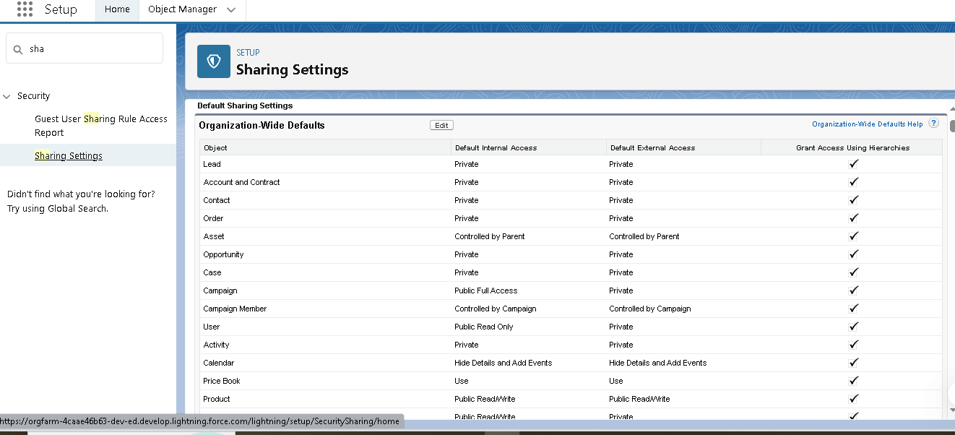
* Field Level Security – Protect sensitive case fields.
* Session Settings – Enforce secure login/session behavior.
* Login IP Ranges – Restrict access for admins/integration users.
* Audit Trail – Track changes to routing logic and integrations.
* 