Phase 2 — Salesforce Org Setup & Configuration

Project: Intelligent Case Routing for Faster Customer Support

This document summarizes the work performed in Phase 2 of the capstone: setting up the Salesforce Developer Org and configuring the resources required for the Intelligent Case Routing project. It includes step-by-step actions completed and a screenshot of the custom object & fields created for routing configuration.

## Step 1 — Sign up & Login

Signed up for a Salesforce Developer Edition and logged into the Lightning Experience. Confirmed access to the Setup area using the gear icon (⚙️).

## Step 2 — Open Setup & Object Manager

From Setup, opened Object Manager to create and manage custom objects. This is where the custom object for routing configuration was created.

## Step 3 — Create Custom Object

Created a custom object to hold routing configurations. Object name shown in Object Manager: IntelligentCaseRouting (API name: Intelligent_Case_Routing__c). Enabled 'Allow Reports' and configured record name and description.

## Step 4 — Add Fields & Relationships (Key fields added)

Added the most important fields required for intelligent routing and project tracking. The fields created include Project/record identifiers, routing controls, and ownership fields. See the screenshot below showing the Fields & Relationships list for the object.

## Screenshot — Object: Fields & Relationships

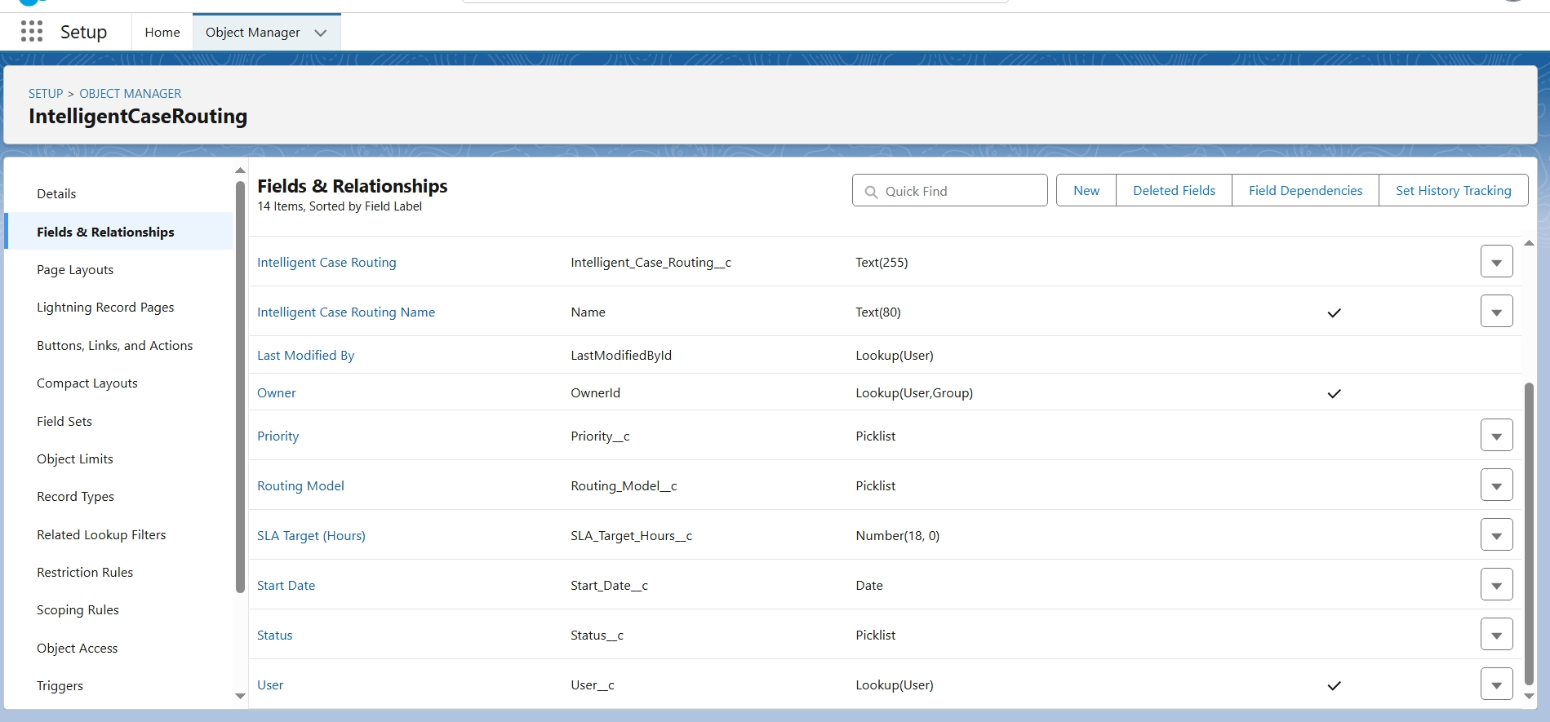

## Summary of Important Fields Created (from screenshot)

|  |  |  |
| --- | --- | --- |
| Field Label | API Name | Type |
| Intelligent Case Routing | Intelligent_Case_Routing__c | Text (255) |
| Intelligent Case Routing Name | Name | Text (80) |
| Last Modified By | LastModifiedById | Lookup(User) |
| Owner | OwnerId | Lookup(User,Group) |
| Priority | Priority__c | Picklist |
| Routing Model | Routing_Model__c | Picklist |
| SLA Target (Hours) | SLA_Target_Hours__c | Number |
| Start Date | Start_Date__c | Date |
| Status | Status__c | Picklist |
| User | User__c | Lookup(User) |

## Step 5 — Create Custom Tab

Created a Custom Object Tab for the 'Project Details' / 'IntelligentCaseRouting' object so it appears in the App navigation. Selected a tab icon and set default visibility for required profiles.

## Step 6 — Add Tab to Lightning App

Opened App Manager → Edit the Lightning App → Navigation Items and added the custom object tab to the selected items so users can access it from the app navigation bar.

## Step 7 — Field Level Security & Page Layouts

Configured Field-Level Security for relevant profiles and added fields to the page layout. Ensured managers and admins have visibility and edit rights as needed.

## Step 8 — Profiles & Permission Sets

Assigned access to System Administrator and created/used custom profiles or permission sets to grant the required object permissions (Read/Create/Edit). Recommended creating a Support Manager profile or a permission set for managers.

## Step 9 — Validation & Testing

Added validation rules and tested record creation. Created sample records to confirm the fields, lookups, and related lists are working as intended.

## Step 10 — Documentation & Repository

Captured screenshots (like the one included), documented steps in a README, and uploaded assets to the project repository under a folder such as /Phase2_Salesforce_Setup/.

## Notes / Recommendations

• Use Permission Sets where possible instead of editing profiles for quick access control.  
• Use the custom object to store routing configurations and link cases using a Lookup(Case) if you need to associate projects with cases.  
• Build simple reports and a dashboard to monitor SLA breaches, routing performance, and project status.  
• Keep screenshots and the step-by-step guide in your repository to support your project submission.

