Step-by-Step Process for Intelligent Case Routing for Faster Customer Support

# Phase 1 — Goals, scope & KPIs

* Identify channels (email, phone, chat, social, web form, API) and languages to route.
* Define success KPIs: First Response Time (FRT), Mean Time To Resolution (MTTR), SLA breach rate, assignment accuracy, agent utilization, case re-routing rate.
* Identify constraints (PII, regulatory zones, working hours, skills).
* Document stakeholder owners (support managers, data science, IT, legal).
* Deliverables: problem statement, acceptance criteria, placement matrix.

# Phase 2 — Data collection & preparation

* Export historical case dataset with fields like subject, description, priority, channel, etc.
* Clean text, redact PII, normalize fields, handle missing labels.
* Label engineering: ensure routing target labels are reliable.
* Create training, validation, and test splits.
* Deliverables: cleaned dataset, data dictionary, baseline routing confusion matrix.

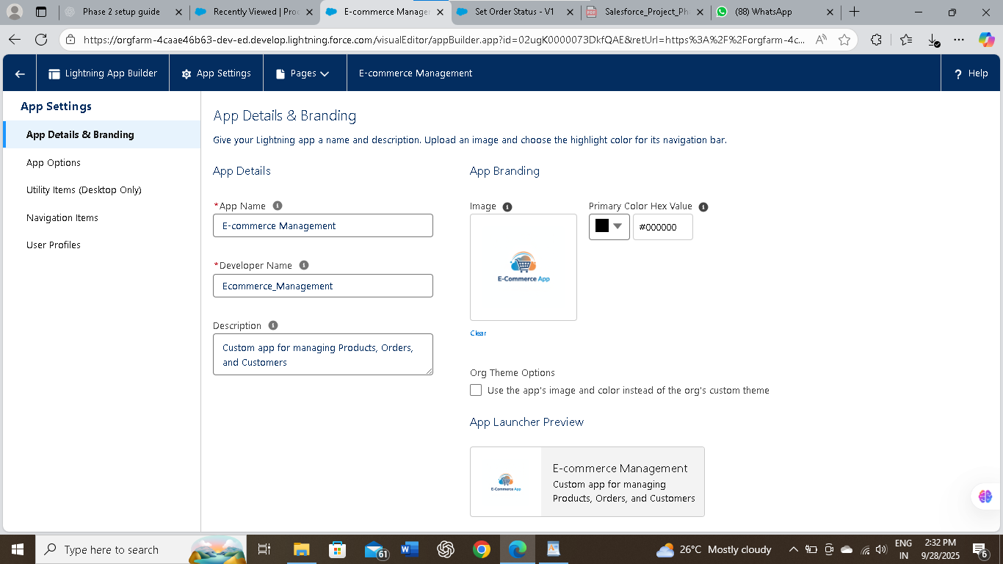

# Phase 3 — Design routing strategy (rules + ML hybrid)

* Create deterministic rules for high-certainty cases (VIP, legal, SLA).
* Use ML recommendations for ambiguous cases.
* Define fallback flows for low confidence predictions.
* Set confidence thresholds for auto-assign vs. human review.
* Deliverables: routing decision matrix, thresholds, fallback plan.

# Phase 4 — Build & evaluate ML/NLP models

* Feature set: tokenized subject+description, embeddings, channel, language, product.
* Choose models: XGBoost, LightGBM, or transformer-based text classifiers.
* Monitor metrics: precision, recall, F1, top-1/top-3 accuracy.
* Perform error analysis and human-in-loop validation.
* Deliverables: trained model, evaluation report, sample outputs.

# Phase 5 — Salesforce implementation & orchestration

* Configure deterministic rules in Assignment Rules and Flows.
* Use Omni-Channel with Skills-based routing for specialized teams.
* Integrate ML (Einstein Case Classification or external service via Apex/Flow).
* Provide recommendations with confidence scores in UI.
* Deliverables: configured Omni-Channel, Apex/Flow integration, LWC triage component.

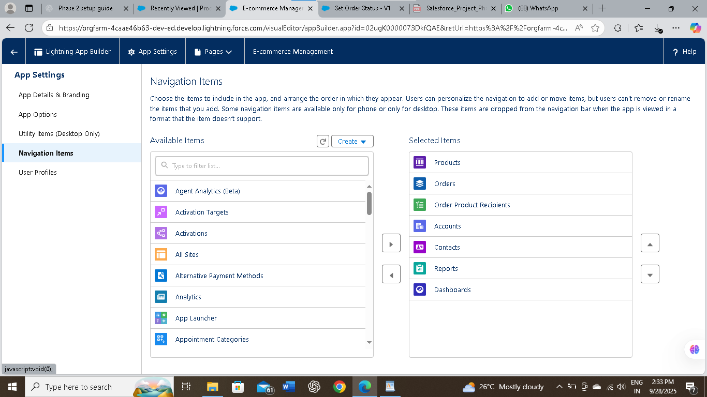

# Phase 6 — Agent UX & automation

# 

* Design triage Lightning Record Page with recommended queue, confidence, and reasons.
* Enable one-click Accept/Reject/Request Escalation actions.
* Notify via Slack/email for manual triage queues.
* Create macros and quick actions for fast responses.
* Deliverables: LWC Triage Panel, console utilities, macros.

# Phase 7 — Testing, pilot & rollout

* Run offline tests with Apex/Flow simulations.
* Pilot with limited case subset or channel.
* Compare KPIs between control and treatment groups.
* Collect agent feedback on routing accuracy and usability.
* Deliverables: pilot performance report, updated rules.

# Phase 8 — Monitoring, feedback loop & improvement

* Create dashboards for routing latency, SLA, assignment acceptance.
* Log model predictions, inputs, and overrides for retraining.
* Set retraining cadence and drift detection triggers.
* Perform periodic bias, fairness, and privacy audits.
* Deliverables: monitoring dashboards, retraining playbook, audit logs.

