7. Write a C program for the following ciphertext was generated using a simple substitution algorithm. 53‡‡†305))6*;4826)4‡.)4‡);806*;48†8¶60))85;;]8*;:‡*8†83
(88)5*†;46(;88*96*?;8)*‡(;485);5*†2:*‡(;4956*2(5*—4)8¶8*
;4069285);)6†8)4‡‡;1(‡9;48081;8:8‡1;48†85;4)485†528806*81 (‡9;48;(88;4(‡?34;48)4‡;161;:188;‡?;

Program:-

def decrypt_substitution(ciphertext):
key = {
'5': 'a', '3': 'g', '‡': 'o', '†': 'd',
'0': 'l', ')': 's', '6': 'i', '*': 'n',
';': 't', '4': 'h', '8': 'e', '2': 'b',
'.': 'p', '¶': 'v', ']': 'w', ':': 'y',
'(': 'r', '9': 'm', '?': 'u', '—': 'c',
'1': 'f'
}
result = ""
for ch in ciphertext:
if ch in key:
result += key[ch]
elif ch.isspace():
continue
else:
result += ch
return result
ciphertext = input("Enter the ciphertext: ")
plaintext = decrypt_substitution(ciphertext)
print("\nDecrypted plaintext:")
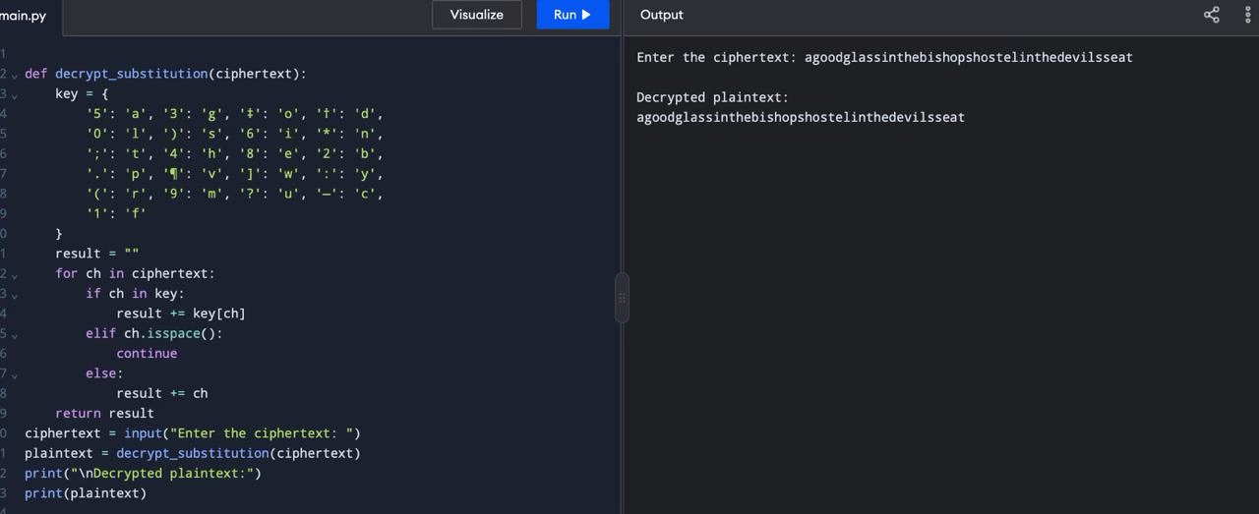
print(plaintext)

