11. Write a C program for possible keys does the Playfair cipher have? Ignore the fact that some keys might produce identical encryption results. Express your answer as an approximate power of 2.
a. Now take into account the fact that some Playfair keys produce the same encryption results. How many effectively unique keys does the Playfair cipher have? give python code for this

Program:-

import math
# Playfair cipher uses a 5 x 5 matrix
# I and J are treated as the same letter
n = 25
# Total possible keys: permutations of 25 letters
total_keys = math.factorial(n)
print("Total possible keys:", total_keys)
# Express the number of keys as an approximate power of 2
power = math.log2(total_keys)
print("Approximate power of 2: 2^", round(power, 2))
# Equivalent keys: transformations that produce the same encryption
# Each key has 25 possible starting positions and 8 symmetries
# (4 rotations and 4 reflections)
unique_keys = total_keys // (25 * 8)
print("\nApproximate effectively unique keys:", unique_keys)
print("Approximate unique keys as power of 2:",
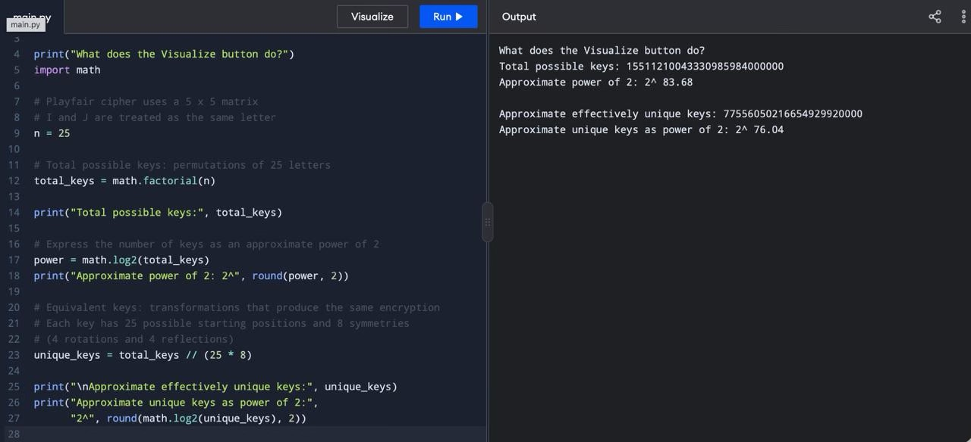
"2^", round(math.log2(unique_keys), 2))

