12.Write a C program to Encrypt the message “meet me at the usual place at ten rather than eight oclock” using the Hill cipher with the key.
9 4
5 7
a. Show your calculations and the result.
b. Show the calculations for the corresponding decryption of the ciphertext to recover the original plaintext.

Program:-

import string
K = [[9, 4],
[5, 7]]
# Plaintext
plaintext = "meet me at the usual place at ten rather than eight oclock"
plaintext = ''.join(c for c in plaintext.upper() if c.isalpha())
if len(plaintext) % 2 != 0:
plaintext += 'X'
def num(ch):
return ord(ch) - ord('A')
def char(n):
return chr((n % 26) + ord('A'))
# Encryption
ciphertext = ""
for i in range(0, len(plaintext), 2):
a = num(plaintext[i])
b = num(plaintext[i + 1])
c1 = (K[0][0] * a + K[0][1] * b) % 26
c2 = (K[1][0] * a + K[1][1] * b) % 26
ciphertext += char(c1) + char(c2)
print("Plaintext :", plaintext)
print("Ciphertext:", ciphertext)
K_inv = [[5, 12],
[15, 25]]
# Decryption
decrypted = ""
for i in range(0, len(ciphertext), 2):
a = num(ciphertext[i])
b = num(ciphertext[i + 1])
p1 = (K_inv[0][0] * a + K_inv[0][1] * b) % 26
p2 = (K_inv[1][0] * a + K_inv[1][1] * b) % 26
decrypted += char(p1) + char(p2)
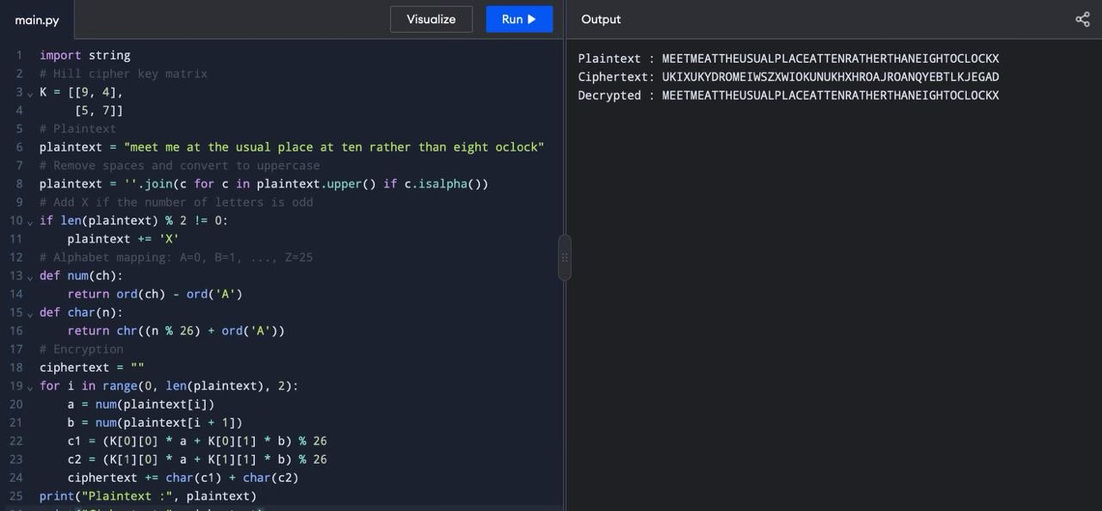
print("Decrypted :", decrypted

