13. Write a C program for Hill cipher succumbs to a known plaintext attack if sufficient plaintext– ciphertext pairs are provided. It is even easier to solve the Hill cipher if a chosen plaintext attack can be mounted.

Program:-

import numpy as np
MOD = 26
# Original Hill cipher key
K = np.array([[9, 4],
[5, 7]])
def text_to_numbers(text):
return [ord(ch.upper()) - ord('A')
for ch in text if ch.isalpha()]
def numbers_to_text(numbers):
return ''.join(chr(int(n) % 26 + ord('A'))
for n in numbers)
def encrypt_pair(pair, key):
P = np.array(pair).reshape(2, 1)
C = (key @ P) % MOD
return C.flatten().tolist()
def inverse_matrix_mod26(matrix):
a, b = matrix[0]
c, d = matrix[1]
det = (a * d - b * c) % MOD
det_inv = next((i for i in range(MOD)
if (det * i) % MOD == 1), None)
if det_inv is None:
raise ValueError("Matrix is not invertible modulo 26")
adj = np.array([[d, -b],
[-c, a]])
return (det_inv * adj) % MOD
def recover_key(P, C):
P_inv = inverse_matrix_mod26(P)
return (C @ P_inv) % MOD
# Known plaintext attack
plaintext = "BAAB"
p = text_to_numbers(plaintext)
# Arrange plaintext pairs as columns
P = np.array([[p[0], p[2]],
[p[1], p[3]]])
# Encrypt each pair using the secret key
c1 = encrypt_pair(p[0:2], K)
c2 = encrypt_pair(p[2:4], K)
ciphertext = numbers_to_text(c1 + c2)
C = np.array([[c1[0], c2[0]],
[c1[1], c2[1]]])
print("Known Plaintext:", plaintext)
print("Ciphertext:", ciphertext)
# Recover key
try:
recovered_key = recover_key(P, C)
print("\nRecovered Hill Cipher Key:")
print(recovered_key)
except ValueError as e:
print("Key recovery error:", e)
# Chosen plaintext attack
chosen_plaintext = "BAAB"
chosen = text_to_numbers(chosen_plaintext)
chosen_cipher = []
for i in range(0, len(chosen), 2):
chosen_cipher.extend(encrypt_pair(chosen[i:i+2], K))
print("\nChosen Plaintext:", chosen_plaintext)
print("Chosen Plaintext Ciphertext:",
numbers_to_text(chosen_cipher))
print("Secret Key:")
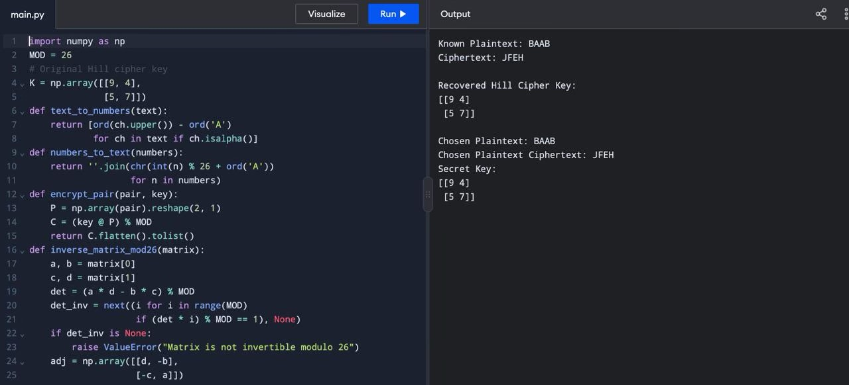
print(K)

