14. Write a C program for one-time pad version of the Vigenère cipher. In this scheme, the key is a stream of random numbers between 0 and 26. For example, if the key is 3 19 5 . . . , then the first letter of plaintext is encrypted with a shift of 3 letters, the second with a shift of 19 letters, the third with a shift of 5 letters, and so on.
a. Encrypt the plaintext send more money with the key stream
9 0 1 7 23 15 21 14 11 11 2 8 9
b. Using the ciphertext produced in part (a), find a key so that the cipher text decrypts to the plaintext cash not needed.

Program:-

def encrypt(plaintext, key):
result = ""
j = 0
for ch in plaintext.lower():
if ch.isalpha():
p = ord(ch) - ord('a')
c = (p + key[j]) % 26
result += chr(c + ord('a'))
j += 1
else:
result += ch
return result
def decrypt(ciphertext, key):
result = ""
j = 0
for ch in ciphertext.lower():
if ch.isalpha():
c = ord(ch) - ord('a')
p = (c - key[j]) % 26
result += chr(p + ord('a'))
j += 1
else:
result += ch
return result
# Part (a): Encrypt the plaintext
plaintext = "send more money"
key = [9, 0, 1, 7, 23, 15, 21, 14, 11, 11, 2, 8, 9]
ciphertext = encrypt(plaintext, key)
print("Part (a)")
print("Plaintext :", plaintext)
print("Key :", key)
print("Ciphertext:", ciphertext)
# Part (b): Find a key for the desired plaintext
desired_plaintext = "cash not needed"
# Remove spaces to match letters with the key stream
c_letters = [ord(ch) - ord('a')
for ch in ciphertext if ch.isalpha()]
p_letters = [ord(ch) - ord('a')
for ch in desired_plaintext if ch.isalpha()]
# New key = (ciphertext - desired plaintext) mod 26
new_key = [(c - p) % 26
for c, p in zip(c_letters, p_letters)]
new_ciphertext = encrypt(desired_plaintext, new_key)
print("\nPart (b)")
print("Desired plaintext:", desired_plaintext)
print("New key stream :", new_key)
print("Ciphertext :", new_ciphertext)
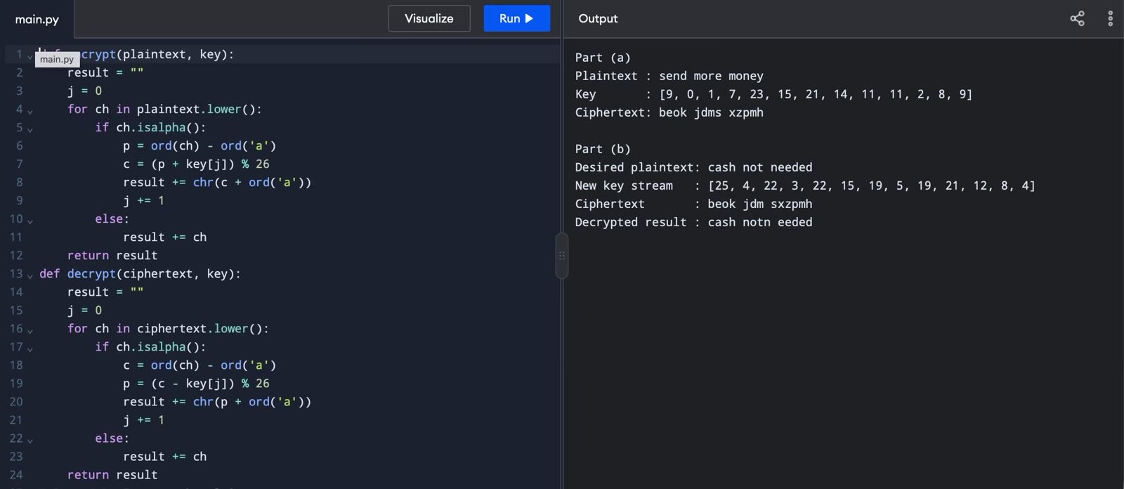
print("Decrypted result :", decrypt(ciphertext, new_key))

