15. Write a C program that can perform a letter frequency attack on an additive cipher without human intervention. Your software should produce possible plaintexts in rough order of likelihood. It would be good if your user interface allowed the user to specify “give me the top 10 possible plaintexts.”

Program:-

from collections import Counter

# English letter frequencies (approximate percentages)
english_freq = {
'E': 12.7, 'T': 9.1, 'A': 8.2, 'O': 7.5,
'I': 7.0, 'N': 6.7, 'S': 6.3, 'H': 6.1,
'R': 6.0, 'D': 4.3, 'L': 4.0, 'C': 2.8,
'U': 2.8, 'M': 2.4, 'W': 2.4, 'F': 2.2,
'G': 2.0, 'Y': 2.0, 'P': 1.9, 'B': 1.5,
'V': 1.0, 'K': 0.8, 'J': 0.15, 'X': 0.15,
'Q': 0.10, 'Z': 0.07
}

def decrypt(ciphertext, shift):
result = ""
for ch in ciphertext:
if ch.isalpha():
base = ord('A') if ch.isupper() else ord('a')
result += chr((ord(ch) - base - shift) % 26 + base)
else:
result += ch
return result

def score_text(text):
letters = [ch.upper() for ch in text if ch.isalpha()]
if not letters:
return 0

counts = Counter(letters)
total = len(letters)

# Compare observed frequencies with English frequencies
score = 0
for letter, frequency in english_freq.items():
observed = counts[letter] / total * 100
score += abs(observed - frequency)

return score

def frequency_attack(ciphertext, top_n=10):
results = []

for shift in range(26):
plaintext = decrypt(ciphertext, shift)
score = score_text(plaintext)
results.append((score, shift, plaintext))

# Lower frequency difference means a better candidate
results.sort(key=lambda item: item[0])

print(f"\nTop {min(top_n, 26)} possible plaintexts:\n")

for rank, (score, shift, plaintext) in enumerate(
results[:top_n], start=1):
print(f"{rank}. Shift = {shift}, "
f"Score = {score:.2f}")
print(f" Plaintext: {plaintext}\n")

# Get input from user
ciphertext = input("Enter ciphertext: ")
top_n = int(input("How many possible plaintexts? (1-26): "))

top_n = max(1, min(top_n, 26))
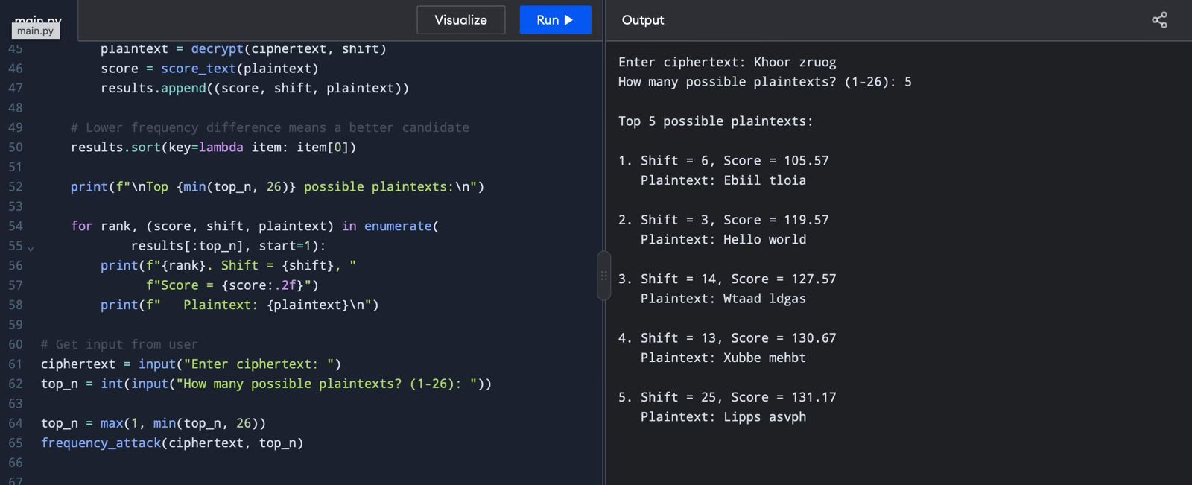
frequency_attack(ciphertext, top_n)

