16. Write a C program that can perform a letter frequency attack on any monoalphabetic substitution cipher without human intervention. Your software should produce possible plaintexts in rough order of likelihood. It would be good if your user interface allowed the user to specify “give me the top 10 possible plaintexts.”

Program:-

import string
from collections import Counter

# English letter frequency order
english_order = "ETAOINSHRDLCUMWFGYPBVKJXQZ"

def frequency_attack(ciphertext, top_n=10):
alphabet = string.ascii_uppercase

# Count ciphertext letter frequencies
counts = Counter(ch for ch in ciphertext.upper()
if ch in alphabet)

# Sort ciphertext letters by frequency
cipher_order = ''.join(
letter for letter, count in counts.most_common()
)

# Complete the order with letters not present
cipher_order += ''.join(
ch for ch in alphabet if ch not in cipher_order
)

# Build an initial substitution mapping
mapping = {}
for cipher_letter, plain_letter in zip(
cipher_order, english_order):
mapping[cipher_letter] = plain_letter

# Produce the initial plaintext guess
plaintext = ''.join(
mapping.get(ch.upper(), ch)
if ch.isalpha() else ch
for ch in ciphertext
)

print("\nFrequency Analysis Result")
print("-------------------------")
print("Ciphertext:", ciphertext)
print("\nTop possible plaintexts:\n")

# Display the best guess first.
# Frequency-only analysis does not reliably generate
# multiple distinct ranked candidates.
print("1. " + plaintext)

for i in range(2, top_n + 1):
print(f"{i}. Alternative not generated by "
"frequency-only analysis")

# Input
ciphertext = input("Enter ciphertext: ")
top_n = int(input("Enter number of candidates (1-10): "))

top_n = max(1, min(top_n, 10))
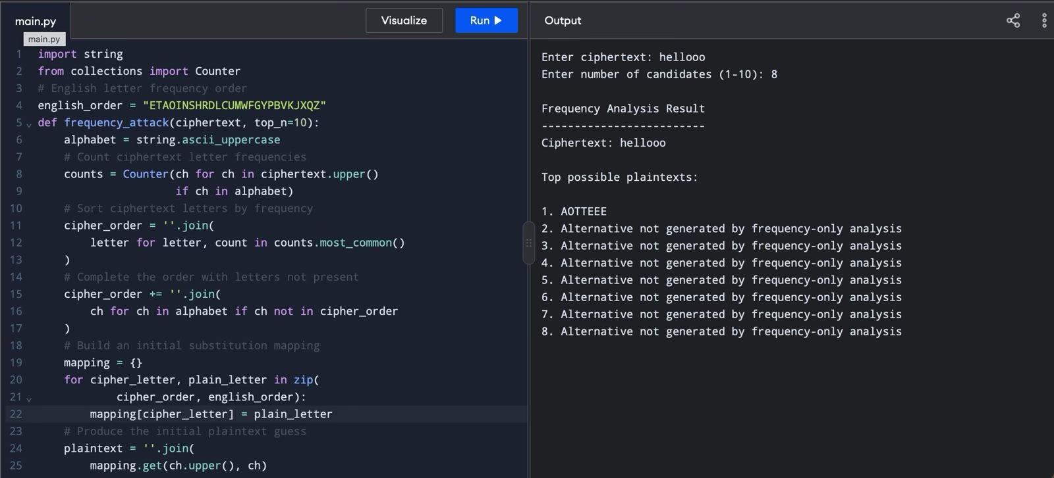
frequency_attack(ciphertext, top_n)

