1.To Write a c program for caeser Cipher involves replacing each other of the alphabet with the letter standing k places further down the alphabet for k In the range 1 through 25.
Program:-
def caesar_cipher(text, k):
result = ""
for ch in text:
if ch.isupper():
result += chr((ord(ch) - ord('A') + k) % 26 + ord('A'))
elif ch.islower():
result += chr((ord(ch) - ord('a') + k) % 26 + ord('a'))
else:
result += ch
return result
text = input("Enter the plaintext: ")
k = int(input("Enter the shift value (1-25): "))
if 1 <= k <= 25:
encrypted = caesar_cipher(text, k)
print("Encrypted text:", encrypted)
else:
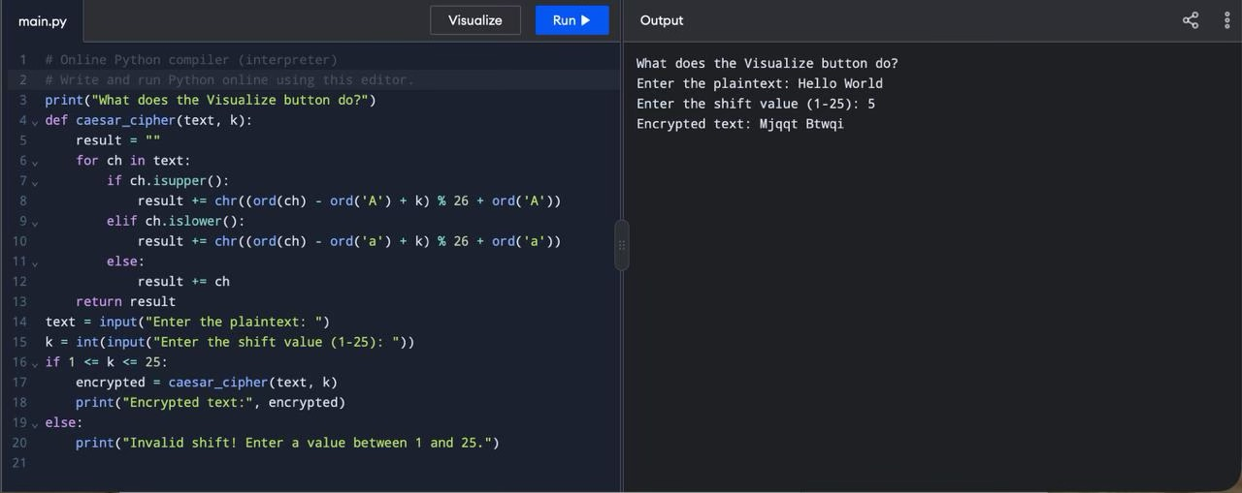
print("Invalid shift! Enter a value between 1 and 25.”)

