2.To Implement a e program for monoalphabetic Substitution,Cipher maps, a plaintext -to ciphertext, So that each letter Of the plaintext alphabet maps to single Unique letter of the ciphertext alphabet.

Program:-

def substitution_cipher(text, key):
alphabet = "abcdefghijklmnopqrstuvwxyz"
result = ""

for ch in text:
if ch.islower():
result += key[alphabet.index(ch)]
elif ch.isupper():
result += key[alphabet.index(ch.lower())].upper()
else:
result += ch

return result

alphabet = "abcdefghijklmnopqrstuvwxyz"
key = "qwertyuiopasdfghjklzxcvbnm"

if len(key) == 26 and len(set(key)) == 26 and key.isalpha():
plaintext = input("Enter the plaintext: ")
ciphertext = substitution_cipher(plaintext, key)
print("Ciphertext:", ciphertext)
else:
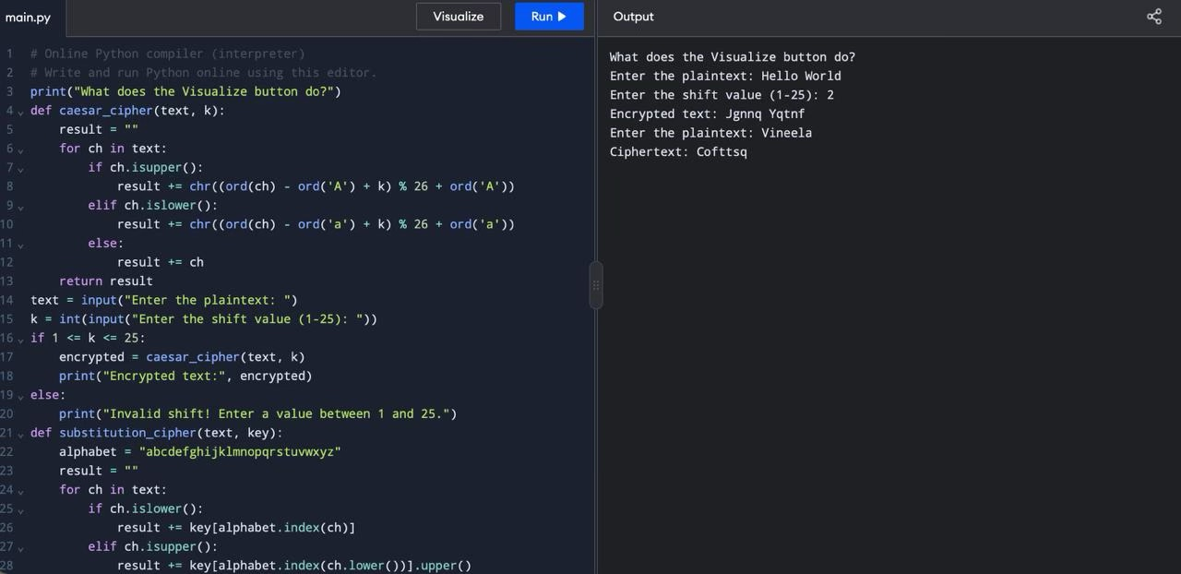
print("Invalid substitution key")

