3.To write a C program for playfair algorithm as based on the use of a 5x5 matrix of letters constructed using a keyword plaintext ls encreypted two letters at a time using matrix.

Program:-

def generate_matrix(key):
key = key.upper().replace("J", "I")
alphabet = "ABCDEFGHIKLMNOPQRSTUVWXYZ"
letters = ""
for ch in key + alphabet:
if ch.isalpha() and ch not in letters:
letters += ch
return [list(letters[i:i+5]) for i in range(0, 25, 5)]
def prepare_text(text):
text = "".join(ch for ch in text.upper() if ch.isalpha())
text = text.replace("J", "I")
result = ""
i = 0
while i < len(text):
a = text[i]
if i + 1 == len(text):
result += a + ("X" if a != "X" else "Q")
i += 1
elif text[i] == text[i + 1]:
result += a + ("X" if a != "X" else "Q")
i += 1
else:
result += text[i:i+2]
i += 2
return result
def encrypt_playfair(text, matrix):
positions = {
matrix[r][c]: (r, c)
for r in range(5) for c in range(5)
}
text = prepare_text(text)
cipher = ""
for i in range(0, len(text), 2):
a, b = text[i], text[i + 1]
r1, c1 = positions[a]
r2, c2 = positions[b]
if r1 == r2:
cipher += matrix[r1][(c1 + 1) % 5]
cipher += matrix[r2][(c2 + 1) % 5]
elif c1 == c2:
cipher += matrix[(r1 + 1) % 5][c1]
cipher += matrix[(r2 + 1) % 5][c2]
else:
cipher += matrix[r1][c2]
cipher += matrix[r2][c1]
return cipher
key = input("Enter the keyword: ")
plaintext = input("Enter the plaintext: ")
matrix = generate_matrix(key)
print("\nPlayfair Matrix:")
for row in matrix:
print(" ".join(row))
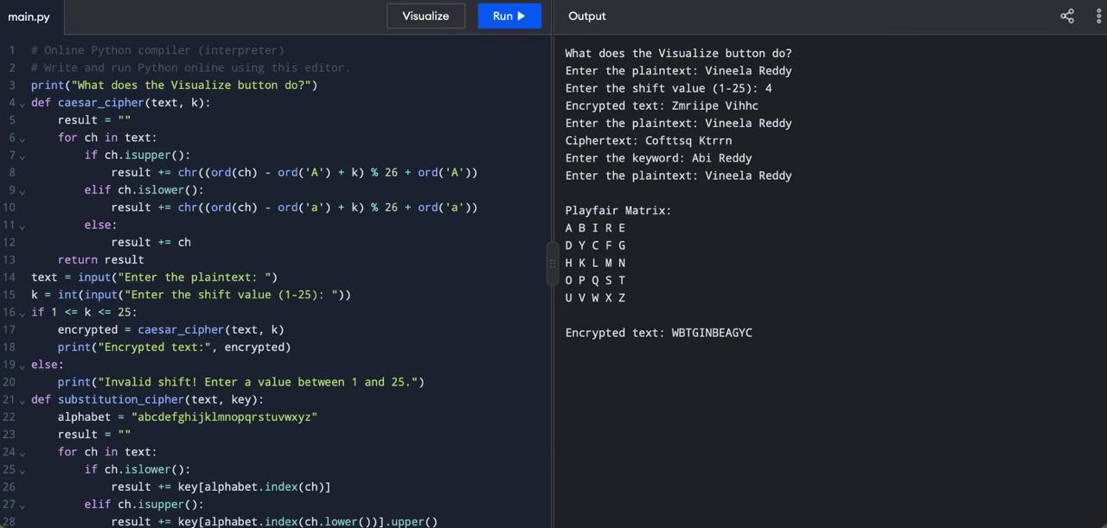
print("\nEncrypted text:", encrypt_playfair(plaintext, matrix))

