4.To Implement a polyalphabetic Substitution Cipher uses a seperate Monoalphabetic Rubstitution Cipher.

Program:-

def vigenere_encrypt(plaintext, key):
result = ""
key = key.upper()
j = 0
for ch in plaintext:
if ch.isalpha():
shift = ord(key[j % len(key)]) - ord('A')
if ch.isupper():
result += chr((ord(ch) - ord('A') + shift) % 26 + ord('A'))
else:
result += chr((ord(ch) - ord('a') + shift) % 26 + ord('a'))
j += 1
else:
result += ch
return result
plaintext = input("Enter the plaintext: ")
key = input("Enter the keyword: ")

if key.isalpha():
ciphertext = vigenere_encrypt(plaintext, key)
print("Encrypted text:", ciphertext)
else:
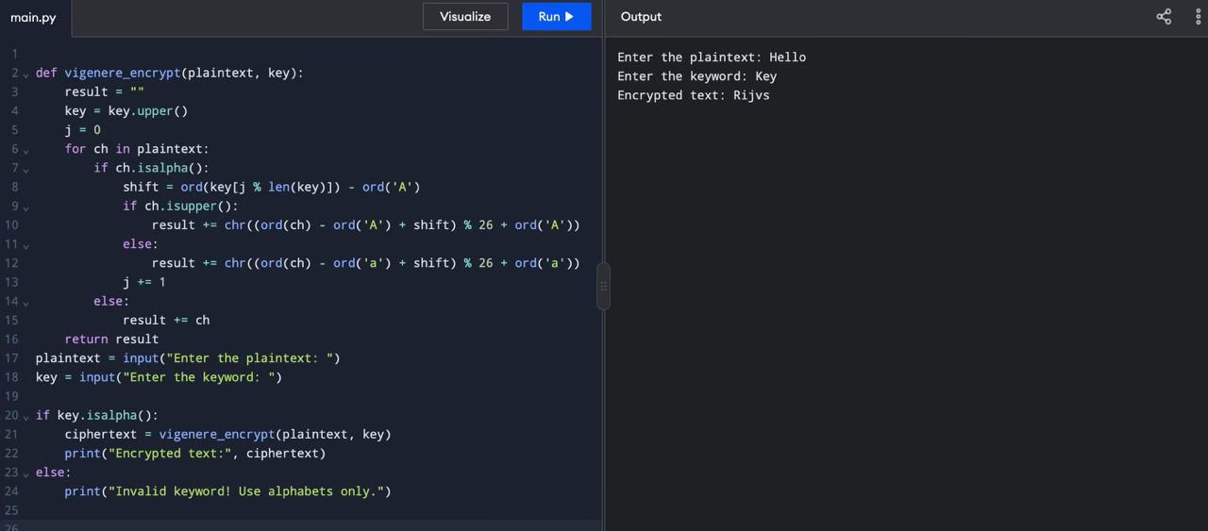
print("Invalid keyword! Use alphabets only.")

