5. Write a C program for generalization of the Caesar cipher, known as the affine Caesar cipher, has the following form: For each plaintext letter p, substitute the ciphertext letter C: C = E([a, b], p) = (ap + b) mod 26 A basic requirement of any encryption algorithm is that it be one-to-one. That is, if p q, then E(k, p) E(k, q). Otherwise, decryption is impossible, because more than one plaintext character maps into the same ciphertext character. The affine Caesar cipher is not one-to-one for all values of a. For example, for a = 2 and b = 3, then E([a, b], 0) = E([a, b], 13) = 3.
a. Are there any limitations on the value of b?
b. Determine which values of a are not allowed.

Program:-
def affine_encrypt(text, a, b):
result = ""
for ch in text:
if ch.isupper():
p = ord(ch) - ord('A')
c = (a * p + b) % 26
result += chr(c + ord('A'))
elif ch.islower():
p = ord(ch) - ord('a')
c = (a * p + b) % 26
result += chr(c + ord('a'))
else:
result += ch
return result
a = int(input("Enter key a: "))
b = int(input("Enter key b: "))
if 0 <= b < 26 and 0 <= a < 26:
if __import__('math').gcd(a, 26) == 1:
text = input("Enter plaintext: ")
print("Encrypted text:", affine_encrypt(text, a, b))
else:
print("Invalid a! gcd(a, 26) must be 1.")
else:
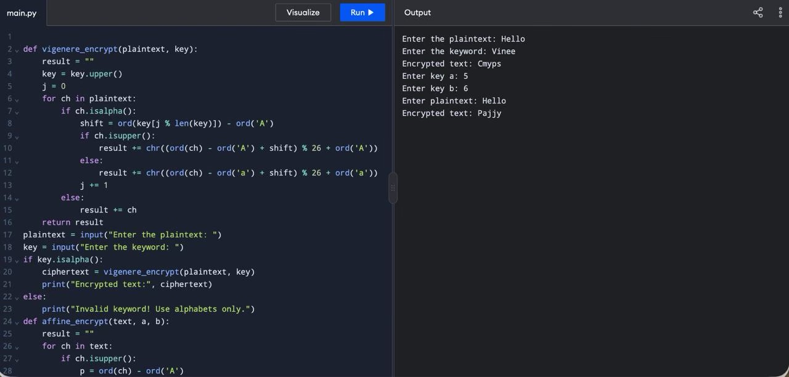
print("Enter a and b between 0 and 25.")

