6. Write a C program for ciphertext has been generated with an affine cipher. The most frequent letter of the ciphertext is “B,” and the second most frequent letter of the ciphertext is “U.”Break this code.

Program:-

from math import gcd
def mod_inverse(a, m=26):
for i in range(m):
if (a * i) % m == 1:
return i
return None
def break_affine_cipher():
# Assume E -> B and T -> U
p1, c1 = 4, 1
p2, c2 = 19, 20
for a in range(26):
if gcd(a, 26) == 1:
b = (c1 - a * p1) % 26

if (a * p2 + b) % 26 == c2:
a_inv = mod_inverse(a)
print("Encryption key: a =", a, ", b =", b)
print("Decryption formula: p =",
a_inv, "(C -", b, ") mod 26")
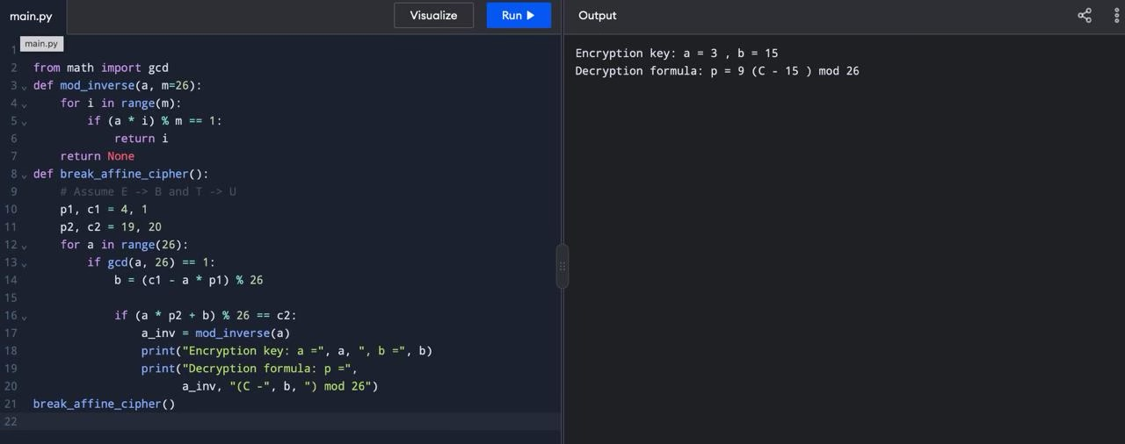
break_affine_cipher()

