10. Write a C program for Playfair matrix:
M F H I/J K
U N O P Q
Z V W X Y
E L A R G
D S T B C
Encrypt this message: Must see you over Cadogan West. Coming at once.

Program:-

def find_position(matrix, ch):
if ch == 'J':
ch = 'I'
for r in range(5):
for c in range(5):
if matrix[r][c] == ch:
return r, c
def encrypt_pair(matrix, a, b):
r1, c1 = find_position(matrix, a)
r2, c2 = find_position(matrix, b)
# Same row
if r1 == r2:
return matrix[r1][(c1 + 1) % 5] + matrix[r2][(c2 + 1) % 5]
# Same column
elif c1 == c2:
return matrix[(r1 + 1) % 5][c1] + matrix[(r2 + 1) % 5][c2]
# Rectangle rule
else:
return matrix[r1][c2] + matrix[r2][c1]
matrix = [
['M', 'F', 'H', 'I', 'K'],
['U', 'N', 'O', 'P', 'Q'],
['Z', 'V', 'W', 'X', 'Y'],
['E', 'L', 'A', 'R', 'G'],
['D', 'S', 'T', 'B', 'C']
]
message = "Must see you over Cadogan West. Coming at once."
message = ''.join(ch for ch in message.upper() if ch.isalpha())
message = message.replace('J', 'I')
# Prepare letter pairs
pairs = []
i = 0
while i < len(message):
a = message[i]
if i + 1 < len(message):
b = message[i + 1]
else:
b = 'X'
if a == b:
pairs.append(a + 'X')
i += 1
else:
pairs.append(a + b)
i += 2
ciphertext = ''
for pair in pairs:
ciphertext += encrypt_pair(matrix, pair[0], pair[1])
print("Plaintext:", message)
print("Letter pairs:", ' '.join(pairs))
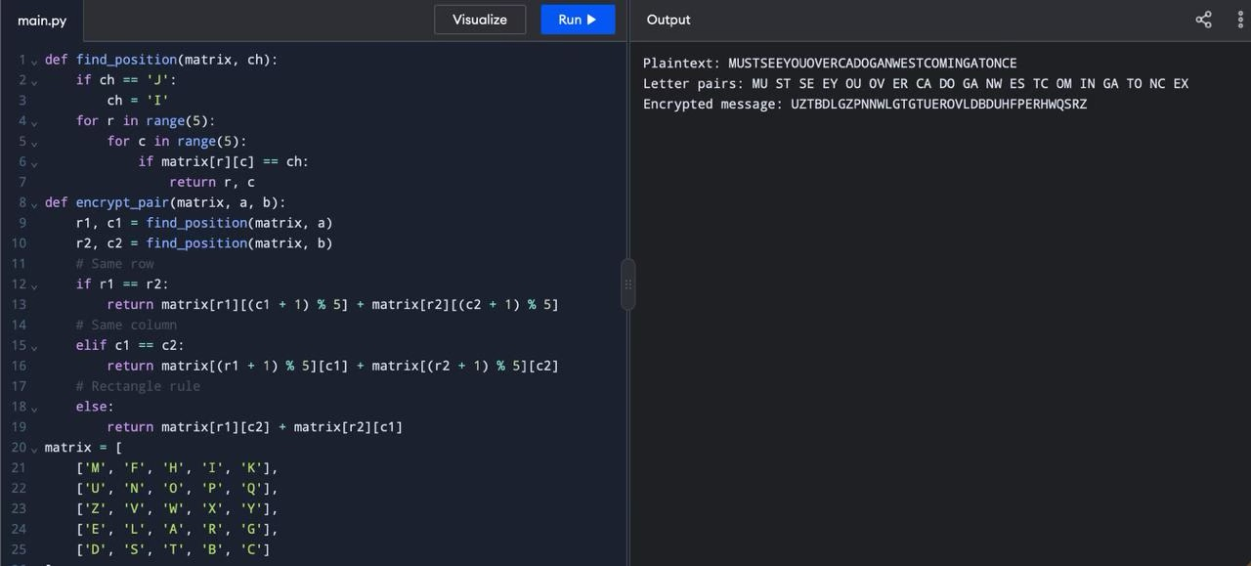
print("Encrypted message:", ciphertext)

